RUNNING THE CODE
Step 1.
Download all files from CemeteryLab folder.
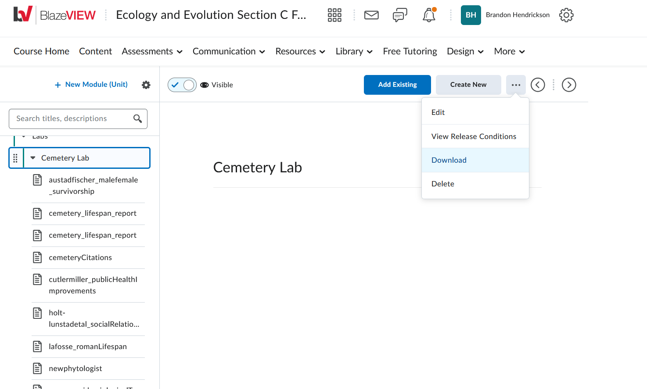
Step 2. Create a new folder in your documents directory:
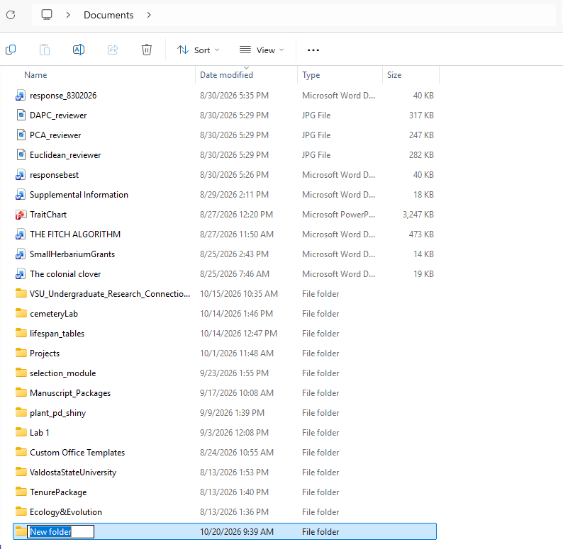

And then move the newly downloaded files into the new folder (I named it ‘cemeteryLab’)
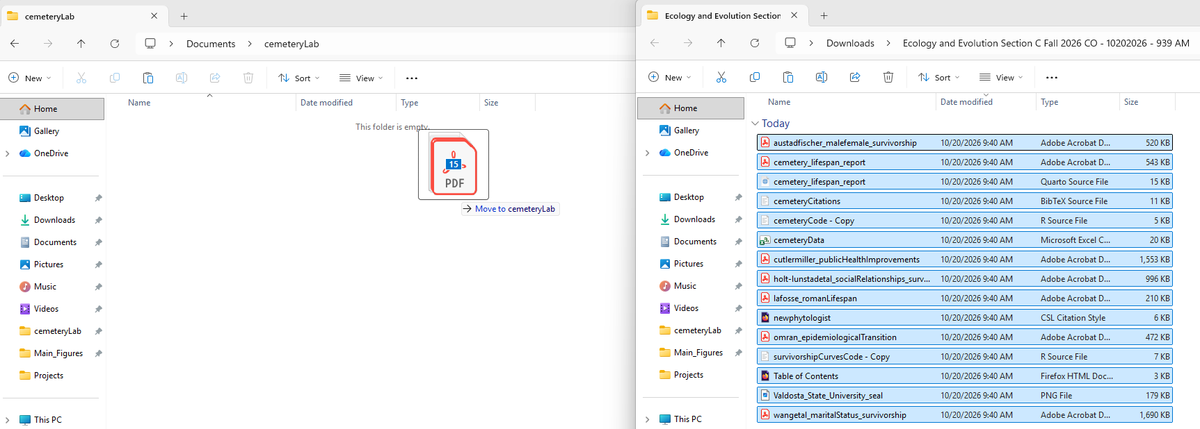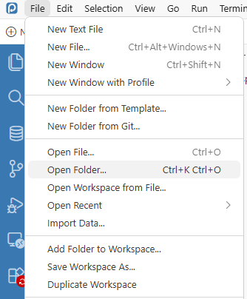

Step 3. Open up positron. Open up a new window in the ‘cemeteryLab’ folder you just created.
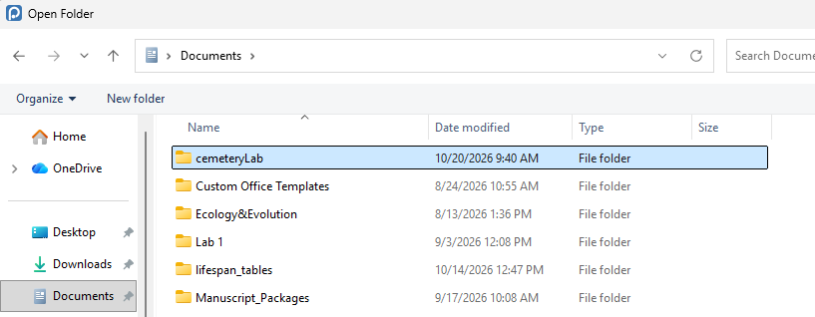
You should see the files in the left hand like this
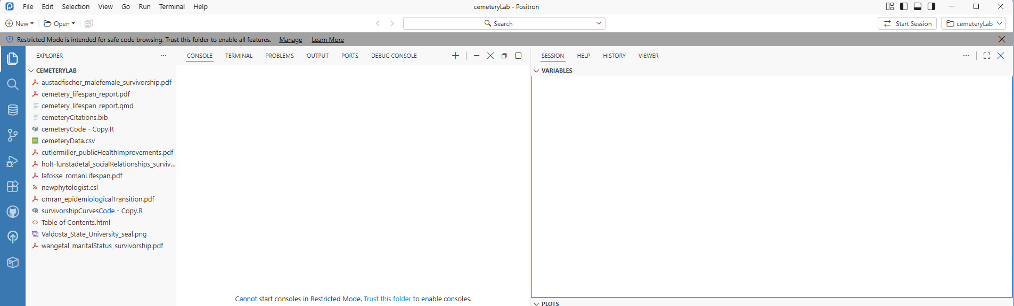

*Make sure you give positron permission to read files from this folder: so, click on ‘Manage’ and then ‘Trust this folder’
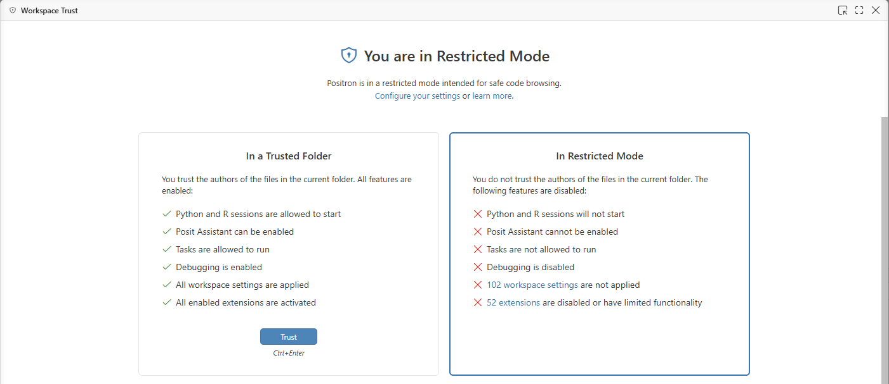
*Click ‘Trust’
*Then, ‘start session’ in your consol, making sure to run R when provided an option.
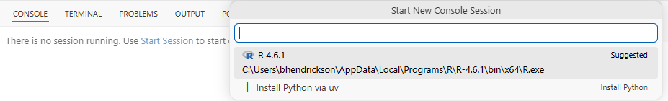

Step 4. Make sure to have pacman installed … type the following : install.packages(“pacman”)
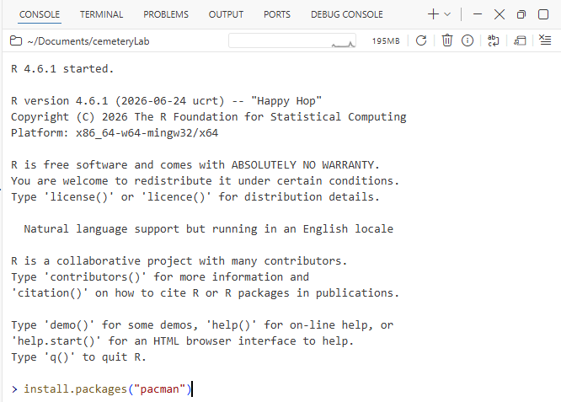

Step 5. Open up ‘cemeteryCode.R’ by clicking on it in the explorer tab of positron.
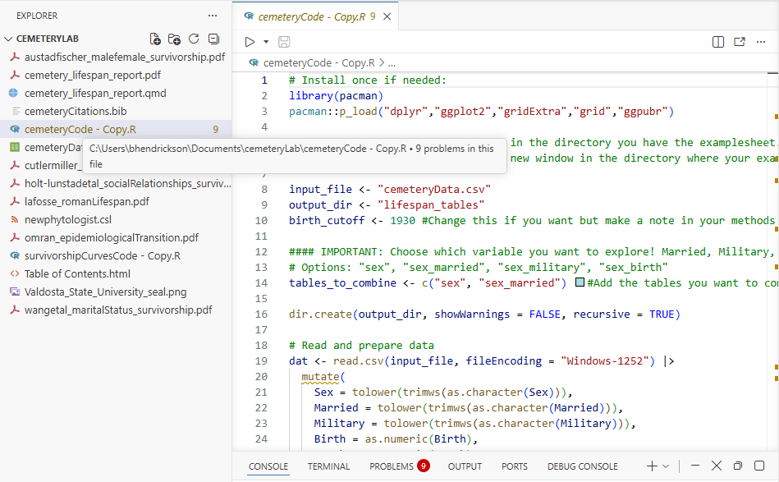

Step 6. RUN IT!
Highlight the whole text block (click in the file, then do Ctrl + A (Cmd + A on Mac) and then click the play button at the top of the text editor tab.
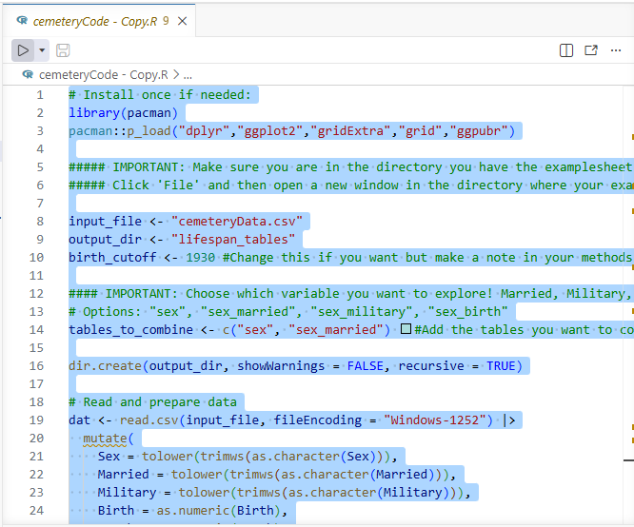

Step 7. Repeat with ‘survivorshipCurvesCode.R’ by Ctrl + A and run.

