Milestones | Date | Version | Remarks
ERD Diagram &  Schema | 4-24-2026 | 1.0 | -------

CINETRACE PROJECT MILESTONES

TASK 1:
- ERD (Entity-Relationship Diagram) of your project
- Relational Database Schema Description (tables, attributes, keys, relationships)

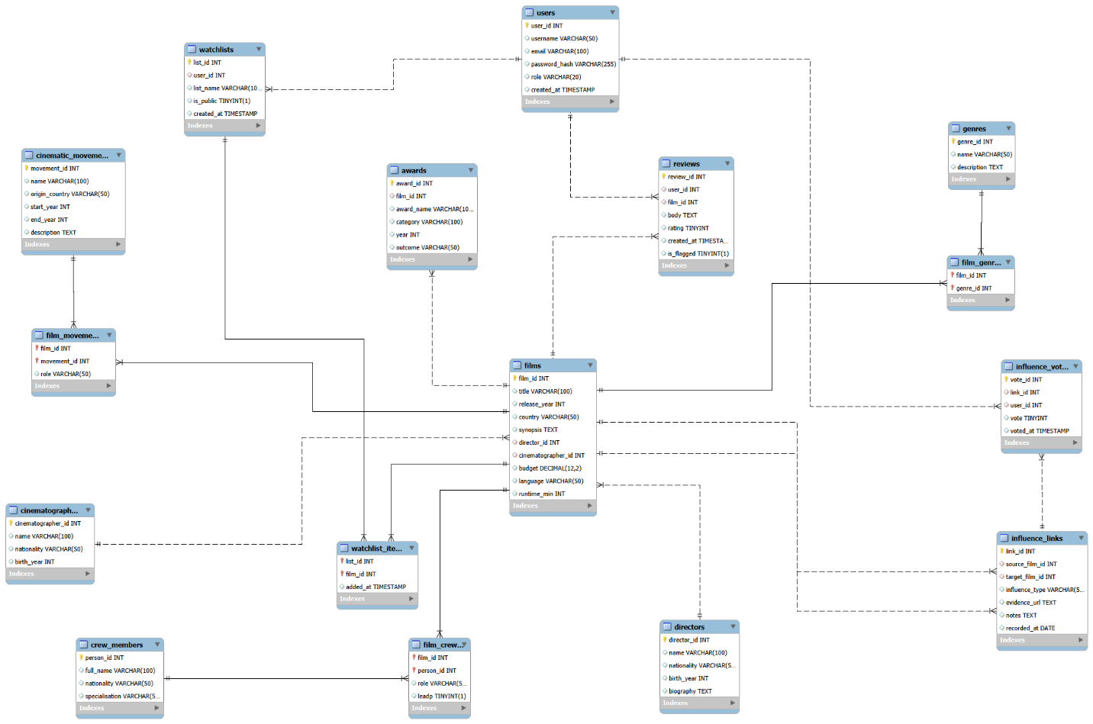

Tables:
1. Directors
This table stores information about film directors.
Attributes:
- director_id (Primary Key)
- name
- nationality
- birth_year
- biography
Relationship:
- One director can direct many films (1:N with Films)

2. Cinematographers
Stores details of cinematographers.
Attributes:
- cinematographer_id (Primary Key)
- name
- nationality
- birth_year
Relationship:
- One cinematographer can work on many films (1:N with Films)

3. Films
This is the central table of the database.
Attributes:
- film_id (Primary Key)
- title
- release_year
- country
- synopsis
- director_id (Foreign Key)
- cinematographer_id (Foreign Key)
- budget
- language
- runtime_min
Relationships:
- Many films belong to one director (N:1)
- Many films belong to one cinematographer (N:1)
- Many-to-many with Genres, Crew Members, and Movements

4. Genres
Stores film genres.
Attributes:
- genre_id (Primary Key)
- name (Unique)
- description
Relationship:
- Many-to-many with Films (via Film_Genres)
5. Film_Genres
Junction table to resolve many-to-many relationship between Films and Genres.
Attributes:
- film_id (Foreign Key)
- genre_id (Foreign Key)
Key:
- Composite Primary Key (film_id, genre_id)

6. Influence_Links
Represents relationships between films (self-referencing).
Attributes:
- link_id (Primary Key)
- source_film_id (Foreign Key)
- target_film_id (Foreign Key)
- influence_type
- evidence_url
- notes
- recorded_at
Relationship:
- A film can influence many films (1:N self relationship)

7. Cinematic_Movements
Stores film movements like “French New Wave”.
Attributes:
- movement_id (Primary Key)
- name (Unique)
- origin_country
- start_year
- end_year
- description

8. Film_Movements
Junction table for films and movements.
Attributes:
- film_id (Foreign Key)
- movement_id (Foreign Key)
- role
Key:
- Composite Primary Key (film_id, movement_id)

9. Crew_Members
Stores data about film crew.
Attributes:
- person_id (Primary Key)
- full_name
- nationality
- specialisation

10. Film_Crew
Handles many-to-many relationship between Films and Crew Members.
Attributes:
- film_id (Foreign Key)
- person_id (Foreign Key)
- role
- is_lead
Key:
- Composite Primary Key (film_id, person_id)

11. Awards
Stores awards received by films.
Attributes:
- award_id (Primary Key)
- film_id (Foreign Key)
- award_name
- category
- year
- outcome
Relationship:
- One film can have many awards (1:N)

12. Users
Stores user accounts.
Attributes:
- user_id (Primary Key)
- username (Unique)
- email (Unique)
- password_hash
- role
- created_at

13. Reviews
Stores user reviews of films.
Attributes:
- review_id (Primary Key)
- user_id (Foreign Key)
- film_id (Foreign Key)
- body
- rating
- created_at
- is_flagged
Relationships:
- One user can write many reviews
- One film can have many reviews

14. Watchlists
Stores user-created lists.
Attributes:
- list_id (Primary Key)
- user_id (Foreign Key)
- list_name
- is_public
- created_at

15. Watchlist_Items
Links films to watchlists.
Attributes:
- list_id (Foreign Key)
- film_id (Foreign Key)
- added_at
Key:
- Composite Primary Key (list_id, film_id)

16. Influence_Votes
Stores user votes on influence relationships.
Attributes:
- vote_id (Primary Key)
- link_id (Foreign Key)
- user_id (Foreign Key)
- vote
- voted_at

