Project Log Book

Group Members:
Entry Date | Work Done
October 30th, 2021 | Discussed the basic plan to build the prototype for PMS in class, noting down all constraints to be taken care of. Furthermore, we decided our next group meeting would be on November 6th, 2021 (Saturday) at 2:30, meeting place: PAF-KIET city campus
November 6th, 2021 | Meeting at Campus: We discussed about the project objective. Using the Software Management Plan template printed from the web site, we stepped through each section and discussed what was required and what resources were available to us. We also discussed how this prototype should be flexible. There was constant reference to the " Pharmacy Management System" and other related articles.
November 7th, 2021 | Finished a rough draft prototype and set it up on the online account.
November 10th, 2021 | Rameen Tariq checked the document of the Software Project Management Plan, and she made some correction marking the corrections in red.
November 11th, 2021 | The mistakes were corrected on the web site, and email was sent to Rameen Tariq to check the document for any more mistakes
November 18th, 2021 | The document was checked by Rameen Tariq and few more mistakes were found. These mistakes were corrected and put on the web.
November 27th, 2021 | Meeting at City campus: We discussed the Management System in more detail and added more information to the SPMP document.
December 2nd, 2021 | Rameen Tariq checked the document of the Software Project Management Plan, and she made some corrections.
December 15th, 2021 | The mistakes were corrected on the web site, and email was sent to Rameen Tariq to check the document for any more mistakes.
December 26th, 2021 | Meeting at city campus: We discussed parts 4 and 5 of the Software Project Management Plan in more detail and decided to update some information in the SPMP document. The different parts of the document were divided between the team for updates.
January 3rd, 2021 | Finished updating the rough draft prototype and set it up on the online account. Sent all team members email with link to latest copy of the document.
January 12th, 2021 | Rameen Tariq checked the document of the Software Project Management Plan. The mistakes were corrected on the web site. The latest version of the document is available online.

Last Updated on Novemeber 6th, 2021
Software Requirements Specification
for
Pharmacy Management System
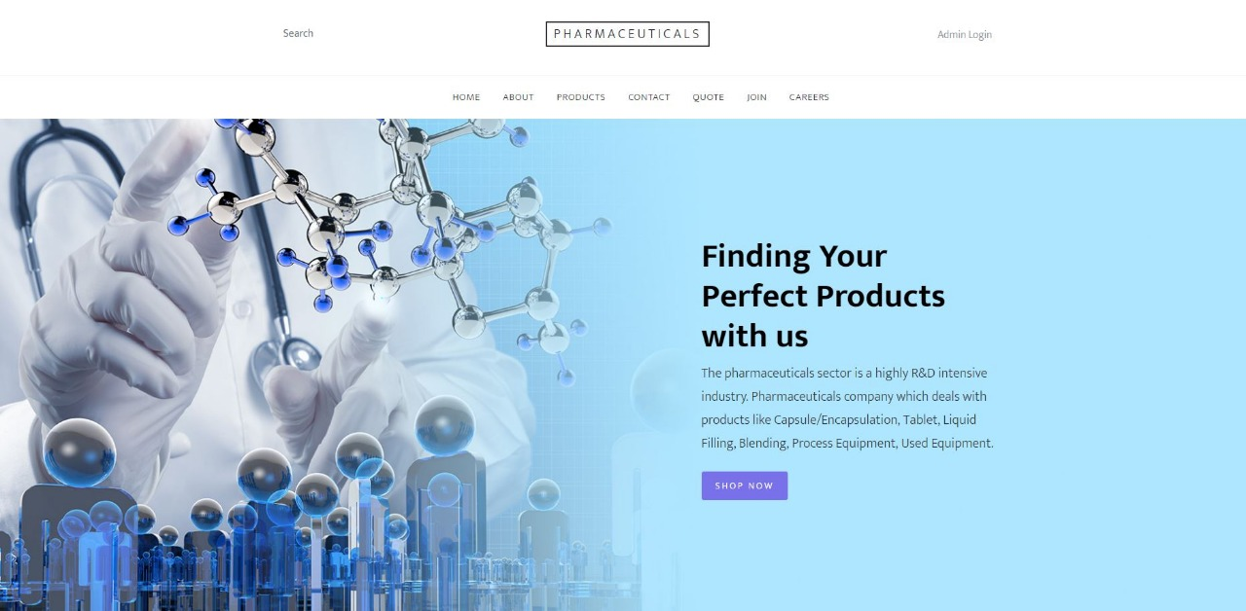

Rameen Tariq
Tahreem Yousuf
Rabbia Noreen
Alina Mushtaq
November 06, 2021

Version | Changes Made | Date
1.0 | First Pass for Review | 11/06/2021
1.2 | Second Pass for Review | 11/20/2021
1.3 | Third Pass for Review | 12/11/2021
1.4 | PMS Review Version | 1/15/2021

Table of Contents
1. Introduction
2. The General Description
3. Specific Requirements
4. Supporting Information

1. Introduction

1.1 Purpose

The purpose of this SRS is to provide all the possible information about the website for pharmaceutical’s developers, users and customers. So that they could access efficiently and website would work effectively.

1.2 Scope In

This website can be used by pharmacists and customers intended to buy medical stuff. The main objective of this project is to make it easier for people to get medicines at their doorstep by leading pharmacists having all kinds of required products

1.3 Scope Out

The following features will not be the part of this Project:

1.3 Definitions, Acronyms, and Abbreviations.

CASE – Computer Aided Software Engineering
PP - Project Plan
SDD - Software Design Description
SRS - Software Requirement Specification
SDS – Software Design Specification
SPMP - Software Project Management Plan
GUI – Graphical User Interface
QAM – Quality Assurance Manager
PDM – Project Development Manager
PMS – Pharmacy Management System
PMP – Project Management Professional
TBD – To be determined
UML – Unified Modeling Language

1.4 References

1.5 Overview

Chapter 2 of the SRS is a brief description of the characteristics of the software to be built, its functions, its users, its constraints and its dependencies.

Chapter 3 is about specific requirements, such as functional requirements, external interface requirements, performance requirements, and also design constraints and quality characteristics.

Finally, chapter 4 includes all the supporting information, such as the Table of Contents, the Appendices, and the Index.

2. The General Description

This section describes the general factors that affect the product and its requirements. This section consists of five subsections that follow. This section does not state specific requirements. Each of the subsections makes those requirements easier to understand, it does not specify design or express specific requirements. Such detail is provided in section 3.

2.1 Product Perspective
This is a new software based on the process followed by various pharmacists and patients across the country, to get data and information about the prescribed medicines for the pharmacist and for patient/customers to buy them easily with guaranteed genuine medical products , and show the employees record who are working for the field.

Functions of System Components:

Database:
• Stores data
• Creates reports
• Provides access to data
• Updates information

Server:
• Provides access to the database
• Authenticates users
• Processes Medicines
• Performs backups
• Produces reports

External Interfaces:

Personal Computers
• Users (Admin, Pharmacist, Customer and Developer) may use personal computers to obtain a remote access to the server and the medicine database via the Internet.

Cell Phones
• Serve as a medium of accessing the server and the medicine database.
• Users may use cell phones and the latest telecommunication technologies to access the server and the medicine database via Internet, or they may use cell phones to call to inquire about medicine and shipping information.

Computer Hardware and Peripheral Equipment to be used:
• 30 workstations, which include CPUs, monitors, keyboards, and mice
• Printers
• Network
• Cell phones to test connection to the server via remote access

2.2 Product Functions
This section provides a summary of the functions that the software will perform.
2.2.1 Function Relationships

2.2.2 Function Descriptions (Functional Requirement Listings)

2.2.2.1 Log In Function

Description: This function ensures that only authorized users gain access to the Orders databases. An authorized user is a user who has an account on the system. Users include customer, pharmaceutical officials, and authorized doctors. The user must type a valid username and password to gain access.

2.2.2 Module 1: Signup/Login Authentication

Description::
User will enter the website and authenticate by providing necessary credentials to login or a new user will signup for future use.
Then a home page will appear on the screen comprising of elements of website header on navigation bar and a shop now option for further member to work on,
Product next screen will provide complete details of the product and crud functions.

2.2.3 Module 2: Home page and Product details

Description: Sales features will be added by this member which consists of Features are product attributes or product aspects and capabilities. The key thing to know about features is that features are 100% focused on your product or service offering. To demonstrate, the rates discounts cart and order facility.

2.2.4 Module 3: Sales Features
Description: Autocomplete or query suggestions (also known as predictive search or autosuggest) provides users with search recommendations in real time as they type queries. These suggestions, contextually related to their queries or other queries popular on the site, are intended to speed up the search process and increase click-through rates.

2.2.5 Module 4: Shipping and contact details

Description: Shipping contact information can contain address, name, phone, and email fields.

2.3 User Characteristics
The main users of the system will be the pharmacist and customer buying medicine. The users are not required to have knowledge in the computer field. The graphical interface provides an easy way of using the PM system with minimum of training.

2.4 General Constraints
The constraints for the project are:
- The functional prototype should be available after 30 days. This may prove to be a serious time constraint on the development of a successful prototype.
- Team members are restricted from bringing their own equipment, and insufficient equipment supply may hinder project development.
- Team members are restricted to bringing only the analysts of the team . This might affect the project development if more people are needed or the required skills are not available
2.5 Assumptions and Dependencies or Business Logic
The assumptions for the project are:
- Pharmacy Management System
- Workflow System
- POS (Point-of-Sale) System
- Medicaid Billing/Claims Submission
- Documentation and Billing for Immunizations
- Patient Communications Management (e.g. IVR, text, email or other outbound and inbound communications tools)
- Mobile Delivery Tracking
- Barcode Scanning
- Pre edit Services
- Drug Visuals (Image of product dispensed as part of quality assurance process)
- Off-Site Backup/Recovery
- Pharmacy Inventory Control System
- Prescriber Validation/Verification
- Data Management (e.g., conversion, archiving, decommissioning, analysis, etc.)

3. Specific Requirements

This section of the SRS contains design requirements for the Pharmacy Management System.

3.1 Functional Requirements

3.1.1 Log In Function

- Description: This function ensures that only authorized users gain access to the Pharmacy databases. An authorized user is a user who has an account on the system. Users include doctors, pharmacists, and site users. The user must type a valid username and password to gain access.

- Usage Scenario/ Use case Description/ Specification:

Description | Allows access to online PMS
Inputs | Username, password
Source | - User inputs username and password  - Press Login Button

Alternate case
Outputs | Successful login; unsuccessful login
Destination | None
Precondition | Authorized User
Post Condition | No change to Passenger Accounts Database
Side Effects | Failures and successful logins are sent to pharmacy Database

- Detailed Use case Diagram for Login:

- Use case Realization for Login: optional

- Flow of Event or Data Flow Diagram for Login: optional
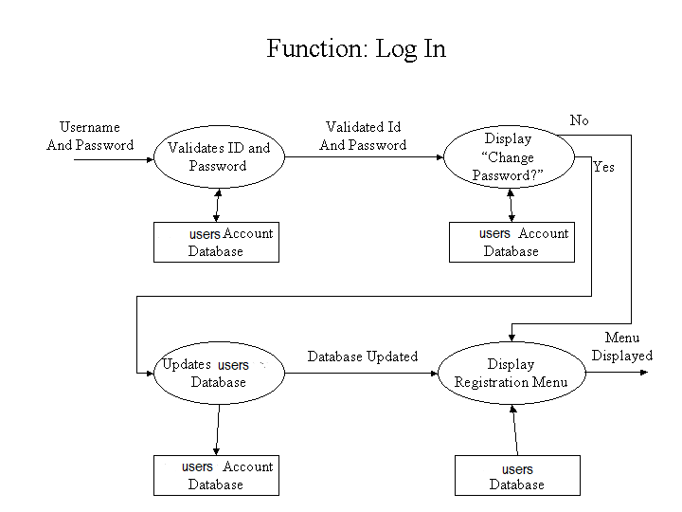

- Sequence Diagram for Login: optional

- Collaboration Diagram for Login: optional

- Activity Diagram for Login: optional

- Class Diagram for Login: optional

- State Chart Diagram for Login: optional

    - Module 1 complete CRUD Product Details

- Description: This function allows the user to [make | delete | view | update] a product for a particular medicine on a particular date for a certain quantity. If the user does not already have an order , then a new booking is created. If the user already has a product in cart, a new product is added to the list of current orders, and the passenger account balance gets updated.

- Usage Scenario/ Use case Description/ Specification:

Description | [ make | drop | view | update] a product to the user’s account
Inputs | From product id, to Air volume, Air pressure, Filling speed, Filling range and created date
Source | - User Orders a certain product  - Press Button …

Alternate Case
Outputs | Added | Deleted | Viewed | Modified order
Destination | Computer screen  Pharmacy database  User Account database
Precondition | Valid information; Product name, date , user name, user contact , date of dispatch
Post Condition | product added to users cart
Side Effects | User’s current order adjusted  Balance due adjusted

- Use case Diagram:

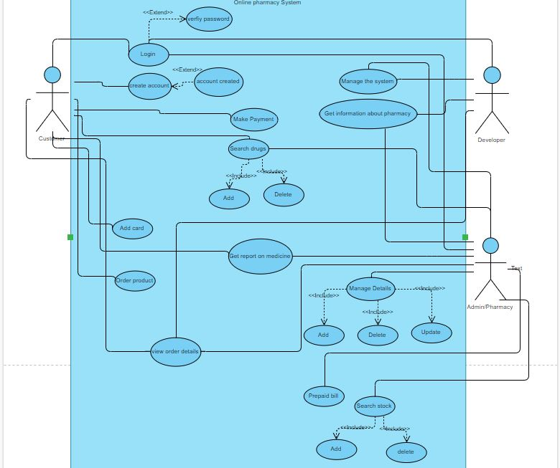

- Flow of Event or Data Flow Diagram:

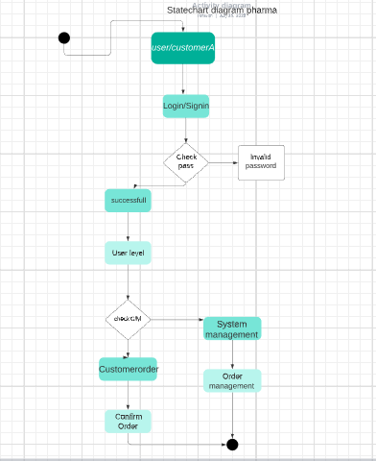

- Sequence Diagram:
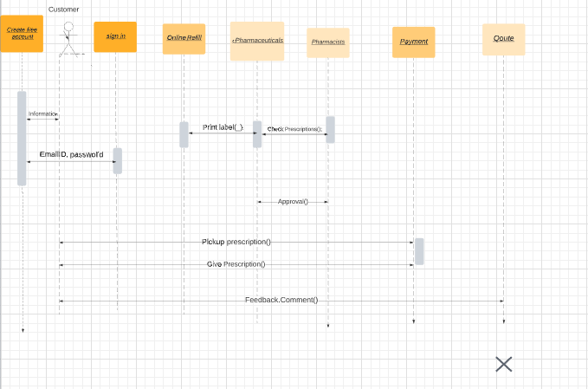

- Collaboration Diagram:
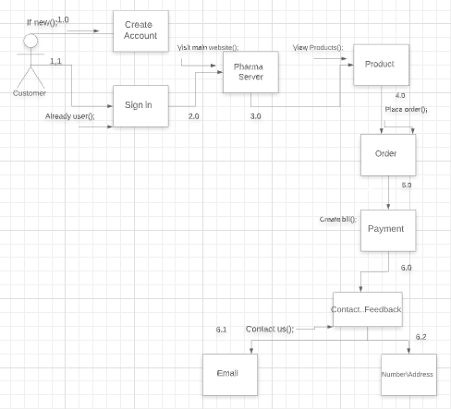

- Activity Diagram:

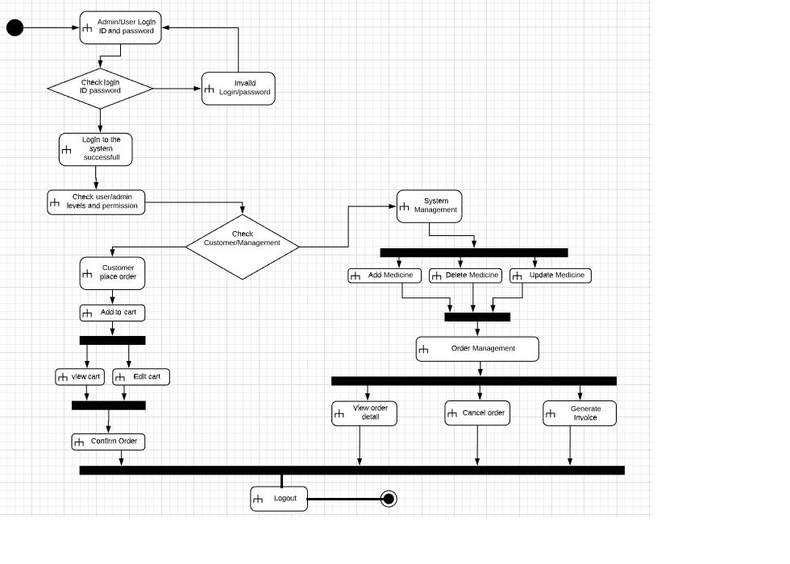

- Class Diagram:
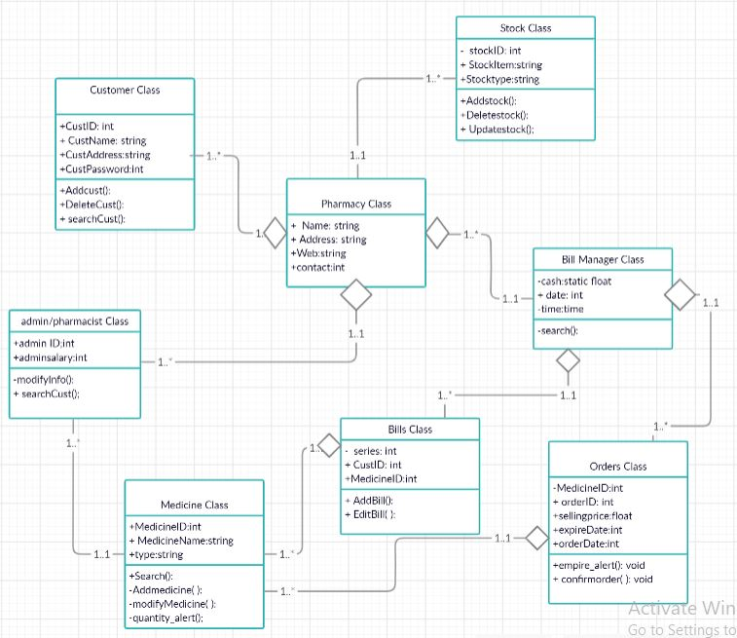

- State Chart Diagram:

3.1.3 Module 3 complete CRUD

3.1.4 Module 4 complete CRUD
3.1.5 Module 5 complete CRUD
3.1.6 Module 6 complete CRUD

3.2. External Interface Requirements
3.2.1 User Interfaces

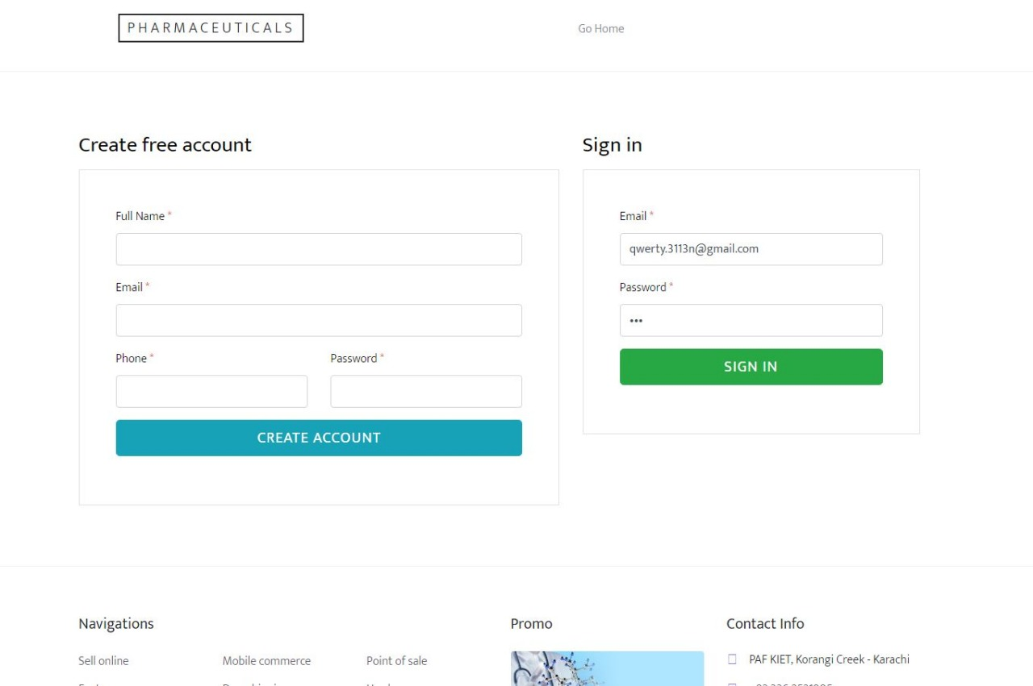

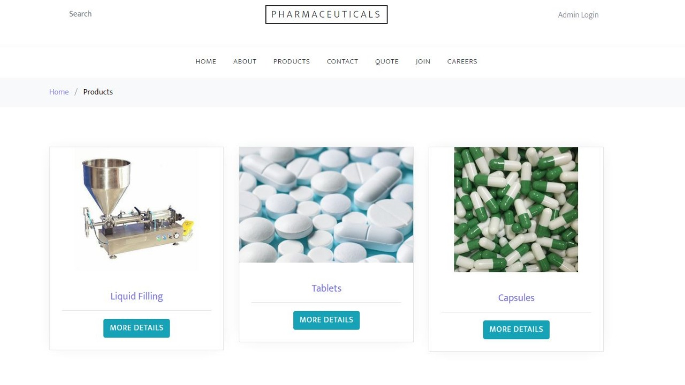

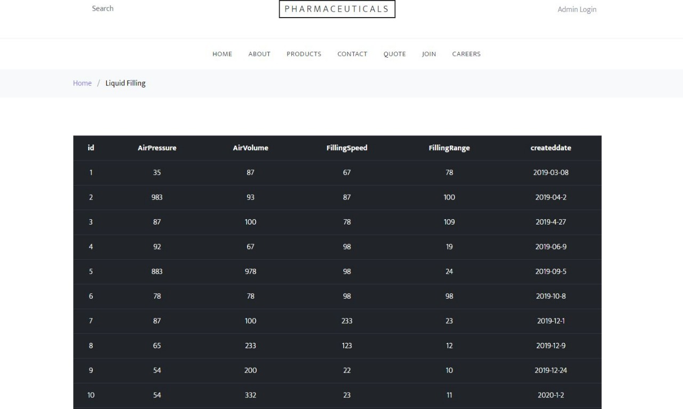

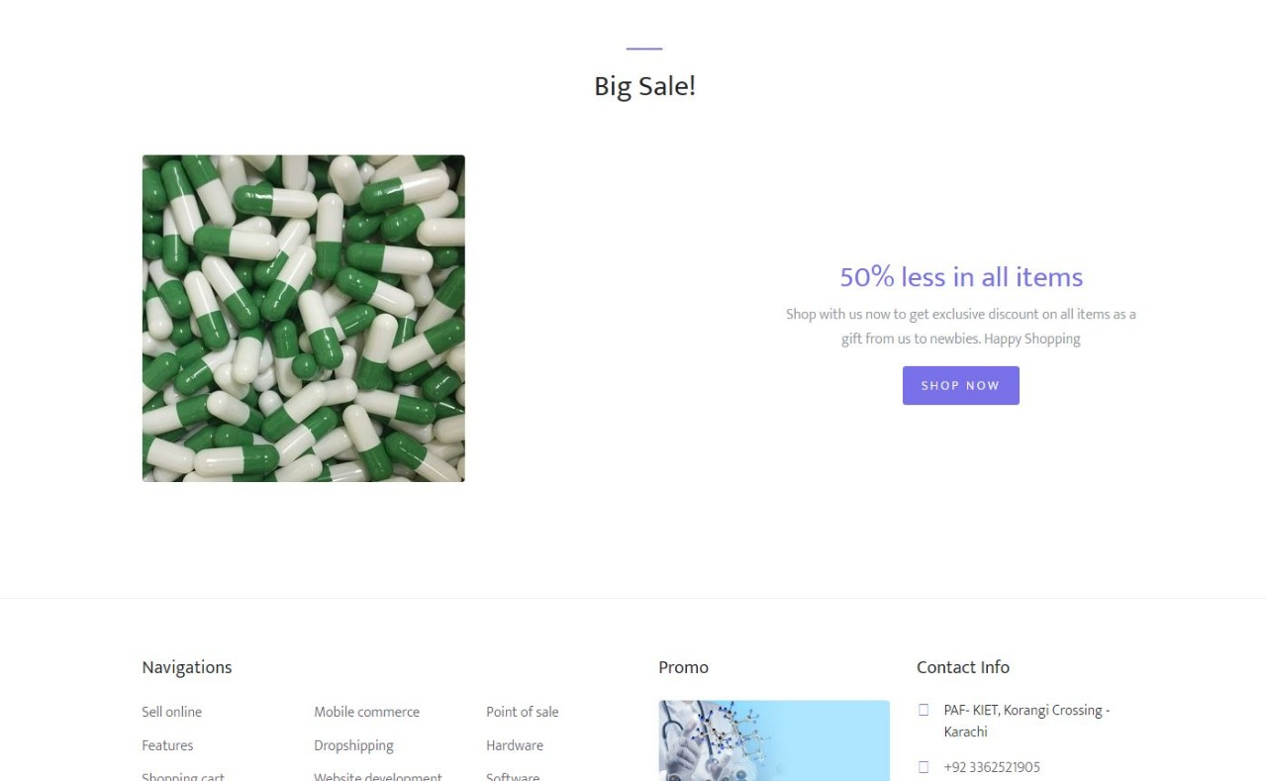

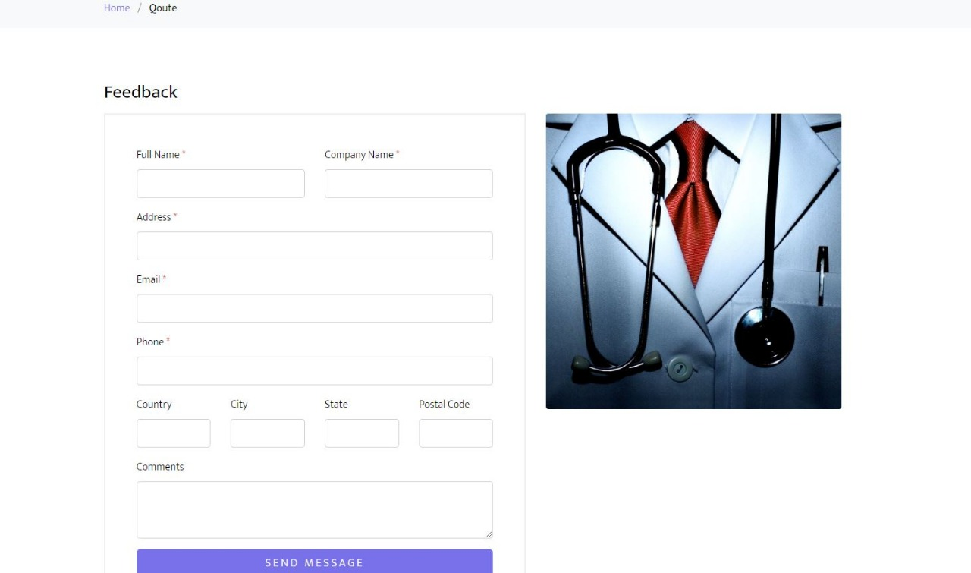

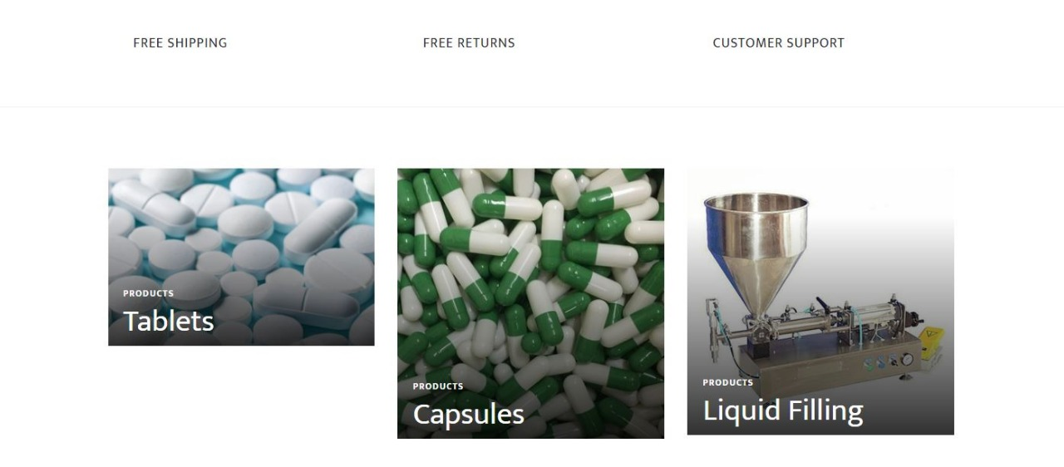

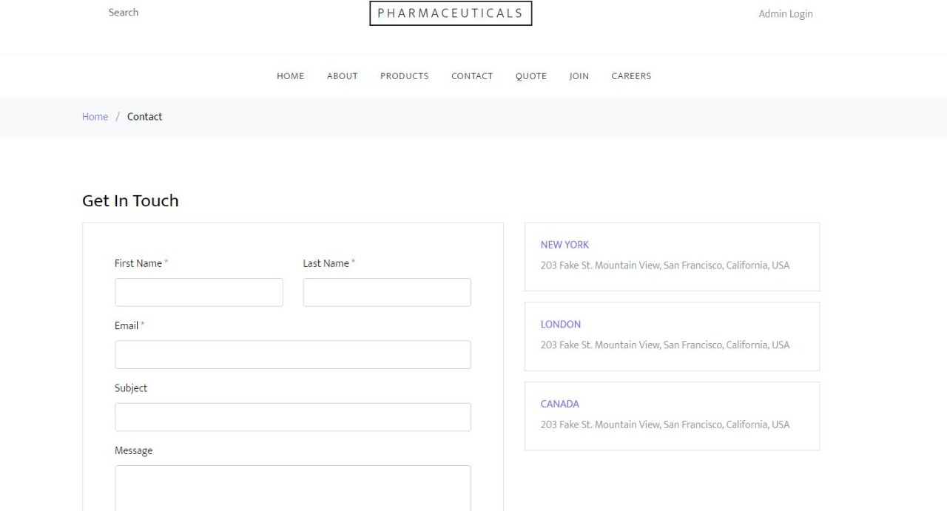

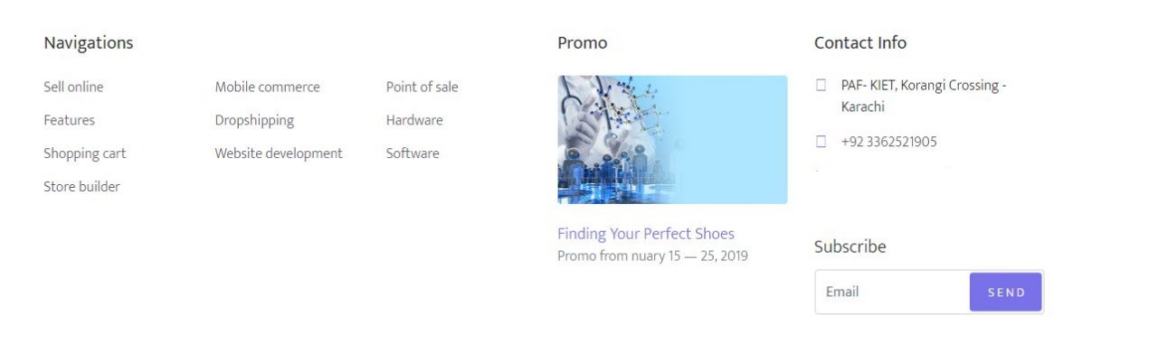

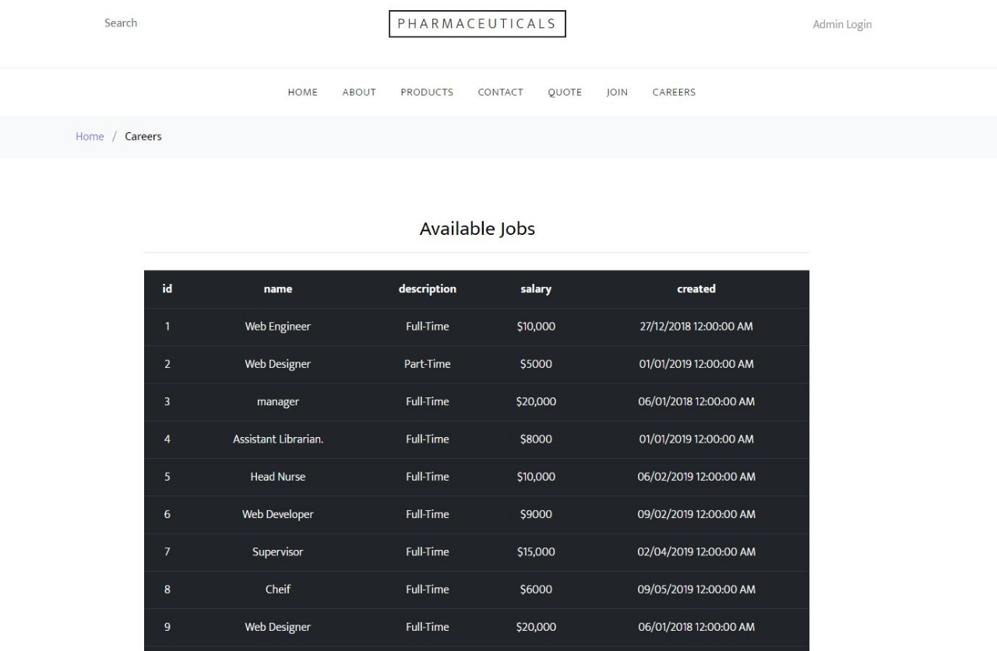
3.2.2 Hardware Interfaces

The PMS includes two major hardware components: cellular phones and regular PC's. The cell phones require WAP (wireless application protocol) network protocol, which is already programmed in the latest phones.
The second component involves the regular PC’s, which communicate with the server. The server then communicates with the database. The protocol involved between the PC's and the server is the HTTP protocol, which allows communication between the PC's and the Server. The remote PC's, such as someone accessing the PMS from home using the Internet, are able access the information through the CGI. The requests come in through the HTTP protocol, and using an ODBC the database results are returned and processed using Perl to give an HTML web page. The format of the output is displayed as web pages.

3.2.3 Software Interfaces
A SQL DBMS will be used to manage the database and any changes made to it. Furthermore, the DBMS will make regular backups of the database and generate reports regularly so that they can be accessed by the PMS . The server between the client and the database will handle all communication, and the server will run on a windows operating system. Furthermore, the HTML pages must be implemented such that they can be displayed on two common browsers: Netscape and Internet Explorer.

Information about the products used for the PMS:

(1) Name: SQL
(2) Mnemonic: sql DB
(3) Version Number: ?
(4) Source: sql server management studio

(1) Name: Windows OS
(2) Mnemonic: Microsoft windowa
(3) Version Number: 10
(4) Source: Microsoft

(1) Name: Internet Explorer
(2) Mnemonic: IE
(3) Version Number: 5.00
(4) Source: Microsoft

3.3 Performance Requirements
The following sections list the performance requirements for the system.

3.3.1 User Requirements

User Requirements | Description of Requirement For Design Environment
Location(s) and Number(s) of Users | Customer, system developer, Admin pharmacy.
Expected Growth in Number of Users | Customer, system developer, Admin pharmacy, added doctors.
After 1 Year | 50%
After 2 Years | TBD
After 3 Years | TBD
User Expectation
Interactivity | User expect that it provides a very easy to use graphical user interface
Reliability | For some applications, reliability must be 100% during the application session
Adaptability | Network must adapt to user additions, deletions and changes
Security | Encryption software would be used for Credit Card transactions
Cost / Funding | Less than Rs 250K

3.3.2 Application Requirements

Since no specified service is indicated, then we have listed the applications as best – efforts. This may change as we learn more about the application.

The communication package is determined to be bursty in nature, with small data sizes and frequent transmissions. We can consider this application to be interactive-burst, while the database transaction-processing application is described by the PMS as transferring large amounts of data (initial estimates are 1 MB/transaction), we have listed this application as interactive-bulk.

Categorizing  Applications | Best-Efforts | Application  Locations
Communication | 100 Kb/s | All Locations
Database Access | 400 Kb/s | All Locations
Database Transaction processing | 1.5 Mb/s | All Locations

3.3.3 Host Requirements

 | Type of Host or  Equipment | Numbers and  Locations
Host A | PC | Karachi
Host B | Database Server | Karachi
Host C | Application Server | Karachi

3.4.1 Standards Compliance
There are no design constraints that can be imposed by other standards limitations.

3.4.2 Software Limitations
• must be able to run Internet Explorer or Netscape Communicator web browsers to access the system.
• must have PC web based capability to access the system from a computer.

3.4.3 Hardware Limitations
• Input/Output: One or two-button mouse, keyboard, cell-phone, or touch screen required.
• Network card required at thin-client terminals to make communication with server possible.

3.5 Quality Characteristics
There are a number of quality characteristics that apply to the PMS software system.

3.5.1 Portability
The PMS system will be developed using HTML and .NET so that it can be accessed from any type of system using just a regular web browser. It will also be available to users that have web access on their cellular phones. The system will be tested on all types of hardware before being released to ensure that is it compliant with this requirement.

3.5.2 Reliability

The system should be capable of processing a given number of orders within a give time frame with no errors and the system should be available and operational all the time. During the development of the prototype, the system will be tested in its actual environment to ensure that it can handle the products and orders with proper management of customer services.

3.5.3 Usability
The PMS system will be developed so that it is an easy to use system that requires the least amount of user input possible. Every input will be validated. The user should only have general computer use knowledge. Error messages will be displayed if the user enters an invalid value or tries to access a function without the required permissions. An easy and well-structured user manual will be provided to the Pharmacies and the system will include descriptive help for all operations allowed.
3.5.4 Correctness
The PMS system will be considered correct when the pharmacy approves the prototype presented and agrees that all the functions they require are implemented as stated in the Software Requirements Specification.
3.5.5 Flexibility
The PMS system should be developed in such a way that it is easily customizable. If new functions are required by pharmacy, there will be little effort required to update the system to support new orders and drug products .
3.5.6 Security

The PMS system should not compromise the customer information at any time. The user information will never be sold to other parties and will be kept secure at all times. Users will be authenticated to ensure that no unauthorized users gain access to private information.

3.5.7 Maintainability
The PMS source code will be kept well structure and documented so that it is easier to maintain and extend the system. All changes to the system shall be documented.

3.6 Other Requirements
Certain requirements may, due to the nature of the software, the user organization, etc., be placed in separate categories such as those below.

3.6.1 Data Base

The Pharmacy Management System will have two main databases. One is the Customer Order Database, and another is the Pharmacy Database. These database will be created with SQL management studio . The following are the requirements for these databases that are to be developed as part of the product. They include:

Customer Orders Database
Types of information | Product name, date , user name, user contact , date of dispatch
Frequency of use | Depends on the Customer demand, which medicines are required as per use provided by the pharmacy.
Accessing capabilities | The database should allow access to at least 1,000 people at once; the users will have a general access to the information about the product details, and a secure access to the reports (available only to Pharmacy officials) using a username and a password
Data element and file descriptions | To be determined
Relationship of data elements, records and files | To be determined
Static and dynamic organization | To be determined
Retention requirements for data | To be determined

Pharmacy Database
Types of information | Pharmacy admin account information including their name, address, phone numbers.
Frequency of use | Depends on the Pharmacy demand, which may reach 25,000 per day during peak periods
Accessing capabilities | The database should allow access to at least 500 people at once; the users will have a secure access to the database using a username and a password
Data element and file descriptions | To be determined
Relationship of data elements, records and files | To be determined
Static and dynamic organization | To be determined
Retention requirements for data | Pharmacy admin account will be available for as long as an admin is using the account, and at least for 6 month since the pharmacy admi logged on last time.

3.6.2 Operations
The normal operations required by the user can be viewed as the following:
User-initiated Operations:
These operations include the login operation, which is initiated by the users. Also, the process of becoming a new user is in this category. Building, changing, and viewing itineraries, as well as paying for the itinerary are all initiated by the users. The user initiates the report generation activity, as well as changing product details.
Interactive Operations and Unattended Operations:
The users initiate all the operations mentioned above, and almost all of them are somehow interactive. Displaying the train schedule is non-interactive. The report display is a non-interactive operation, although selecting the desired reports will require user input.
Data Processing Support Functions:
The user account data is used to create new accounts, as well as to validate user id's during login functions. For building itineraries, user input, user account data, and product details are used, and processed. User data along with final results of user interaction (whether the user purchased a medicine , quantity of products , etc.) are collected, and used for report generation purposes. Administrative users' inputs are collected in order to modify and present details.
Backup and Recovery Operations:
Both databases used (passenger account database and reservations database) are production databases. The main operation used for the backup and recovery is SQL backup, which is also known as the "archive mode". Depending on the customer's needs and budget, additional redundancy can be added using systems like RAID 5 and tape backup.
3.6.3 Site Adaptation Requirements
There are no site adaptation requirements for this project.

4. Supporting Information.
There is no supporting information required for this project.

