**Shell-Edunet Skills4Future AICTE Internship**

**Week 1 Task Submission**

**Sustainable Supply Chain Performance Dashboard using Power BI**

By: Tahseen Hashmi

2025-01-24

**Introduction:**

**Project Title-** Sustainable Supply Chain Performance Dashboard using Power BI.

This document outlines the initial steps for creating a Sustainable Supply Chain Performance Dashboard in Power BI. The first phase of the project focuses on preparing and structuring data for analysis by creating specific tables required for the dashboard.

The tasks involve duplicating the original supply chain dataset, renaming the tables, and filtering out unnecessary columns to match the requirements of each table. This step ensures that the data is clean, organized, and ready for further visualization and analysis in Power BI.

The tables being created are:

1. **Inventory Table** – Contains information about stock levels, product availability, and related metrics.
2. **Manufacturing Table** – Focuses on production volumes, lead times, and defect rates.
3. **Supplier Table** – Includes supplier details, transportation modes, and routes.
4. **Supply Chain Table** – Provides an overview of the supply chain, including product details, availability, shipping data, and supplier information.

**STEPS:**

**Step 1: Open the Dataset**

1. Import the Sustainable Supply Chain Performance.csv file into Power BI after selecting a blank report:
   * Go to **Home > Get Data > Text/CSV**.
   * Select the “Sustainable Supply Chain Performance.csv” CSV file and click **Open**.
   * Preview the data and click **Load**.

**Step 2: Duplicate the Supply Chain Table**

1. Open the **Power Query Editor**:
   * Navigate to **Home > Transform Data**.
   * Select the **Sustainable** **Supply Chain Table**.
2. Duplicate the table:
   * Right-click the table name in the Queries pane and choose **Duplicate**.

**Step 3: Create Specific Tables**

**Inventory Table**

1. Rename the duplicated table to **Inventory Table**:
   * Right-click the duplicated table and choose **Rename**.
   * Enter "Inventory Table".
2. Remove unnecessary columns:
   * Select all columns except:
     + Product type
     + SKU
     + Availability
     + Number of products sold
     + Customer demographics
     + Stock levels
     + Lead times
     + Order quantities
     + Revenue generated.

* Right-click and choose **Remove Other Columns**.

**Manufacturing Table**

1. Duplicate the original table again and rename it to **Manufacturing Table**.
2. Remove unnecessary columns:

Keep only:

* + Product type
  + SKU
  + Production volumes
  + Manufacturing lead time
  + Manufacturing costs
  + Inspection results
  + Defect rates.

**Supplier Table**

1. Duplicate the original table again and rename it to **Supplier Table**.
2. Remove unnecessary columns:

Keep only:

* + - Supplier name
    - Location
    - Lead time
    - Transportation modes
    - Routes.

**Supply Chain Table**

1. Rename the duplicated table to **Supply Chain Table**
2. Keep the following columns:

* Product type
* SKU
* Price
* Availability
* Number of products sold
* Revenue generated
* Customer demographics
* Stock levels
* Lead times
* Order quantities
* Shipping times
* Shipping carriers
* Shipping costs
* Supplier name
* Location

**Step 4: Clean and Apply Changes**

1. Review all new tables to ensure accuracy.
2. Click **Close & Apply** to load the modified tables into Power BI.
3. Save the file.

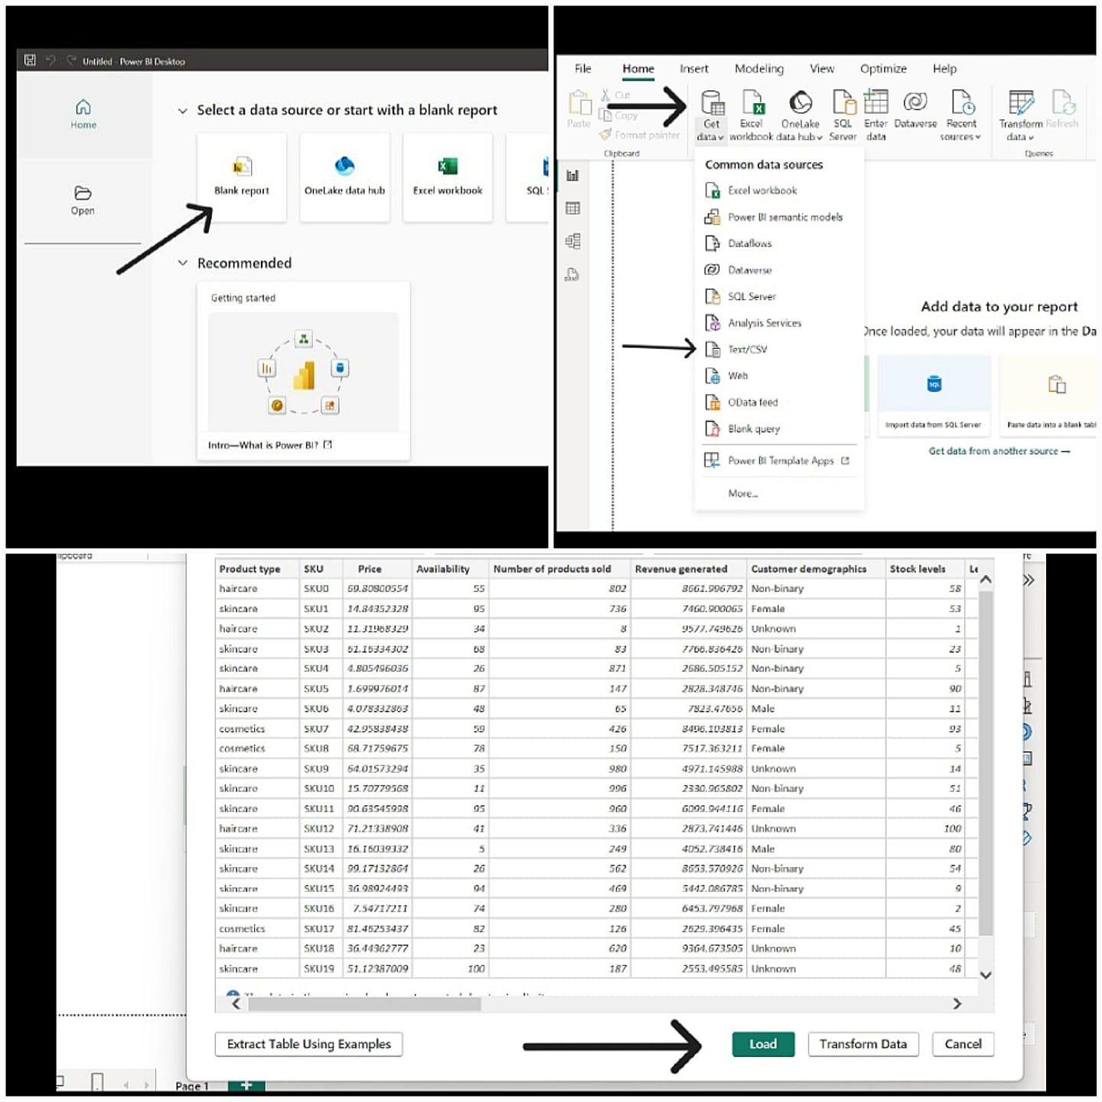

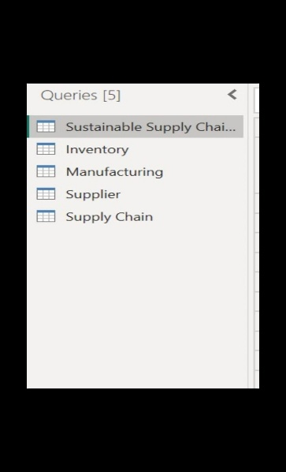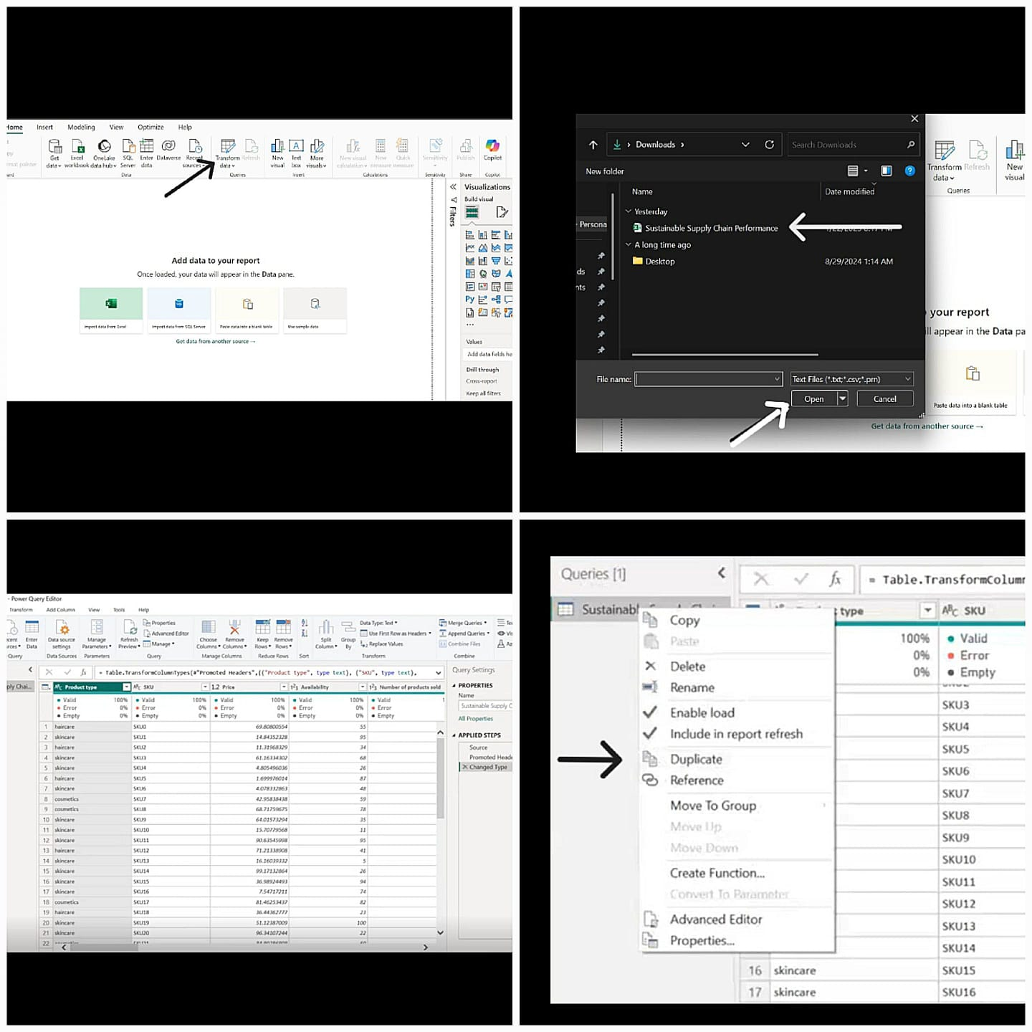STEP-1

STEP-2

STEP-3

**Conclusion-**

In this phase of the project, four key tables were successfully created using Power BI's Power Query Editor: the Inventory Table, Manufacturing Table, Supplier Table, and Supply Chain Table. Each table was carefully prepared by duplicating the original dataset, renaming the tables for clarity, and removing unrequired columns to align with the project requirements.

These tables serve as the foundation for analyzing the performance of a sustainable supply chain and will enable the creation of meaningful visualizations in the subsequent phases of the project. The structured data ensures accuracy and consistency, paving the way for a comprehensive and interactive dashboard.