Extra Questions:

1. Why digital image do not contains fractional co-ordinates ? Why can not be the value of x and y in a digital image contain something like 0.25 and 0.32 when the analog image can be continuous ? Notice we are not talking about intensity values, we are talking about co-ordinate values of a digital image.

An image may be continuous with respect to the x- and y-coordinates, and
also in amplitude. Converting such an image to digital form requires that the
coordinates, as well as the amplitude, be digitized. Digitizing the coordinate
values is called sampling; digitizing the amplitude values is called quantization.
Thus, when x, y, and the amplitude values off are all finite, discrete quantities,
we call the image a digital image.

Lab 1

1. 89

2. Explain what contrast and brightness are. What change in the histogram is related to
the contrast and what change is related to the brightness? Illustrate this by drawing
graphs showing how the graylevel transform changes as the contrast and brightness
are varied ?

Brightness refers to the overall lightness or darkness of the image. Increasing the brightness every pixel in the frame gets lighter. Contrast is the difference in brightness between objects in the image. Increasing the contrast makes light areas lighter and dark area in the frame becomes much darker.
Tweaking brightness simply brightens the entire image from the shadows to the highlights equally. While increasing contrast would result in increase in the separation between dark and bright areas, making shadows darker and highlights brighter. Decrease contrast and you bring the shadows up and the highlights down to make them closer to one another.
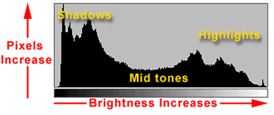

When the contrast adjustment is raised, the middle tones are eliminated. The image will have a higher percentage of darks or blacks and whites or highlights with minimal midtones. The midtones are literally squeezed outward, left and right, as visualized on a histogram. When contrast is lowered, the darks and blacks as well as the whites and highlight tones are eliminated. The image, as viewed on a histogram, will have an average percentage of midtones, darks, and whites. When looking at a histogram, a high contrast image will have a distinct peak at either end with little or no rise of the graph in-between. With a low contrast image, there will be little or no peak on either end and the graph is generally flat from left to right, or there may be a slight upward curve in the central mid tone areas.

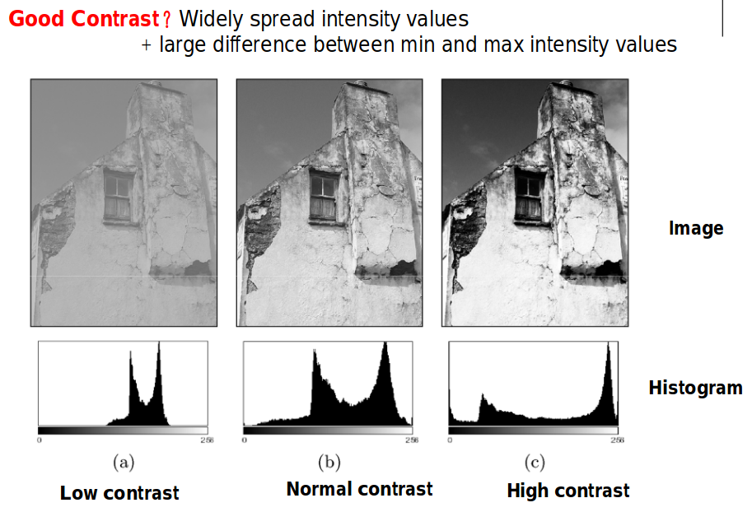

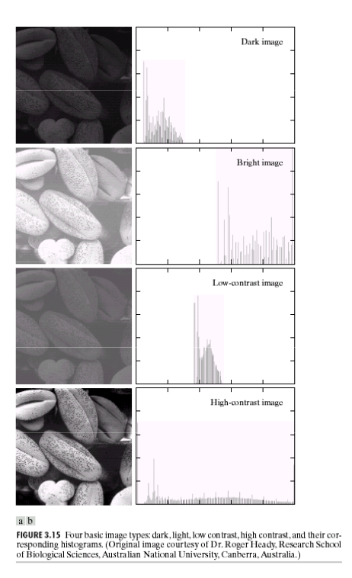

3. Explain the difference of imagesc((I/64)*64) and imagesc((Is/64)*64), where I is uint8
and Is is single ?

I = 5x5 uint8 matrix

1 54 107 160 213
12 65 117 170 223
22 75 128 181 234
33 86 139 192 244
43 96 149 202 255

Convert the array to class single .
I2 = im2single(I)
I2 = 5x5 single matrix

0.0039 0.2118 0.4196 0.6275 0.8353
0.0471 0.2549 0.4588 0.6667 0.8745
0.0863 0.2941 0.5020 0.7098 0.9176
0.1294 0.3373 0.5451 0.7529 0.9569
0.1686 0.3765 0.5843 0.7922 1.0000

Similar to im2single, (Is/255) will actually normalize all of your uint8 image data such that all values are between 0 and 1. This scaling is necessary to get proper behavior when saving the image to a file or displaying it using imshow.
On the other hand, single(I) will simply convert the image data to the single datatype with no scaling.
That is why when we try to show the image by using imtool(Is) , we can not see the expected image. Imtool defines four basic types of images. Our ‘Is’ is a gray scale image of class single. for single class gray scale image imtool sets the intensity value range to [0,1] . But our ‘Is’ has intensity values greater than 1 . That is why imtool can not show the image properly. To show the image properly, we need to normalize the image so that all pixel intensities fit into the range [0,1] . We do this by Is/255.

uint8 contains intensity values between 0 and 255 (28-1) and single can be scaled to contain those values between the range 0 and 1, it is used to hold larger values without upsetting the range error.

So, I is of type uint8 and Is is of type single. Let us consider intensity values of four pixels of I. Suppose they are:

89, 2 , 16, 255

So, I/64 is :

1.39, 0.031, 0.25, 3.98

As I is of type uint8, only integer part will be considered. So, the actual values will be:

1, 0, 0, 3

So, (I/64) * 64 will be:

64, 0, 0, 192

Thus, all the pixels of (I/64) * 64 will have only 4 values. They will be: 0, 64, 128, 192 . That is why we do not see the clear image by imagesc((I/64)*64)

But, Is is of type single. So, the decimal part will not be omitted. So, all the pixels of (Is/64) * 64 will have any of 255 unique values of Is. That is why we see more clear image by imagesc((Is/64) * 64) .

4. Demonstrate an expression involving I to make it brighter.

NewI = I + C

5. Demonstrate an expression involving I to give it lower contrast.

NewI = I * C

6. Use g = 2 and g = ½ and explain the resulting images.

Gamma transformation is used to correct image brightness. Why not contrast ? Because enhancing contrast means dark regions will get darker and bright regions will get brighter. But in gamma transformation, it is like dark regions remain dark and bright regions get darker or the other way around. That is why gamma transformation is used to correct image brightness.

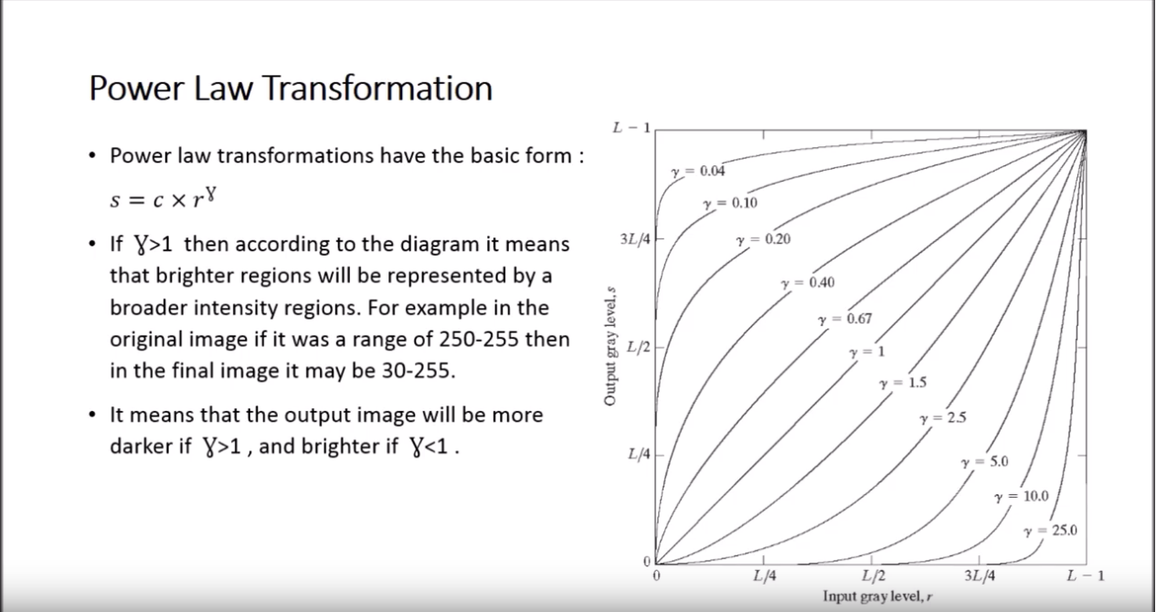
So, if gamma > 1, then if input gray level of a pixel is 150, output gray level of that pixel will be like 40. So, the image becomes darker. The opposite happens if gamma < 1 .

7. Explain how histogram equalization works in theory. Compare the histograms of the
original images and the output images. Do the changes to the histograms and the
images agree with the theory of histogram equalization?

Histogram equalization is used to enhance image contrast. The enhancement is done in such a way so that all the intensity levels can get almost equal number of pixels or as close as possible to equalize the distribution of intensity values among all the pixels of the image. By doing this, what actually happens is that bright regions get darker, dark regions get brighter and thus the contrast gets enhanced.

8. Explain the role of the interpolation method as well as the role of the lowpass-filter.
Which combination of options do you prefer? And why?

In short, resizing is a geometric transformation, or more precisely a scale transformation. For each pixel in the output image, imresize is doing a point transformation to find where the corresponding point maps in the input image. Once imresize has formed a collection of remapped points, interpolatation is performed to resolve sub-pixel remapped locations (the default of imresize is bicubic interpolation).

Aliasing is generally avoided by applying low pass filters or anti-aliasing filters (AAF) to the input signal before sampling and when converting a signal from a higher to a lower sampling rate. If the output image is being scaled with a scale factor less than 1, then by default a low-pass anti-aliasing filter is applied to the input image prior to the steps described above to prevent high frequency content from the input image introducing distortions due to down-sampling the input image. You can turn this anti-aliasing filtering off to see how it effects results. It's generally a very important step when down sizing an image to get visually nice looking resized images.

Imresize is simply applying a scale transformation to the original image. You could think of this operation as the application of the following affine transformation matrix to the original image:

T = [4 0 0; 0 4 0; 0 0 1];

Imresize uses inverse mapping to figure out where each point in the output grid maps in the input grid. We then interpolate within the input grid to determine the output grid values. By default, imresize uses bicubic interpolation by default.

Applying a scale geometric transformation to an image is not a "resolution enhancement" technique. You do not have any more information in the output image than you started with in the input image, you have simply interpolated to create a larger grid than you started with.

So, in our problem, bilinear with anti-aliasing option set to true seems a better option.

The image size is increased automatically by padding to fit the rotation.

9. Can you give a real-life example of aliasing outside the area of image analysis and
signal processing in general? Have you seen this phenomenon before?

One of the most common examples of temporal aliasing is the "wagon wheel" effect, in which wheels with spokes in a sequence of images (for example, in a movie) appear to be rotating backwards. This is caused by the frame rate being too low with respect to the speed of wheel rotation in the sequence.

10. How can a “standard” healthy brain, or a mean image, of the two images brain1.png
and brain2.png be constructed?

Add brain1.png and brain2.png.

11. Find the difference between the “standard” brain and the image from the stroke patient
(brain3.png). Where in the brain is the change located?

Subtract brain3.png from the standard brain constructed in question 10.

12. What happens when a pixel gets a value less than 0 or a value greater than 255? Are
there other ways this can be handled?

Implementations of the operator vary as to what they do if the output pixel values are negative. Some work with image formats that support negatively-valued pixels, in which case the negative values are fine (and the way in which they are displayed will be determined by the display colormap). If the image format does not support negative numbers then often such pixels are just set to zero (i.e. black typically). Alternatively, the operator may `wrap' negative values, so that for instance -30 appears in the output as 226 (assuming 8-bit pixel values).

To handle this situation, you can apply saturation thresholding. Or you can use normalization. Saturation threshold clipping is very simple to realize and provide excellent performance provided that intermediate processing stages will not magnify the intensities too much above 255 (or below 0). Otherwise, it will severely distort the image. Normalization guarantees a loss free output but may severely degrade the algorithm quality. Besides it requires you to know in advance the normalization scale, which may not be possible always.

normalization would be the most straightforward solution, as you can divide all values by 255 (the known largest value), perform your operations, find the new maximum value, then scale back up afterward so that your maximum value is 255 again. This, I think, should work for any operation you want to do, as long as you can keep the flating-point precision required to not lose any information about your original signal.
Of course, if beforehand you do know what kind of operations you need to apply, then you can do something else. For example, you can just multiply by a constant like 0.8 (as you suggested), if you know that your values aren't going to be terribly large. Or, if you're performing convolutions, you can scale your kernel down before convolving.
13. Compare rotations performed with and without interpolation. It is easiest to see differences along lines and edges of the images. What does interpolation mean in this case?
Manipulation of digital images often requires resampling of the pixel data. Usually, the pixel positions in the transformed image do not coincide with grid positions. Therefore, an interpolation algorithm has to be applied to somehow derive the pixel data for these in-between positions. The effort spent for this interpolation is crucial for the image quality of the result image.
Most common in computer graphics applications is bilinear interpolation. As the name suggests, off-grid points are linearly interpolated between their four neighboring grid-pixels.
14. In general it is faster to rotate the image by a multiple of 90 degrees than by some arbitrary degree. Explain why. For this task use Matlab functions tic and toc.
Because you don’t need to resample the image. The 90° rotation is lossless because no pixel ever has to be repositioned onto the border between two pixels (and therefore divided). Image resampling is required for every geometric transform of discrete images except shifts over integer distances or rotations about multiples of 90.
Non-adaptive algorithms include: nearest neighbor, bilinear, bicubic, spline, sinc, lanczos and others. Depending on their complexity, these use anywhere from 0 to 256 (or more) adjacent pixels when interpolating. The more adjacent pixels they include, the more accurate they can become, but this comes at the expense of much longer processing time.
As you don’t need to resample the image, interpolation no longer needed. That is why it is faster to rotate the image by a multiple of 90 degrees than by some arbitrary degree.

Code:

tic;
imrotate(I,90);
time_taken = toc;

15.

code:

I = imread(“image.png”);
Inew = rgb2gray(I);
[rows,cols] = size(Inew);
b = imresize(Inew,128/rows);
b = imresize(b,128/cols);

for x = 1:1:rows
for y = 1:1:5

