- No, the two classes are not possible to separate by using either the x or y co-ordinate as a single feature. Because if we use only x co-ordinate then we will get vertical lines, using only y co-ordinates as a single feature will give us horizontal lines. This is not possible to separate because we need atleast two co-ordinates to separate the classes.

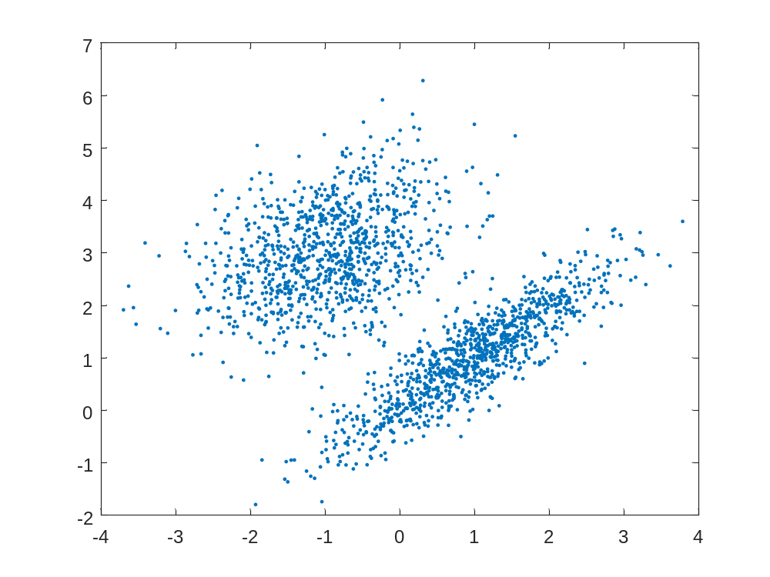

- No, because for multiple objects the gray scale values overlap. That is why, in this case multiple thresholding can not successfully classify three classes. We can observe this behavior from the histogram given below-

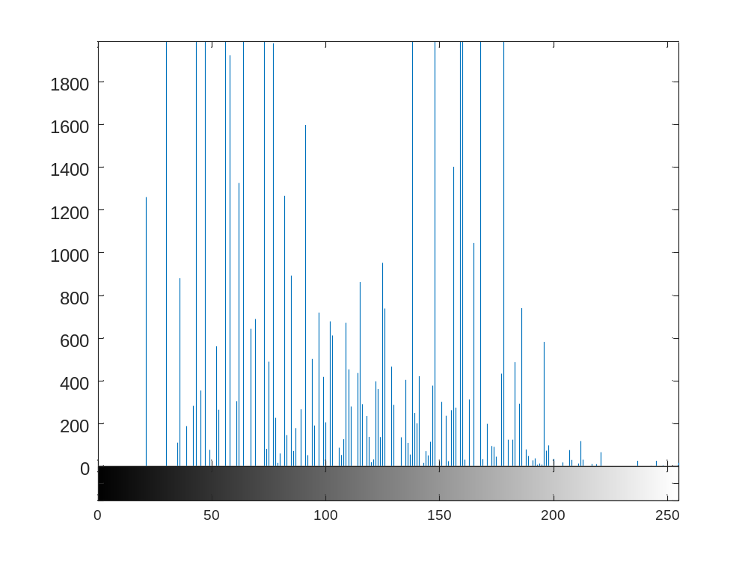
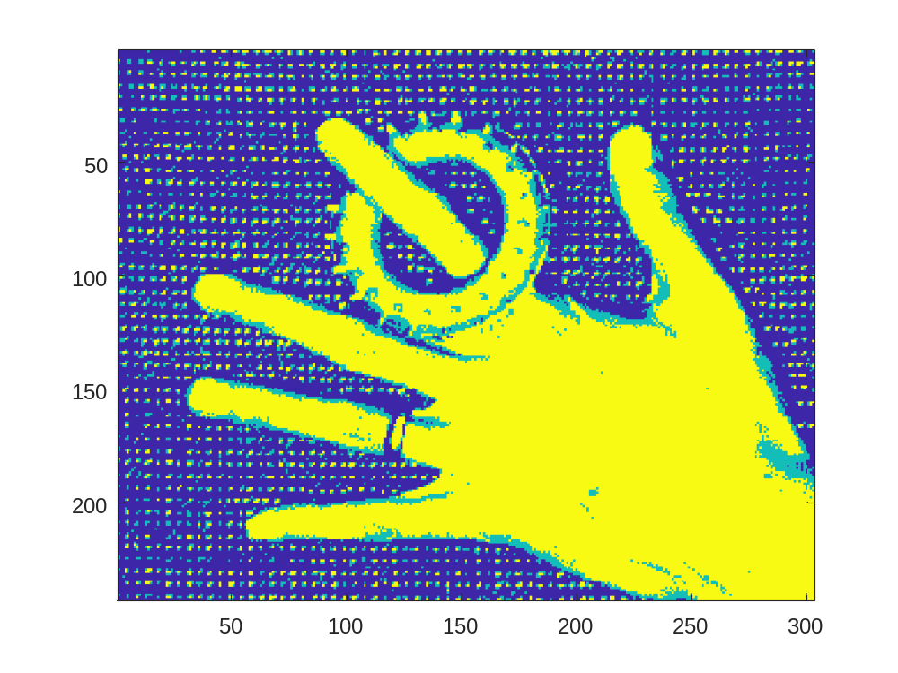
- We are using linear classification model. The linear classification allows us to draw lines between classes. The assumption is that we can draw lines between different RGB bands to differentiate between classes.

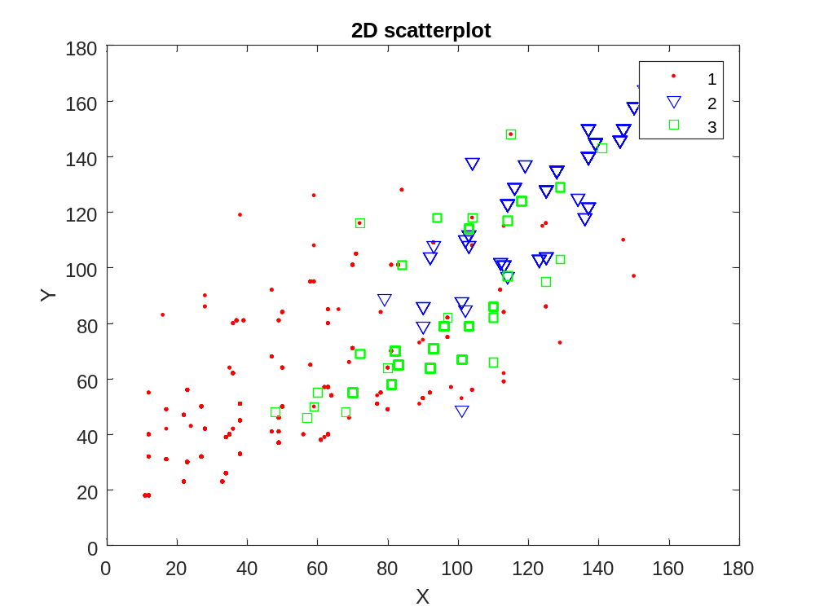

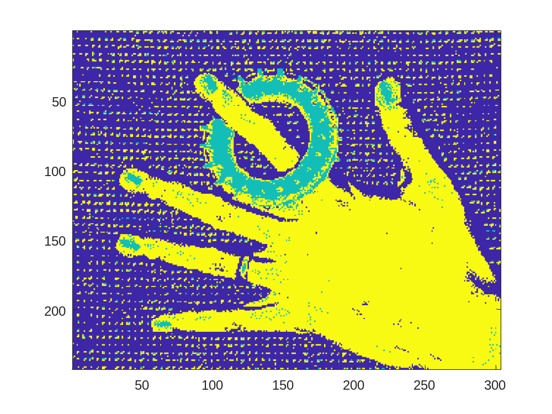
- No, the result did not improve when we used classification on our grayscale image.

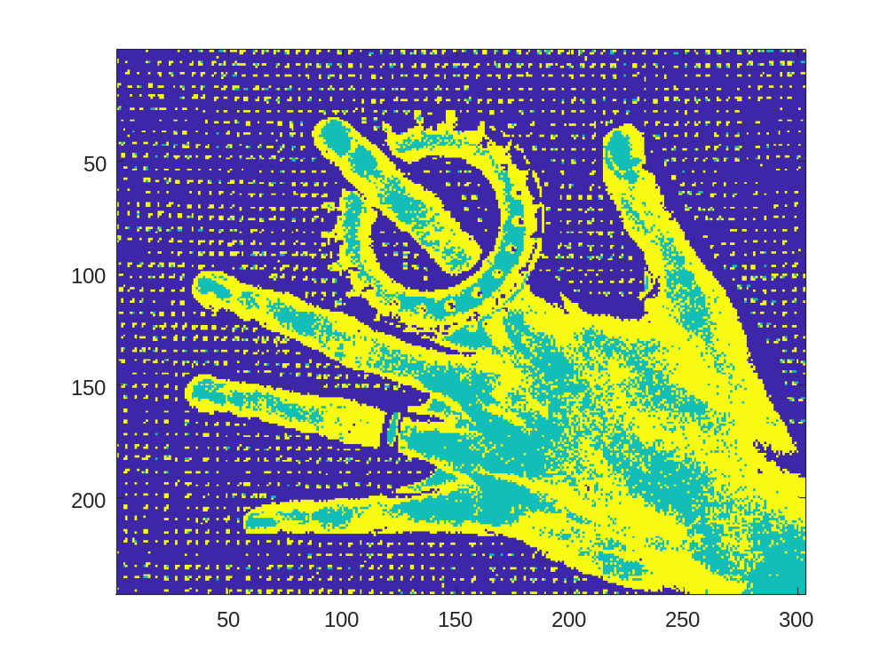
The result got improved when we used single band image instead of grayscale image. We have used green channel to create our single band image. Our classification has separated the object from the hand. This is possible as the object and the hand have different RGB values whereas they have same grayscale values in the grayscale image.

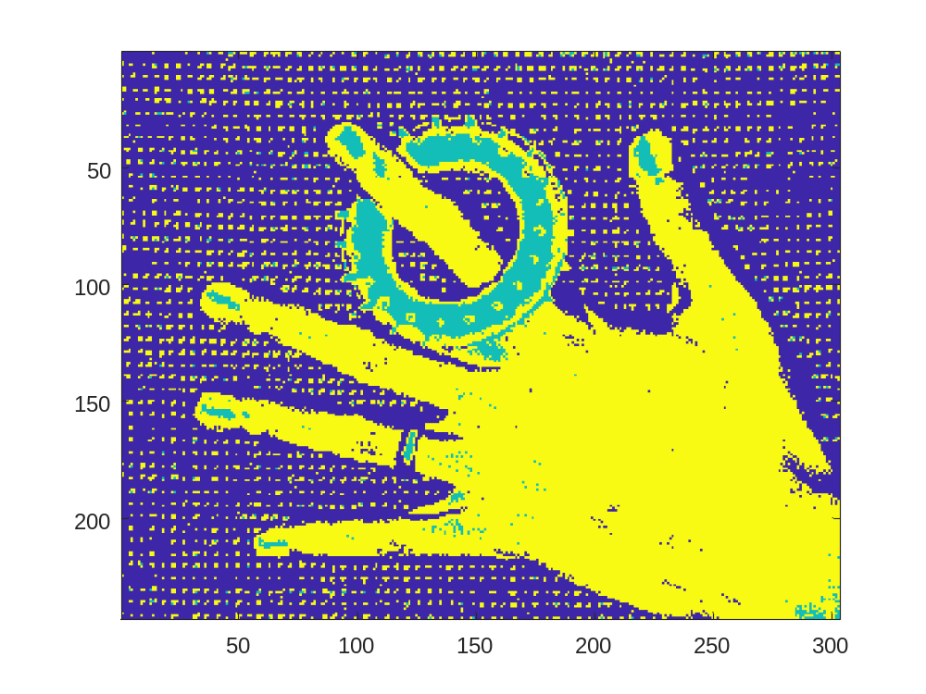
Incorporating pairs of bands will improve the classification even more. If we use full RGB information then the classification gets even better as all three channels can be used as discriminative features.

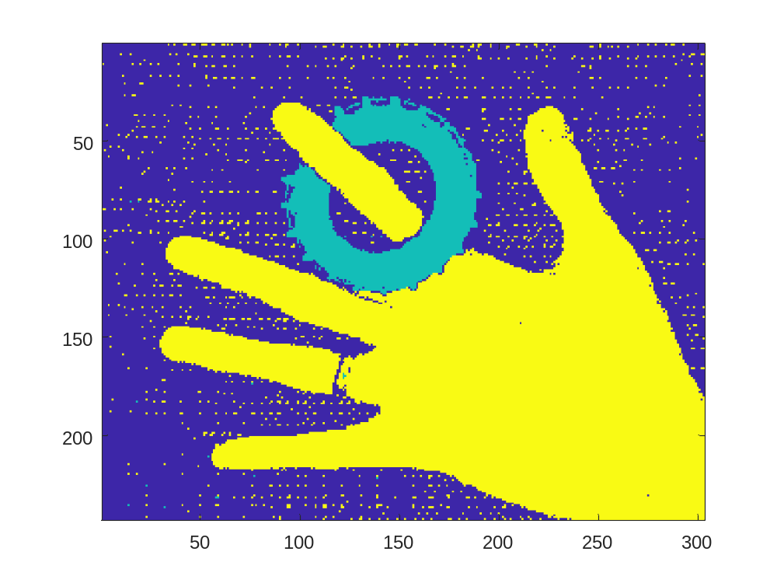
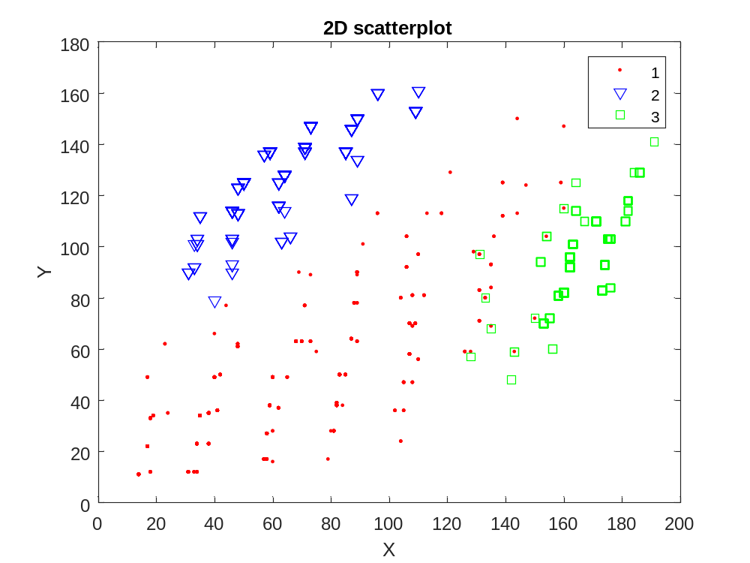

- We have used bands 1, 3 and 4. Because we can discriminate buildings, forest and field using these bands.
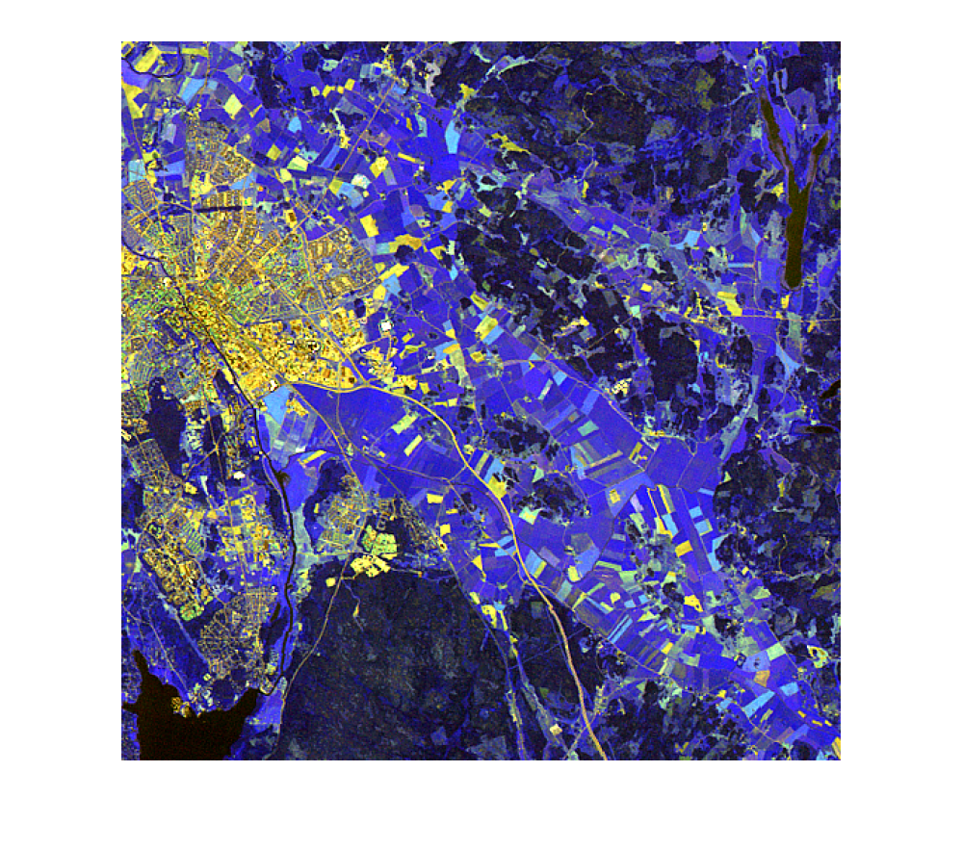
We have used linear classification and classified using the selected bands 1,3 and 4 and got the following result.
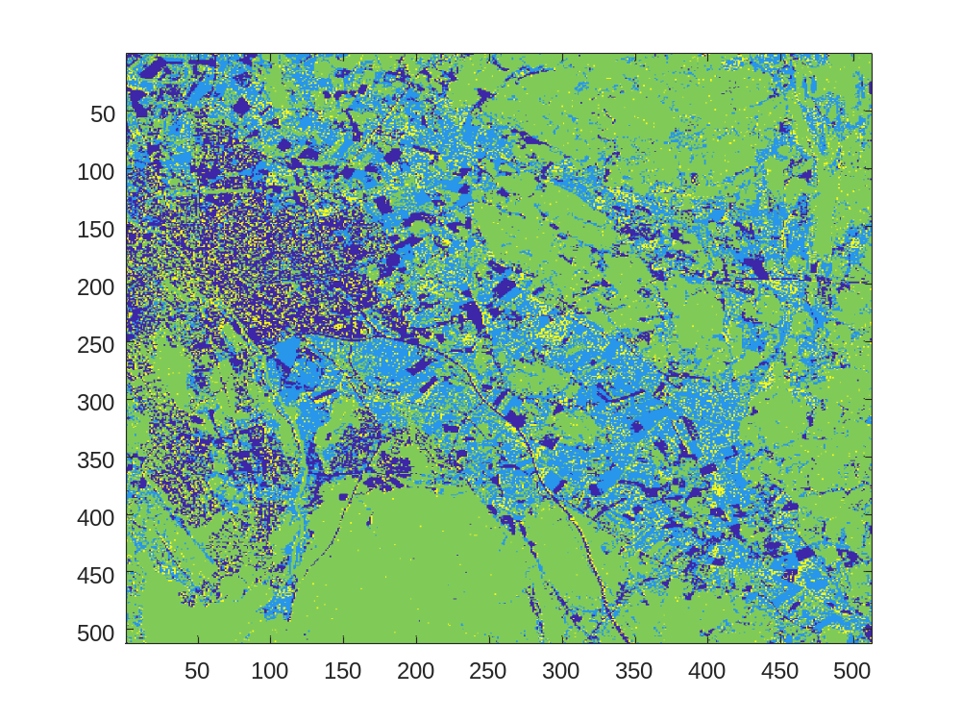

Here is our scatterplot figure.

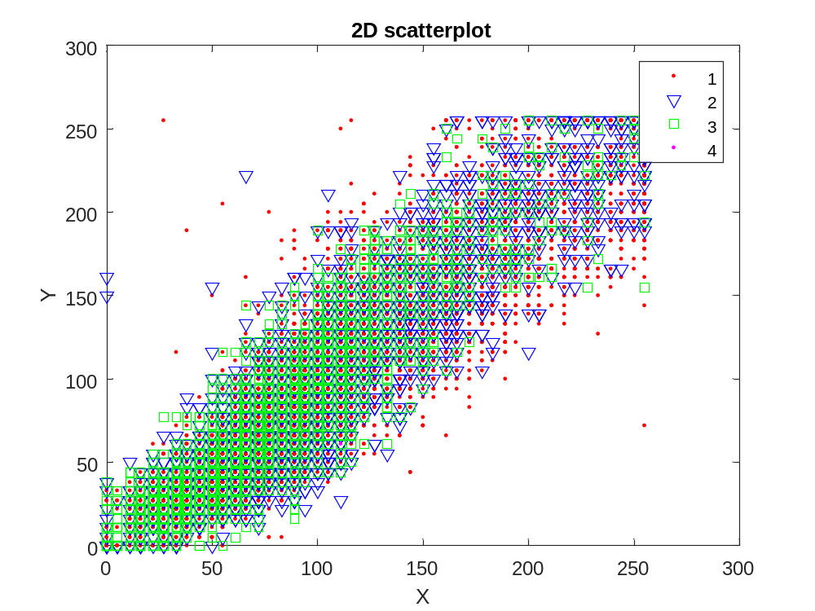

If we use all bands for classification, we do not see much difference. Here is the result of classification using all bands.

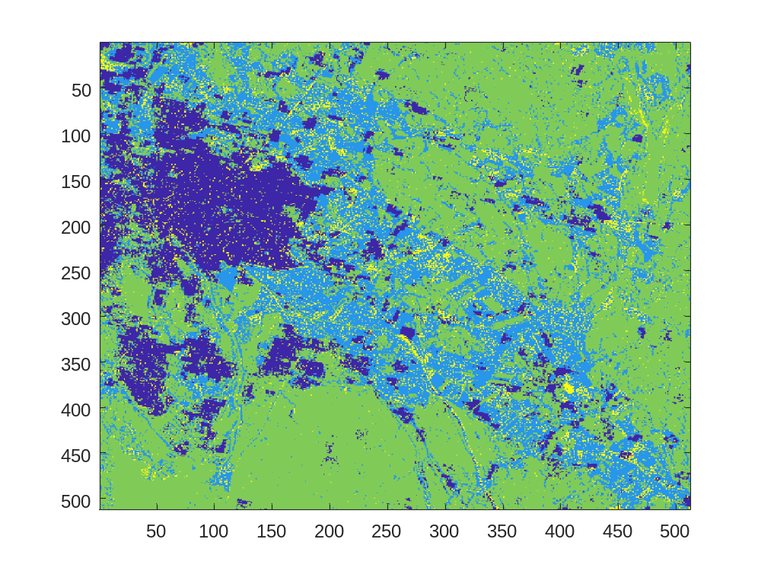

- Using all bands for classification may overfit the image and the result may remove some details. It will also slow down the classification process.

- We have used offset of 1 pixel because real viruses have many small areas of high and nearly same grayscale values.

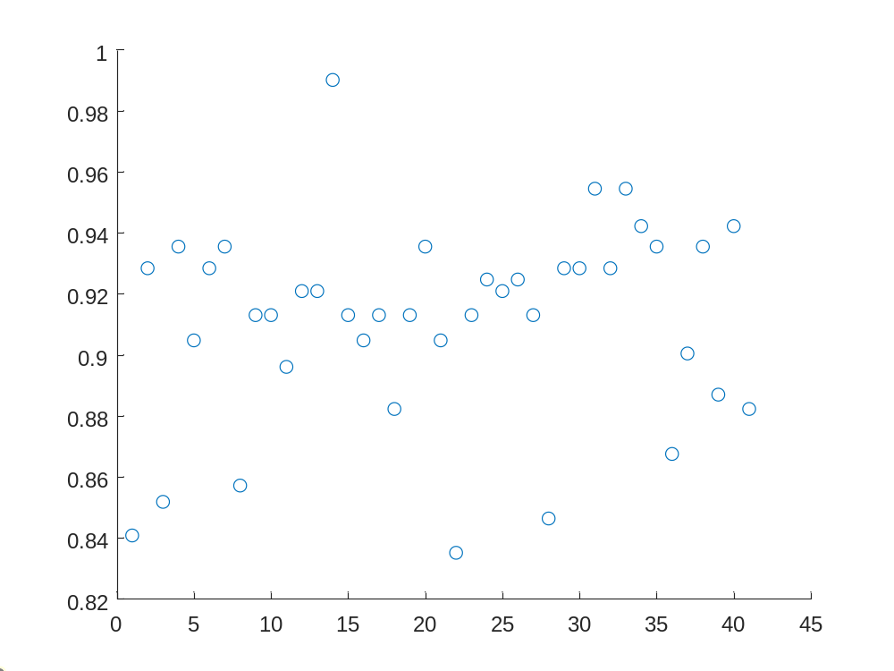

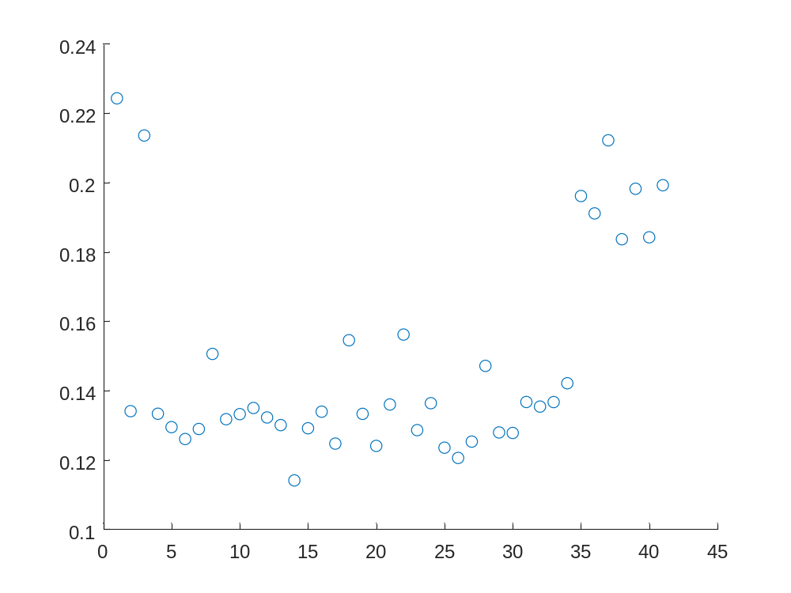
From the above images of entropy and uniformity, we can say that outliers are the ones with low entropy and high uniformity. So, those objects should be removed. Real virus should have higher entropy because of the randomness of nearly same grayscale value. Images with fewer different grayscale values have higher uniformity. So, real viruses should have lower uniformity.

