

Project Interim Report
On
Weather Monitoring System
(Using Core Java & OOP Concepts)
RU-100-01-00012
Object Oriented Programming with Java

SESSION: 2025-26

Submitted By Syed Tahseen Raza
RU-25-11500
Bachelor of Computer Application with AI and ML in
association.

Under the Guidance of
Mr. Harsh Multani

SCHOOL OF COMPUTER SCIENCE AND ENGINEERING RUNGTA INTERNATIONAL SKILLS UNIVERSITY BHILAI, CG
(April 2026)

Table Of Content

Serial No. | Title | Page Number
1. | Front Page | 1
2. | Table of Content | 2
3. | Abstract | 3
4. | Introduction | 4
5. | Scope | 5
6. | System Requirements | 6
7. | Methodology | 7
8. | Flowchart | 8
9. | Implementation | 9-10
10. | Conclusions | 11
11. | References | 12

Abstract

This project is about making a Game Scoreboard System using Core Java and Object Oriented Programming concepts. The project is a console based application which stores player names and scores, sorts them based on performance, and displays a ranked leaderboard.
In todays world scoreboards and rankings are used everywhere, from sports events to online games and competitions. Many real world systems use this kind of logic to track player performance and show who is leading. This project simulates that kind of system in a simple way so that students can understand how OOP concepts are applied in real life scenarios.
The system stores each player's data in a class called Player using private variables (encapsulation). A constructor is used to initialize the player name and score, and getter methods are used to access this data. Multiple Player objects are stored in an array, sorted in descending order of score, and then displayed to the user in a leaderboard format showing rank, player name, score, and the top player.

Introduction

A scoreboard is basically a way of collecting and displaying player performance data such as names and scores. In this project we are only dealing with player name and score because those are the two most common and important details needed for a leaderboard.
The idea behind this project is very simple. We create multiple objects of the Player class, each with a name and a score, and store them in an array. Then we sort this array based on the score values in descending order so that the player with the highest score appears first. After sorting, we display the leaderboard showing the rank, name, and score of each player, along with the top player.
The main OOP concept used here is encapsulation because we are keeping the data (player name and score) private inside the class and providing methods to access them. We are also using constructors and arrays of objects, which are other important OOP concepts. This project helped me understand how to design a class properly, use arrays of objects, and apply sorting logic inside a program.

Scope

This project is a console based application made for educational purpose. It currently handles a fixed set of players with their names and scores. The scope of this project includes:
- Storing player names and scores using objects
- Storing multiple players together using an array of objects
- Sorting players based on their scores in descending order
- Displaying a ranked leaderboard showing rank, player name, and score
- Identifying and displaying the top scoring player
In future this project can be extended to accept player details as user input at runtime, store a dynamic number of players using ArrayList, and allow searching for a player or updating their score. We can also add a menu driven interface or even a simple GUI using Java Swing. If time permits we can even connect it to a database to store and retrieve player records permanently.

System Requirements

Hardware Requirements
    - Any computer or laptop with at least 2GB RAM
    - Keyboard and monitor

Software Requirements
    - Java JDK 8 or above
    - Any IDE like VS Code, Eclipse, or EditPlus
    - Windows 10 or above (or any Linux/Mac system with JDK installed)
    - Command Prompt or Terminal to run the program

Methodology
Step 1: Create Player Class
Created a class named Player to represent each player in the game. This class is responsible for storing the player information, similar to how WeatherData stored temperature and humidity in the previous project.
Step 2: Store Player Details
Added private variables to maintain encapsulation:
private String playerName;
private int score;

Using private variables ensures that no other class can directly access or modify these values, which is the encapsulation pillar of OOP.
Step 3: Create Constructor
A parameterized constructor initializes the player name and score when an object is created:
public Player(String playerName, int score) {
this.playerName = playerName;
this.score = score;
}
Step 4: Use Array of Players
An array is used to store multiple Player objects:
Player[] players = new Player[5];
Step 5: Implement Sorting Logic
The players are sorted based on their scores in descending order (highest score first), using either:
- Simple sorting techniques (Bubble Sort / Selection Sort), or
- Built-in methods (Arrays.sort with a Comparator)
Step 6: Display Leaderboard
After sorting, the players are displayed showing:
- Rank
- Player Name
- Score
Step 7: Main Method (Testing)
A main class (GameSystem) is used to:
- Create multiple Player objects
- Store them in an array
- Sort the array based on scores
- Display the leaderboard
.

Flowchart
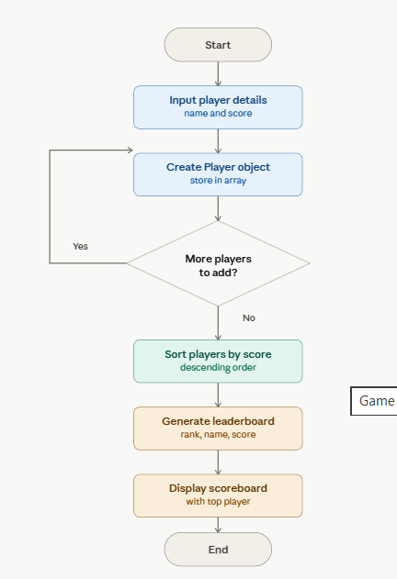

Implementation

Concept | How it is Used
Class & Object | Player class stores the player data. GameSystem creates objects of Player and stores them in an array.
Encapsulation | playerName and score are declared as private. They cannot be accessed directly from outside the class.
Constructor | A parameterized constructor is used to initialize playerName and score when the object is created.
Arrays of Objects | A Player[] array is used to hold multiple Player objects together for processing.
Sorting Logic | Arrays.sort() with a Comparator is used to arrange players in descending order of score.
Methods | getPlayerName() and getScore() return player details. displayLeaderboard() prints the ranked scoreboard.

9. Sample Output

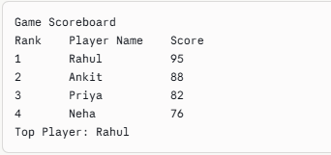

Conclusion
Through this project I learned how to apply Object Oriented Programming concepts in a real life scenario. I understood how to create a class with private variables, how to use a constructor to initialize data, and how to write methods that perform specific tasks.

The checkAlert() method was a little tricky at first because I had to handle multiple conditions at the same time. For example if both temperature and humidity are high then both alerts should show together. I solved this by using a String variable and appending messages to it based on conditions, and then returning that string.

Overall this was a very good learning experience. I now feel more confident about OOP in Java. In future I would like to add more features to this project like a menu to enter multiple weather records, or maybe a file to store all the readings. I also want to try adding a simple GUI using Java Swing.

Reference
- Java - The Complete Reference by Herbert Schildt
- Head First Java by Kathy Sierra and Bert Bates
- Lecture notes from Object Oriented Programming with Java (BCAP-204) class
- Javatpoint.com - Java OOP Concepts: https://www.javatpoint.com/java-oops-concepts
- GeeksforGeeks Java Tutorials: https://www.geeksforgeeks.org/java/

