

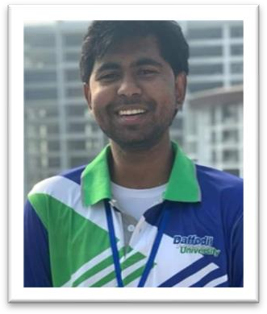

SRS

Name : Md. Tahsinul Islam
Id : 193-35-2926
Course Code : SE 331
Course Name : Software Engineering Design Capstone Project
Project Name : Interview Share

Table of Contents

Content Nmae | Page Number
1.1.Overview | 3-4
1.2.Project Delivery | 4-6
1.3. Summary | 6
1.4. References | 6
1.Requirement Specification | 7
1.1 Functional Requirements | 7-10
1.2 Non Functional Requirements | 11
Use case | 12
Use case description | 13-23
Activity diagram | 24-34
Sequence diagram | 35-46

Overview
    - Background
In traditional system software engineering interview candidate need company wise interview experiences article but it is very difficult to gather this information. For this reason we make a website where we can easily find this information.

    - Objectives
We make a website where user can create a profile and share their interview experience and user can find company wise interview experiences article. As the numbers of web surfers are increasing day by day, a web base solution will be certainly more accurate than a traditional solution. Only registered user will able to view information page.
The list of operations that the system will provide are-
- Registered user will able to view information page.
- User can create a profile and share their interview experience create post.
- User can add image in their post.
- User can update and delete post.
- User can read their post.
- User can search using keyword.
- User can comment their post.

    - Scope
This website can help many software engineering interview candidate to take their company wise interview preparation properly.

    - Assumptions and Constraints
It is assumed that the user is comfortable with computer. The user interface is in English as a result people lacking in English skill will face difficulty in using the system. Login and password is used for identification of user and there is no facility for guest.

    - Dependencies and Risks

The user must have web access in order to use the system. The main risk behind implementing the project is security. If somebody hacks the system then it will be a total disorder. So during development it will be one of our major concerns. Another concern is having common bugs such as the common users are having the same functionalities as the doctors or system admin.

Project Delivery
1.2.1 Deliverables
The following contents will be delivered with the project:
- Project CD
  - Project Demo
  - User manual along with Tutorial
- Documentation
1.2.2 Timescales
The time frame for implementing the project is given in Figure 1.2.1.
1.2.3 Work Distribution
The work distribution of the project is given in Table 1.2.1.
1.2.4 Project Resources
The resources required to finish the project is given in Table 1.2.2.

Duration
 |  | 7 days | 7 days | 7 days | 7 days | 7 days | 7 days | 7 days | 7 days | 7 days
Project Proposal
SRS
Designing
Coding
Testing
Finalization

Figure 1.2.1: Time frames for project implementation

Project Proposal | Tahsin | 7days
Software Requirement Specification | Tahsin | 7 days
Software Design | Tahsin | 21 days
Coding | Tahsin | 14 days
Software Testing | Tahsin | 7 days
Project Finalization | Tahsin | 7 days

Table 1.2.1 Work Distribution
Hardware Requirements
Processor | RAM |  | Hard Disk Space
Pentium II or higher | 64 Mb or higher |  | 128 Mb or higher
Software Requirements
Operating System |  | Database
For user no specific OS is required. The server machine must have Windows XP/Vista/10 along with .NET framework 4 and IIS. |  | MongoDB

Table 1.2.2 Project Resources
1.3. Summary
Time is our most valuable asset. We cannot waste it when there is scope of utilizing it in a better way. Our proposed system named “Interview Share” will be developed to meet this purpose. It will save the time of the mass people wasted during the time of gather company wise previous interview experiences article. As a result s/he can take decisions more wisely.
1.4. References
1. https://leetcode.com/discuss/interview-experience?currentPage=1&orderBy=hot&query=

- Requirement Specification
The complete requirement specification based on the elicitation process is described in this section.

  - Functional Requirements
The Functional Requirements Specification is designed to be read by a general audience. Readers should understand the system, but no particular technical knowledge should be required to understand the document

FR-01 | Registration & Login
After entering the url in any internet browser, in the software index page the user must have to register himself first. After every time of access he has
to log-in first before entering the main software. All user mandatory for
login. Only authorized users can login to the software.
Stakeholder | User

FR-02 | Create Profile

Users can create a user profile in the Interview Share
And and share their interview experience.
Stakeholder | User

FR-03 | Update User Information
 | Users can update their old information.
Stakeholder | User

FR-04 | Create Post
 | A user can create a post through some text, picture etc.
Stakeholder | User

FR-05 | Delete post

 | After log-in, users can delete post.
Stakeholder | User

FR-06 | Search Content
 | After log-in, users can search the specific content.
Stakeholder | User

FR-07 | Read Post
 | After log-in, users can read post.
Stakeholder | User

FR-8 | Update Post

 | After log-in, users can update post.
Stakeholder | User

FR-9 | Comment
 | Users can comment on another member's post.
Stakeholder | User

FR-10 | Logout
 | Users can logout their profile.
Stakeholder | User

1.2 Non Functional Requirements :
1. User Friendly interface.
2. Security.
3. More Accessibility.
4. More Reliability.
5. More Affordability.
6. More sustainability.
7. Activity log.

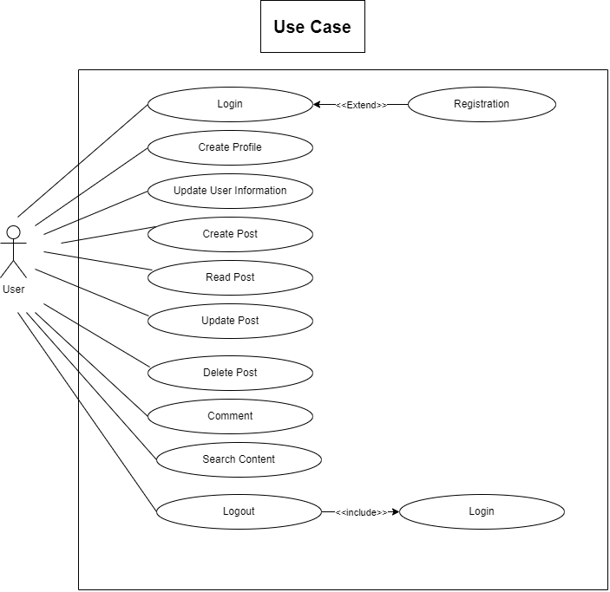

Use Case Description

Use Case | Registration
Goal  <a longer statement of the goal in context if needed> | Create a new account of this system
Preconditions
<what we expect is already the state of the world>
Success End Condition  <the state of the world upon successful completion> | A new user can to the register system.
Failed End Condition  <the state of the world if goal abandoned> | A new user can’t to the register system.
Primary Actors:  Secondary Actors: | User
Trigger  <the action upon the system that starts use case> | Send a registration request.
Description / Main Success Scenario  <the steps of the scenario from trigger to goal delivery and any clean up after> | Step | Action
 | 1 | Using unique email address
 | 1.1  1.2 | Using unique username  Using password its must be 8 characters
 | 2 | Submit the register request.
Alternative Flows  <a: condition causing branching>  <a1: action or name of sub use case> | Step | Branching Action
 | 1a | Invalid email address system show an invalid data message.
 | 2a | Invalid username system show an invalid data message.
 | 3a | Invalid password system show an remainder message.
Quality Requirements | Step | Requirement
 | 1 | Submit the register request time should be 5s.

Use Case | Login
Goal  <a longer statement of the goal in context if needed> | Log into the system with username and password.
Preconditions  <what we expect is already the state of the world> | User must register into the system
Success End Condition  <the state of the world upon successful completion> | User can logged into the system.
Failed End Condition  <the state of the world if goal abandoned> | User can’t logged into the system.
Primary Actors:  Secondary Actors: | User
Trigger  <the action upon the system that starts use case> | Send a Login request.
Description / Main Success Scenario  <the steps of the scenario from trigger to goal delivery and any clean up after> | Step | Action
 | 1 | Enter username
 | 1.1 | Enter password
 | 2 | Validate username and password
 | 3 | Allow access to the system
Alternative Flows  <a: condition causing branching>  <a1: action or name of sub use case> | Step | Branching Action
 | 1a | Invalid username system show an wrong username message.
 | 2a | Invalid password system show an wrong password message.
 | 3a | Invalid password for 4 times Application closed.
Quality Requirements | Step | Requirement
 | 1 | Login time should be 5s.

Use Case | Create Profile
Goal  <a longer statement of the goal in context if needed> | Make a Unique Identity.
Preconditions  <what we expect is already the state of the world> | User must logged into the system
Success End Condition  <the state of the world upon successful completion> | User can operate this Interview Share and he connect this large community.  The company gets a new user.
Failed End Condition  <the state of the world if goal abandoned> | User can’t operate this Interview Share and he connect this large community.  The company not gets a new user.
Primary Actors:  Secondary Actors: | User
Trigger  <the action upon the system that starts use case> | A new Profile create request comes in.
Description / Main Success Scenario  <the steps of the scenario from trigger to goal delivery and any clean up after> | Step | Action
 | 1 | User send new profile create request.
 | 1.1  1.2 | User send request in via Browser.
Alternative Flows  <a: condition causing branching>  <a1: action or name of sub use case> | Step | Branching Action
 | 1
Quality Requirements | Step | Requirement
 | 1 | Create Profile time should be 5s.

Use Case | Update User Information
Goal  <a longer statement of the goal in context if needed> | User update user information
Preconditions  <what we expect is already the state of the world> | User must logged into the system
Success End Condition  <the state of the world upon successful completion> | User update user information
Failed End Condition  <the state of the world if goal abandoned> | User can not update user information
Primary Actors:  Secondary Actors: | User
Trigger  <the action upon the system that starts use case> | A update user information request comes in.
Description / Main Success Scenario  <the steps of the scenario from trigger to goal delivery and any clean up after> | Step | Action
 | 1 | User send update user information request.
 | 1.1  1.2 | User send request in via Browser.
Alternative Flows  <a: condition causing branching>  <a1: action or name of sub use case> | Step | Branching Action
 | 1
Quality Requirements | Step | Requirement
 | 1 | Update user information time should be 5s.

Use Case | Create Post
Goal  <a longer statement of the goal in context if needed> | A user can create a post through some text, picture etc.
Preconditions  <what we expect is already the state of the world> | User must logged into the system and must have a user profile.
Success End Condition  <the state of the world upon successful completion> | A user can create a post.
Failed End Condition  <the state of the world if goal abandoned> | A user can not create a post.
Primary Actors:  Secondary Actors: | User
Trigger  <the action upon the system that starts use case> | Send a create post request.
Description / Main Success Scenario  <the steps of the scenario from trigger to goal delivery and any clean up after> | Step | Action
 | 1 | A user can create a post.
Alternative Flows  <a: condition causing branching>  <a1: action or name of sub use case> | Step | Branching Action
 | 1
Quality Requirements | Step | Requirement
 | 1 | Create post time should be 5s.

 | Read Post
Goal  <a longer statement of the goal in context if needed> | Users can read post.
Preconditions  <what we expect is already the state of the world> | User must logged into the system and must have a user profile.
Success End Condition  <the state of the world upon successful completion> | Users can read post.
Failed End Condition  <the state of the world if goal abandoned> | Users can not read post.
Primary Actors:  Secondary Actors: | User
Trigger  <the action upon the system that starts use case> | Send a read post request.
Description / Main Success Scenario  <the steps of the scenario from trigger to goal delivery and any clean up after> | Step | Action
 | 1 | A user can read a post.
Alternative Flows  <a: condition causing branching>  <a1: action or name of sub use case> | Step | Branching Action
 | 1
Quality Requirements | Step | Requirement
 | 1 | Read post time should be 5s.

 | Comment
Goal  <a longer statement of the goal in context if needed> | Users can comment to post.
Preconditions  <what we expect is already the state of the world> | User must logged into the system and must have a user profile.
Success End Condition  <the state of the world upon successful completion> | Users can comment to post.
Failed End Condition  <the state of the world if goal abandoned> | Users can not comment post.
Primary Actors:  Secondary Actors: | User
Trigger  <the action upon the system that starts use case> | Send a comment to post request.
Description / Main Success Scenario  <the steps of the scenario from trigger to goal delivery and any clean up after> | Step | Action
 | 1 | A user can comment a post.
Alternative Flows  <a: condition causing branching>  <a1: action or name of sub use case> | Step | Branching Action
 | 1
Quality Requirements | Step | Requirement
 | 1 | Comment time should be 5s.

Use Case | Update Post
Goal  <a longer statement of the goal in context if needed> | A user can update a post.
Preconditions  <what we expect is already the state of the world> | User must logged into the system and must have a user profile.
Success End Condition  <the state of the world upon successful completion> | A user can update a post.
Failed End Condition  <the state of the world if goal abandoned> | A user can not update a post.
Primary Actors:  Secondary Actors: | System
Trigger  <the action upon the system that starts use case> | Send a update post request.
Description / Main Success Scenario  <the steps of the scenario from trigger to goal delivery and any clean up after> | Step | Action
 | 1 | A user can create a post.
 | 1.1 | A user can update a post.
Alternative Flows  <a: condition causing branching>  <a1: action or name of sub use case> | Step | Branching Action
 | 1
Quality Requirements | Step | Requirement
 | 1 | Update post time should be 5s.

Use Case | Delete Post
Goal  <a longer statement of the goal in context if needed> | A user can delete a post.
Preconditions  <what we expect is already the state of the world> | User must logged into the system and must have a user profile.
Success End Condition  <the state of the world upon successful completion> | A user can delete a post.
Failed End Condition  <the state of the world if goal abandoned> | A user can not delete a post.
Primary Actors:  Secondary Actors: | System
Trigger  <the action upon the system that starts use case> | Send a delete post request.
Description / Main Success Scenario  <the steps of the scenario from trigger to goal delivery and any clean up after> | Step | Action
 | 1 | A user can create a post.
 | 1.1 | A user can delete a post.
Alternative Flows  <a: condition causing branching>  <a1: action or name of sub use case> | Step | Branching Action
 | 1
Quality Requirements | Step | Requirement
 | 1 | Delete post time should be 5s.

Use Case | Search Content
Goal  <a longer statement of the goal in context if needed> | Find out a specific content
Preconditions  <what we expect is already the state of the world> | User must logged into the system and must have a user profile.
Success End Condition  <the state of the world upon successful completion> | User can find specific content easily
Failed End Condition  <the state of the world if goal abandoned> | User can’t find specific content easily
Primary Actors:  Secondary Actors: | User
Trigger  <the action upon the system that starts use case> | Send a search request
Description / Main Success Scenario  <the steps of the scenario from trigger to goal delivery and any clean up after> | Step | Action
 | 1 | Input content or users information.
 | 1.1  1.2 | Submit search request with the information.  System Show the output or specific thinks which you want.
Alternative Flows  <a: condition causing branching>  <a1: action or name of sub use case> | Step | Branching Action
 | 1.1a | The finding information out of the server.
Quality Requirements | Step | Requirement
 | 1 | search time should be 2s

Use Case | Logout
Goal  <a longer statement of the goal in context if needed> | Logout into the system.
Preconditions  <what we expect is already the state of the world> | System must logged into the system.
Success End Condition  <the state of the world upon successful completion> | User can logout into the application.
Failed End Condition  <the state of the world if goal abandoned> | User can’t logout into the application.
Primary Actors:  Secondary Actors: | User.
Trigger  <the action upon the system that starts use case> | Send a Logout request.
Description / Main Success Scenario  <the steps of the scenario from trigger to goal delivery and any clean up after> | Step | Action
 | 1. | Select Logout.
 | 1.1 | Submit logout request to the system.
Alternative Flows  <a: condition causing branching>  <a1: action or name of sub use case> | Step | Branching Action
Quality Requirements | Step | Requirement
 | 1 | Logout time should be 5s.


Activity Diagram

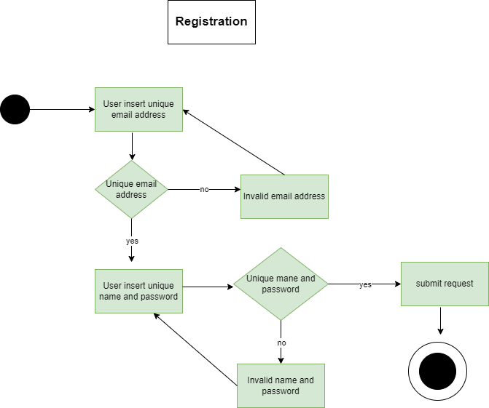

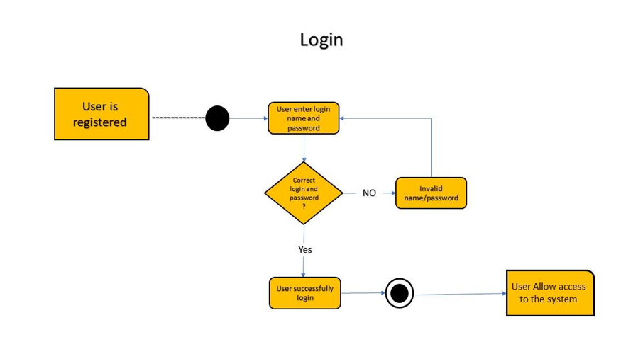

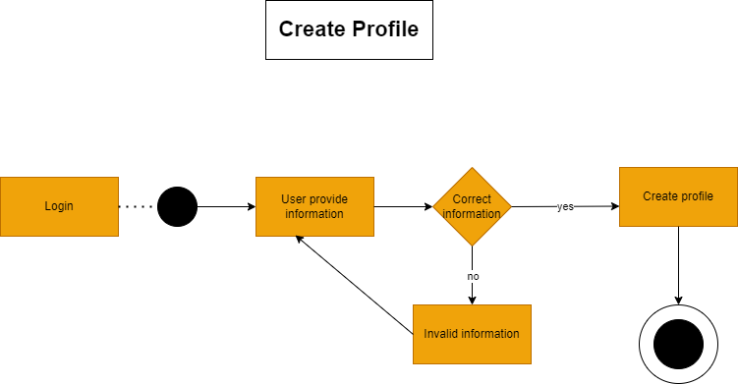

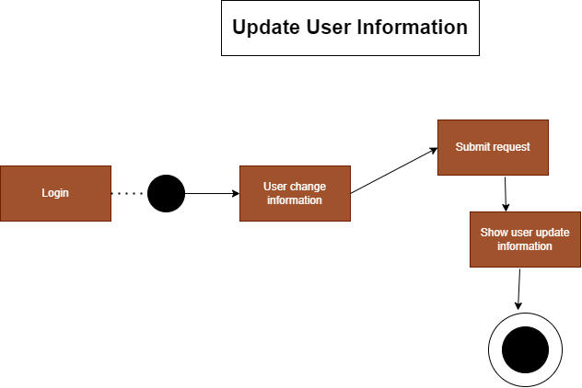

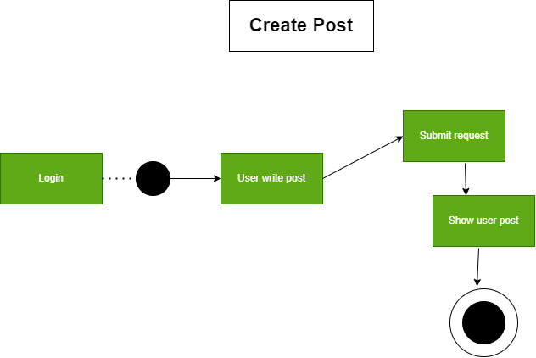

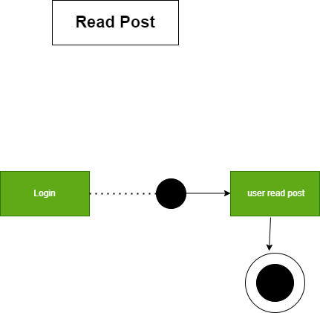

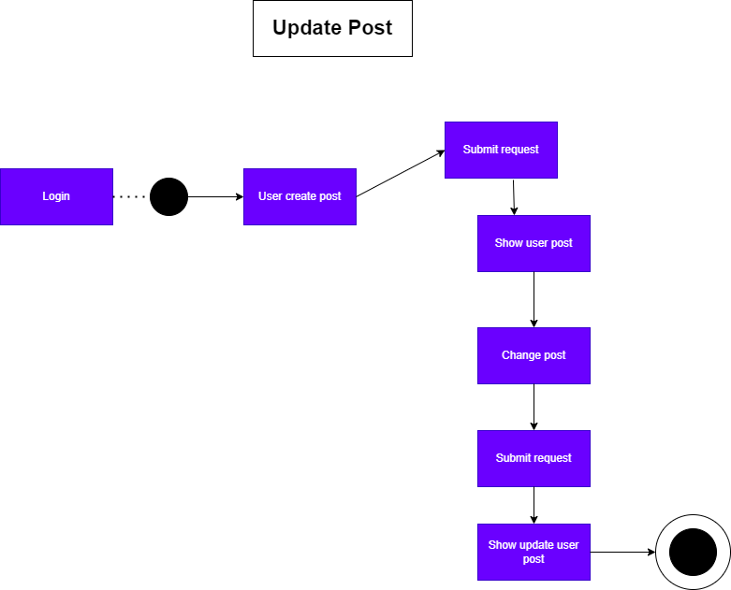

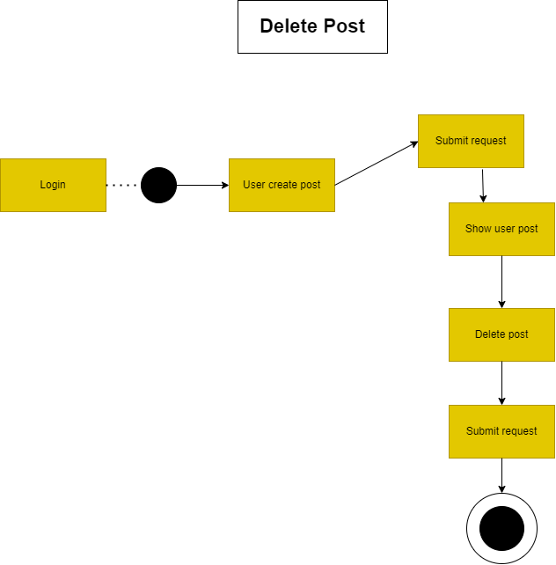

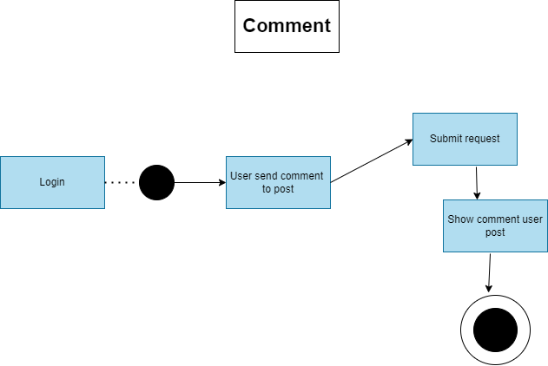

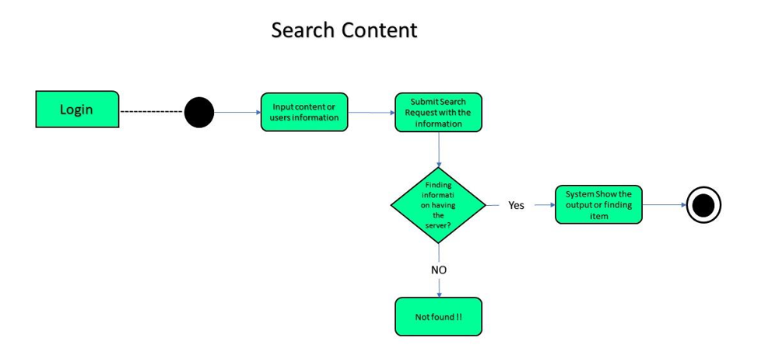

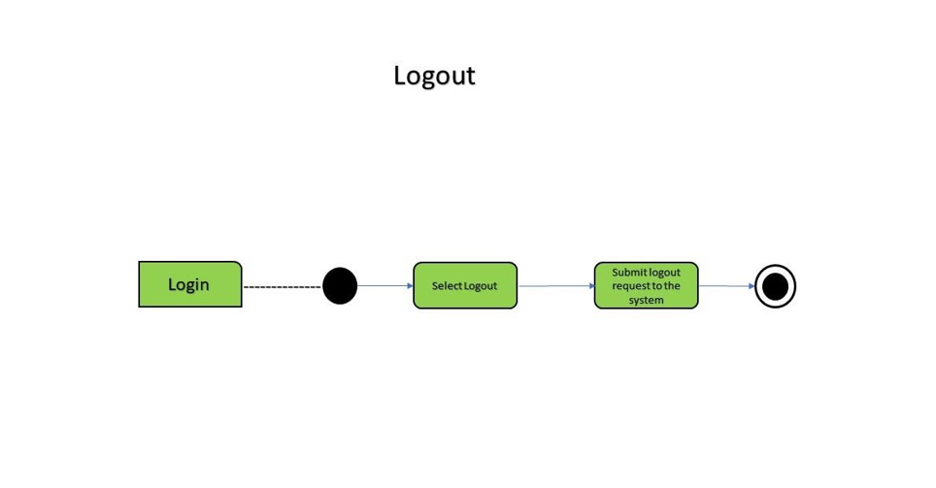

Sequence Diagram

