

**Khulna University of Engineering & Technology Khulna.**

*Department of Electronics & Communication Engineering*

*A Report On Signal Generator*

*Course No : ECE 2200*

*Group : 8*

*Submitted To: Submitted by:*

***Md.Mehedi Hasan Md. Imran Hossain (1409021)*** Lecturer of the Department of ECE, KUET ***Akash Shingha Bappy(1409037)***  ***Shuvashis Saha* *Ananna Biswas(1409038 )*** Lecturer of the Department of ECE, KUET ***Amiotosh Roy Akash(1409039* )**

*December 20, 2016*

***Contents***

*1.Objectives.*

*2.Introduction.*

*3.Theory.*

*4.Appartus Required.*

*5.Circuit Diagram.*

*6.Result Analysis*

*7.Problem Faced.*

*8.Limitations.*

*9.Possible Improvement.*

*10.Application*

*11.Discussion.*

*12.Conclusion.*

*13.References.*

* ***Objectives:-***

The objectives of this project are

1.To make a signal generator.

2.To make a signal generator that can regulate signal at a specific range.

3.To make a signal generator that can regulate the signal voltage at a specific range .

* ***Introduction:-***

A signal generator is an [electronic](https://en.wikipedia.org/wiki/Electronics) device that generates repeating or non-repeating electronic signals in either the analog or the digital domain. It is generally used in designing, testing, troubleshooting, and repairing electronic or electroacoustic devices, though it often has artistic uses as well.

There are many different types of signal generators with different purposes and applications and at varying levels of expense. These types include [function generators](https://en.wikipedia.org/wiki/Function_generator), RF and microwave signal generators, pitch generators, [arbitrary waveform generators](https://en.wikipedia.org/wiki/Arbitrary_waveform_generator), [digital pattern generators](https://en.wikipedia.org/wiki/Digital_pattern_generator) and frequency generators. In general, no device is suitable for all possible applications.

* ***Theory:-***

In this circuit, we will show how to build a function generator circuit using an LM324 operational amplifier chip.

A function generator is a electronic device that can produce a variety of different waveforms. The one we will build can output square, triangle, or sine waveforms. Like standard function generators, the circuit allows for frequency adjustment; we get ours through a potentiometer. The circuit can also easily allow for amplitude adjustment.

The circuit works on the principle of just using op amps.

The LM324 is a quad op amp, meaning it's composed of 4 independent op amps.

In this circuit, the first op amp produces a square wave. After that, the circuit uses 2 integrator circuits to convert the square wave into triangle and sine wave signals.

* ***Apparatus Required:-***

1.LM324 -3 pcs

2.Resistor -24 pcs

3.Non-polar Capacitors - 6pcs

4.LM317T -1pc

5.Polar Capacitors-2pcs

6.Diodes- 4pcs

7. IC7824- 1pc

8.Transformer -1pc

9.Connecting wire

* ***Circuit Diagram :-***

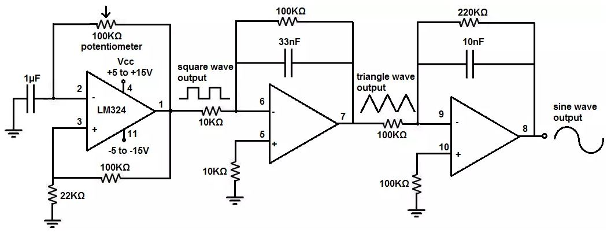

*Fig :- A Signal Generator using LM324*

* ***Result Analysis:-***

The range & the result of the following generator

Sine wave :- 1kHz-5kHz

Square wave :- 800Hz-12kHz

Triangle wave :- 1kHz-8kHz

Voltage regulations:- 1v-15 v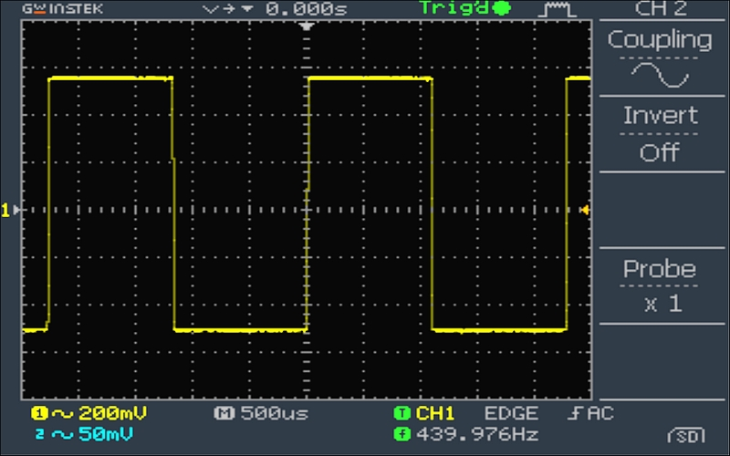

Fig:- Square wave shape 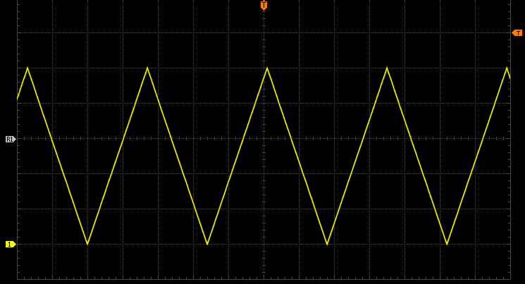

*Fig :- Triangular waveshape*

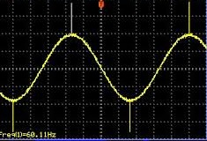

*fig:- sine waveshape*

* ***Problem faced:-***

There are some problems faced during our experiment . Firstly We didn’t get the perfect square wave at very high frequency . we get some distorted wave in it . Again for the low frequency we didn’t get the perfect distortion free wave . That was not our wanted things . it is mainly for the capacitor we can’t get such type of capacitor that can fulfill both the condition at a same time so there is a big drawback in our circuit.

* ***Limitations:-***

There is some limitations in this circuit

1.The frequency was not high for the square wave

2.The frequency was not low for the sine & triangle wave

3.After a portion the wave shape has a distortion

* ***Possible Improvement:-***

To minimize the following drawbacks we use 3 different IC for the 3 different wave shape . First we use the IC to adjust the square wave .Then their another IC was used in the circuit for the Sine wave thus we get the almost perfect wave shape though their was some drawbacks mean there are some distortion in the wave shape that cant be minimized .

* ***Application:-***

We can use the circuit to following use

1.It can be used as function generator in laboratory.

2.The basic pulse in the lab can be given by this machine.

3.This circuit can be used as any voltage and at any frequency.

* ***Discussion:-***

In this lab we make a signal generator that can generate 3 types of signal square triangle and sine at different frequency . That can be useful for us in the lab .Because there is a some problem which is describe or solved by these signal generator .Hopefully this circuit will help us in the future life

* ***Conclusion:-***

All the objectives are fulfilled in the project and this will

help us in the future electronics life .

* ***References:-***

1. [www.youtube.com](http://www.youtube.com).
2. en.wikipedia.org
3. [www.myelectronicsproject.com](http://www.myelectronicsproject.com)
4. Op-amp and linear circuit