

***KHULNA UNIVERSITY OF ENGINEERING & TECHNOLOGY***

***Department of Electronics & Communication Engineering***

***ECE-2200***

***REPORT***

***ON***

***Instant Power Supply( IPS )***

***SUBMITTED TO***

***Mr. Md. Mehedi Hasan***

***Mr. Shuvasish shaha***

*SUBMITTED BY*

**NAME: ROLL:**

* **MD. BAYEZID DHALI 1409029**
* **ATKIA FARJANA 1409058**
* **SHOVON DASH 1409059**
* **MUNNA MIA 1409060**

**Submission Date: 20 December 2016**

CONTENTS:

1. Summary

2. Introduction

3 .Theory and literature review

5 .Implementation

➢ Circuit diagram

➢ Apparatus required

➢ Circuit description

6..Performance and result analysis

7.Data analysis

8.Circiut stability and reliability

9.Cost analysis

10.Problem faced

11 .Applications

12. Advantages and disadvantages

13. Limitations

14. Possible improvement

15. Discussion

16. Conclusion

17. Reference

INTRODUCTION:

An Inverter Power Supply or inverter is an electronic device or circuitry that changes direct current (DC) to alternating current (AC). The input voltage, output voltage and frequency, and overall power handling depend on the design of the specific device or circuitry. The inverter does not produce any power; the power is provided by the DC source. A power inverter can be entirely electronic or may be a combination of mechanical effects (such as a rotary apparatus) and electronic circuitry. Static inverters do not use moving parts in the conversion process.

**Background:**

One of the most significant battles of the 19th century was fought not over land or resources but to establish the type of electricity that powers our buildings.

**Early inverters:**

From the late nineteenth century through the middle of the twentieth century, DC-to-AC power conversion was accomplished using rotary converters or motor-generator sets (M-G sets). In the early twentieth century, vacuum tubes and gas filled tubes began to be used as switches in inverter circuits. The most widely used type of tube was the thyratron.

The origins of electromechanical inverters explain the source of the term inverter. Early AC-to-DC converters used an induction or synchronous AC motor direct-connected to a generator (dynamo) so that the generator's commutator reversed its connections at exactly the right moments to produce DC. A later development is the

synchronous converter, in which the motor and generator windings are combined into one armature, with slip rings at one end and a commutator at the other and only one field frame. The result with either is AC-in, DC-out. With an M-G set, the DC can be considered to be separately generated from the AC; with a synchronous converter, in a certain sense it can be considered to be "mechanically rectified AC". Given the right auxiliary and control equipment, an M-G set or rotary converter can be "run backwards", converting DC to AC. Hence an inverter is an inverted converter.

**Controlled rectifier inverters:**

Since early transistors were not available with sufficient voltage and current ratings for most inverter applications, it was the 1957 introduction of the thyristor or silicon-controlled rectifier (SCR) that initiated the transition to solid state inverter circuits.

The commutation requirements of SCRs are a key consideration in SCR circuit designs. SCRs do not turn off or commutate automatically when the gate control signal is shut off. They only turn off when the forward current is reduced to below the minimum holding current, which varies with each kind of SCR, through some external process. For SCRs connected to an AC power source, commutation occurs naturally every time the polarity of the source voltage reverses. SCRs connected to a DC power source usually require a means of forced commutation that forces the current to zero when commutation is required. The least complicated SCR circuits employ natural commutation rather than forced commutation. With the addition of forced commutation circuits, SCRs have been used in the types of inverter circuits described above.

In applications where inverters transfer power from a DC power source to an AC power source, it is possible to use AC-to-DC controlled rectifier circuits operating in the inversion mode. In the inversion mode, a controlled rectifier synchronous converter, in which the motor and generator windings are combined into one armature, with slip rings at one end and a commutator at the other and only one field frame. The result with either is AC-in, DC-out. With an M-G set, the DC can be considered to be separately generated from the AC; with a synchronous converter, in a certain sense it can be considered to be "mechanically rectified AC". Given the right auxiliary and control equipment, an M-G set or rotary converter can be "run backwards", converting DC to AC. Hence an inverter is an inverted converter.

Theory:

One of Tesla's legacies (and that of his business partner George Westinghouse, boss of the Westinghouse Electrical Company) is that most of the appliances we have in our homes are specifically designed to run from AC power. Appliances that need DC but have to take power from AC outlets need an extra piece of equipment called a rectifier, typically built from electronic components called diodes, to convert from AC to DC.

An inverter does the opposite job and it's quite easy to understand the essence of how it works. Suppose you have a battery in a flashlight and the switch is closed so DC flows around the circuit, always in the same direction, like a race car around a track. Now what if you take the battery out and turn it around. Assuming it fits the other way, it'll almost certainly still power the flashlight and you won't notice any difference in the light you get—but the electric current will actually be flowing the opposite way. Suppose you had lightning-fast hands and were deft enough to keep reversing the battery 50–60 times a second. You'd then be a kind of mechanical inverter, turning the battery's DC power into AC at a frequency of 50–60 hertz.

Of course the kind of inverters you buy in electrical stores don't work quite this way, though some are indeed mechanical: they use electromagnetic switches that flick on and off at high speed to reverse the current direction. Inverters like this often produce what's known as a square-wave output: the current is either flowing one way or the opposite way or it's instantly swapping over between the two states:



These kind of sudden power reversals are quite brutal for some forms of electrical equipment. In normal AC power, the current gradually swaps from one direction to the other in a sine-wave pattern, like this:

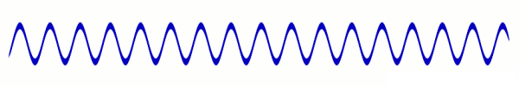

Electronic inverters can be used to produce this kind of smoothly varying AC output from a DC input. They use electronic components called inductors and capacitors to make the output current rise and fall more gradually than the abrupt, on/off-switching square wave output you get with a basic inverter.

Inverters can also be used with transformers to change a certain DC input voltage into a completely different AC output voltage (either higher or lower) but the output power must always be less than the input power: it follows from the conservation of energy that an inverter and transformer can't give out more power than they take in and some energy is bound to be lost as heat as electricity flows through the various electrical and electronic components.

Circuit Diagram:

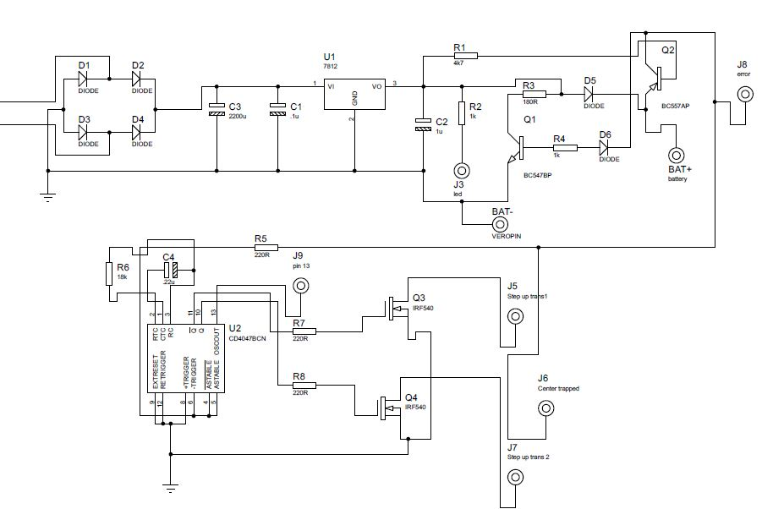

Fig: Diagram of Instant Power Supply (IPS).

PCB Layout of Our Project:

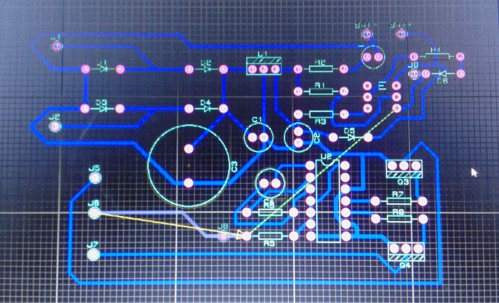

Fig: Pictorial View of PCB Layout

Pictorial View:

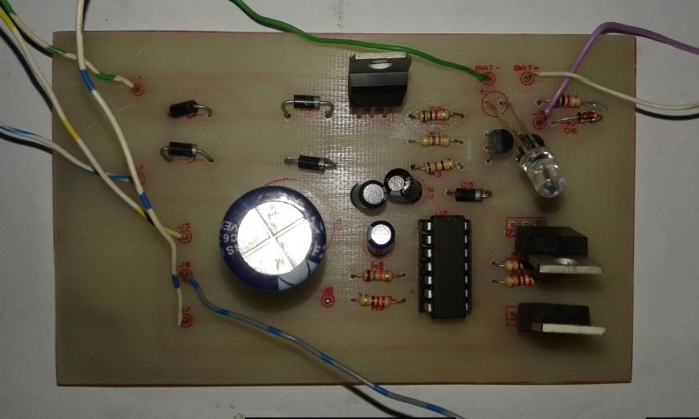

Fig: Pictorial view of Instant Power Supply (IPS)

Required & Cost Analysis:

|  |  |  |  |  |
| --- | --- | --- | --- | --- |
| **S.L**  **No.** | **Name** | **Price per piece (Tk.)** | **Quantity** | **Price (Tk.)** |
| 1 | Step Up Transformer | 1300 | 1 | 1300 |
| 2 | Step Down Transformer | 90 | 1 | 90 |
| 3 | Zener Diode | 1 | 2 | 2 |
| 4 | Capacitor | 10 | 4 | 40 |
| 5 | Resistor | 2 | 7 | 14 |
| 6 | Diode | 2 | 4 | 8 |
| 7 | IC | 10 | 3 | 30 |
| 8 | Transistor | 10 | 2 | 20 |
| 9 | PCB Board | 150 | 1 | 150 |
| 10 | LED | 2 | 1 | 2 |
| 11 | MosFET | 2 | 30 | 60 |
| 14. | Battery | 1050 | 1 | 1050 |
|  | **TOTAL =** |  |  | 2766 |

Performance and Data analysis:

Our desired output was 220 Volt(ac) in 50Hz frequency with sine wave after step up transformer which can be used as instant power supply due to missing the line voltage supply. But our output was 12 volt(ac) in rms with 50 Hz frequency with sine wave. It will be around 220 volt after using step up transformer.so we can say that our result was approximate same with our desired result. Our output of this project in oscilloscope is given bellow.

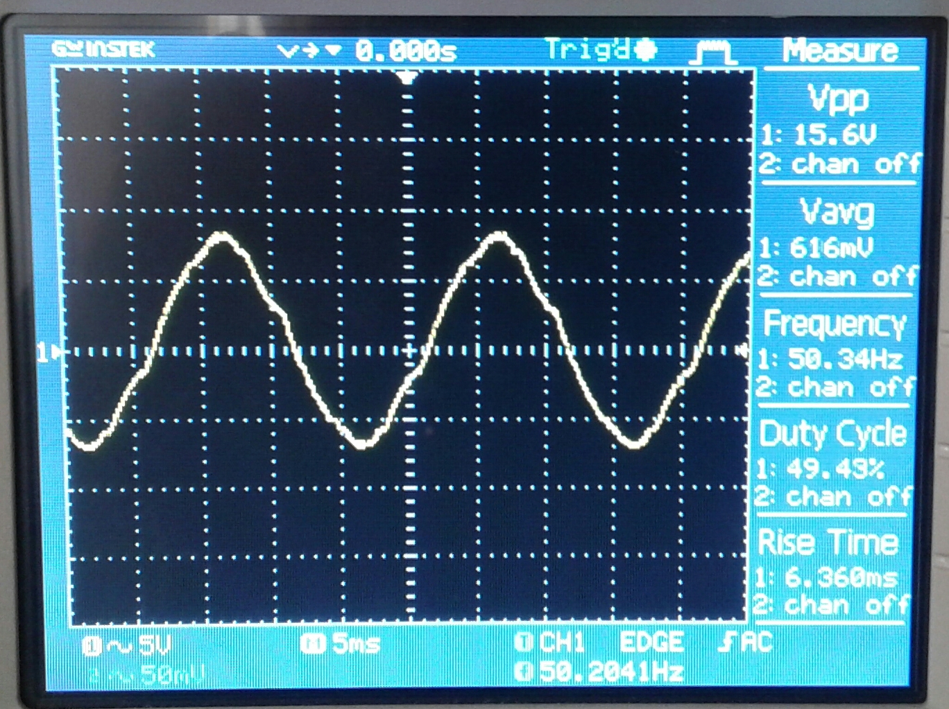

Fig: Project Output in Oscilloscope.

**Advantages:**

**1. Peak / Surge Power Output**

Peak / surge power output is the ability of a power source to provide more than its rated continuous power out for a very brief period to start certain loads. AC induction motor driven loads that require starting against high back pressure / mechanical inertia like reciprocating pumps and compressors used in refrigeration, air-conditioning, Oxygen Concentrators etc. will initially require a very large additional starting surge current over and above the Locked Rotor Current to start from rest. Once they have started moving and have attained their rated speed, their power requirement reduces to their normal running current rating. The starting RMS current surge in these devices may reach up to 5 times their normal RMS running current rating and the starting surge may last > 1 second. Generators have poor peak power capability due to their inherent operating characteristics. Peak power is usually no more than 125% of their continuous power rating. They must be greatly oversized to successfully start the above loads. On the other hand, inverters can provide higher surge power of up to 2 to 3 times their continuous power rating. Thus, a lower size of inverter will be required for meeting the peak / surge power requirements. If a larger than ideal generator is purchased to satisfy the load's peak or motor starting requirements, the excess generator capacity is wasted and will mean additional fuel consumption and reduced life.

**2. No Load / Self Consumption Power**

This is the minimum amount of power needed to keep an inverter or generator in a running / standby condition. Obviously, this is much greater for an unloaded generator as a generator's engine must always be running resulting in higher inefficiency, noise and wear and tear. On the other hand, with no load, an inverter requires very low self-consumption power and yet it can deliver full power instantly to loads when needed. Some inverters like the Samlex America Inc. G4 Series come with a “Power Saving Mode” that draws very minimal power of 5 W to keep the inverter in “Sleep Mode” and wakes up if a programmed value of the load is detected.

**3.Output Frequency**

Many loads, such as motor driven tools, will not operate over a wide frequency range. Output frequency of an engine generator is directly related to the engine RPM (Revolutions per Minute). The RPM of a generator falls when a heavy load is switched on. Similarly, the RPM rises if a heavy load is switched off. The RPM of a generator engine is regulated against the above loading / unloading effect by a mechanical governor that increases / decreases the fuel supply to the engine to maintain a constant RPM. Due to aging, the performance of the governor deteriorates and hence, it is not able to regulate the RPM and hence the frequency. The output frequency of an inverter is precisely regulated at 50 / 60Hz over a wide range of operating conditions.

**4. Output Voltage**

The output voltage of engine generators is sometimes not regulated to within 120 VAC / 230 VAC + / - 10% due to deterioration in the performance of their governor / regulator. These voltage excursions can damage some AC loads. In contrast, inverters closely match utility power and provide the desired output voltage regulation

**5 Less Operating Cost & Environmentally Friendly**

Inverters do not use fuel, lubricants or moving parts. They generate very little heat and do not produce noise or pollutants.

Application:

**Electric motor speed control**

Inverter circuits designed to produce a variable output voltage range are often used within motor speed controllers. The DC power for the inverter section can be derived from a normal AC wall outlet or some other source. Control and feedback circuitry is used to adjust the final output of the inverter section which will ultimately determine the speed of the motor operating under its mechanical load. Motor speed control needs are numerous and include things like: industrial motor driven equipment, electric vehicles, rail transport systems, and power tools. (See related: variable-frequency drive) Switching states are developed for positive, negative and zero voltages as per the patterns given in the switching. The generated gate pulses are given to each switch in accordance with the developed pattern and thus the output is obtained.

**Power grid**

Grid-tied inverters are designed to feed into the electric power distribution system. They transfer synchronously with the line and have as little harmonic content as possible. They also need a means of detecting the presence of utility power for safety reasons, so as not to continue to dangerously feed power to the grid during a power outage.

**Induction heating**

Inverters convert low frequency main AC power to higher frequency for use in induction heating. To do this, AC power is first rectified to provide DC power. The inverter then changes the DC power to high frequency AC power. Due to the reduction in the number of DC sources employed, the structure becomes more reliable and the output voltage has higher resolution due to an increase in the number of steps so that the reference sinusoidal voltage can be better achieved. This configuration has recently become very popular in AC power supply and adjustable speed drive applications. This new inverter can avoid extra clamping diodes or voltage balancing capacitors.

There are three kinds of level shifted modulation techniques, namely:

* Phase Opposition Disposition (POD)
* Alternative Phase Opposition Disposition (APOD)
* Phase Disposition (PD)

**HVDC power transmission**

With HVDC power transmission, AC power is rectified and high voltage DC power is transmitted to another location. At the receiving location, an inverter in a static inverter plant converts the power back to AC. The inverter must be synchronized with grid frequency and phase and minimize harmonic generation.

**Electroshock weapons**

Electroshock weapons and tasers have a DC/AC inverter to generate several tens of thousands of V AC out of a small 9 V DC battery. First the 9 V DC is converted to 400–2000 V AC with a compact high frequency transformer, which is then rectified and temporarily stored in a high voltage capacitor until a pre-set threshold voltage is reached. When the threshold (set by way of an airgap or TRIAC) is reached, the capacitor dumps its entire load into a pulse transformer which then steps it up to its final output voltage of 20–60 kV. A variant of the principle is also used in electronic flash and bug zappers, though they rely on a capacitor-based voltage multiplier to achieve their high voltage.

Discussion:

As the output of our project analysis we have found a Instant Power Supply (IPS) source which is capable of providing 220 volt ac with 50 Hz with sine wave in the missing of line voltage. Again this Instant power supply was a chargeable battery which was used for charging when the line voltage was active. Mainly this battery voltage supplied 220 volt with the help of step up transformer and other circuit. Here IC-CD4047 and the mosFET was used for producing AC voltage from DC voltage .Thus our aims of doing this project are executed more or less in full. So our project on this provide us a huge knowledge on Instant Power Supply (IPS) which will be beneficial for us in future.

Conclusion:

This circuit offers an Instant Power Supply (IPS) with chargeable battery and step up transformer. Here two transistor (bc557 and bc547) was used for switching operation. The main advantage of this Instant Power Supply (IPS) is that the user need not to concern about which type of load can be used. The circuit will determine the case automatically and operate normally if the load is in its range. Using this Instant power supply (IPS) we can work in our everyday life. Its cost is low and it is light in weight. In this modern age IPS is used widely in houses and offices.

Reference:

➢ Electronic Devices And Circuit Theory

-by Robert L.Boylestad, Louis Nashelsky

➢ Electronic Devices And Circuits

-by Jacob Millman

➢ Principles of Electronics-

-by V.K Mehta, Rohit Mehta,S. Chand

➢ Wikipedia