CHAPTER
CodeTutor.AI
Building a Free Programming Tutor for the General Public with Claude
Authors | Athira Nur & Abrar Rahman
Course | Introduction to AI — Class Project Showcase
Assignment | Give Claude a task to make something the general public can use

1. The Work of the App
CodeTutor.AI is a browser-based application that teaches beginners to program in Python, C, C++, or Java through a live, adaptive conversation rather than a fixed set of static lessons. A learner opens the app, picks a language, and states a goal in their own words — anything from “just the absolute basics” to “get me ready for coding interviews.” From that point on, the app behaves like a patient one-on-one tutor sitting beside the learner.
The tutor teaches exactly one concept at a time. Each turn follows the same small pattern: a plain-language explanation with no assumed vocabulary, one short and runnable code example in the learner's chosen language, and a small question or exercise that checks understanding before anything new is introduced. When the learner answers or submits code, the tutor responds specifically to what they wrote — confirming what is correct, correcting what is not, and explaining why — rather than repeating a generic script.
This turns three passive design choices into one active benefit: the learner is never shown more than they can absorb in a single step, the pacing is set entirely by their own answers rather than a fixed syllabus, and the definition of “done” is whatever goal the learner typed in at the start, not a one-size-fits-all curriculum.
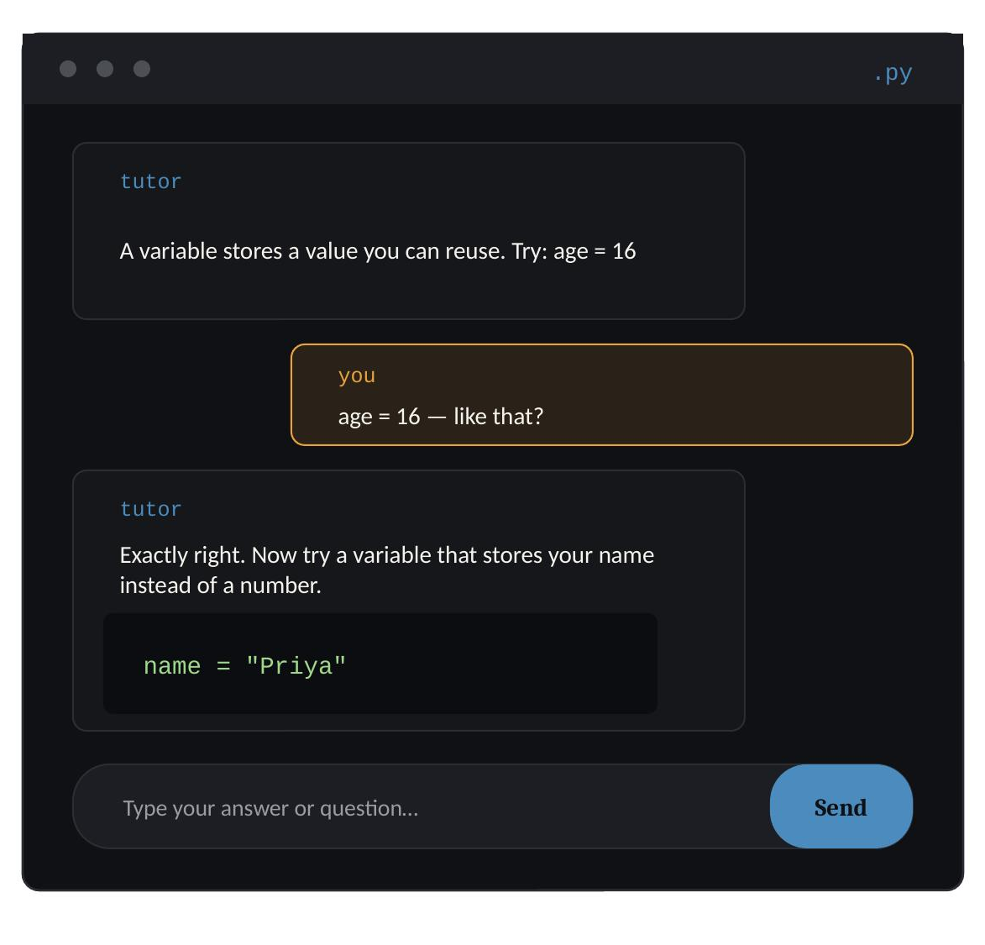
Figure 1. The tutoring interface mid-lesson: the tutor introduces a concept, the learner responds, and the tutor gives targeted feedback before moving on.

2. Tool Used
The application was built entirely inside Claude.ai using Claude's Artifacts feature, which lets Claude write and render a working React application directly inside the conversation. No code was hand-written by either author; every line of the interface, the teaching logic, and the visual design was generated by Claude in response to natural-language instructions.
Claude was used at two distinct levels in this project, which is worth stating explicitly for readers unfamiliar with the workflow:
- Design-time: Claude designed and wrote the application itself — the layout, the styling, the state management, and the logic that governs how a lesson unfolds.
- Run-time: the application, once built, calls the Anthropic API directly from the browser to generate each tutoring message live. In other words, Claude is not only the tool that built CodeTutor.AI — Claude is also the tutor inside it, answering in real time as the learner works through a lesson.

3. The Prompt
Our assignment was to give Claude a single task to build something the general public could use, with no further specification. We chose to describe a real accessibility gap — the cost and rigidity of learning to program — and handed Claude the following instruction, unedited:
ORIGINAL PROMPT
“Can you do this task? Making an AI code teacher that can teach different coding languages such as C, C++, Java or Python to a beginner, given the user provides which language they want to learn and how much they want to learn.”
From this single sentence, Claude made every remaining design decision on its own: it chose to build a two-screen React application (a setup screen and a chat-based tutoring screen), decided to call the Anthropic API live from within the artifact so the tutor could hold a genuine conversation, and wrote the system prompt that governs the tutor's teaching style — one concept at a time, one example, one check-in — without being told to do so.

4. Improvement of the Prompt
The first version of the app was fully functional but visually plain: flat text, no code highlighting, and no motion. Rather than respecting a specific redesign, our second prompt intentionally stayed open-ended so we could evaluate how well Claude could interpret an ambiguous request about quality rather than content:
FOLLOW-UP PROMPT
“How do I make this more refined?”
Claude responded by asking a single clarifying question — whether “refined” meant visual polish, teaching quality, or added features — rather than guessing. We chose visual polish, and Claude rebuilt the interface with: real syntax highlighting for code blocks (keywords, strings, comments, and numbers colored per language), a copy-to-clipboard control on every code sample, staggered entrance animations on the setup screen, a bouncing-dot typing indicator in place of static “thinking…” text, and a subtle background gradient and card-hover elevation throughout.
The lesson we took from this stage was less about the specific visual changes and more about prompting strategy: an intentionally vague instruction (“make this more refined”) produced a clarifying question rather than a guess, and answering that one question in a single word (“visual”) was enough for Claude to correctly scope and execute a substantial, multi-part redesign without any further direction from us.

5. App / Site Link
CodeTutor.AI was built and lives as a Claude.ai Artifact rather than on independently hosted infrastructure. Artifacts can be made publicly accessible with a single click from inside the conversation that created them (open the artifact, click Publish, and copy the generated link), which is the step we completed to obtain the public URL below.
LIVE APPLICATION
[https://claude.ai/share/8c3ee1f4-8ed8-4809-b126-ac6bab251407]
Readers without the link above can still run the application from the source file included in the output package described in the next section — see that file's README for two ways to run it, either directly inside Claude.ai or as a standalone React project.

6. Output Package
Accompanying this chapter is a zip archive, CodeTutorAI_App.zip, containing the application in its own folder exactly as Claude generated it, along with a short README explaining what the code does and how to run it.
Contents
- CodeTutorAI_App/CodeTutor.jsx — the complete, single-file React application (setup screen, tutoring chat screen, syntax highlighting, and the live call to the Anthropic API).
- CodeTutorAI_App/README.md — a description of the app's behavior and two ways to run it: inside Claude.ai with no setup, or as a standalone React project with the API call proxied through the reader's own backend.
About the output
The output is intentionally a single, self-contained file. This was a deliberate simplicity choice on Claude's part rather than an oversight: because the entire application — layout, state, styling, and API logic — lives in one file, it can be copied into a fresh Claude.ai conversation and rendered immediately, or dropped into any React project as a single component with minimal adaptation. The trade-off, discussed further below, is that nothing in the application persists between sessions; every learner starts from a blank slate each time the page is opened.

7. Remarks — How the App Could Be Refined or Improved
CodeTutor.AI met the assignment's core requirement — a working, publicly usable tool built from a single prompt — but the process of building and testing it surfaced several concrete directions for improvement, listed here roughly in order of impact:
- Persistent progress. The app currently keeps no memory between sessions; closing the tab loses the entire lesson. Adding lightweight storage (for example, saving conversation history and a running topic checklist) would let a learner return and continue rather than restart.
- Broader language and topic coverage. The current four languages (Python, C, C++, Java) cover procedural and object-oriented basics well but omit increasingly common beginner entry points such as JavaScript or SQL.
- Verifying code the learner writes. Feedback is currently generated by the tutor reading the learner's typed answer, not by executing it. Running short exercises in a real sandboxed interpreter would let the tutor catch runtime errors it might otherwise miss from reading code alone.
- Accessibility review. The interface has not yet been tested against screen readers or keyboard-only navigation, both of which matter directly for a tool whose stated goal is public accessibility.
- Independent hosting. Relying on a Claude.ai Artifact link is convenient but ties the tool's availability to that platform. Deploying a standalone version (using the included README as a starting point) would give the project a permanent, platform-independent home.
- Usage safeguards. Because the app calls the Anthropic API directly from the browser, a public deployment beyond Claude.ai would need its own API key handling and rate-limiting on a backend, rather than exposing a key in client-side code.
None of these gaps affected the app's ability to fulfil the assignment, but they mark a clear path from “working classroom demonstration” to “production-ready public tool,” which we see as the natural next phase of this project.

