# CPPF to EMTF data format

A. Madorsky, University of Florida/Physics

2016-11-01

DRAFT

CPPF should do the following:

* De-serialize and clusterize RPC data
* Convert raw hits into ϕ and θ coordinates
* Transmit these coordinates to EMTF

Each 10° sector contains 6 RPC chambers in EMTF area, so on each BX up to 12 hits could be present within 10° sector. Hits from one 10° sector can be transmitted via one 10G optical link. Each EMTF processor should receive data from its own sector (60 °), plus data from neighboring sector (10 °). So total count of 10G links per EMTF processor is 7. The neighboring sector number is calculated as shown below:

NB = (N > 1) ? N-1 : 6

N is the number of sector that EMTF belongs to, NB is neighboring sector. All sector numbers range from 1 to 6.

Each 10G link is able to transfer 192 bits per BX. Thus the number of bit available for each RPC hit is 192/12 = 16.

The following format of data fields for each hit is proposed:

|  |  |  |
| --- | --- | --- |
| **Bits** | **Field name** | **Field description** |
| 10:0 | ϕ | Φ coordinate of the hit |
| 15:11 | θ | Θ coordinate of the hit |

## Φ scale

Φ scale should match internal EMTF ϕ scale, with its precision reduced to match RPC ϕ resolution. The EMTF scale starts at previous sector, station ME2, CSCID=3, strip 0, minus 2° (see Fig 1). That location corresponds to binary ϕ code 0000000000. One ϕ bin value for CPPF data is (1/15)° = 0.066666666…°. Φ coordinate of 0x7ff (maximum 11-bit binary value) is used to mark invalid RPC hit.

## Θ scale

Θ scale also should match internal EMTF θ scale, with its precision reduced to match RPC θ resolution. The θ coordinate should be approximated to be as close as possible to the center of corresponding “roll” in the RPC chamber. EMTF internal θ scale starts at θ = 8.5° (binary code 00000). One θ bin for CPPF data is 1.140625°.

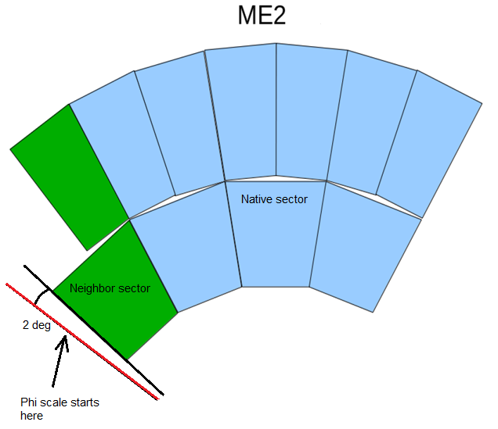

Figure 1. EMTF internal ϕ scale start point

## Revisions

|  |  |
| --- | --- |
| **Date** | **Changes** |
| 2016-10-21 | Initial creation |
| 2016-11-01 | removed valid bit, made phi 11 bit, code 0x7ff used as invalid track marker |