Open Program

目录

*1 , Start Program double click Honeywell.exe in below line* 1

*2, Login* 1

3, Create a sample test. 2

4, Select test sample amount and click next step. 3

5, Input samples information for each sample. And click next 3

6, Start to Get sample value after push start 4

7, Calculate the Result (not finished) 4

8, Create PDF results. (not finished) 4

|  |  |  |
| --- | --- | --- |
| Data | Version | Comments |
| 2019-08-02 | V1.00 | First Release |
| 2019-08-02 | V1.01 | Update Test Program to honeywell_v1.01.exe |
| 2019-08-11 | V1.02 | Add Export function PDF result function |

### 1 , How install the program

* 1. copy below zip file to your desk.
  2. unzip it to D:\Honeywell
  3. 添加环境变量 我的电脑-->鼠标右键属性-->高级系统设置-->系统环境变量-->path-->新建-->"D:\Honeywell\wkhtmltox\bin"-->确认

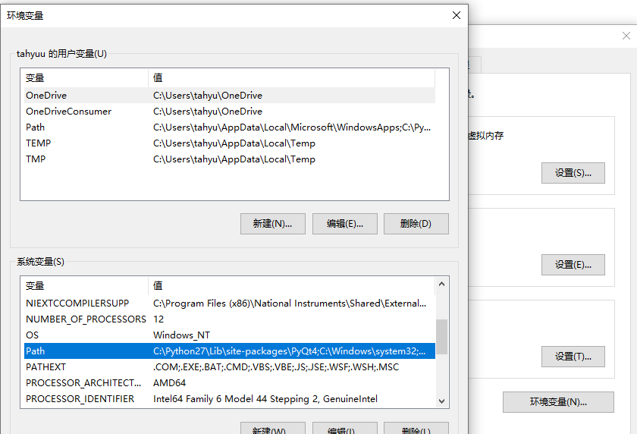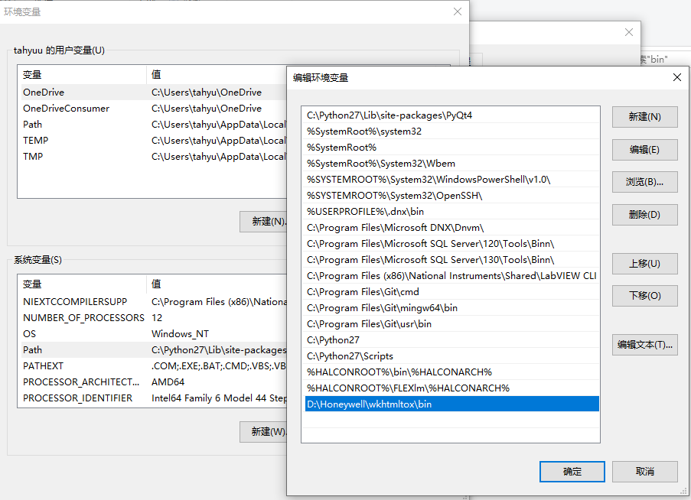

### 2, Login

Uername: admin

Password: admin

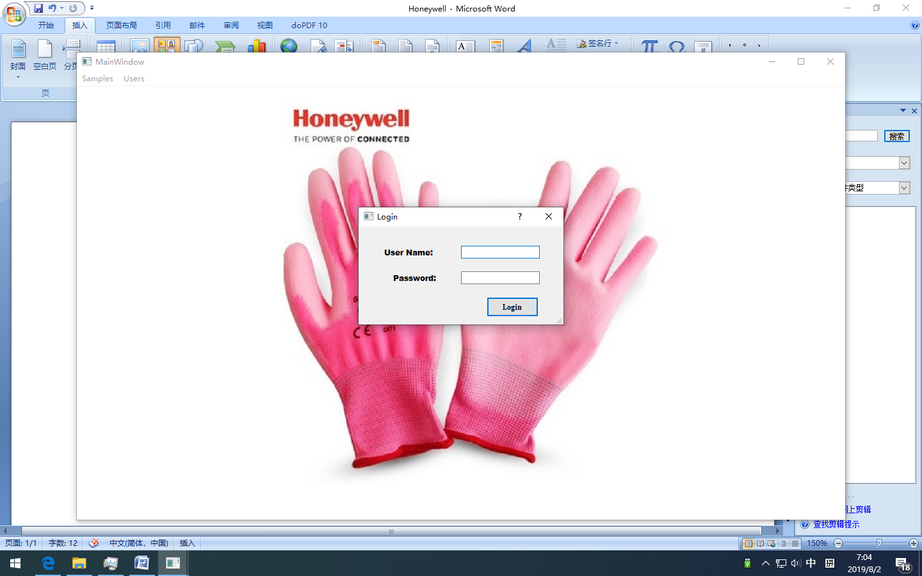

### 3, Create a sample test.

Click Samples🡪 create samples

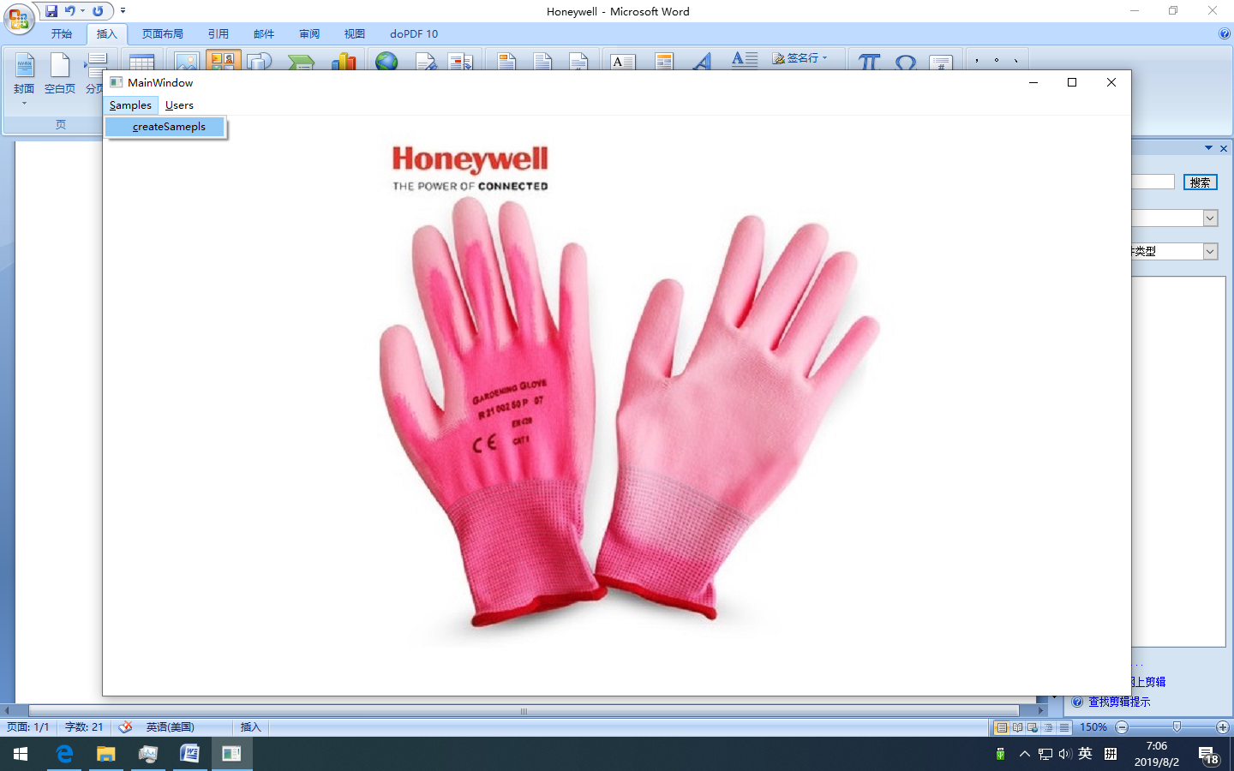

### 4, Select test sample amount and click next step.

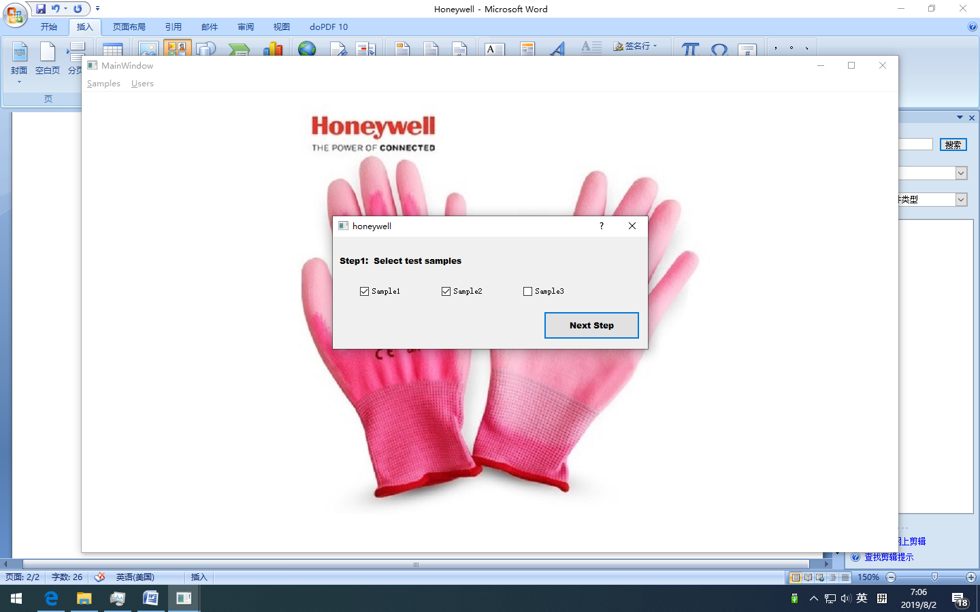

### 5, Input samples information for each sample. And click next

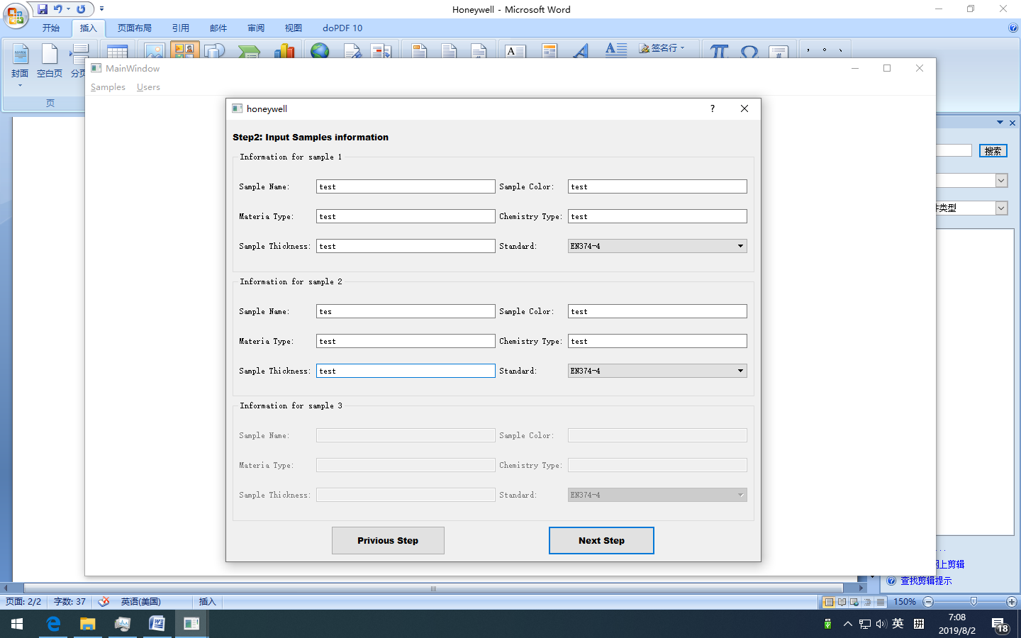

### 6, Start to Get sample value after push start

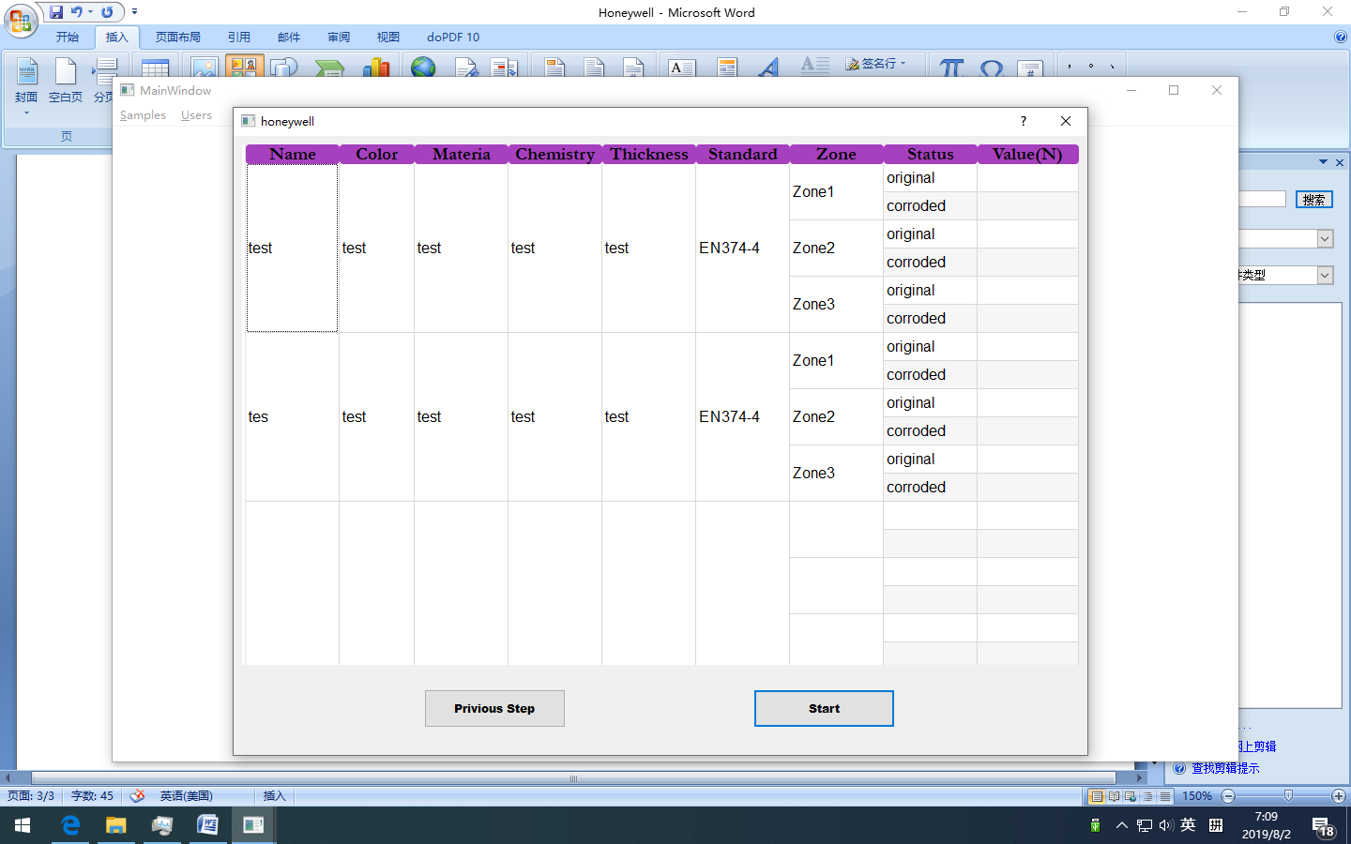

### 7, Calculate the Result

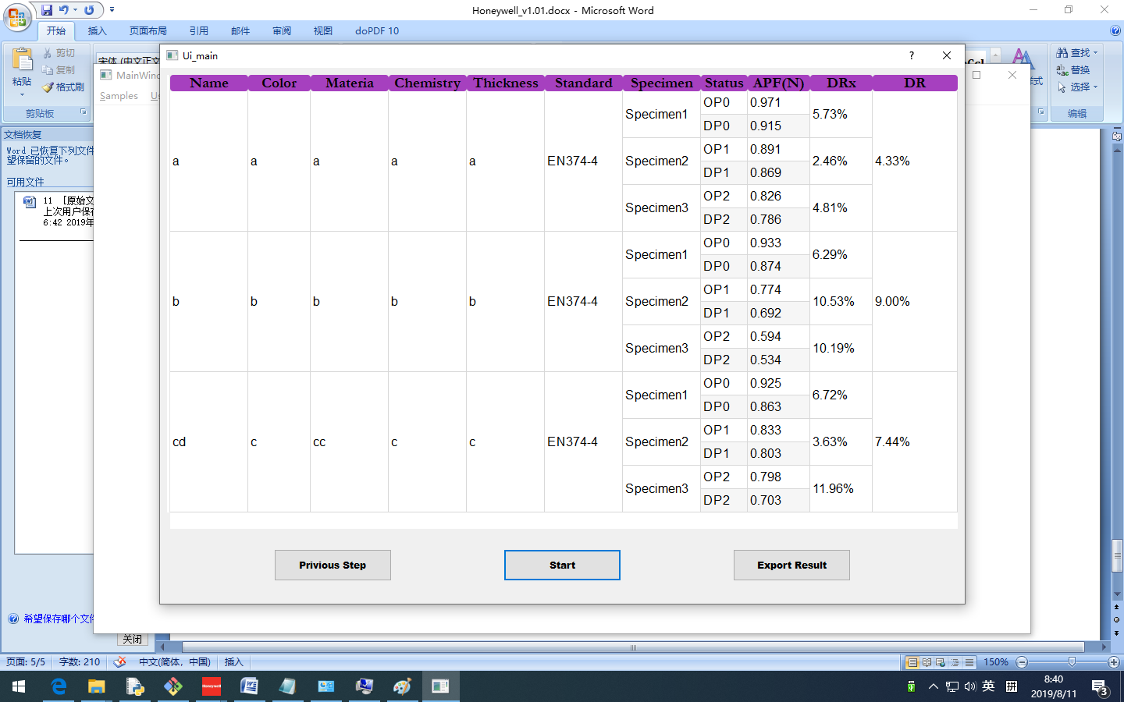

### 8, Create PDF results. (not finished)

