Dsadsadsd

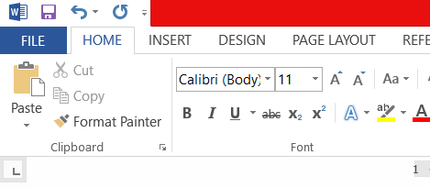

Dấdsadsadsa

Adsasdasdsada

com.itextpdf.kernel.geom.PageSize.A4.getWidth() - document.getLeftMargin() - document.getRightMargin()