Figure 1. Number of Submissions per Year

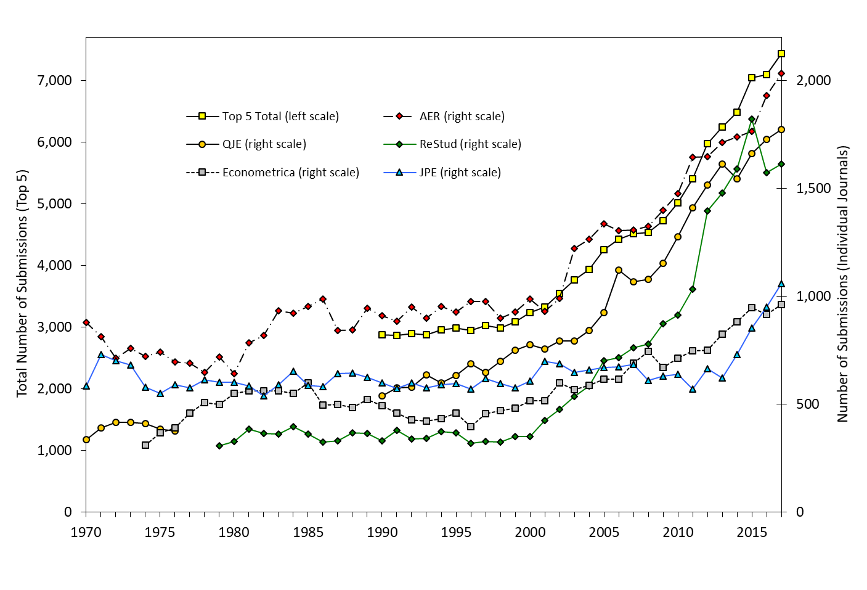

Figure 2. Number of Articles Published per Year

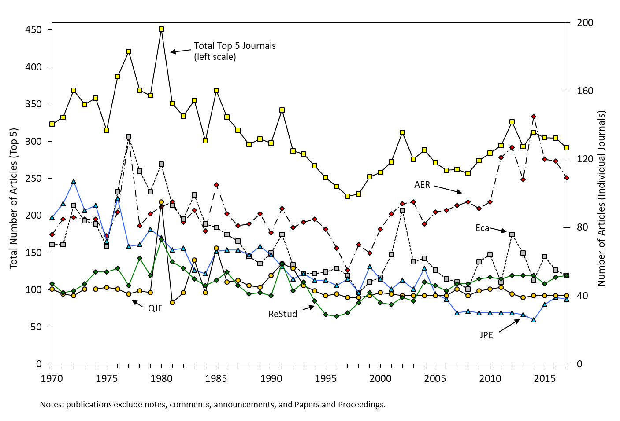

Figure 3. Trends in Length and Number of Authors of Published Papers

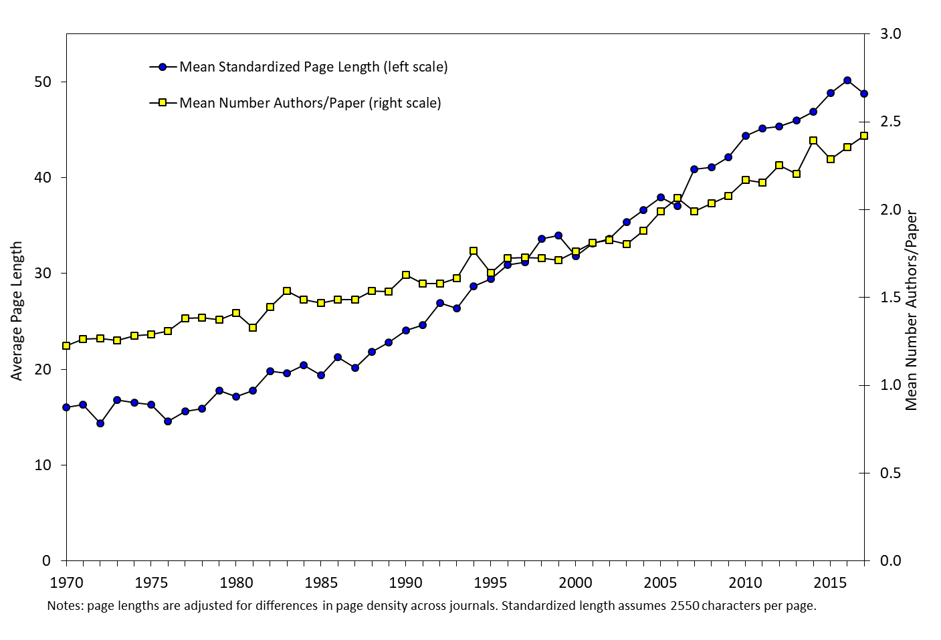

Figure 4. Median Standardized Length of Published Papers by Journal

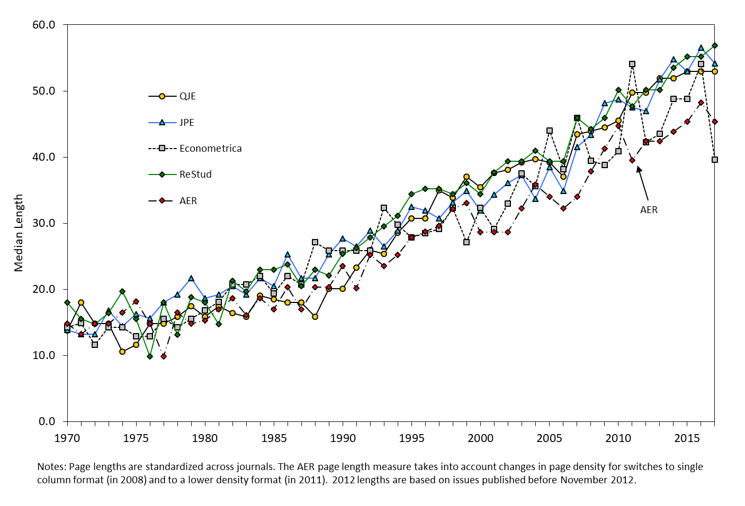

Table 1. Number of Submissions Per Year, and Journal Shares of Submissions to Top 5, 1970-2017



Table 2. Number of Articles Published Per Year, and Journal Shares of Top 5 Publications, 1970-2017

Table 3. Mean and Median Standardized Page Lengths of Published Articles, by Journal

