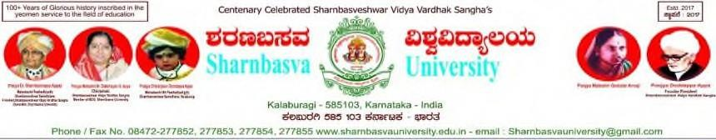

# A PROJECT REPORT

**On**

# “TCS COMPANY”

***Submitted in partial fulfilment of the requirement for the award of***

# Faculty of Computer Applications In

**Branch Of**

# Bachelor of Computer Applications

**SHARNBASVA UNIVERSITY, Kalaburagi**

# By TAIBAZ KHANAM

# SG21BCA160

**Under the guidance of**

**Prof. PRASHANT MUTTA**

**BCA**



# Bachelor of Computer Applications, Faculty of Computer Applications, SHARNBASVA UNIVERSITY,

**Sharan Nagar, Kalaburagi – 585103.**

2023-2024



# Faculty of Computer Applications Course/Programme: BCA (Co-Ed)



**CERTIFICATE**

Certified that the Project work entitled *“*TCS COMPANY” is a bonafide work carried out by TAIBAZ KHANAM and bearing USN No: SG21BCA160 in partial fulfilment of the requirement for the award of the degree of “Bachelor of Computer Applications” SHARNBASVA UNIVERSITY, Kalaburagi during the year 2023-2024. It is certified that all corrections / suggestion indicated for Internal Assessment have been incorporated in the Report. The Project Report has been approved as it satisfies the academic requirements in respect of project work prescribed for the Bachelor of Computer Applications Degree.

**Signature of the Guide Signature of the Chairperson Signature of the Dean**

**Names of the Examiners 1…………………………..**

**2…………………………..**

# Declaration

I, the undersigned **Mrs.TAIBAZ KHANAM (SG21BCA160)** here by declare that the Project work entitled **“ TCS Company”** embodies the report of my project work during the course **“Bachelor Of Computer Applications"** V Semester in year 2023-2024 under the guidance **Prof. PRASHANT MUTTA.**

**TAIBAZ KHANAM**

**Date:**

**Place: Kalburagi**

**ACKNOWLEDGEMENT**

I owe a debt of gratitude to **Prof. SRIDHAR ANAKAL,** Chairperson of **SHARNBASVA UNIVERSITY** Faculty of computer Applications. Who inspires me to **conceive** this project.

I would like to convey my heartfelt thanks to **Prof. PRASHANT MUTTA** Project guide at **SHARNBASVA UNIVERSITY** Faculty of Computer Applications. Who helped me a lot to understand this subject. And gave valuable guidance for completing my project successfully.

Last but not the least I would like to thank my Family and Friends who have helped me with their valuable suggestions.

**TAIBAZ KHANAM**