
20450 Century Boulevard
Germantown, MD 20874
Fax: (301) 407-9418

Security Accelerator LLD

Software Design Specification (SDS)

Revision A

QRSA # 00013358

May 24, 2010

Prepared by: Eric Ruei

NOTICE OF CONFIDENTIAL AND PROPRIETARY INFORMATION
Information contained herein is subject to the terms of the Non-Disclosure Agreement between Texas Instruments Incorporated and your company, and is of a highly sensitive nature. It is confidential and proprietary to Texas Instruments Incorporated. It shall not be distributed, reproduced, or disclosed orally or in written form, in whole or in part, to any party other than the direct recipients without the express written consent of Texas Instruments Incorporated.

Revision Record
Document Title: Software Design Specification

Revision | Description of Change
A | Initial Release
A | - Provide RTSC (IALG-like) system and channel initialization APIs.  - Replace SA system context with system API to support multi-instance system  - Add system and channel getID APIs  - Add some utility APIs  - Add action items for known issues
A | - Revised after the unit test  - Add new API Sa_getSysStats
A | - Revised with review comments
A | API Updates  - Remove IALG dependency  - Use C99 types instead of XDC types  - Update RNG and PKA related APIs
Note: Be sure the Revision of this document matches the QRSA record Revision letter. The revision letter increments only upon approval via the Quality Record System.

TABLE OF CONTENTS

1 Scope 1
2 References 1
3 Definitions 1
4 Overview 1
4.1 Common Interface 2
4.2 Channel Interface 2
5 LLD External Interface Definitions (APIs) 3
5.1 Constant and Type Definitions 3
5.1.1 SALLD Channel Handle 3
5.1.2 Protocol Specification 3
5.1.3 Channel Size Configuration Information 4
5.1.4 Cipher Modes 4
5.1.5 Auth Modes 4
5.1.6 Channel Configuration Information 5
5.1.7 General Control Information 5
5.1.7.1 Protocol Configuration Information 5
5.1.7.2 Destination Information 7
5.1.7.3 General Configuration Information 7
5.1.7.4 Security General Control Information 8
5.1.8 Key Information 8
5.1.8.1 Protocol Specific Key Information 8
5.1.8.2 Security Key Information 10
5.1.9 Channel Control Information 10
5.1.10 SASS Packet Error 11
5.1.11 Packet Descriptor Information 11
5.1.12 SALLD SW Information 12
5.1.13 Command label Information 12
5.1.14 Payload Information 12
5.1.15 Packet Information 13
5.1.16 Key Request Information 13
5.1.17 Security Context Information 14
5.1.18 SASS Reset State and Query Argument 14
5.1.19 PKA Request Information 14
5.1.20 RNG Configuration Information 15
5.1.21 System Size Configuration Information 16
5.1.22 System Configuration Information 16
5.2 Call-in APIs 17
5.2.1 SASS Channel Get Buffer Description 17
5.2.1.1 Purpose/Description 17
5.2.1.2 Prototype 17
5.2.1.3 Implementation 17
5.2.1.4 Return Values 17
5.2.2 SASS Channel Creation 17
5.2.2.1 Purpose/Description 17
5.2.2.2 Prototype 18
5.2.2.3 Implementation 18
5.2.2.4 Return Values 18
5.2.3 SASS Channel Control 18
5.2.3.1 Purpose/Description 18
5.2.3.2 Prototype 18
5.2.3.3 Implementation 18
5.2.3.4 Return Values 19
5.2.4 SASS Channel Send Data 19
5.2.4.1 Purpose/Description 19
5.2.4.2 Prototype 19
5.2.4.3 Implementation 19
5.2.4.4 Return Values 21
5.2.5 SASS Channel Receive Data 21
5.2.5.1 Purpose/Description 21
5.2.5.2 Prototype 21
5.2.5.3 Implementation 22
5.2.5.4 Return Values 24
5.2.6 SASS Channel Statistics Request 24
5.2.6.1 Purpose/Description 24
5.2.6.2 Prototype 24
5.2.6.3 Implementation 25
5.2.6.4 Return Values 25
5.2.7 SASS Channel Close 25
5.2.7.1 Purpose/Description 25
5.2.7.2 Prototype 25
5.2.7.3 Implementation 25
5.2.7.4 Return Values 25
5.2.8 SASS Get Channel ID 25
5.2.8.1 Purpose/Description 25
5.2.8.2 Prototype 25
5.2.8.3 Implementation 26
5.2.8.4 Return Values 26
5.2.9 SASS Get Buffer Description 26
5.2.9.1 Purpose/Description 26
5.2.9.2 Prototype 26
5.2.9.3 Implementation 26
5.2.9.4 Return Values 26
5.2.10 SASS Creation 26
5.2.10.1 Purpose/Description 26
5.2.10.2 Prototype 26
5.2.10.3 Implementation 27
5.2.10.4 Return Values 27
5.2.11 SASS Close 27
5.2.11.1 Purpose/Description 27
5.2.11.2 Prototype 27
5.2.11.3 Implementation 27
5.2.11.4 Return Values 27
5.2.12 SASS System Statistics Request 27
5.2.12.1 Purpose/Description 27
5.2.12.2 Prototype 27
5.2.12.3 Implementation 28
5.2.12.4 Return Values 28
5.2.13 Reset/Enable/Get SASS state 28
5.2.13.1 Description 28
5.2.13.2 Prototype 28
5.2.13.3 Implementation 28
5.2.13.4 Return value 28
5.2.14 Download SASS PDSP Image 29
5.2.14.1 Description 29
5.2.14.2 Prototype 29
5.2.14.3 Implementation 29
5.2.14.4 Return values 29
5.2.15 SASS Init RNG 29
5.2.15.1 Purpose/Description 29
5.2.15.2 Prototype 29
5.2.15.3 Implementation 29
5.2.15.4 Return Values 29
5.2.16 SASS Get Random Number 30
5.2.16.1 Purpose/Description 30
5.2.16.2 Prototype 30
5.2.16.3 Implementation 30
5.2.16.4 Return Values 30
5.2.17 SASS Close RNG 30
5.2.17.1 Purpose/Description 30
5.2.17.2 Prototype 30
5.2.17.3 Implementation 30
5.2.17.4 Return Values 30
5.2.18 SASS Init PKA 31
5.2.18.1 Purpose/Description 31
5.2.18.2 Prototype 31
5.2.18.3 Implementation 31
5.2.18.4 Return Values 31
5.2.19 SASS PKA Operation 31
5.2.19.1 Purpose/Description 31
5.2.19.2 Prototype 31
5.2.19.3 Implementation 31
5.2.19.4 Return Values 32
5.2.20 SASS Close PKA 32
5.2.20.1 Purpose/Description 32
5.2.20.2 Prototype 32
5.2.20.3 Implementation 32
5.2.20.4 Return Values 32
5.2.21 SASS Get System ID 32
5.2.21.1 Purpose/Description 32
5.2.21.2 Prototype 32
5.2.21.3 Implementation 32
5.2.21.4 Return Values 32
5.2.22 SASS Verify Security Context Buffer 32
5.2.22.1 Purpose/Description 32
5.2.22.2 Prototype 33
5.2.22.3 Implementation 33
5.2.22.4 Return Values 33
5.3 Macros 33
5.3.1 Reset Subsystem 33
5.3.1.1 Description 33
5.3.1.2 Invocation 33
5.3.1.3 Implementation 33
5.3.2 Enable Subsystem 33
5.3.2.1 Description 33
5.3.2.2 Invocation 33
5.3.2.3 Implementation 33
5.3.3 Download Image 34
5.3.3.1 Description 34
5.3.3.2 Invocation 34
5.3.3.3 Implementation 34
5.3.4 Get Reset State 34
5.3.4.1 Description 34
5.3.4.2 Invocation 34
5.3.4.3 Implementation 34
5.4 Call-Out APIs 35
5.4.1 SASS Channel Key Request 35
5.4.1.1 Purpose/Description 35
5.4.1.2 Prototype 35
5.4.2 SASS Security Context Allocation 35
5.4.2.1 Purpose/Description 35
5.4.2.2 Prototype 35
5.4.3 SASS Security Context Release 35
5.4.3.1 Purpose/Description 35
5.4.3.2 Prototype 35
5.4.4 SASS Channel Routing Registration 36
5.4.4.1 Purpose/Description 36
5.4.4.2 Prototype 36
5.4.5 SASS Channel Routing Un-registration 36
5.4.5.1 Purpose/Description 36
5.4.5.2 Prototype 36
5.4.6 SASS Send Null Packet 36
5.4.6.1 Purpose/Description 36
5.4.6.2 Prototype 36
6 Multi Core Considerations 37
6.1 Multiple-Core System Resources 37
6.2 System Level Resources 37
6.3 System Level Operation 37
7 Design 37
7.1 GEM Software Resource Requirements 37
7.1.1 LLD MCPS Requirements 37
7.1.2 LLD Memory Requirements 37
7.1.2.1 Per System/Per IP block Instance Memory 37
7.1.2.2 Per Channel/Connection/Application Link Memory Requirements 37
7.2 HW and PDSP Resource Requirements 38
7.2.1 Hardware/PDSP cycle information 38
7.2.2 Hardware/PDSP memory information 38
7.3 Subsystem Integration Call Flow 38
7.3.1 Subsystem Control/Initialization 38
7.3.2 Channel Setup/Teardown Call flow 38
7.3.3 Data Flow 40
8 Testing Considerations 42
9 Future Extensions 42
9.1 Known Issues 42
9.1.1 Multi-core Channel Support 43
9.2 Potential Enhancements 43

Scope
This document describes the functionality, architecture, and operation of the Security Accelerator Low Level Driver.

References
The following references are related to the feature described in this document and shall be consulted as necessary.

No | Referenced Document | Control Number | Description
1 | SA LLD PRD 1.0 |  | Product Requirements
Table 1. Referenced Materials

Definitions

Acronym | Description
AppSvc | Application Services
API | Application Programming Interface
CPPI | Communication Processor Peripheral Interface
DSP | Digital Signal Processor
LLD | Lower Level Driver
MKI | Master Key Index
MSU | Media Security Unit
PKA | Public Key Accelerator
RNG | Random Number Generator
RTP | Real-time Transport Protocol
QMSS | Queue Manager Sub-System
SA | Security Accelerator
SASS | Security Accelerator Sub-System
Table 2. Definitions

Overview
The Security Accelerator (SA) also known as cp_ace (Adaptive Cryptographic Engine) is designed to provide packet security as part of IPSEC, SRTP and 3GPP industry standard. The SASS low level driver provides an abstraction layer between the application and the Security Accelerator Sub System (SASS). It provides both the system level interface and the channel level interface with a set of APIs defined at section 5.

Common Interface
The common interface maintains the system level resources and needs to be coordinated among multiple CGEM cores. All the data access provided by the common interface should invoke the SASS CSL layer. The common interface performs the following tasks:
- Reset, download and update the SASS PDSP images.
- Query SASS states and statistics.
- Read a 64-bit true random number
- Perform the large integer arithmetic through the PKA module
- Monitor and report SASS system error

Channel Interface
The channel interface performs protocol-specific pre-processing for all the packets to be passed to SASS and protocol-specific post-processing for all the packets received from SASS. The channel interface performs the following tasks:
- Convert the channel configuration information into the security contexts defined by the SASS.
- Perform protocol-specific packet operations such as insertion of the ESP header, padding and ESP tail.
- Decrypt and authenticate the received SRTP packet if the SASS is not able to perform the operations due to the key validation failure.
- Generate the command labels in data mode operation.
- Maintain the protocol-specific channel statistics.

The driver does not contain a transport layer and is always non-blocking. The software layers above the SASS LLD must call the appropriate SASS LLD APIs, and then call the appropriate CPPI and QMSS APIs to actually send the data to the SASS.
The interface between the driver, the application, and the SASS is illustrated at Figure 1 .
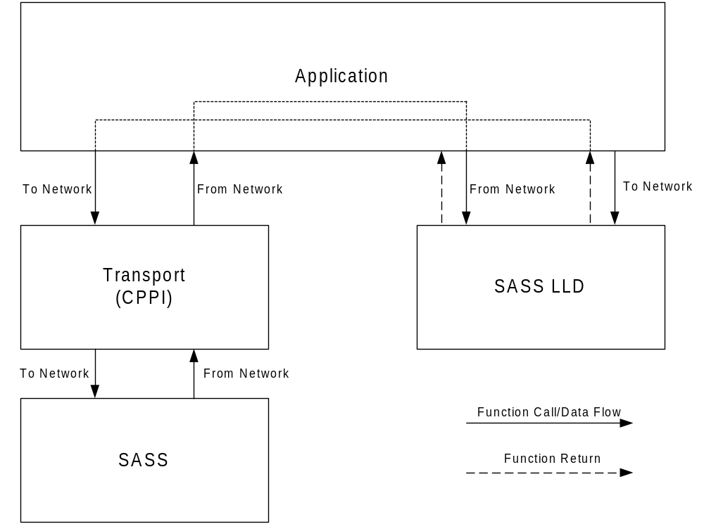
- APP/SASS/SASS LLD Data Flow

LLD External Interface Definitions (APIs)

Constant and Type Definitions

SALLD Channel Handle
The SALLD Channel Handle (salldChanHandle_t) is used to identify a SASS channel; it is created and returned by the channel Initialization API.

Protocol Specification
This enumeration defines the security protocol type of the packets to be processed in the SASS.

Name | Description
SALLD_PROT_NULL | No Protocol Specified. The channel will be operating in data mode.
SALLD_PROT_SRTP | Security RTP
SALLD_PROT_SRTCP | Security RTCP
SALLD_PROT_IPSEC_AH | IPSEC AH mode
SALLD_PROT_IPSEC_ESP | IPSEC ESP mode
SALLD_PROT_3GPP_AC | 3GPP Air Ciphering

Channel Size Configuration Information
This structure defines the size configuration information for a security channel.

SALLD_CHAN_SIZE_CONFIG_T:
Name | Description
protocolType | Specify the protocol type of the security channel as defined at section 5.1.2.

Cipher Modes
This enumeration defines the cipher modes used for encryption and decryption. It can be used as an index to the encryption/decryption call table used in software mode, and the encryption and decryption engine software mode control word array used in firmware mode.

Name | Description
SALLD_CIPHER_NULL | No encryption
SALLD_CIPHER_AES_CTR | AES Counter mode
SALLD_CIPHER_AES_F8 | AES F8 mode
SALLD_CIPHER_AES_CBC | AES CBC mode
SALLD_CIPHER_DES_CBC | DES CBC mode
SALLD_CIPHER_CCM | Counter with CBC-MAC mode
SALLD_CIPHER_GCM | Galois Counter mode
SALLD_CIPHER_GSM_A53 | 3GPP GSM A5/3
SALLD_CIPHER_KASUMI_F8 | Kasumi F8 mode
SALLD_CIPHER_SNOW_3G_ F8 | Snow 3G F8 mode

Auth Modes
This enumeration defines the supported authentication modes. It can be used as an index to the authentication call table used in software mode, and the engine software mode control word array used in firmware mode.

Name | Description
SALLD_AUTH_NULL | No Authentication
SALLD_AUTH_MD5 | MD5 mode
SALLD_AUTH_SHA1 | SHA1 mode
SALLD_AUTH_SHA2_224 | 224-bit SHA2 mode
SALLD_AUTH_SHA2_256 | 256-bit SHA2 mode
SALLD_AUTH_HMAC_MD5 | HMAC with MD5 mode
SALLD_AUTH_HMAC_SHA1 | HMAC with SHA1 mode
SALLD_AUTH_HMAC_SHA2_224 | HMAC with 224-bit SHA2 mode
SALLD_AUTH_HMAC_SHA2_256 | HMAC with 256-bit SHA2 mode
SALLD_AUTH_GMAC | Galois Counter mode
SALLD_AUTH_CMAC | Cipher-based Message Authentication Code mode
SALLD_AUTH_CBC_MAC | Cipher Block Chaining – Message Authentication Code mode
SALLD_AUTH_KASUMI_F9 | Kasumi F9 mode

Channel Configuration Information
This structure defines the configuration information used for security channel creation.

SALLD_CHAN_CONFIG_T:
Name | Description
ID | Specify the logical channel identification
sizeConfig | Specify the size configuration information as defined at section 5.1.3.

General Control Information
The following sub-sections define the channel general control information.

Protocol Configuration Information
The following structures define the protocol-specific configuration parameters excluding the keys. There are very few commonly used combinations of key sizes for certain security protocol, such as SRTP and SRTCP. In this case, the user can create table of all the valid combination of keys and use an index to specify the desired key combination.

SALLD_SRTP_CONFIG_PARAMS_T:
Name | Description
masterKeySize | Specify the size of the master key in bytes.
masterSaltSize | Specify the size of the master salt in bytes.
sessionEncKeySize | Specify the size of the session encryption key in bytes.
sessionMacKeySize | Specify the size of the session mac key in bytes.
sessionSaltSize | Specify the size of the session Salt in bytes.
macSize | Specify the size of the authentication tag in bytes.

SALLD_IPSEC_CONFIG_PARAMS_T:
Name | Description
transportType | Specify the transport Type (Transport/Tunnel)
ctrlBitMap | Various control information as specified here:  0x0001: ESN enabled
encryptionBlockSiz | Specify the encryption block size:  1: Stream encryption and no alignment requirement  4: AES-CTR or other stream-like encryption with 4-byte alignment  block size: specified by the block encryption algorithm
sessionEncKeySize | Specify the size of the session encryption key in bytes.
sessionMacKeySize | Specify the size of the session mac key in bytes.
sessionSaltSize | Specify the size of the session salt in bytes
ivSize | Specify the size of the initialization vector in bytes.
macSize | Specify the size of the authentication tag in bytes.
nextHdr | Specify the next protocol header
spi | Specify the SPI (Security Parameter Index)
esn | Specify the initial value of the extended sequence Number

SALLD_AC_CONFIG_PARAMS_T:
Name | Description
countC | Specify the high bits, HFN, for the frame Counter:  WCDMA RLC AM: the high 20 bits are used  WCDMA RLC UM: the high 25 bits are used  WCDMA RLC TM: the high 25 bits are used  LTE: All 32-bit is used as Count-C  GSM: Not used
freash | Specify the 32-bit random number (fresh) required for some integrity check algorithm
ivLow26 | Specify the low 26-bit value of the initialization vector
pduType | Specify the Air Ciphering PDU Type (GSM/WCDMA_TMD/WCDMA_UMD/WCDMA_AMD/LTE)
ctrlBitMap | Various control information as specified here:  0x00FF: Bearer Mask  0x0100: Direction (uplink/downlink) = (0/1)
sessionEncKeySize | Specify the size of the session encryption key in bytes
sessionMacKeySize | Specify the size of the session mac key in bytes.
ivSize | Specify the size of the initialization vector in bytes.
macSize | Specify the size of the authentication tag in bytes.

SALLD_DATA_MODE_CONFIG_PARAMS_T:
Name | Description
sessionEncKeySize | Specify the size of the session encryption key in bytes.
sessionMacKeySize | Specify the size of the session mac key in bytes.
sessionSaltSize | Specify the size of the session salt used in GCM/CCM operation in bytes
ivSize | Specify the size of the initialization vector in bytes.
macSize | Specify the size of the authentication tag in bytes.
aadSize | Specify the size of the additional authenticated Data in bytes used in CCM and GCM modes
enc | TRUE: Encryption; FALSE: Decryption
enc1st | TRUE: perform encryption first; FALSE: perform authentication first

SALLD_PROTOCOL_CONFIG_PARAMS_T:
Name | Description
srtp | Specify the configuration parameters for SRTP/SRTCP.
ipsec | Specify the configuration parameters for IPSEC.
ac | Specify the configuration parameters for 3GPP Air Ciphering
data | Specify the configuration parameters in data mode.

Destination Information
This structure defines the destination parameters which are used by the SASS to deliver the processed packets to the desired destination.

SALLD_DEST_INFO_T:
Name | Description
flowID | Specify the 8-bit CPPI Flow ID
queueID | Specify the 16-bit destination Queue ID

General Configuration Information
This structure defines the general configuration parameters excluding the keys and related re-key parameters.

SALLD_GEN_CONFIG_PARAMS_T:
Name | Description
cipherMode | Specify the cipher mode as defined at section 5.1.4.
authMode | Specify the authentication mode as defined at section 5.1.5.
destInfo | Specify the post-SA destination information
params | Specify the protocol-specific general configuration parameters as defined at section 5.1.7.1.

Security General Control Information
This structure defines the general control information of the security channel except of the actual keys which will be configured with a separate data structure, which can be used to reconfigure the security channel with new keys during the call period without affecting the general control information specified here.

SALLD_GEN_CTRL_INFO_T:
Name | Description
validBitfield | The bitmap specifies valid parameters as defined below:  - SALLD_CONTROLINFO_VALID_CTRL_BITMAP  - SALLD_CONTROLINFO_VALID_TX_CTRL  - SALLD_CONTROLINFO_VALID_RX_CTRL  - SALLD_CONTROLINFO_VALID_REPLAY_WIN
ctrlBitfield | The bitmap specifies the tx, rx and other operations as defined below:  - SALLD_TX_ON: Enable Tx  - SALLD_RX_ON: Enable Rx  - SALLD_SW_ONLY: Software support only. It is used for the protocols which have not been supported by SASS firmware such as SRTCP.
txCtrl | Specify the general configuration parameters in Tx (To-Network) direction.
rxCtrl | Specify the general configuration parameters in Rx (From-Network) direction.
replayWindowSize | Specify the replay window size

Key Information
The following sub-sections define the Security Key related information. The key related information is part of the LLD channel configuration information. It is defined separately since it will be used frequently during the re-key operation while the general control information stays the same.

Protocol Specific Key Information
The following structures define the security key information for each protocol type respectively.

SALLD_SRTP_KEY_PARAMS_T:
Name | Description
ctrlBitfield | Specify the master key types and other control bit definitions as defined below:  - SALLD_SRTP_KEY_CTRL_MASTER_KEY  - SALLD_SRTP_KEY_CTRL_MASTER_SALT  - SALLD_SRTP_KEY_CTRL_KEY_DERIVE_RATE  - SALLD_SRTP_KEY_CTRL_KEY_LIFETIME  - SALLD_SRTP_KEY_CTRL_ROC  - SALLD_SRTP_KEY_TYPE_MKI: mki in the packet  - SALLD_SRTP_KEY_TYPE_FROM_TO: From-To Key is used
masterKey | Specify the master key.
masterSalt | Specify the master salt.
derivationRate | Specify the key derivation rate in n of 2^n format
keyLifetime | Specify the maximum number of packets allowed for the specified key combination
roc | Specify the initial value of the rollover counter
fromEsn | Specify the starting 48-bit extended sequence number of the specified From-To keys
toEsn | Specify the end 48-bit extended sequence number of the specified From-To keys
mkiSize | Specify the MKI size in bytes
mki | Specify the MKI value

SALLD_IPSEC_KEY_PARAMS_T:
Name | Description
ctrlBitfield | Specify the Key types and other control Information:  - SALLD_IPSEC_KEY_CTRL_ENC_KEY  - SALLD_IPSEC_KEY_CTRL_MAC_KEY  - SALLD_IPSEC_KEY_CTRL_SALT
sesionEncKey | Specify the session encryption key.
sessionAuthKey | Specify the session authentication key
sessionSalt | Specify the session salt

SALLD_AC_KEY_PARAMS_T:
Name | Description
ctrlBitfield | Specify the Key types and other control Information:  - SALLD_AC_KEY_CTRL_ENC_KEY  - SALLD_AC_KEY_CTRL_MAC_KEY
sesionEncKey | Specify the session encryption key.
sessionAuthKey | Specify the session authentication key

SALLD_DATA_MODE_KEY_PARAMS_T:
Name | Description
ctrlBitfield | Specify the Key types and other control Information:  - SALLD_DATA_MODE_KEY_CTRL_ENC_KEY  - SALLD_DATA_MODE_KEY_CTRL_MAC_KEY  - SALLD_DATA_MODE_KEY_CTRL_SALT
sesionEncKey | Specify the session encryption key.
sessionAuthKey | Specify the session authentication key
sessionSalt | Specify the session salt

SALLD_PROTOCOL_KEY_PARAMS_T:
Name | Description
srtp | Specify the key parameters for SRTP/SRTCP
ipsec | Specify the key parameters for IPSEC.
ac | Specify the key related parameters for 3GPP Air Ciphering
data | Specify the key parameters in data mode.

Security Key Information
This structure defines the key control information of the security channel. It is used for both initial configuration and re-key operations.

SALLD_KEY_CTRL_INFO_T:
Name | Description
ctrlBitfield | The bitmap Specify the tx, rx and other operations as defined below:  - SALLD_TX_KEY_VALID: Tx key is available  - SALLD_RX_KEY_VALID: Rx key is available
txKey | Specify the security key parameters in Tx (To-Network) direction.
rxKey | Specify the security key parameters in Rx (From-Network) direction.

Channel Control Information
The following structures define the security channel control related information. They are used by the SASS channel control API as defined at section 5.2.3.

This enumeration defines the channel control types.
SALLD_CHAN_CTRL_TYPE_T:
Name | Description
SALLD_CHAN_CTRL_GEN_CONFIG | SASS channel general configuration
SALLD_CHAN_CTRL_KEY_CONFIG | SASS channel key configuration

This structure defines the channel control information.
SALLD_CHAN_CTRL_INFO_T:
Name | Description
ctrlType | Specify the channel control type as defined above
ctrlInfo | Union of various channel control information including  - SALLD_GEN_CTRL_INFO_T  - SALLD_KEY_CTRL_INFO_T

SASS Packet Error
This enumeration lists all the packet error conditions which may occur in the SASS.

SALLD_PKT_ERR_T:
Name | Description
SALLD_PKT_ERR_OK | No Error
SALLD_PKT_ERR_REPLAY_OLD | The packet is rejected by SASS because it is out of the replay window range
SALLD_PKT_ERR_REPLY_DUP | The packet is rejected by SASS because it is duplicated.
SALLD_PKT_ERR_INVALID_KEY | The packet is rejected by SASS because the key in the security context is out of range
SALLD_PKT_ERR_INVALID_MKI | The packet is rejected by SASS because the MKI mismatches
SALLD_PKT_ERR_AUTH_FAIL | The packet is rejected by SASS because the Authentication (hash) verification fails.

Packet Descriptor Information
It is important to pass the packet header parsing information among the PASS, SASS, SA LLD and application to avoid re-parsing the packet multiple times. The following structures define the packet descriptor information. It may be defined in a global common header file to be shared among modules.

SA_PKT_DESC_T:
Name | Description
size | Specify the packet length.
payloadOffset | Specify the offset from the top of the packet to the protocol header.  IPSEC ESP/AH: IP header  SRTP: RTP header  SRTCP: RTCP header  3GPP Air Ciphering: PDU header
payloadLen | Specify the total payload length to be processed
nSegments | Specify number of data segments in the packet
segments | Pointer to the array which contain the segment addresses
segUsedSizes | Pointer to the array which contain the used size in each data segment
segAlloSizes | Pointer to the array which contain the allocated size in each data segment

SALLD SW Information
This structure contains the SA-specific software information required for all packets to be delivered to SA. It will be provided by the SA LLD based on the general channel configuration parameters and the security protocols. The software information words should be copied to the CPPI Software words area by the CPPI LLD or equivalent as provided.

SALLD_SW_INFO_T:
Name | Description
size | Specify the software info size in 32-bit words
swInfo | Contain the software info words required by SA

Command label Information
This structure defines the SA-specific command label information used by SASS to route packets to sub-engines within SASS. The command label information will be formatted by the SA LLD based on the channel configuration parameters and the payload information as defined at section 5.1.14 in data mode. The command label should be copied to the protocol-specific section at the CPPI packet descriptor as provided through the CPPI LLD or equivalent component.

SALLD_CMD_LABEL_INFO_T:
Name | Description
cmdLbSize | Specify the size of the command labels in bytes.
cmdLbBuf | Pointer to the buffer which contains the command labels

Payload Information
This structure defines the payload related information used to construct the SA-specific command labels in data mode.

SALLD_PAYLOAD_INFO_T:
Name | Description
encOffset | Specify the offset to the encrypted/decrypted data in the packet in bytes.
authOffset | Specify the offset to the authenticated data in the packet in bytes
encSize | Specify the total number of bytes to be encrypted or decrypted
authSize | Specify the total number of bytes to be authenticated
encIV | Contain the initialization vectors used in certain encryption mode.  Note: IV should be specified here in GCM/CCM mode
authIV | Contain the initialization vectors used in certain authentication mode.  Note: IV should be specified here in GMAC mode
aad | Contain the additional authenticated data in GCM/CCM modes

Packet Information
This structure defines the input and output packet formats. It may be converted to more generic packet format specified by the network driver or equivalent.

SALLD_PKT_INFO_T:
Name | Description
pktDesc | Specify packet descriptor
validBitmap | Specify which parameter is valid as defined below:  - SALLD_PKT_INFO_VALID_RX_ERR_CODE  - SALLD_PKT_INFO_VALID_SW_INFO  - SALLD_PKT_INFO_VALID_CMDLB_INFO  - SALLD_PKT_INFO_VALID_PAYLOAD_INFO
pktErrCode | Specify the received error code from SASS. It is only valid in the from-network direction
swInfo | Store the software information required by SA as defined at section 5.1.12. It is only valid in to-network direction.
cmdLbInfo | Command label information as defined at section 5.1.13. It is only valid in to-network direction.
payloadInfo | Specify the payload information in data mode

Key Request Information
The following structures define the Security Key request information. It is only used for SRTP re-key operation at this moment. However, protocol specific structures are defined so that it can be used for other protocols if required.

SALLD_SRTP_KEY_REQUEST_T:
Name | Description
ctrlBitfield | The bitmap Specify the master key types and other control bit definitions as defined below:  - SALLD_SRTP_KEY_TYPE_MKI:  - Set: MKI key is used  - Clear: From-To key is used  - SALLD_SRTP_KEY_MKI_VALID: MKI Value is specified  - SALLD_SRTP_KEY_TX: Tx key  - SALLD_SRTP_KEY_RX: Rx key
mki | Specify the mki value of the MKI keys

SALLD_KEY_REQUEST_T:
Name | Description
srtp | Specify the key request parameters for SRTP.

Security Context Information
The 16-bit security context ID and its corresponding context buffer which contains the security context parameters should be maintained across multiple DSP cores. Therefore, they are multi-core system resources and should be managed by the application. This structure is used to exchange security context information between SA LLD and the application.

SALLD_SC_INFO_T:
Name | Description
scID | Security Context ID specified by the application
scBuf | Security Context Buffer provided by the application. It is required to be 16-byte aligned.
scSize | Specify the required size of the security context

SASS Reset State and Query Argument
This enumeration defines SA Sub-System queries and states (see section 5.3.4)
SALLD_STATE_RESET
SALLD_STATE_ENABLE
SALLD_STATE_QUERY
SALLD_STATE_INCONSISTENT
SALLD_STATE_INVALID_REQUEST
SALLD_STATE_ENABLE_FAILED

PKA Request Information
The following structures define the PKA request information which is used to perform the large vector arithmetic operations.

This enumeration defines the PKA arithmetic operation.
SALLD_PKA_OP_T:
Name
SALLD_PKA_OP_ADD
SALLD_PKA_OP_SUB
SALLD_PKA_OP_MUL
SALLD_PKA_OP_DIV
SALLD_PKA_OP_RSHIFT
SALLD_PKA_OP_LSHIFT
SALLD_PKA_OP_COMPARE
SALLD_PKA_OP_COPY
SALLD_PKA_OP_EXP2
SALLD_PKA_OP_EXP4

This enumeration defines the PKA comparison result.

SALLD_PKA_CMP_T
Name | Description
SALLD_PKA_CMP_AEQB | A = B
SALLD_PKA_CMP_ASUPB | A > B
SALLD_PKA_CMP_AINFB | A < B

SALLD_PKA_REQ_INFO_T
Name | Description
operation | Specify the arithmetic operation as defined above
oprandPtr[3] | Pointers to up to 3 operands.  Note: Number of valid operands is based on the operation
oprandSize[3] | Specify the size of operand in 32-bit words
remSize | Specify the size of reminder in 32-bit words
resultSize | Specify the size of reminder in 32-bit words
remPtr | Pointer to the reminder
resultPtr | Pointer to the arithmetic result
numShiftBits | Number of bits in shift operation
cmpResult | Result of comparison

RNG Configuration Information
The following structures define the RNG configuration information.

SALLD_RNG_CONFIG_PARAMS_T:
Name | Description
ctrlBitfield | The bitmap specify the initialization mode and other control bit definitions as defined below:  - SALLD_RNG_CTRL_REINIT:  - Set: Force re-initialization  - Clear: Initialize RNG only if it has not been initialized  - SALLD_RNG_CTRL_ENABLE_INT:  - Set: Interrupt Mode  - Clear: Poll Mode  - SALLD_RNG_CTRL_RESET: Software reset
clockDiv | Specify the clock divider (1, 16) 0: default
startupCycles | Specify the number of clock cycles (2**8, 2**24) to start up the random number generator initially(0:default)
minRefillCycles | Specify the minimum number of clock cycles (2**6, 2**14) to generate the next random number (0:default)
maxRefillCycles | Specify the maximum number of clock cycles (2**8, 2**24) to generate the next random number (0:default)

System Size Configuration Information
This structure defines the size configuration information for a SA instance.

SALLD_SIZE_CONFIG_T:
Name | Description
nMaxChan | Specify the maximum number of channels supported

System Configuration Information
This structure defines the configuration information when a SA instance is created.

SALLD_CONFIG_T:
Name | Description
ID | Specify the logical instance identification
callTable | Pointer to call-out function Table as defined at section 5.4

Call-in APIs
APIs are called by application or higher level drivers (typically configuration APIs and transmit to peripheral type APIs). The APIs listed in this section are presented as pseudo code. In cases where functions have large argument lists it is likely that one or more structures will be used instead of the argument list.

The SA LLD channel interface provides the call-in APIs described from section 5.2.1 to section 5.2.8. The SA LLD common interface provides the call-in APIs described from section 5.2.9 to section 5.2.21. The SA LLD also provides some utility APIs described from section 5.2.22.

SASS Channel Get Buffer Description

Purpose/Description
The function is called by the application to inquire the specific memory requirement of the SASS channel.

Prototype
Result = Sa_chanGetBufferReq(
*sizeCfg, /* channel size configuration information defined at section 5.1.3*/
size[], /* array of size requirements */
align[]); /* array of alignment requirements */
);

Implementation
The memory size and alignment requirements are calculated and returned. The application must allocate the size and alignment requirement array with the number of elements defined by sa_CHAN_N_BUFS. The application must allocate the requested memory and provide it back to the driver in the call to Sa_chanCreate.

Return Values
SALLD_ERR_OK
SALLD_ERR_PARAMS.

SASS Channel Creation

Purpose/Description
The function creates a SASS channel and initializes the corresponding instance structure based on the channel configuration data including the SASS protocol type and etc. Other configuration information will be provided through the SASS channel control API when the information is available at the application.

Prototype
Result = Sa_chanCreate(
handle , /* Handle of its parent SALLD instance */
*chanCfgInfo , /* channel configuration information defined at section 5.1.6 */
*bases, /* Array of the memory buffer base addresses */
*pChanHdl /* Store the channel handle */
);

Implementation
The chanCreateAPI is the combination of the tranditional chanNew and chanOpen APIs. It performs the following actions:
- Verify the allocated memory buffers match the SASS channel memory requirements
- Initialize the common channel instance
- Initialize the instance call table based on the channel protocol type
- Initialize the protocol-specific channel instance

Return Values
SALLD_ERR_OK
SALLD_ERR_INVALID_BUF
SALLD_ERR_INVALID_PROTO_TYPE

SASS Channel Control

Purpose/Description
The function is called to configure or re-configure the SASS channel with various control information. Only the control type SALLD_CHAN_CTRL_GEN_CONFIG and SALLD_CHAN_CTRL_KEY_CONFIG are supported. In the typical call flow, the function will be called with both control types multiple times to configure and activate the SASS channel during the call setup period and then it should be called with SALLD_CHAN_CTRL_KEY_CONFIG only to perform re-key operation.

Prototype
Result = Sa_chanContro(
sassHandle, /* channel identifier */
chanCtrlInfo /* channel control information defined at section 5.1.9 */
);

Implementation
The SASS Channel Control API behaves differently based on the protocol type. The protocol-specific implementations will be accessed through the call table. They perform the following actions:
- Enable/Disable Tx/Rx channel.
- Convert and record the configuration information at the channel instance
- Activate the channel when all the configuration information is available
  - Call application to request the security context ID and buffer and record them at the channel instance
  - Convert the configuration information into protocol-specific SASS security context
  - Call application to register the security context ID and buffer pointer for Rx (from-Network) operation
  - Set channel state to ACTIVE
- Allocate buffer and record key information during the re-key operation

Return Values
SALLD_ERR_OK
SALLD_ERR_OUT_OF_CTX_BUF

SASS Channel Send Data

Purpose/Description
The function processes the data packet in the To-Network direction. It performs protocol-specific operations to prepare the data packet to be encrypted, decrypted and/or integrity protected or checked by the SASS. It also performs the actual encryption and/or integrity protection for RTP/RTCP packets in the SW only mode.

Prototype
Result = Sa_chanSendData(
sassHandle, /* channel identifier */
pktInfo , /* packet information defined at section 5.1.14 */
clear /* TRUE: force non-encryption */
);

Implementation
The protocol specific implementations described at the sub-sections will be accessed through the call table.

SRTP
It performs the following actions in Firmware mode
- Perform Re-key operation
  - Verify whether the master key is expired.
    - If the masker key is expired and the new key is not available, call API to request new key and return error.
    - If the masker key is expired and the new key is available, derive the new session keys and generate the new SASS security context.
  - If the session key is expired, derive the new session keys and generate the new SASS security context.
- Generate SRTP padding if necessary
- Update the packet size and protocol (TCP/UDP) payload size in the packet descriptor to reserve room for the MKI and authentication tag
- Prepare the CPPI Software information as defined at section 5.1.12.
- Update statistics

It performs the following actions in SW only mode
- Perform Re-key operation
  - Verify whether the master key is expired.
    - If the masker key is expired and the new key is not available, call API to request new key and return error.
    - If the masker key is expired and the new key is available, derive the new session keys.
  - If the session key is expired, derive the new session keys.
- Generate SRTP padding if necessary
- Perform data encryption based on the specified cipher mode.
- Append the roc at the end of the packet and perform authentication operation based on the specified mac mode.
- Append the MKI and the authentication tag at the end of packet.
- Update the packet size and protocol (TCP/UDP) payload size in the packet descriptor
- Update statistics

IPSEC AH
It performs the following actions:
- Reserve room for the Authentication Header (the next header, AH length, SPI, sequence number, IV and the authentication data) following the external IP header for Tunnel mode or the original IP header for transport mode.
- Perform ICV padding for IPV6 if necessary since the AH header should be multiple of 8-bytes
- Extract the next header (protocol) from the IP header, and replace it with AH Transport (51)
- Fill in the next header and the AH length.
- Adjust the payload length of the external IP header.
- Update the packet size and protocol (IP) payload size in the packet descriptor to reserve room for the ESN and payload padding if necessary
- Prepare the CPPI Software information as defined at section 5.1.12.

IPSEC ESP
It performs the following actions:
- Reserve room for the ESP Header (SPI and sequence number) and IV following the external IP header for Tunnel mode or the original IP header for transport mode.
- Extract the protocol (next header) from the original IP header, and replace it with ESP Transport (50).
- Calculate the ESP padding size, insert ESP padding and the ESP Trail (padding size + next header)
- Adjust the payload length of the external IP header
- Update the packet size and protocol (IP) payload size in the packet descriptor to reserve room for the ESN and authentication data if necessary
- Prepare the CPPI Software information as defined at section 5.1.12.

3GPP Air Ciphering
It performs the following actions:
- Prepare the CPPI Software information as defined at section 5.1.12.
- Update statistics

Data
It performs the following actions:
- Prepare the CPPI Software information as defined at section 5.1.12.
- Prepare the Command Label information as defined at section 5.1.13.
- Update statistics

Return Values
SALLD_ERR_OK
SALLD_ERR_OUT_OF_CTX_BUF
SALLD_ERR_SRTP_NO_KEY

SASS Channel Receive Data

Purpose/Description
The function processes the data packet in the From-Network direction. It performs protocol-specific post-SASS operations on the decrypted/encrypted and /or integrity-checked data packet. It also performs the actual decryption and/or integrity check for the SRTP/SRTCP packets in the SW only mode.

Prototype
Result = Sa_chanReceiveData(
sassHandle, /* channel identifier */
pktInfo /* packet information defined at section 5.1.14 */
);

Implementation
The protocol specific implementations described at the sub-sections will be accessed through the call table.

SRTP
To provide fully-offloaded SRTP operation in the From-Network direction, the SASS is equipped to perform key validation and pass the original packet to the CGEM when the key validation fails. This function will perform the general re-key operation and the authentication and decryption operation if new keys are available when error packet is received.

It performs the following actions in Firmware mode
- Process the packet with SASS error code SALLD_PKT_ERR_INVALID_KEY
  - Verify whether the master key is expired.
    - If the masker key is expired and the new key is not available, call API to request new key and return error.
    - If the masker key is expired and the new key is available, derive the new session keys and generate the new SASS security context.
  - If the session key is expired, derive the new session keys and generate the new SASS security context.
  - Record the authentication tag and remove MKI and authentication tag from the packet.
  - Append the roc at the end of packet and perform authentication operation based on the specified auth mode and the new authentication session key.
  - Perform data decryption based on the specified cipher mode and the new session keys if the authentication tag matches. Otherwise, update the statistics and return error.
  - Change internal state to the key transition state. Stay in this state until the replay window base is within the new range. Call API to register the new security context and enter normal state.
- Process the packet with SASS error code SALLD_PKT_ERR_INVALID_MKI
  - If the new key is not available, call API to request new key and return error.
  - If the new key is available and the MKI matches, derive the new session keys and generate the new SASS security context.
  - Record the authentication tag and remove MKI and authentication tag from the packet.
  - Append the roc at the end of packet and perform authentication operation based on the specified auth mode and the new authentication session keys.
  - Perform data decryption based on the specified cipher mode and the new session keys if the authentication tag matches. Otherwise, update the statistics and return error.
  - Change internal state to the key transition state. Stay in this state until the replay window base is within the new range. Call API to register the new security context and enter normal state.
- Process the packet with SASS error code SALLD_PKT_ERR_REPLAY_OLD, SALLD_PKT_ERR_REPLAY_DUP or SALLD_PKT_ERR_AUTH_FAIL
  - Update statistics and return Error
- Process the packet without Error SALLD_PKT_ERR_OK
  - Remove the MKI and authentication tag
- Replay window updates
- Update the packet size and protocol (TCP/UDP) payload size in the packet descriptor
- Update statistics

It performs the following actions in SW only mode
- Perform Re-key operation
  - Verify whether the master key is expired.
    - If the masker key is expired and the new key is not available, call API to request new key and return error.
    - If the masker key is expired and the new key is available, derive the new session keys.
  - If the session key is expired, derive the new session keys.
- Record the authentication tag and remove MKI and authentication tag from the packet.
- Append the roc at the end of the packet and perform authentication operation based on the specified auth mode.
- Perform data decryption based on the specified cipher mode if the authentication tag matches. Otherwise, update the statistics and return error.
- Remove the MKI and the authentication tag at the end of packet.
- Update the packet size and protocol (TCP/UDP) payload size in the packet descriptor.
- Replay window updates
- Update statistics

IPSEC AH
It performs the following actions:
- Return Error if the SASS packet error occurs.
- Extract the next header from the AH header and replace the one in the IP header with it.
- Update the packet size and protocol (IP) payload size in the packet descriptor by removing the size of the AH header
- Remove the AH Header

IPSEC ESP
It performs the following actions:
- Return Error if the SASS packet error occurs.
- Verify the ESP padding bytes
- Extract the next header from the ESP Trailer and replace the one in the IP header with it.
- Update the packet size and protocol (IP) payload size in the packet descriptor by removing the size of the authentication data, the ESP header, padding and the ESP trailer.
- Remove the ESP header, Trailer and the Authentication data
- Update statistics

3GPP Air Ciphering
It performs the following actions:
- Update the corresponding statistics and return Error if the SASS packet error occurs.
- Update statistics

Data
This function should not be used in data mode.

Return Values
SALLD_ERR_OK
SALLD_ERR_OUT_OF_CTX_BUF
SALLD_ERR_SRTP_NO_KEY
SALLD_ERR_REPLAY_OLD
SALLD_ERR_REPLAY_DUP
SALLD_ERR_AUTH_FAIL
SALLD_ERR_PADDING_FAIL

SASS Channel Statistics Request

Purpose/Description
The function queries the SASS channel statistics. Some statistics can be clear if the reset flag is set.

Prototype
Result = Sa_chanGetStats(
sassHandle, /* channel identifier */
flags, /* STATS_QUERY_FLAG_CLEAR: Clear some statistics after they are reported
STATS_QUERY_FLAG_TRIG: Inform the SASS to provide statistics
STATS_QUERY_FLAG_NOW: Request the SA LLD to provide the latest available statistic */
*stats /* pointer to the buffer where the protocol specific statistics
* to be copied to */
);

Implementation
Perform the following actions:
- Invoke send null-packet API to trigger SASS to report the channel statistics if STATS_QUERY_FLAG_TRIG is set
- Copy the requested common statistics if available
- Copy the requested protocol-specific statistics if available
- Reset the internal statistics which can be clear when the clear flag is set

Return Values
SALLD_ERR_OK
SALLD_ERR_STATS_UNAVAIL

SASS Channel Close

Purpose/Description
The function deletes a SASS channel and releases all the internal resources and returns the memory buffer information so that the application may free the allocated buffers.

Prototype
Result = Sa_chanClose(sassHandle , /* channel identifier */
*bases); /* output array of the memory buffer base addresses*/

Implementation
The chanFree API is the combination of the tranditional chanClose and chanDelete APIs. It performs the following actions:
- Clear and release the protocol-specific resources and buffers.
- Return the memory buffer requests of the SASS channel so that they can be freed by the application.

Return Values
SALLD_ERR_OK

SASS Get Channel ID

Purpose/Description
The function returns the SA channel ID associated with the channel handle.

Prototype
Result = Sa_chanGetID (sassHandle ) /* channel identifier */

Implementation
Extract and return the channel ID from the channel instance.

Return Values
SA channel ID

SASS Get Buffer Description

Purpose/Description
The function is called by the application to inquire the specific memory requirement of the SASS instance.

Prototype
Result = Sa_getBufferReq(
*sizeCfg, /* channel size configuration information defined at section 5.1.20 */
size[], /* array of size requirements */
align[]); /* array of alignment requirements */
);

Implementation
The memory size and alignment requirements are calculated and returned. The application must allocate the size and alignment requirement array with the number of elements defined by sa_N_BUFS. The application must allocate the requested memory and provide it back to the driver in the call to Sa_create.

Return Values
SALLD_ERR_OK
SALLD_ERR_PARAMS

SASS Creation

Purpose/Description
The function creates a SASS instance and initializes the corresponding instance structure based on the system configuration data including the SASS call-out function table and etc.

Prototype
Result = Sa_create(
*cfgInfo /* channel configuration information defined at section 5.1.22 */
*bases, /* Array of the memory buffer base addresses */
*pHandle /* Store the system handle */
);

Implementation
The system Init API is the combination of the traditional system New and Open APIs. It performs the following actions:
- Verify the allocated memory buffers match the SASS system memory requirements
- Initialize the system instance
- Verify and initialize the call-out function table

Return Values
SALLD_ERR_OK
SALLD_ERR_PARAMS
SALLD_ERR_NOMEM
SALLD_ERR_INVALID_BUF

SASS Close

Purpose/Description
The function deletes a SASS instance and releases all the internal resources and returns the memory buffer information so that the application may free the allocated buffers.

Prototype
Result = Sa_close(handle , /* instance identifier */
*memTab); /* Output array of memory buffer base addresses */

Implementation
The system Close API is the combination of the traditional system Close and Delete APIs. It performs the following actions:
- Clear and release the instance resources and buffers.
- Return the memory buffer requests of the SASS instance so that they may be freed by the application.

Return Values
SALLD_ERR_OK

SASS System Statistics Request

Purpose/Description
The function queries the SASS systeml statistics.

Prototype
Result = Sa_getSysStats(
handle, /* SALLD instance identifier */
*stats /* pointer to the buffer where the system statistics
* to be copied to */
);

Implementation
Perform the following actions:
- Extract and copy the system statistics from the SASS

Return Values
SALLD_ERR_OK

Reset/Enable/Get SASS state

Description
This function will set or release reset for the SASS subsystem. Because this command results in direct access to the SASS it could be blocking. Because of this a macro is provided which the system can use to provide its own transport mechanism.

Prototype
Result = Sa_resetControl (
handle, /* SALLD instance identifier */
newState /* specify the new state as defined below */
);

The following values are used both for the input argument and the result.
Enum newState {
SALLD_STATE_RESET, /* Input arg and output result */
SALLD_STATE_ENABLE, /* Input arg and output result */
SALLD_STATE_QUERY, /* Input arg only */
SALLD_STATE_INCONSISTENT, /* Output only */
SALLD_STATE_INVALID_REQUEST, /* Output only */
SALLD_STATE_ENABLE_FAILED /* Output only */
};

Implementation
The function uses the CSL layer to make direct writes to the SASS control registers. Because these registers exist in config space and a read is always required, this command can block while the config bus is unavailable.

Return value
The return values are the same as the input value, except that SALLD_STATE_QUERY will never be returned. The value SALLD_STATE_INCONSISENT means that some of the elements of the SASS are out of reset, but others are in reset.

Download SASS PDSP Image

Description
This function is used to download a PDSP image to one of the two PDSPs. Because this function call results in direct access to the SASS it could be blocking. Because of this a macro is provided which the system can use to provide its own transport mechanism.

Prototype
Result = Sa_downloadImage (
handle, /* SALLD instance identifier */
moduleId, /* Identifies the PDSP */
address, /* The image source */
sizeBytes /* The image size */
);

Implementation
The LLD will check the state of the PDSP prior to writing the image. An error is returned if the specified PDSP is not in reset. Otherwise the image is copied to the PDSP program memory using direct writes.

Return values
SALLD_ERR_OK
SALLD_ERR_SYS_INVALID_STATE

SASS Init RNG

Purpose/Description
The function is called to configure and initialize the RNG (Random Number Generator) module inside SASS. For a multi-core device, it is up to the upper-layer application to make sure that only the master core performs the RNG hardware initialization.

Prototype
Result = Sa_rngInit(
handle, /* SALLD instance identifier */
*cfg /* Pointer to the configuration structure defined at 5.1.20 */
);

Implementation
Initialize the system-level variables and invoke CSL registers to reset and configure the RNG module if hardware initialization is required.

Return Values
SALLD_ERR_OK
SALLD_ERR_PARAMS

SASS Get Random Number

Purpose/Description
The function is used to get a 64-bit true random number. It is a non-blocking function call with return code which indicates whether the random number is available.

Prototype
Result = Sa_getRandonNum(
handle, /* SALLD instance identifier */
*number /* function return: 64-bit random number */
);

Implementation
It performs the following actions:
- Call the CSL function to check the RNG status
- If the RNG is busy, return the error code to indicate that RNG is unavailable
- If the RNG is ready, call the CSL function to retrieve the random number.

Return Values
SALLD_ERR_OK
SALLD_ERR_PARAMS
SALLD_ERR_MODULE_BUSY
SALLD_ERR_MODULE_UNAVAIL

SASS Close RNG

Purpose/Description
The function is called to deactivate the RNG module and clears its corresponding internal state. For a multi-core device, it is up to the upper-layer application to make sure that only the master core performs the RNG hardware shutdown.

Prototype
Result = Sa_rngClose(
handle /* SALLD instance identifier */
);

Implementation
Reset the system-level variables and invoke CSL registers to disable the RNG module..

Return Values
SALLD_ERR_OK

SASS Init PKA

Purpose/Description
The function is called to initialize the PKA module inside SA. For a multi-core device, it is up to the upper-layer application to make sure that only the master core performs the PKA hardware initialization.

Prototype
Result = Sa_pkaInit(
Handle /* SALLD instance identifier */
);

Implementation
Initialize the system-level variables and invoke CSL functions to reset the PKA if hardware initialization is required.

Return Values
SALLD_ERR_OK

SASS PKA Operation

Purpose/Description
The function is called to perform a large vector arithmetic operation through the PKA module. It is considered as a blocking function call since it will wait for the PKA module to complete the arithmetic operation. However, it only takes a few cycles for PKA to complete any operation. This function also returns with error code immediately if the PKA is still in the process to perform the previous operation. For multi-core device, it is up to the application to prevent this function to be invoked by multiple CGEM cores simultaneously.

Prototype
Result = Sa_pkaOperation(
handle, /* SALLD instance identifier */
pkaReqInfo /* PKA Request Information as defined at section 5.1.19 */
);

Implementation
It performs the following actions:
- Call the CSL function to check the PKA status
- If the PKA is busy, return the error code to indicate that PKA is unavailable
- If the PKA is ready, call the CSL functions to access the PKA registers and vector RAM to prepare and trigger the specified operation. Copy the operation result from the PKA registers and vector RAM to the PKA request information data structure.

Return Values
SALLD_ERR_OK
SALLD_ERR_PKA_UNAVAIL

SASS Close PKA

Purpose/Description
The function is called to deactivate the PKA module and clears its corresponding internal state. For a multi-core device, it is up to the upper-layer application to make sure that only the master core performs the PKA hardware shutdown.

Prototype
Result = Sa_pkaClose(
handle /* SALLD instance identifier */
);

Implementation
Reset the system-level variables and invoke CSL registers to disable the PKA module..

Return Values
SALLD_ERR_OK

SASS Get System ID

Purpose/Description
The function returns the SA instance ID associated with the instance handle.

Prototype
Result = Sa_getID (handle) /* SALLD instance identifier */

Implementation
Extract and return the system ID from the instance.

Return Values
SA system ID

SASS Verify Security Context Buffer

Purpose/Description
The function verifies whether the security context buffer is freed by the SASS.

Prototype
Result = Sa_isScBufFree (*scBuf) /* Pointer to the Security Context buffer */

Implementation
Verify the owner bit of the control bitmap at the security context buffer.

Return Values
TRUE if buffer is free; FALSE if otherwise

Macros
To separate the commands from the transport layer, each macro makes use of the following macros that must be defined outside the system. These macros are used by the sass utility macros in this section.

SYSTEM_WRITE32(address32, uvalue32)
SYSTEM_COPY(destAddr32, srcAddr32, sizeBytes)
SYSTEM_READ32(address32)

Reset Subsystem

Description
The SASS consists of multiple PDSPs and hardware sub-modules. A subsystem reset will assert reset all of these modules.

Invocation
SALLD_RESET_SUBSYSTEM()

Implementation
The macro performs multiple invocations of SYSTEM_READ32 and SYSTEM_WRITE32 to put every PDSP into reset.

Enable Subsystem

Description
Enable subsystem takes all systems out of reset

Invocation
SALLD_ENABLE_SUBSYSTEM()

Implementation
The macro performs multiple invocations of SYSTEM_READ32 and SYSTEM_WRITE32 to release every PDSP from reset.

Download Image

Description
An image is downloaded into a single PDSP. The PDSP must be in reset or unpredictable behavior from the SASS could occur.

Invocation
SALLD_DOWNLOAD_MODULE(moduleId, address32, sizeBytes)

Implementation
The macro invokes SYSTEM_COPY to copy the image to the desired module. Module IDs have values 0-1 but are not symbolically enumerated.

Get Reset State

Description
This macro returns the reset state of the SASS.

Invocation
SALLD_GET_SYSTEM_STATE()

Implementation
The macro invokes the SYSTEM_READ32 macro to determine the operational state of the subsystem. The result is a value as defined in section 5.1.18.

Call-Out APIs
The un-restricted call-out APIs may cause OS context switch or unexpected long call chain which requires deep stack. To avoid those problems, most of the call-out APIs defined below can be invoked by the application at the end of some call-in APIs based on its return value and/or control flags. Other call-out APIs should be implemented as simple non-blocking functions.

SASS Channel Key Request

Purpose/Description
The function is invoked to request a new security key. It may be triggered by either the Sa_chanSendData() or Sa_chanReceiveData() API. The application should call the SASS Channel Control function to pass the new key when it is available.

Prototype
*ChanKeyRequest(sassHandle, /* channel identifier */
chanKeyRequest /* key request information as defined at section 5.1.16*/
);

SASS Security Context Allocation

Purpose/Description
The function is called to request the application to allocate the security context with the specified size. It must be implemented as a simple non-blocking function.

Prototype
*ScAlloc(sassHandle /* channel identifier */
chanScInfo /* security context request information as defined at section 5.1.17 */
);

SASS Security Context Release

Purpose/Description
The function is called to inform the application to release the specified security context. It must be implemented as a simple non-blocking function.

Prototype
*ScFree(sassHandle, /* channel identifier */
scID /* security context ID */
);

SASS Channel Routing Registration

Purpose/Description
The function is called for the application to register the specified software routing information into the PASS Lookup table. It may be triggered by the Sa_chanControl(), Sa_chanSendData() and Sa_chanReceiveData() APIs.

Prototype
*ChanRegister(sassHandle, /* channel identifier */
swInfo /* software routing information as defined at section 5.1.12 */
);

SASS Channel Routing Un-registration

Purpose/Description
The function is called for the application to remove the specified software routing information from the PASS Lookup table. It may be triggered by the sSa_chanClose(), Sa_chanSendData() and Sa_chanReceiveData() APIs.

Prototype
*ChanUnregister(sassHandle, /* channel identifier */
swInfo /* software routing information as defined at section 5.1.12 */
);

SASS Send Null Packet

Purpose/Description
The function is called to request the application to send the Null packet to the SA sub-system. The null packet is used to evict and/or tear down the security context associated with the channel. It may be triggered by the Sa_chanClose(), Sa_chanSendData() and Sa_chanReceiveData() APIs.

Prototype
*ChanSendNullPkt(sassHandle, /* channel identifier */
pktInfo /* packet information defined at section 5.1.14 */
);

Multi Core Considerations

Multiple-Core System Resources
The SA LLD should work so that multiple instances of the driver can operate simultaneously on different cores. It is up to the application to maintain the multi-core resources such as the security context IDs and security context buffers which can be pre-allocated as per-core resources or be shared among multiple cores.

System Level Resources
Both the RNG (Random Number Generator) and the PKA (Public Key Accelerator) within SASS are shared among multiple cores. They can be invoked through the memory-mapped registers by one core at a time. Therefore, multiple-core semaphore or similar mechanism should be used to coordinate their usages.

System Level Operation
A coordination mechanism should be provided to make sure that all system level operations such as SASS reset, download and update will be performed on the master core only.

Design

GEM Software Resource Requirements

LLD MCPS Requirements
The per-channel MCPS requirements vary based on the channel protocol. The most MCPS-intensive operation will be the SRTP in pure software mode and it should be similar to the current MSU channel MCPS. The pre-channel MCPS in all other modes should be much smaller since all the MCPS-intensive encryption and authentication operations are performed by the SASS. The detailed LLD MCPS requirement will be provided in details when the software benchmark is available.

LLD Memory Requirements

Per System/Per IP block Instance Memory
- Protocol Specific Call Tables
- Encryption Mode Specific Mode Control Word Table (27 bytes per mode)
- Air Ciphering Mode Specific Mode Control Word Table (27 bytes per mode)

Per Channel/Connection/Application Link Memory Requirements
In addition to the channel instance memory which size is similar to the size of the MSU channel instance, each SASS channel needs to maintain two protocol-specific security contexts. The following table shows the SASS per-channel memory requirements:

Protocol | Instance | CTX Rx | CTX Tx | CTX Total
IPSEC AH | 180 | 320 | 288 | 608
IPSEC ESP | 180 | 320 | 288 | 608
SRTP | 320 | 288 | 224 | 512
Air Ciphering | 180 | 160 | 160 | 320

HW and PDSP Resource Requirements

Hardware/PDSP cycle information
All offloaded packets to the SASS will be divided into multiple data chunks of size 252 bytes or less. All data chunks will be processed by the packet header processing PDSP. It may enter the PHP PDSP multiple times. These run at 350 MHz, independent of the CPU clock (they are divided down from the SGMII PLL). The following table shows the maximum cycle requirements for different protocols:

Protocol | Maximum cycles per 64-byte packet
IPSEC AH | 240
IPSEC ESP | 260
SRTP | 290
3GPP Air Ciphering | 560

Hardware/PDSP memory information
PDSP memory is visible through the system configuration bus, but should not be accessed by the LLD or the application during normal operation.

Subsystem Integration Call Flow
The following sections illustrate the call flow for subsystem control and initialization, the SASS channel setup and packet data flow.

Subsystem Control/Initialization
Initialization is done by using the system APIs to put the subsystem into reset, download all required images, and release reset.

Channel Setup/Teardown Call flow
The CGEM application will invoke multiple SASS LLD API calls to setup and/or teardown a SASS security channel. Each SASS channel only represents the operation of a single security protocol. For the nested security channel such as SRTP over IPSEC, it is up to the application to setup and coordinate multiple SASS channels.

The following figures illustrate the typical call flow to setup and teardown a SASS channel.

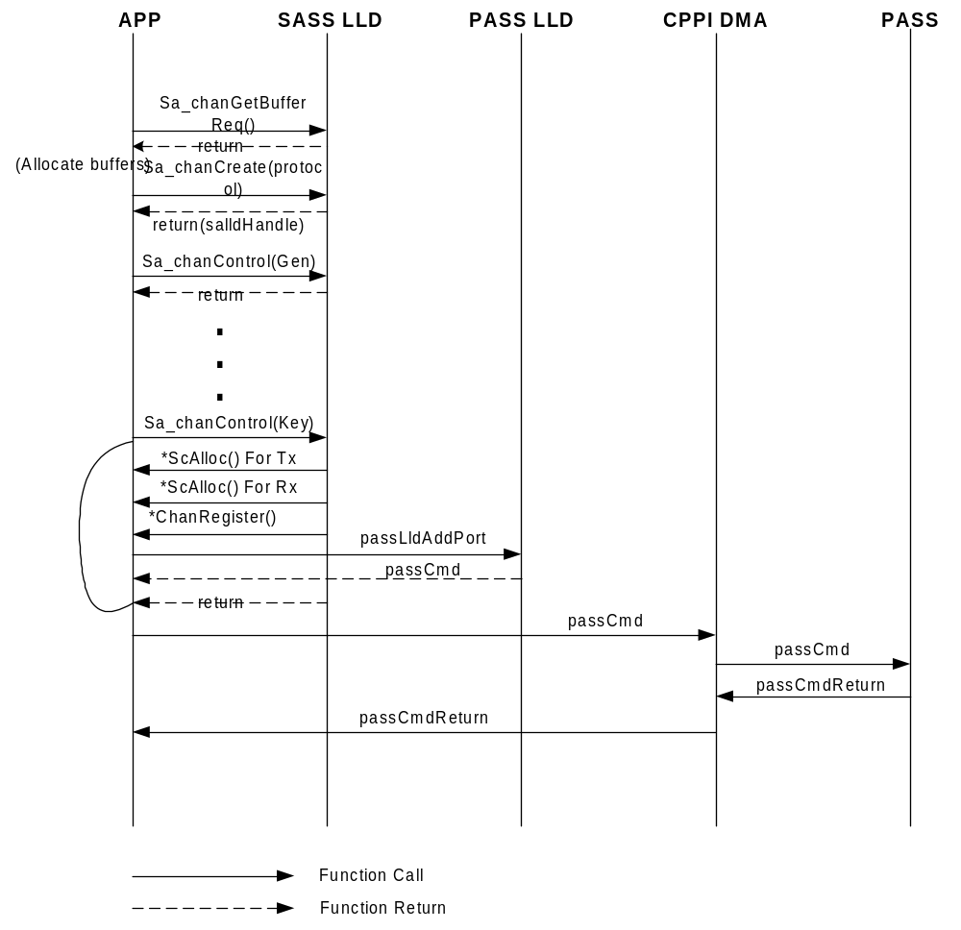
- SASS Channel Setup Call Flow

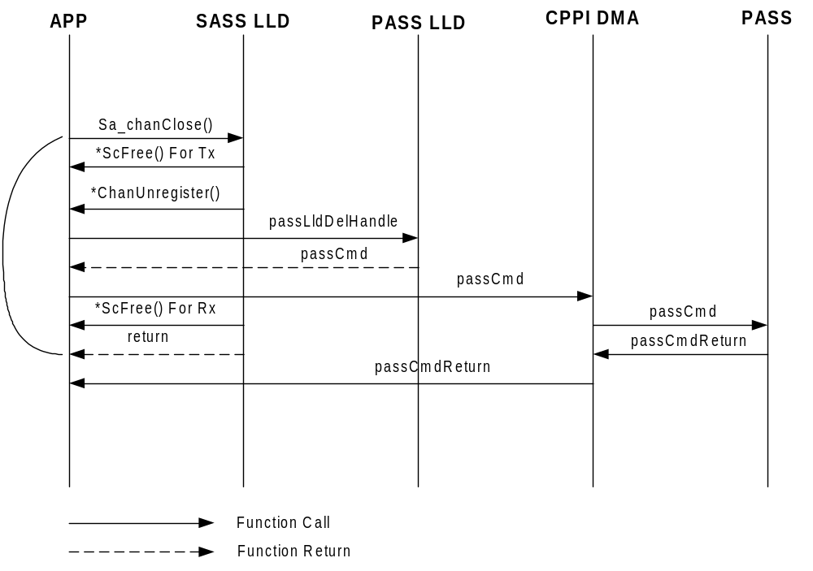
- SASS Channel Teardown Call Flow

Data Flow
The application shall call the Sa_chanSendData() API to perform protocol-specific packet pre-processing in the To-Network direction. It needs to call the Sa_chanSendData() API for each security protocol for the nested security packet. It then prepares and forwards the packet to SASS through the CPPI DMA. Figure 4 shows the typical transmit data flow for SRTP over IPSEC packets.
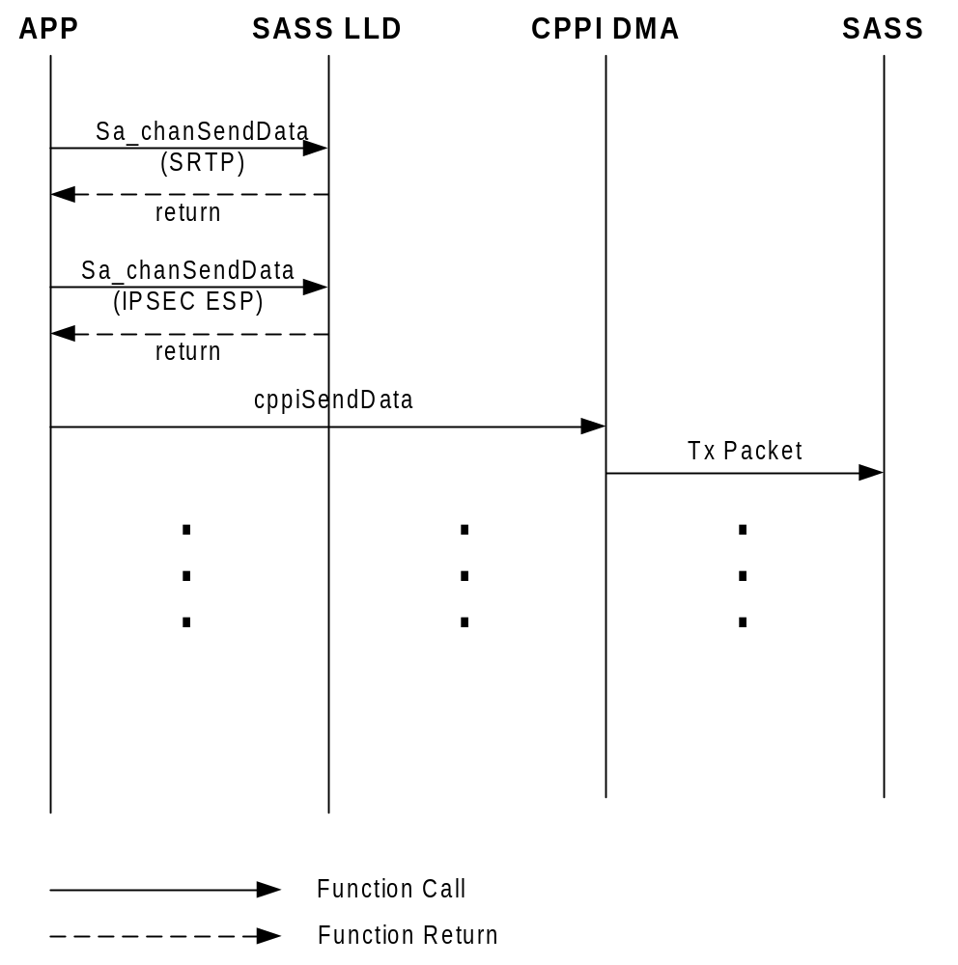

- SASS Tx Data Flow (SRTP over IPSEC ESP)

The application shall call the Sa_chanReceiveData() API to perform protocol-specific packet post-processing when it receives the packet from the CPPI DMA in the From-Network direction. It may need to call the Sa_chanReceiveData() API for each security protocol for the nested security packet. It then continues the packet processing. Figure 5 shows the typical receive data flow for SRTP over IPSEC packets.
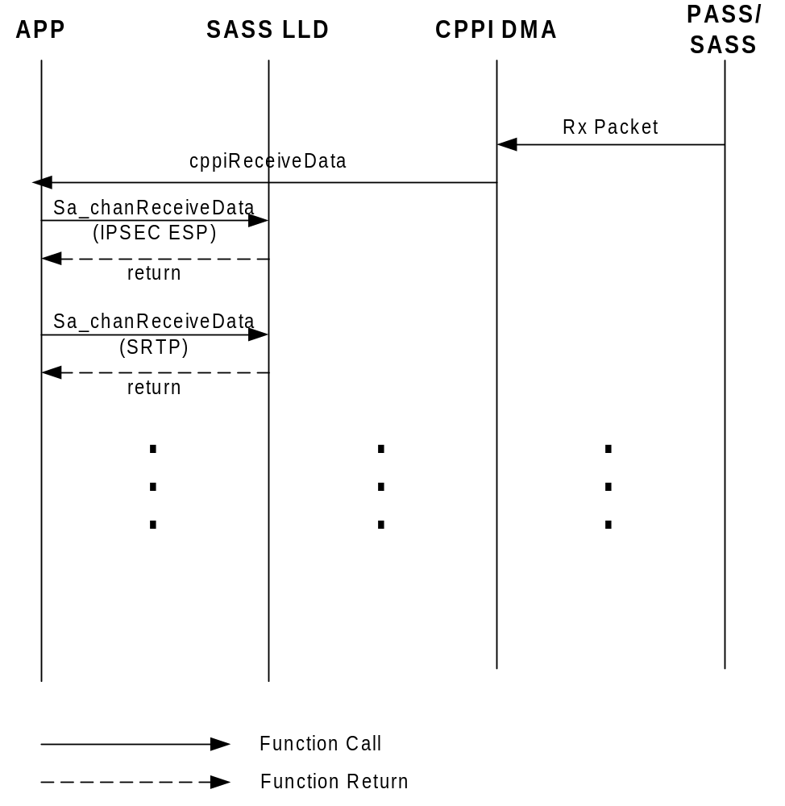

- SASS Rx Data Flow (SRTP over IPSEC ESP)

Testing Considerations
Provide high level testing plans/ideas that will be later expanded into unit test plan and integration/system test plan.

Refer to the unit test plan.

Future Extensions

Known Issues
Put action items to be completed or known limitations to the design.

Multi-core Channel Support
It will be desired to support SA LLD channel over multiple DSP cores. New API such as global channel registration will be provided to support this feature.

Potential Enhancements
Put ideas that could be used to enhance future versions of the IP block.

In TI VoIP DSP Architecture, the channel interface provides MSU-like APIs and functionalities.
In data mode, the user specifies the SASS operations and provides payload information for each packet. There is no protocol-specific packet header parsing performed at SASS.
The SW only mode is only applicable to SRTP and SRTCP.
The SW only mode is only applicable to SRTP and SRTCP.

