Tab 1

Bizophia

## Requirement definition

### Target

* + 1. Age group: High school to college students (relatively young)
    2. Interest level:
       1. Direct target: People who clearly want to become entrepreneurs.
       2. Indirect Target: People who become interested in the life of an entrepreneur and starting a business through the game.

### Concept

* + 1. Learn the skills necessary for starting a business while reliving the life of an entrepreneur.
    2. Experience challenges and failures in a safe environment while avoiding real risks.
    3. Cultivate the ability to have a vision as you progress through the game, and encourage growth in "shaping your own worldview."
  1. Elements to experience in the game:
     1. 1. Business idea creation: Users conduct market research and create their own ideas.
     2. 2. Fundraising: Options and negotiation experience such as VC, crowdfunding, and bank loans.
     3. 3. Team building: Build a team by gathering friends and referrals using SNS.
     4. 4. Product development and marketing: Selecting user groups, improving products, advertising and SNS strategies.
     5. 5. Market competition and growth strategy: A realistic strategy simulation in which you compete against competitors while expanding your market share.

### Learning Objectives

* + 1. Skills:
       1. Problem-finding and solving abilities
       2. Creativity
       3. Critical thinking
       4. Leadership
    2. Goals:
       1. Users can develop their own vision and the ability to realize it.

### Game mechanics

* + 1. Scenario-based:
       1. Progresses while following the story of an entrepreneur.
          1. Examples: "A high school student aims to start a business by developing an app" or "A university student launches a business that solves local issues."
       2. Ranking elements: Compete with players from all over the world.
       3. Pitch competition: An event held each season where users present the businesses they have created.
       4. DM function: A LinkedIn-style chat function for connecting with entrepreneurs and VCs.

### Technology

* + 1. Platform: Mainly smartphone apps.
    2. AI agent: A function that acts as an entrepreneurial consultant and advises on next steps and actions.
    3. Intuitive UI: Easy to understand even for children and beginners.

### Business Model

* + 1. Monetization:
       1. -Freemium Model: Free to play, but charge for advanced features and items.
       2. Carefully consider the advertising model.
    2. User Acquisition Strategy:
       1. Partner with schools and educational institutions.
       2. Partner with business schools and student groups.

### Content Design

* + 1. Mini-Games:
       1. Simulation of acquiring customers through sales.
       2. Role-play of fundraising negotiations.
    2. Challenges:
       1. Challenges based on real entrepreneur stories.
       2. Receive feedback and choose the next step.

### Competitive Analysis

* + 1. Research the features of existing entrepreneurship education apps.
    2. Differentiation Points:
    3. Fun as a game.
    4. Learning elements based on practice.

### Next steps

* + 1. 1. Create a simple prototype:
       1. First, create a mini-game to test which parts resonate with users.
    2. 2. User research:
       1. Interview the target demographic (high school and college students) and dig deeper into their interests and needs.
    3. 3. Competitive research:
       1. Analyze apps in the same genre and extract success factors and challenges.

## Screen Design_v02

* 1. Login/Signup Screen
     1. Purpose: A screen for users to log in or sign up for the app.
     2. Elements:
        1. Login button (Google only)
        2. Signup button
        3. Password reset link
        4. Language selection option (first-time signup)
     3. Functions:
        1. Log in with an existing account (Google only)
        2. Create a new account
        3. Select language
  2. 2. Home Screen
  3. Purpose: The main screen for users to start learning.
  4. Elements:
  5. User profile (level, BP, financial status, following/followers, streak)
  6. List of ongoing courses
  7. Daily quests (missions)
  8. Link to the shop (in-app store)
  9. Asset holdings
  10. Leaderboard (market capitalization ranking)
  11. Course selection (Telecommunications, Finance, Advertising, Manufacturing, Retail, Healthcare, Automotive, Education)
  12. Progress of each course (locked/unlocked)
  13. Executive Coach (AI agent)
  14. Functions:
  15. Select a course
  16. Check daily quests
  17. Display rankings
  18. Display office
  19. Track course progress
  20. Interact with the Executive Coach (AI agent)
  21. 3. Course Selection Screen
  22. Purpose: A screen for users to select the course they want to learn.
  23. Elements:
  24. Course list (Telecommunications, Finance, Advertising, Manufacturing, Retail, Healthcare, Automotive, Education)
  25. Description and goals of each course
  26. Course progress status
  27. Functions:
  28. Select a course
  29. View course details
  30. Check course progress
  31. 4. Stage Selection Screen
  32. Purpose: A screen for users to select a stage based on investment rounds.
  33. Elements:
  34. Stage list (Seed, Early, Middle, Later)
  35. Description and goals of each stage
  36. Stage progress status
  37. Functions:
  38. Select a stage
  39. View stage details
  40. Check stage progress
  41. 5. Unit Selection Screen
  42. Purpose: A screen for users to select a unit within a stage.
  43. Elements:
  44. Unit list (multiple units within each stage)
  45. Description and goals of each unit
  46. Unit progress status
  47. Functions:
  48. Select a unit
  49. View unit details
  50. Check unit progress
  51. 6. Lesson Screen
  52. Purpose: The screen where users engage in learning.
  53. Elements:
  54. Problem display area (text, image)
  55. Answer options (choices, input field)
  56. Hint button
  57. Progress bar
  58. Executive Coach (AI agent) advice
  59. Functions:
  60. Display and answer questions
  61. Provide hints
  62. Give feedback on correct/incorrect answers
  63. Offer advice from the Executive Coach (AI agent)
  64. 7. Results Screen
  65. Purpose: A screen that displays results after completing a lesson.
  66. Elements:
  67. Score (BP earned)
  68. Correct answer rate
  69. Option to review incorrect answers
  70. Button for the next lesson
  71. Feedback from the Executive Coach (AI agent)
  72. Functions:
  73. Display results
  74. Provide review functionality
  75. Transition to the next lesson
  76. Offer feedback from the Executive Coach (AI agent)
  77. 8. Streak Screen
  78. Purpose: A screen that displays the user’s continuous learning streak.
  79. Elements:
  80. Current streak days
  81. Reminder settings for maintaining the streak
  82. Past streak records
  83. Functions:
  84. Display streak
  85. Set reminders
  86. 9. Shop Screen (BP Store)
  87. Purpose: A screen where users can purchase items using in-app currency (BP).
  88. Elements:
  89. In-app currency (BP) balance
  90. Purchasable items (e.g., office items, BP boosters)
  91. Special offers (paid plans and bundles)
  92. Functions:
  93. Purchase items
  94. Announce paid plans
  95. 10. Leaderboard Screen
  96. Purpose: A screen that displays user rankings to boost motivation.
  97. Elements:
  98. User’s current rank
  99. List of top users
  100. Tips for ranking up
  101. Functions:
  102. Display rankings
  103. Promote ranking up
  104. 11. Profile Screen
  105. Purpose: A screen to manage the user’s learning status and settings.
  106. Elements:
  107. User information (name, user ID, icon, following/followers)
  108. Learning statistics (total BP, total streak, learning time)
  109. Settings (notifications, language, account)
  110. Functions:
  111. Edit profile
  112. Check learning statistics
  113. Change settings
  114. 12. Notification Screen
  115. Purpose: A screen to notify users of reminders and updates.
  116. Elements:
  117. List of unread notifications
  118. Notification types (streak reminders, event information)
  119. Functions:
  120. Display notifications
  121. Manage notification settings
  122. 13. Settings Screen
  123. Purpose: A screen for changing app settings.
  124. Elements:
  125. Notification settings
  126. Language settings
  127. Account settings
  128. Help and support
  129. Functions:
  130. Change various settings
  131. Access support
  132. 14. UI/UX Design Key Points
  133. Simple and Intuitive Design:
  134. Standardize icon and button layouts for intuitive operation.
  135. Gamification:
  136. Use elements like BP, streaks, and leaderboards to encourage continuous learning.
  137. Immediate Feedback:
  138. Provide instant feedback on correct/incorrect answers during lessons to enhance learning effectiveness.
  139. Personalization:
  140. Offer lessons and missions tailored to the user’s learning progress.
  141. Accessibility:
  142. Allow adjustable font sizes and color settings to accommodate a wide range of users.
  143. 15. Course, Stage, and Unit Structure
  144. Course Selection:
  145. Users choose from courses like Telecommunications, Finance, Advertising, Manufacturing, Retail, Healthcare, Automotive, and Education.
  146. Stages:
  147. Each course is divided into stages based on investment rounds: Seed, Early, Middle, and Later.
  148. Units:
  149. Each stage contains multiple units, with lessons mixing categories like Management, Sales, Marketing, Finance, and Technology.
  150. Example: A unit in the Seed stage might combine Management and Finance challenges.
  151. Progress:
  152. Users progress through one course at a time, unlocking units sequentially within each stage.
  153. 16. Executive Coach (AI Agent)
  154. Role:
  155. Provide advice based on the user’s learning progress.
  156. Offer feedback during lessons and on the results screen.
  157. Motivate users with encouragement and hints.

## Screen Design_v01

### Login/Signup Screen

* + 1. Purpose: A screen for users to log in or sign up for the app.
    2. Elements:
       1. Login button (email, Google, LinkedIn)
       2. Sign up button
       3. Password reset link
       4. Language selection option (first time sign up)
    3. Functions:
       1. Log in with existing account
       2. Create new account
       3. Language selection

### Home Screen

* + 1. Purpose: The main screen for users to start learning.
    2. Elements:
       1. User profile (level, BP, financial statements, following/followers, streak)
       2. List of courses in progress
       3. Daily quests (missions)
       4. Link to shop (Apple store)
       5. Asset holdings
       6. Leaderboard (market capitalization ranking)
       7. Lesson categories (e.g. basics, phrases, travel)
       8. Progress of each lesson (locked/unlocked)
       9. Executive coach (AI management agent)
    3. Functions:
       1. Course selection
       2. Check daily quests
       3. Display rankings
       4. Display office
       5. Lesson selection
       6. Check progress
       7. Display coaching voice chat (log is displayed after completion)

### Lesson screen

* + 1. Purpose: The screen where users actually learn about business.
    2. Elements:
       1. Problem display area (text, image)
       2. Answer options (choices, input field)
       3. Hint button
       4. Progress bar
    3. Functions:
       1. Display and answer questions
       2. Provide hints
       3. Feedback on correct/incorrect answers

### Result screen

* + 1. Purpose: A screen that displays the results after the lesson is completed.
    2. Elements:
       1. Score (BP acquired)
       2. Correct answer rate
       3. Option to review questions that were incorrect
       4. Button for next lesson
    3. Functions:
       1. Display results
       2. Provide review function
       3. Transition to next lesson

### Streak screen

* + 1. Purpose: A screen that displays the user's continuous learning record (streak).
    2. Elements:
    3. Current streak days
       1. Reminder settings for maintaining streak
       2. Record past streaks
    4. Functions:
       1. Display streak
       2. Reminder settings

### Shop screen (BP store)

* + 1. Purpose: A screen where users can purchase items using in-app currency (BP).
    2. Elements:
       1. In-app currency (BP) balance
       2. Purchasable items (e.g. office items, BP increase items)
       3. Special offers (paid plans and bundles)
    3. Functions:
       1. Purchase items
       2. Announcement of paid plans

### Leaderboard screen

* + 1. Purpose: A screen that displays the user's ranking and increases motivation.
    2. Elements:
       1. Current rank of user
       2. List of top users
       3. Tips for ranking up
    3. Function:
       1. Display ranking
       2. Promote ranking up

### Profile Screen

* + 1. Purpose: A screen to manage user's learning status and settings.
    2. Elements:
       1. User information (name, user ID, icon, following/followers)
       2. Learning statistics (total BP, total streak, learning time)
       3. Settings (notifications, language, account)
    3. Function:
       1. Edit profile
       2. Check learning statistics
       3. Change settings

### Notification Screen

* + 1. Purpose: A screen to notify users of reminders and updates.
    2. Elements:
       1. Unread notification list
       2. Notification type (streak reminder, event information)
    3. Functions:
       1. Display notifications
       2. Manage notification settings

### Settings screen

* + 1. Purpose: A screen for changing app settings.
    2. Elements:
       1. Notification settings
       2. Language settings
       3. Account settings
       4. Help and support
    3. Functions:
       1. Changing various settings
       2. Access to support

### Key points for UI/UX design

* + 1. Simple and intuitive design:
       1. Standardize the layout of icons and buttons to make operation intuitive.
    2. Gamification:
       1. Use elements such as BP, streaks, and leaderboards to promote continuous learning.
    3. Immediate feedback:
       1. Provide immediate feedback on correct/incorrect answers during lessons to improve learning effectiveness.
    4. Personalization:
       1. Provide lessons and missions according to the user's learning situation.
    5. Accessibility:
       1. Adjustable font size and color settings to accommodate a wide range of users.

## Reference

### Image

* + 1. UI/UX：[Duolingo](https://www.duolingo.com/)
       1. I want to design a UX that is simple enough that even elementary school students can enjoy it.
       2. 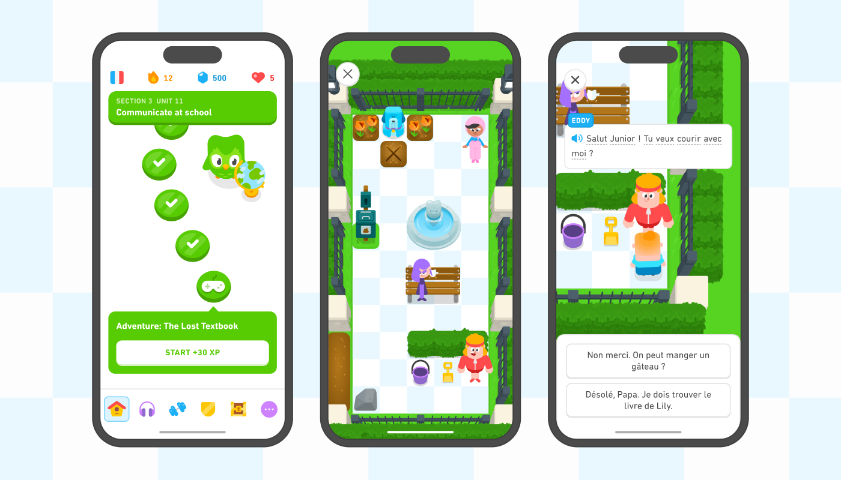  
          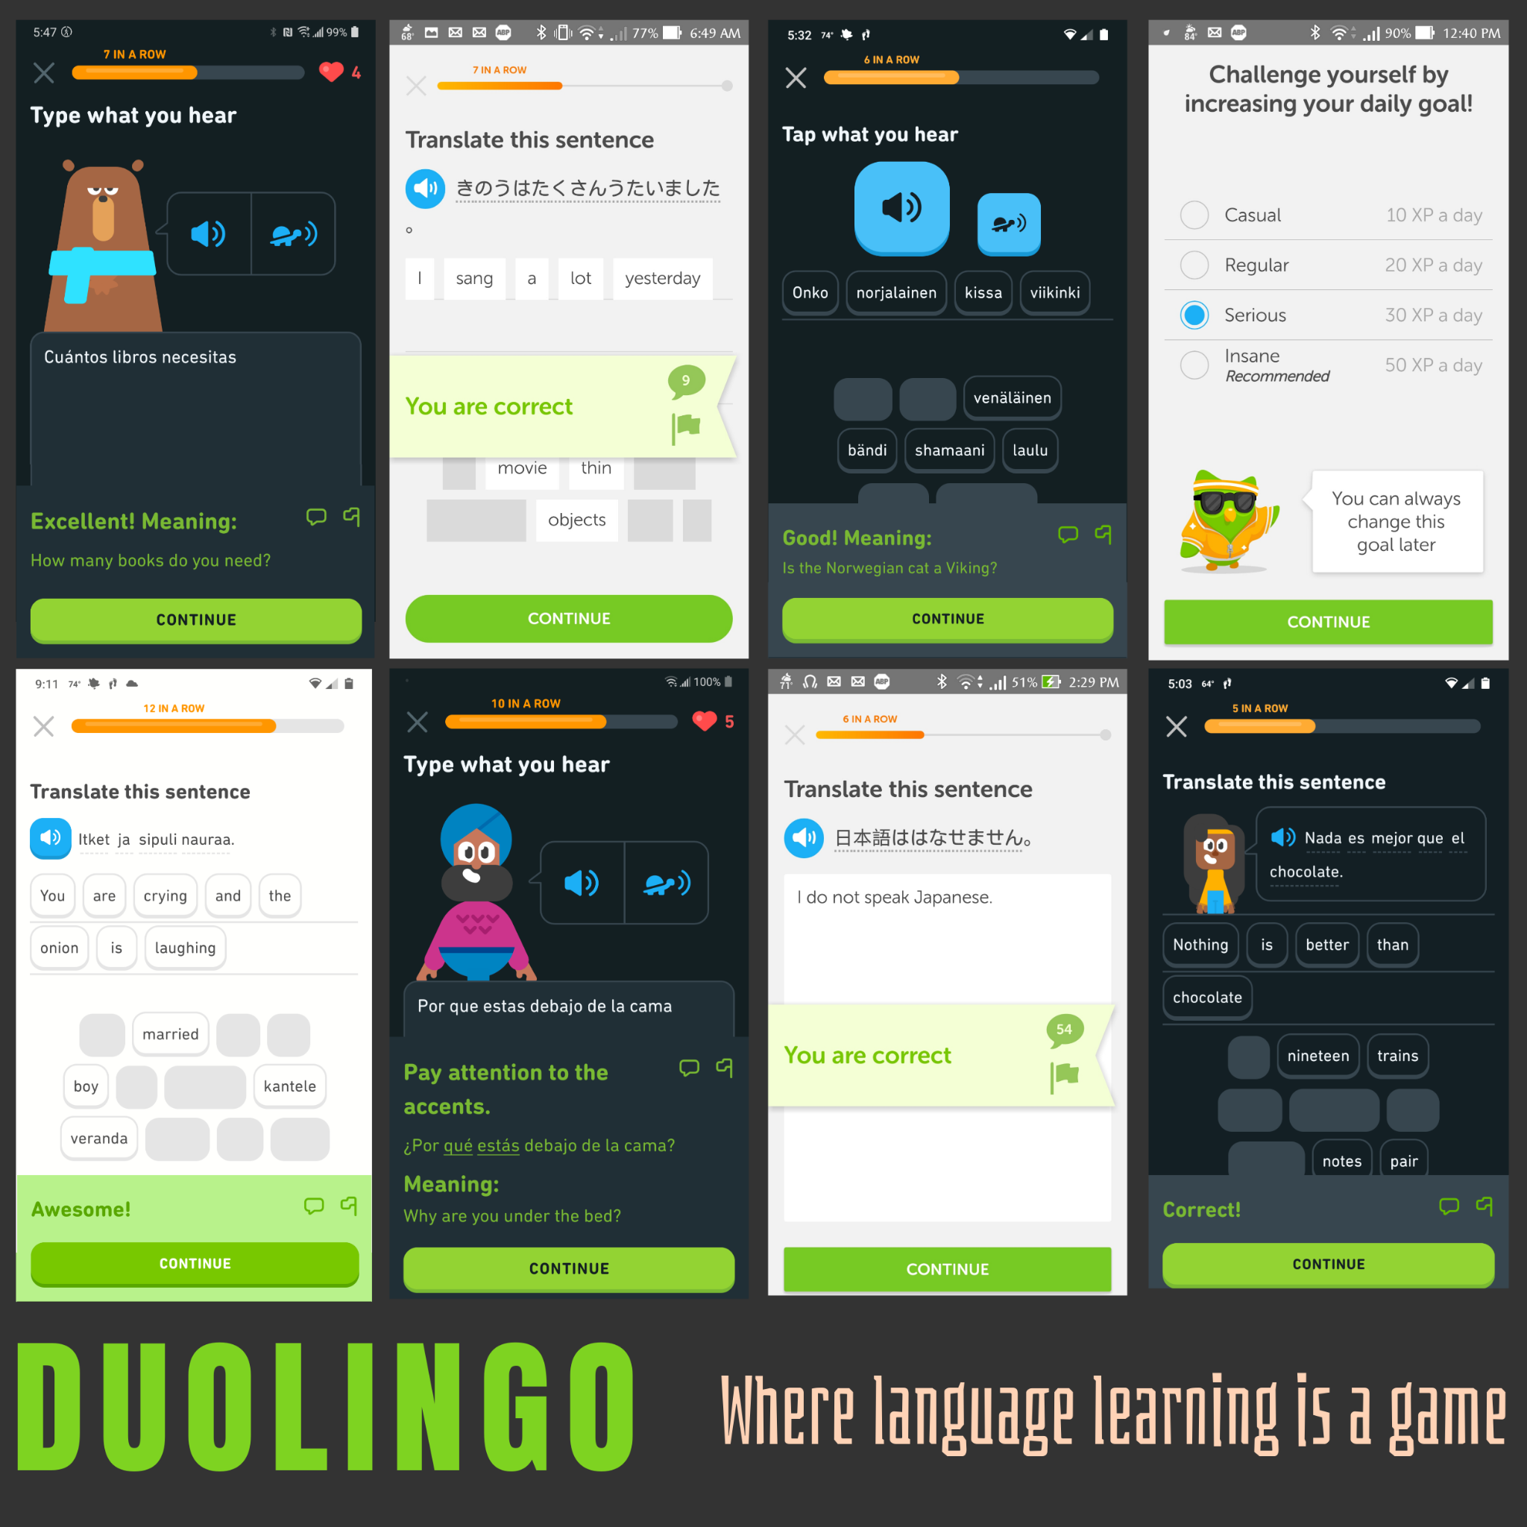
    2. Strategy：duolingo
    3. GamiFi：[let me speak](https://letmespeak.org/)
       1. 