Logic Documentation

Project Objective

To find the fastest route for the Annual Luke Foundation for the Poor Biathlon.

Program Overview

We started by taking the user input and storing them in an array of objects. Then using Floyds algorithm, it looks at all the possible routes and finds the quickest one. After the quickest route has been generated it shows the user which route it is, how long it takes and whether the person was running or biking.

Floyd’s Algorithm

To find the fastest route program, we implemented Floyds algorithm.

Floyd’s algorithm operates on the array A of the graph. A pseudocode description of the algorithm is:

set the value of k to 0

while (k <= n – 1) do

set the value of i to 0

while (i <= n – 1) do

set the value of j to 0

while (j <= n – 1) do

if A[i, k] + A[k, j] < A[i, j]

A[i, j] = A[i, k] + A[k, j]

end of the j-loop

end of the i-loop

end of the k-loop

We built the internal array (timeSpent) to keep a possible route as Floyd’s algorithm like below.

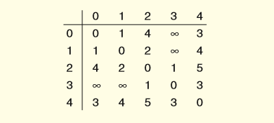

Then the program re-calculates the route using the time of the current fastest route. The final result is stored in the array fastestRoute array, but we only need the first row to display from the start to finish.

Program Example:

Input

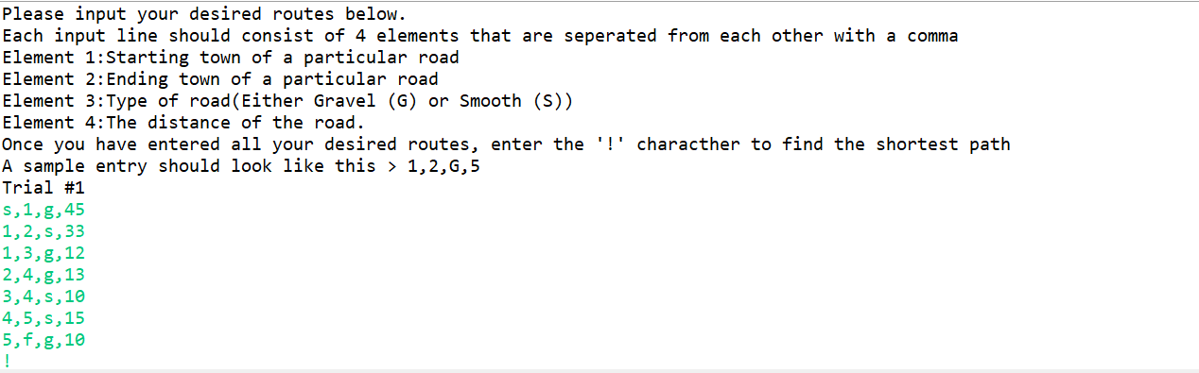

Output

