Name: ____Tailang CAO___

Q1 | The main file is executing file01 and file02, which are each 4kb big, and too small. The runtime is thus too short to be recorded with two decimal numbers.
Q2 | 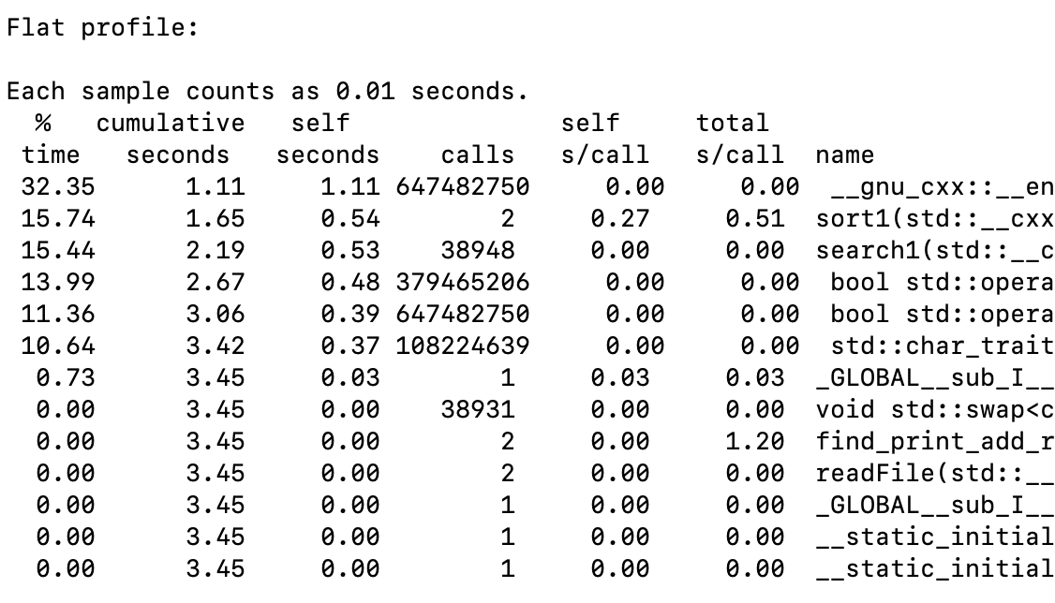  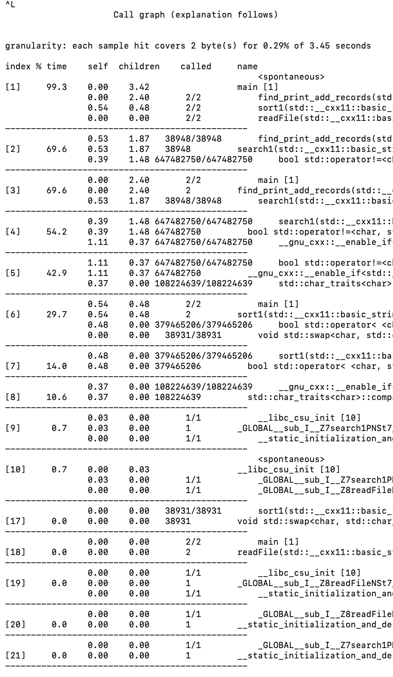
Q3 | __gnu_cxx::__enable_if<std::__is_char<char>::__value, bool>::__type std::operator==<char>(std::__cxx11::basic_string<char,$  Consuming 32.35% of time
Q4 | The same one as the one consuming the most time.  __gnu_cxx::__enable_if<std::__is_char<char>::__value, bool>::__type std::operator==<char>(std::__cxx11::basic_string<char,$
Q5 | Search1 uses 0.53 seconds per call, total call time is 0 second.  This might be because search1 itself consumes a significant runtime, but the functions search1 calls do not contribute significantly to the overall execution time.
Q6 | Self seconds per call: 0.00 seconds  Total seconds per call: 0.60 seconds  This implies that the majority of the time spent in find_print_add_records is due to the functions it calls rather than its own code.
Q7 | The total time was 2.40 seconds contributing from the find_print_add_records  child function.
Q10

Q8:
Optimization Level | Total execution time
O0 (default) | 3.28 sec
O1 | 2.87 sec
O2 | 1.93 sec
O3 | 1.62 sec

Q9:
Optimization level | Search1 | Sort1
O1 | 69.7% | 27.4%
O2 | 57.2% | 45.32%
O3 | 49.1% | 49.3%

Q11:
Sort function | Search function | Total execution time
Sort1 | Search1 | 3.42 sec
Sort2 | Search1 | 4.58 sec
Sort3 | Search1 | 2.47 sec
Sort1 | Search2 | 0.83 sec
Sort2 | Search2 | 2.76 sec
Sort3 | Search2 | 0.01 sec

Q12:
Sort3 Search2 has the best performance fin terms of execution time

Q13:
(3.42 - 0.01)/3.42 = 99% program enhancement percentage.

