**Name - YASH TAILOR**

**DEPT - JAVA**

**MENTOR - YASH FOFDIYA**

**GIT ASSIGNMENT - 3**

**Problem Definition**

- create a branch from the master and made some changes

- Commit code in a branch.

Step - 1 : Created index.html and commit

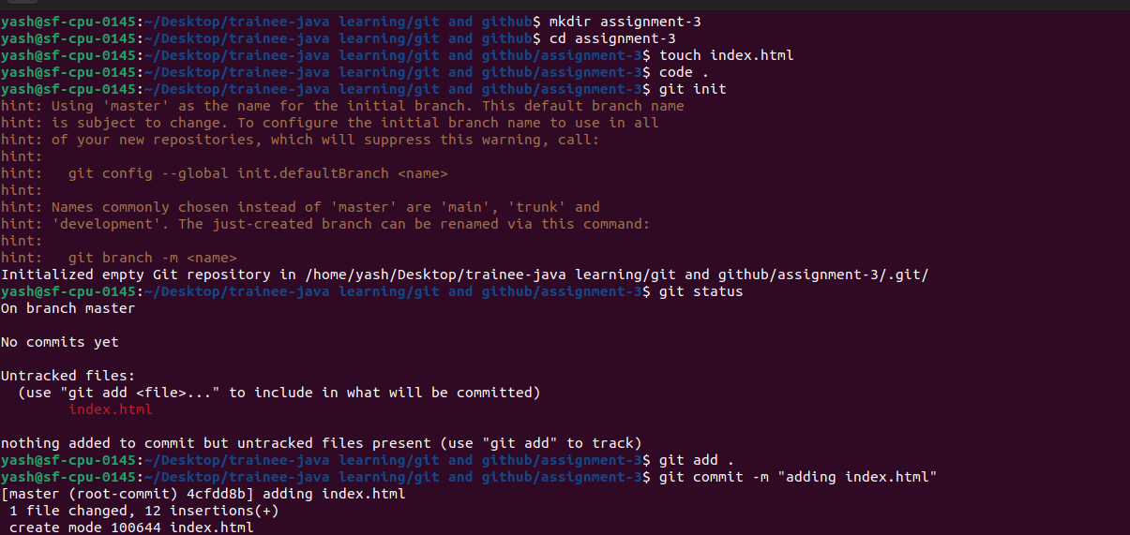

Step - 2 : creating assignment3_dev branch and commit changes

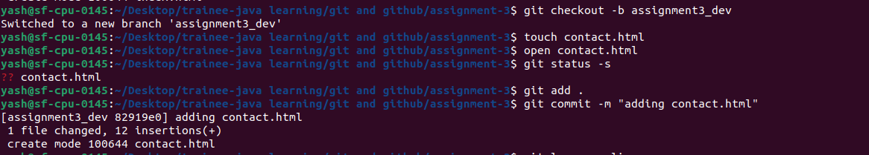

- Revert recently committed code

-- Before and After log of commits

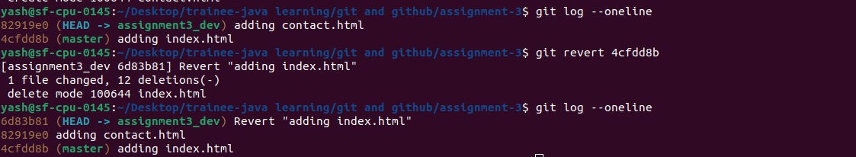

**GITHUB REPO LINK - <https://github.com/tailoryash/GIT-assignment-3>**