**Name - TAILOR YASH**

**DEPT - JAVA**

**MENTOR - YASH FOFDIYA**

**GIT ASSIGNMENT - 2**

**Problem Definition**

- Create a branch from the master branch and make changes and commit changes

Step - 1 : Initializing Assignment-2 folder, adding and commiting main.java

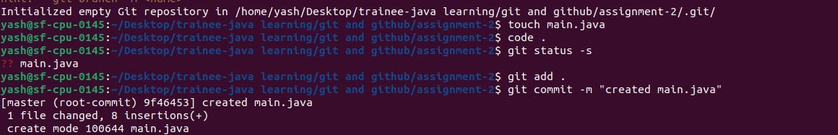

Step - 2 : Creating new branch assignment2_dev and Commit changes

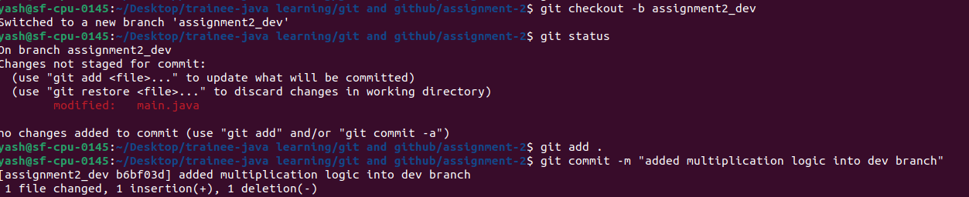

Step - 3 : Push Code from Master branch into remote repo

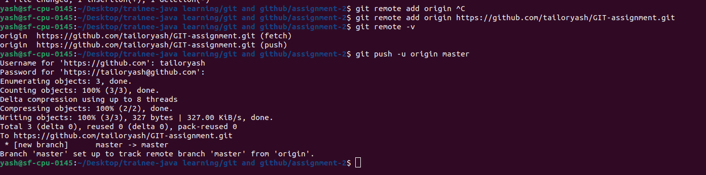

Step - 4 : Pushed Code

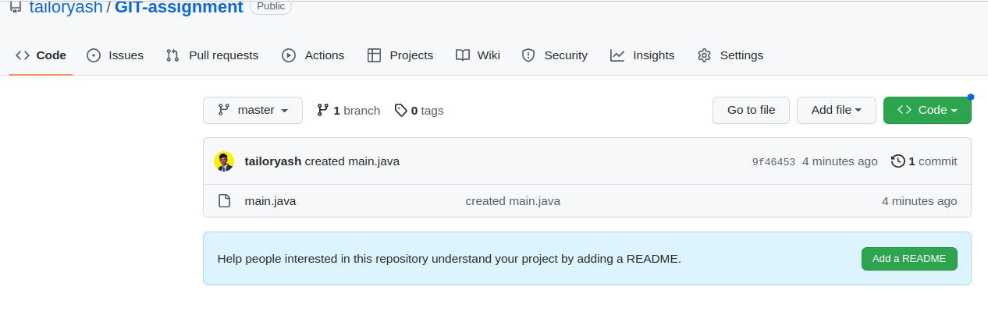

- Create a pull request for the first branch and merge it to the master.

Step - 1 : Pushing code of Assignment2_dev branch into remote repo

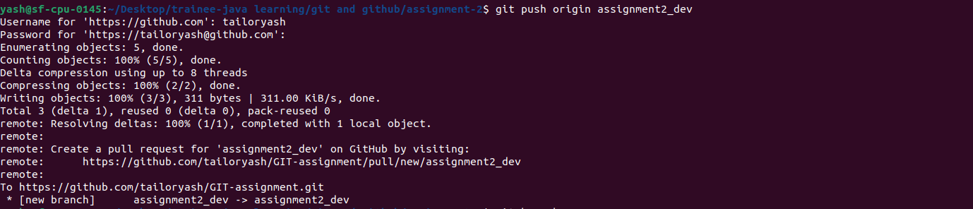

Step - 2 : Pushed Code

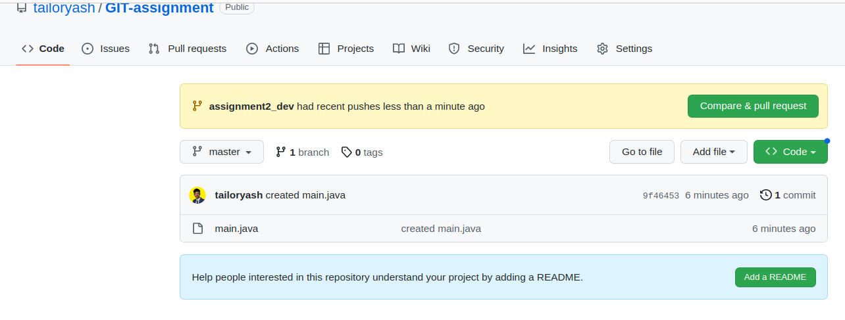

Step - 3 : Open a Pull Request

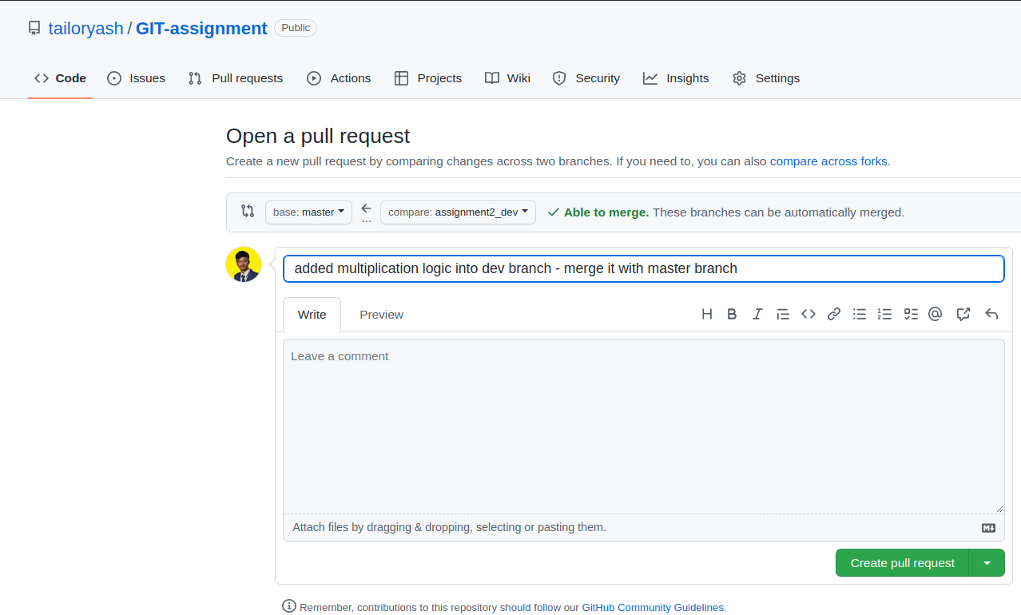

Step - 4 : Requested PR

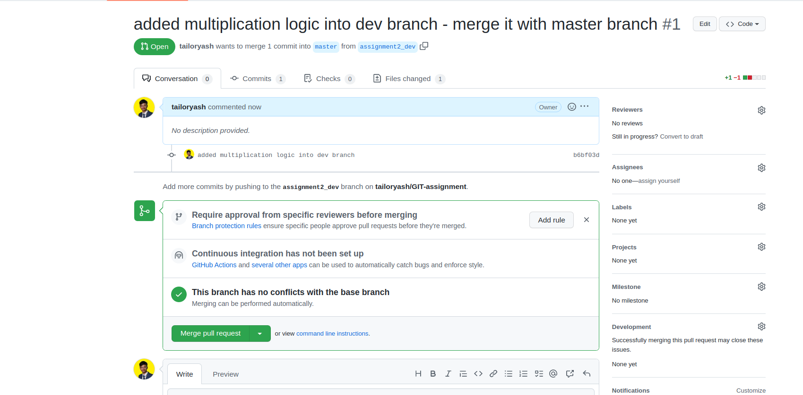

Step - 5: Merge it with Master branch

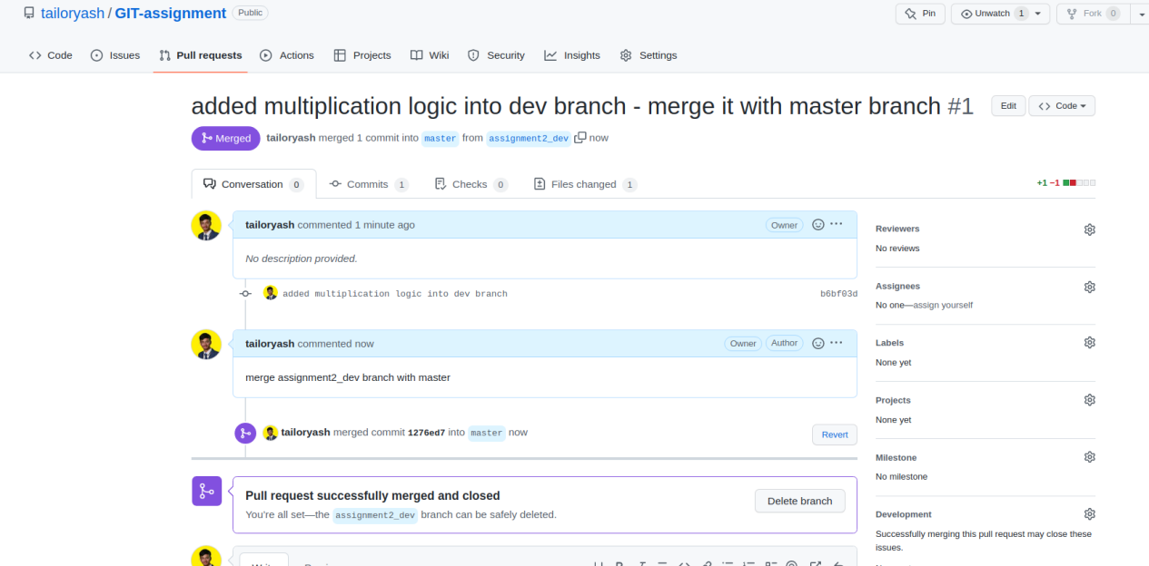

- Create a new branch from the master.

10

- Rebase the second branch with the master branch and make changes in the second branch and commit changes

Step - 1 : Few changes in Second branch and commit

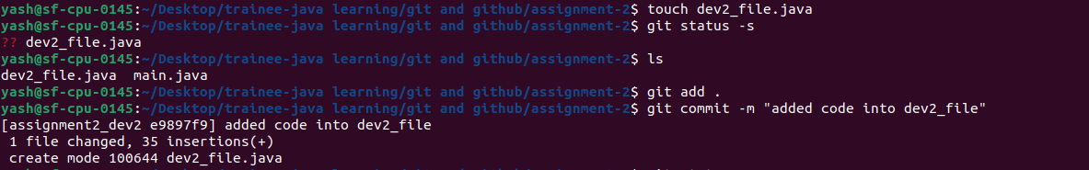

Step - 2 : Log before rebase



Step - 3 : Resolved Conflicts and Log after rebase

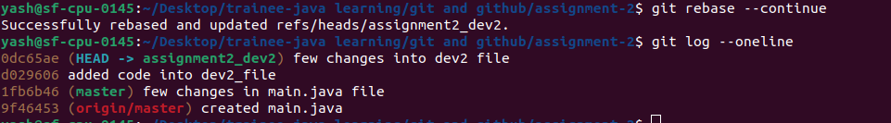

**GITHUB REPO LINK -**

**<https://github.com/tailoryash/GIT-assignment-2>**