**ONLINE BIDDING SYSTEM**

Semester - VIII

### AN INTERNSHIP REPORT

***Submitted by***

## YASH TAILOR

### 190770107282

***In fulfillment for the award of the degree of***

# BACHELOR OF ENGINEERING

***in***

**Computer Engineering**

**Silver Oak College of Engineering & Technology , Ahmedabad**





## Gujarat Technological University, Ahmedabad April, 2023

 

## **Silver Oak College of Engineering & Technology**, Ahmedabad

CERTIFICATE

This is to certify that the Internship/Project entitled **Online Bidding System** has been carried out by Enroll No: **190770107282** Name: **YASH TAILOR** for subject: **Internship (3180701**) under my guidance in partial fulfilment of the degree of Bachelor of Engineering in Information Technology , 8th Semester of Gujarat Technological University, Ahmadabad during the academic year 2022-23.

Prof. Digant Kumar Parmar Dr. Satvik Khara

Internal Guide Head of Department

#### Simform Software LLP

5th floor. Bsquare 2,

**Nr. Ooubfetree Hotel.**

lscon-BopaJRoad, Ahmedabad-380058

**Gujarat, India**

LLP Identification Number: AAT-1120

**+91 (79)40070170**

**[hcllo@simform.com](mailto:hcllo@simform.com) [www.simform.com](http://www.simform.com/)**

**Date: 27th April 2022**

#### CERTIFICATE OF INTERNSHIP

This is to certify that **Dhruv Patel** a student of **BE(IT), L.D. COLLEGE OF ENGINEERING.** He **has successfully completed his Internship** In **JAVA from 3rd January 2022 to 25"' April 2022.** Duling his internship. he has demonstrated his skills with self-motivation to learn new skills and his performance exceeded the company's expectations.

We at Simform wish him the best and success in his life andcareer.

**Authorized Signatory**



**Nikita Trivedi**

Senior Manager- Human Resource



 

## **Silver Oak College of Engineering & Technology**, Ahmedabad

DECLARATION

We hereby declare that the Internship / Project report submitted along with the Internship / Project entitled **Online Bidding System** submitted in partial fulfillment for the degree of Bachelor of Engineering in **Computer Engineering** to Gujarat Technological University, Ahmedabad, is a bonafide record of original project work carried out by me / us at **Silver Oak College of Engineering & Technology** under the supervision of **Prof. Digant Kumar Parmar** and that no part of this report has been directly copied from any students’s reports or taken from any other source, without providing due reference.

Name of the Student Sign of Student

YASH TAILOR

# ACKNOWLEDGEMENT

With great pleasure, I take this opportunity to express my deep sense of gratitude and indebtedness to my renowned and esteemed guide **Prof. Digant Kumar Parmar** Assistant Professor, Department of Computer Engineering, Silver Oak College of Engineering & Technology, Ahmedabad for his consummate knowledge, due criticism, invaluable guidance and encouragement which has enabled us to give present shape to this work.

I am heavily indebted to HOD **Dr. Satvik Khara**, Professor& Head, Department of Computer Engineering, Silver Oak College of Engineering & Technology, Ahmedabad, for his everlasting willingness to extend his profound knowledge and experience in the preparation of this report. Any attempt to define this indebtedness would be incomplete.

I sincerely thank to **Mr. Yash Fofidya, Software Engineer at Simform** for giving me great help to undergo training, always looking to provide great help to trainees in any case, motivating them to do something extraordinary.

I express my deep sense of gratitude and indebtedness to my mentors for their effective guidance and constant encouragement throughout the period of training.

Finally, I would like to thank our friends and family for their support and patience, and other faculty member of the department for his everlasting willingness to extend his support and help in the completion of this work. Especially to our parents who without their encouragement and financial support, this would not have been possible.

Yours Sincerely,

YASH TAILOR

(190770107282)

# ABSTRACT

**“Online Bidding System”** is a web-based application which will help users to buy or sell item; they can trade anything they want by posting ad. This application will allow users to post their products for auction; bidder can register and can bid for any available product.

An online auction is an auction which is held over the internet. It is a popular method for buying and selling products and services. Online Auction System s helps to customer to sell and buy product in best price. It is developed with the objective of making the system reliable, easier and fast.

This application is used to sell the anything on the website from house. It developed with the objective of making the system reliable, easier and fast. The application is made as simple as surfing a website. There by non-technical persons can also interact with the processing on the application easily.

## List of Figures

Figure 3-1 Gantt chart 6

Figure 5-1 Incremental Design 10

Figure 5-2 Database Relationship 11

Figure 7-1 Screenshots of Working Project 17

## List Of Tables

Table 1 Test Cases 13

**List of Abbreviations**

|  |
| --- |
| API : Application programming interface |
| DB : Database |
| etc : Et cetera |
| JDK : Java Development Kit |
| RAM : Random-access memory |
| SAAS : Software as a service |
| UML : Unified Modeling Language |
| UI - User Interface |
| SRS - Software Requirements Specification |

# TABLE OF CONTENTS

ACKNOWLEDGEMENT… I

ABSTRACT… II

LIST OF FIGURES III

LIST OF TABLES… III

LIST OF ABBREVIATIONS ,,,,,,,III

TABLE OF CONTENTS IV

1. OVERVIEW OF THE COMPANY 1
   1. HISTORY… 1
   2. DIFFERENT PRODUCT / SCOPE OF WORK… 1
2. OVERVIEW OF DIFFERENT DEPARTMENT… 2
   1. DETAILS ABOUT THE WORK BEING CARRIED OUT IN EACH DEPARTMENT 2
   2. TECHNICAL SPECIFICATIONS OF MAJOR EQUIPMENT USED IN

EACH DEPARTMENT 2

1. INTERNSHIP MANAGEMENT… 3
   1. INTERNSHIP SUMMARY… 3
   2. PURPOSE… 3
   3. OBJECTIVE 3
   4. SCOPE… 4
   5. TECHNOLOGY AND LITERATURE REVIEW 4
      1. Spring Framework… 4
      2. What is Spring Framework? 4
      3. How does it work? 4
   6. INTERNSHIP PLANNING… 6
      1. Roles and Responsibilities… 6
      2. Group Dependencies… 6
   7. INTERNSHIP SCHEDULING 6
2. SYSTEM ANALYSIS 7
   1. STUDY OF CURRENT SYSTEM… 7
   2. PROBLEM AND WEAKNESS OF CURRENT SYSTEM… 7
   3. REQUIREMENT ANALYSIS OF NEW SYSTEM… 7
   4. SYSTEM FEASIBILITY… 7
   5. PROCESS IN NEW SYSTEM… 8
   6. FEATURES OF NEW SYSTEM… 8
   7. PROCESS OF PROPOSED SYSTEM 8
   8. SELECTION OF SOFTWARE… 9
3. SYSTEM DESIGN 10
   1. SYSTEM DESIGN & METHODOLOGY 10
   2. DATABASE DESIGN 11
4. IMPLEMENTATION… 12
   1. IMPLEMENTATION ENVIRONMENT 12
   2. PROCESS/MODULE SPECIFICATION 12
5. TESTING… 13
   1. TESTING STRATEGY 13
   2. TEST RESULTS AND ANALYSIS 13
   3. SCREENSHOTS 15
6. CONCLUSION AND DISCUSSION… 18
   1. OVERALL ANALYSIS OF INTERNSHIP 18
   2. DATES OF CONTINUOUS EVALUATION 18
   3. SUMMARY OF INTERNSHIP 18
7. REFERENCE 19
8. ANNEXURE 1 20
9. ANNEXURE 1 52

220538

Company Overview

# CHAPTERS

## Overview of the Company

### History

Simform is a new age software development company. Build innovative custom software applications by hiring remote engineering teams that extend your team.

We are a software development company with proven experience in providing services that range from customized development to complete control on maintenance and support. Stay ahead of your competition by tapping into our technical proficiency in software development techniques.

Our experts help you build cloud-native applications that are high in software performance, flexibility, and extensibility. Whether you want to migrate to a microservices architecture, modularize existing monolithic patterns or exploit cloud environments to the maximum potential, our pool of software architects has got you covered.

Upgrade, revamp, migrate or extend your software as you envision without deviating from necessary incremental development. Our software developers not only condense architecture design and write advanced codes, but they also have hands-on experience to track progress, measure results, and optimize processes. As a result, you get the best of both worlds- operations and development.

### Different product / scope of work

* Software Development Services
* DevOps Services
* Cloud Development Services
* Software Testing Services

220538

Department Overview

## Overview of different department

* The detailed technical consultation includes things like challenges of the project, what tech-stack to use to solve those challenges. A detailed hiring plan is also part of this consultation and includes details on what skill set and experience your team need to have.
* Project’s execution roadmap brings all the pieces together to show how your project will come to life. Based on your project goals we help you define processes and delivery roadmap that suits your needs.
* Tech architecture solution includes things like how features will be implemented with what technology and framework. It will also include things like algorithms and cloud integrations will be required to build your IP and build the tech engine.
* This tech consultation and talent skillset specification are provided for free so even if you don't work with us, you can take it forward and use it in the future.

### Details about the work being carried out in each department

* **HR department**: Human resources is in charge of arranging interviews, coordinating hiring efforts, and on-boarding new employees.
* **Marketing Team**: Conducting campaign management for marketing initiatives, Creating content providing search engine optimization for company website. Defining and managing company brand.
* **Development Team**: Building Projects as per client’s requirements is their main purpose This team includes Java team, Python team, Node team etc. I am part of Java team.
* **Customer Care**: address customer issues and resolve them in a timely and efficient manner. Support reps interact with customers on a variety of channels such as phone, email, and social media, and ensure that all valid customer concerns are being dealt with immediately.

### Technical specifications of major equipment used in each department

Personal Computer

* Intel core i3 11th generation
* 8 GB Graphics
* 16 GB RAM
* 256 GB SSD
* Windows 10

220538

Internship Management

## Internship Management

### Internship Summary

I began my internship with Simform in February 2023. I found motivation in my daily commutes through an incredible work environment. The employees were immensely friendly, supporting, customer-service oriented, caring, and honest. It was an opportunity for me to prove myself as a reputable employee, a reliable coworker, and a motivated student. It was also an opportunity to gain the critical office experience I had not received through my past work experience.

One of the most valuable skills I developed was my versatility. In companies it is common to work across various Technology and that was exactly what I did. Over the duration of my internship, I had worked on a product which is an Online Bidding Platform.

I earned an increasing amount of responsibility as I accomplished more tasks and was always happy to receive new work. The support and direct feedback that I received was more than enough to make me feel comfortable. I am greatly humbled and thankful for all of my coworkers at Simform for providing me with the ability to develop personally and professionally.

### Purpose

It is an excellent learning curve for me while meeting new people and making connections in the professional world. In today’s job market, passing exams with high scores and getting a degree doesn’t offer the much- needed work experience, you will need to succeed in a workspace. In an internship, you will be able to gain real-life exposure, grow your knowledge and determine if you are in the right career field.

### Objective

The main objective is to develop an online auction system which will provide a forum for sellers to meet and interact with buyers, and sell items to interested bidders.

The Objective of this project is to improve the auction system as well as increase its reach to global level. This project address major problems faced by the offsite bidders and assets owner like finding good buyer or acquiring exotic items.

Its Objective is to invite potential buyers to bid on item from any corner and help buyers and auction houses to take their items and auctions to global level by providing on demand software operator to deploy the bidding process on the internet.

220538

Internship Management

### Scope

Using this online auction management system, bidders will be able to get connected to the specific sellers who will offer them necessary information and or give hand to sell their items to them. It will help save time and offer quality deliverable to the bidders by quick response and attention services. This system will replace the manual way of seeking items in the market and travelling long journeys just to get an item yet there are available items just in the neighborhood.

### Technology and Literature Review

#### Spring Framework:



Spring Boot is an open source Java-based framework used to create a microservice. It is developed by Pivotal Team and is used to build stand-alone and production ready spring applications. This chapter will give you an introduction to Spring Boot and familiarizes you with its basic concepts.

#### What is Spring Framework?

The Spring Boot provides a good platform for Java developers to develop a stand-alone and production-grade spring application that you can **just run**. You can get started with minimum configurations without the need for an entire Spring configuration setup.

You can choose Spring Boot because of the features and benefits it offers as given here -

* + - * It provides a flexible way to configure Java Beans, XML configurations, and Database Transactions.
      * It provides a powerful batch processing and manages REST endpoints.
      * In Spring Boot, everything is auto configured; no manual configurations are needed.
      * It offers annotation-based spring application
      * Eases dependency management
      * It includes Embedded Servlet Container

#### How does it work?

Spring Boot automatically configures your application based on the dependencies you have added to the project by using **@EnableAutoConfiguration** annotation. For example, if MySQL database is on your classpath, but you have not configured any database connection, then Spring Boot auto-configures anin-

memory database.

The entry point of the spring boot application is the class contains **@SpringBootApplication** annotation and the main method.

Spring Boot automatically scans all the components included in the project by using **@ComponentScan** annotation.

#### Java:



Java is a [high-level](https://en.wikipedia.org/wiki/High-level_programming_language), [class-based,](https://en.wikipedia.org/wiki/Class-based_programming) [object-oriente](https://en.wikipedia.org/wiki/Object-oriented_programming)d [programming](https://en.wikipedia.org/wiki/Programming_language) [languag](https://en.wikipedia.org/wiki/Programming_language)e that is designed to have as few implementation [dependencie](https://en.wikipedia.org/wiki/Dependency_(computer_science))s as possible. It is a [general-](https://en.wikipedia.org/wiki/General-purpose_language) [purpos](https://en.wikipedia.org/wiki/General-purpose_language)e programming language intended to let [programmer](https://en.wikipedia.org/wiki/Programmer)s write once, run anywhere (WORA), meaning that [compiled](https://en.wikipedia.org/wiki/Compiler) Java code can run on all platforms that support Java without the need to recompile. Java applications are typically compiled to [bytecode](https://en.wikipedia.org/wiki/Java_bytecode) that can run on any [Java virtual](https://en.wikipedia.org/wiki/Java_virtual_machine) [machine](https://en.wikipedia.org/wiki/Java_virtual_machine) (JVM) regardless of the underlying [computerarchitecture.](https://en.wikipedia.org/wiki/Computer_architecture) The [syntax](https://en.wikipedia.org/wiki/Syntax_(programming_languages)) of Java is similar to [C](https://en.wikipedia.org/wiki/C_(programming_language)) and [C++,](https://en.wikipedia.org/wiki/C%2B%2B) but has fewer [low-level](https://en.wikipedia.org/wiki/Low-level_programming_language) facilities than either of them. The Java runtime provides dynamic capabilities (such as [reflection](https://en.wikipedia.org/wiki/Reflective_programming) and runtime code modification) that are typically not available in traditional compiled languages. As of 2019, Java was one of the most popular programming languages in use according to [GitHub](https://en.wikipedia.org/wiki/GitHub), particularly for client–server web applications, with a reported 9 million developers.

Java was originally developed by James Gosling at Sun Micro-systems and released in May 1995 as a core component of Sun Micro-systems' Java platform. The original and reference implementation Java compilers, virtual machines, and class libraries were originally released by Sun under proprietary licenses.

As of May 2007, in compliance with the specifications of the Java Community Process, Sun had re-licensed most of its Java technologies under the GPL-2.0-only license. Oracle offers its own HotSpot Java Virtual Machine, however the official reference implementation is the Open-JDK JVM which is free open-source software and used by most developers and is the default JVM for almost all Linux distributions.

#### MySQL:



MySQL is the most popular Open Source Relational SQL database management system. MySQL is one of the best RDBMS being used for developing web-based software applications.

A database is a structured collection of data. It may be anything from a simple shopping list to a picture gallery or a place to hold the vast amounts of information in a corporate network. In particular, a relational database is a digital store collecting data and organizing it according to the relational model. In this model, tables consist of rows and columns, and relationships

220538

Internship Management

220538

Internship Management

between data elements all follow a strict logical structure. An RDBMS is simply the set of software tools used to actually implement, manage, and query such a database.

### Internship Planning

#### Roles and Responsibilities

Creating Database Schema Creating APIs

Testing APIs briefly in Postman

#### Group Dependencies

Frontend dependency to use these APIs to save and retrieve data from database.

Devops dependency to deploy the project.

### Internship Scheduling

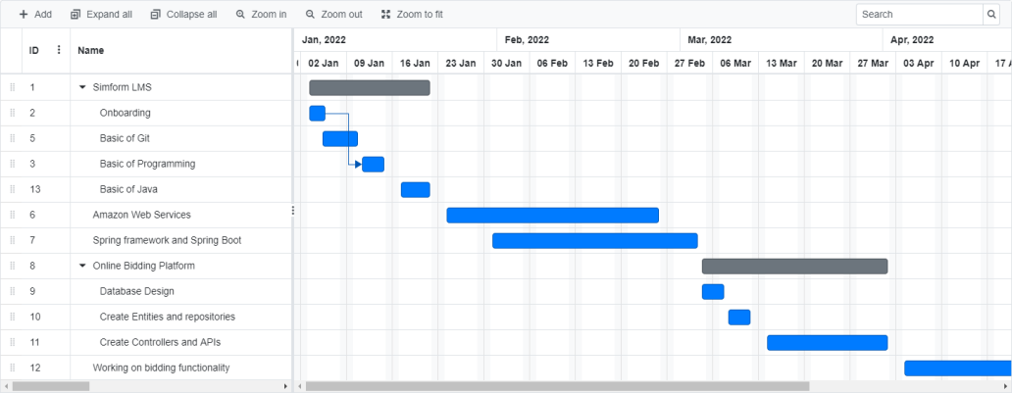

Figure 3-1 Gantt chart

220538

System Analysis

## System Analysis

### Study of current System

There are some existing applications that allow users for bidding but the product is not available in your local area, you cannot do inspection of the product that you are going to buy. By online Auction application user will be able to bid for product that is available in his local area.

### Problem and weakness of Current System

Currently There is also onsite bidders participate in the Event that’s why they may repeatedly interrupting by bidding and online bidders cannot completely know who is winning the bid. There may be spam users who enter bid and then request to retract.

### Requirement analysis of New System

User requirements include minor details, but most importantly users must be aware that the system works properly with full availability, reliability, security and safety. The user responsibility is as follows: User should know how to use the application and should adhere to the guidelines and prescribed standards.

#### Hardware-Software Used

* IDE: Intelij Idea
* Backend: Java
* Database: MySQL
* Minimum 4 GB RAM
* Any Browser
* Microsoft® Windows® 7/8/10.

### System Feasibility

#### Does the system contribute to the overall objectives of the organization?

Yes, system is eventually intended to make it easier for Buyers and Sellers for trading goods in an online auction at ease of their time and from any remote location.

#### Can the system be implemented using the current technology and within the given cost and schedule constraints

220538

System Analysis

Yes, This system uses tools and technologies like Intelij IDEA, MySQL and Java which are free and open source software with active communities backing the system.

#### Can the system be integrated with other systems which are already in place?

Yes, but as it is a standalone system, It doesn’t require any major integrations. We can include integration with a payment gateway as an example of integration with other system.

### Process in New System

* Signup and login for users: This process will call apis to set and get data of users (Sellers and Bidders) from database
* Create Auction Event: Sellers can create their events (Auctions) to sell their goods.
* Bidding from Bidder: When an event is running, any bidders can bid on their item of choice
* Authorization: After Login, JWT is generated for authorization. So, users can not access unauthorized pages.
* Retract Bid: If bidder wants to retract the bid place by them on any item, they can contact Admin to retract their bid.

### Features of New System

* It is an Online platform where sellers can create auctions and buyers can bid on item of their choice.
* It is very easier for sellers to create an auction and if they face ant problems in the process then our team is always there to create auction on the seller’s behalf.
* It is easier for buyers to bid on their choice of item at any time and from any remote location.
* If bid was places by mistake, then it can be retracted by contacting the Admin.

### Process of Proposed System

An architectural diagram of a proposed system that is used to abstract the overall outline of the software system. To allow relevant users to understand a system architecture and follow it in their decision-making, we need to communicate information about the architecture. It is an important tool as it provides an overall view of the physical deployment of the software system and its evolution roadmap.

220538

System Analysis

### Selection of software

Organization is using software like java, AWS, MySQL database for most of application and services so that software we have used.

220538

System Design

## System Design

### System Design & Methodology

In our system we will be following incremental model. Because requirements of the system are clearly defined and understood. Major requirements are defined; however, some details can evolve with time. Technology which will be used to develop this project is also well understood and is available easily.

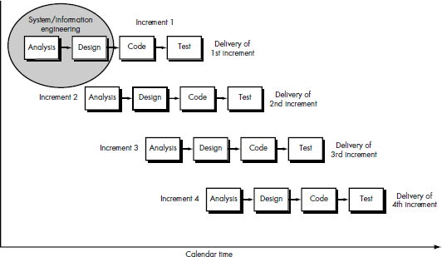

Figure 5-1 Incremental Design

**Design**. Software design is actually a multistep process that focuses onfour distinct attributes of a program: data structure, software architecture, interface representations, and procedural (algorithmic) detail. The design process translates requirements into a representation of the software that can be assessed for quality before coding begins. Like requirements, the design is documented and becomes part of the software configuration.

**Code** generation. The design must be translated into a machine-readable form.

The code generation step performs this task. If design is performed in a detailed manner, code generation can be accomplished mechanistically.

**Testing**. Once code has been generated, program testing begins. The testing process focuses on the logical internals of the software, ensuring that all statements have been tested, and on the functional externals; that is, conducting tests to uncover errors and ensure that defined input will produce actual results that agree with required results.

**Support**. Software will undoubtedly undergo change after it is delivered to the customer (a possible exception is embedded software). Change will

220538

System Design

occur because errors have been encountered, because the software must be adapted to accommodate changes in its external environment (e.g., a change required because of a new operating system or peripheral device), or because the customer requires functional or performance enhancements.

### Database Design

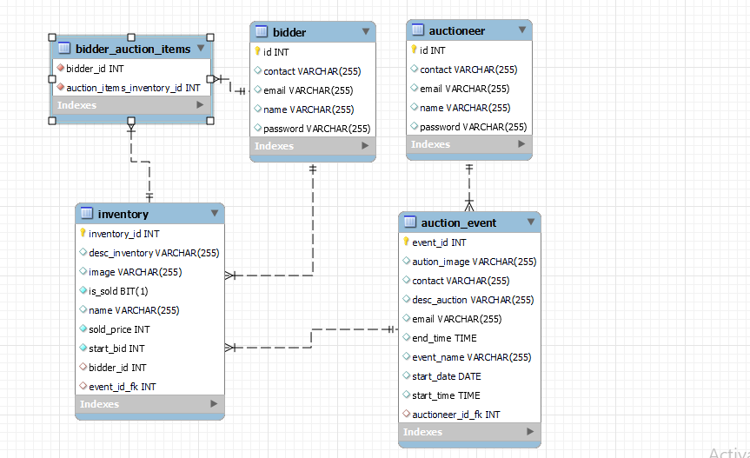

Figure 5-2 Database Relationship

220538

Implementation

## Implementation

### Implementation Environment

For implementation I have used:

1. Intelij IDEA as IDE
2. Java as programming language
3. MySQL as Database

Intelij IDEA is an IDE which we found as the most suitable ide torun our project.

### Process/Module Specification

#### Java

Java is used as the programming language for developing and maintaining the system. Java is a widely used high-level programming language for general purpose programming, The language provides constructs intended to enable writing clear programs on both a small and large scale. Java features a static type system and automatic memory management and supports object-oriented programming paradigm. It has a large and comprehensive standard library. Java compilers are available for many operating systems, allowing Java code to run on a wide variety of systems.

#### MySQL

MySQL is a relational database management system (RDBMS) based on the SQL (Structured Query Language) queries. It is one of the most popular languages for accessing and managing the records in the table.

MySQL is open-source and free software under the GNU license. Oracle Company supports it.

220538

Testing

## Testing

### Testing Strategy

Once source code has been generated, the software must be tested to uncover as many errors as possible before delivery to the customer. Our goal is to design a series of test cases that have a high likelihood of finding errors. Software testing techniques provide systematic guidance for designing tests that (1) Exercise the internal logic of software components

(2) Exercise the inputs and outputs domains of the program to uncover errors in program function, behavior, and performance.

During the early stages of testing, a software engineer performs all tests. However, as the testing process progresses, testing specialists may become involved. Reviews and other activities can and do uncover errors, but they are not sufficient. Every time the program is executed, the customer tests it! Therefore, you have to execute the program before it gets to the customer with the specific intent of finding and removing all errors. In order to find the highest possible number of errors, tests must be conducted systematically and test cases must be designed using disciplined techniques.

### Test Results and Analysis

#### Test Cases (test ID, test condition, expected output, actual output, remark)

Table 1 Test Cases

|  |  |  |  |  |
| --- | --- | --- | --- | --- |
| **Test ID** | **Test Condition** | **Expected Output** | **Actual Output** | **Test Result** |
| 1 | Registered Email, CorrectPassword, Submit | Success | Success | Pass |
| 2 | Unregistered Email, Password | Ask user to Register First | Ask user to Register First | Pass |
| 3 | UserName, Email, other details, Password | Success | Success | Pass |

220538

Testing

|  |  |  |  |  |
| --- | --- | --- | --- | --- |
| 4 | Valid Credentials | Success | Success | Pass |
| 5 | Select auctionevent | Enter in Live Auction | Enter in Live Auction | Pass |
| 6 | Click bid  button | Bid reflected | Bid reflected | Pass |
| 7 | Auction details, Catalog details | Success | Successfully  added auction | Pass |
| 8 | Click Accept button | Bid Completed on bidder  side | Bid completed onbidder side | Pass |

Table 7.1 Test Cases

220538

Testing

# SCREENSHOTS

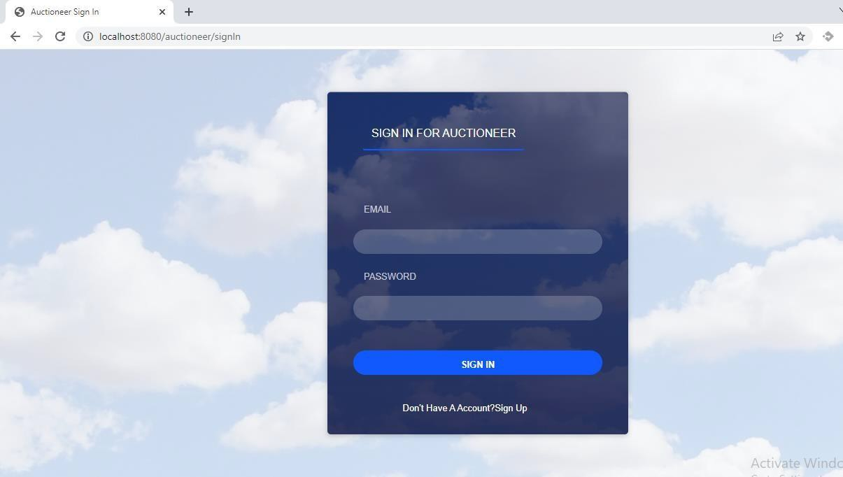

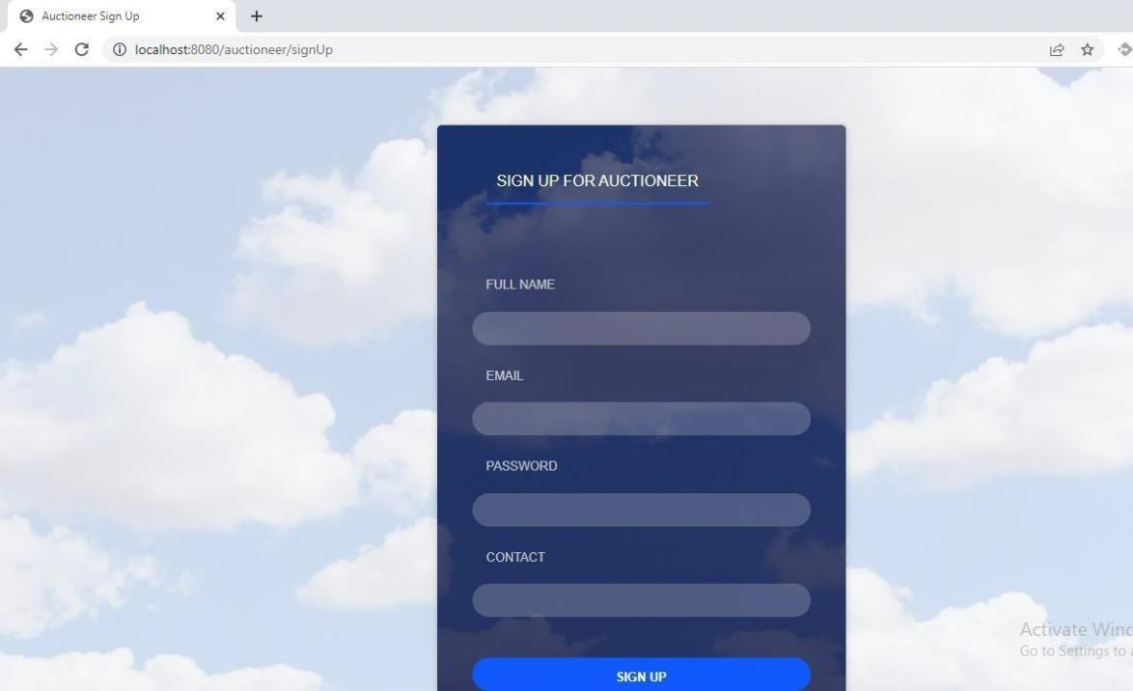

220538

Testing

* Dashboard view and Event view for Bidder

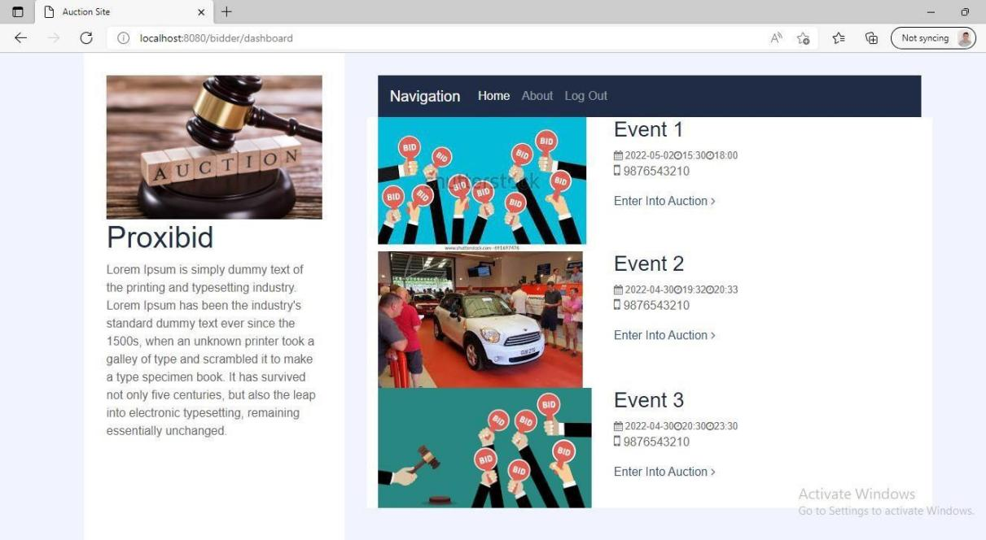

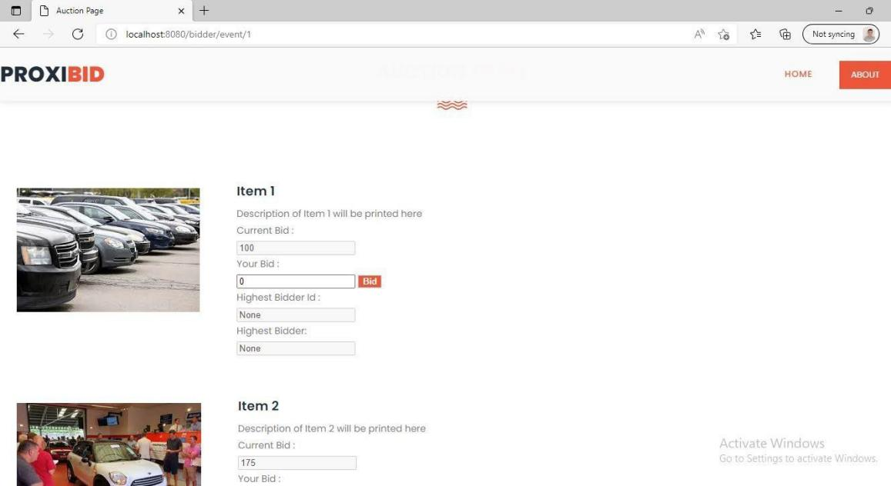

220538

Testing

* Bidder Can not bid less than required bid , also Auctioneer can not accept bid if no has bided for inventory

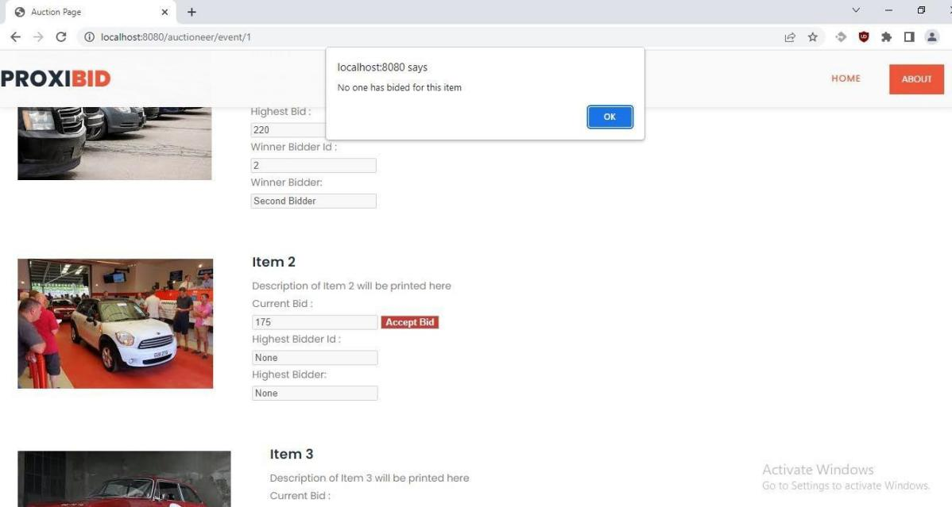

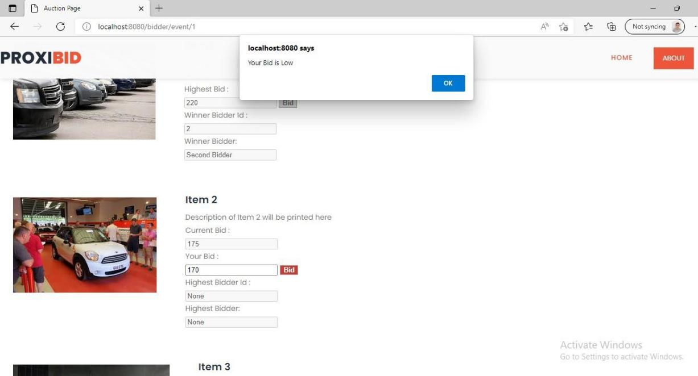

Figure 7-1 Screenshots of Working Project

220538

Conclusion and Discussion

## Conclusion and Discussion

### Overall Analysis of Internship

The main reason for building system is to provide a Online platform for hosting auctions. Also, it will act as a platform where sellers can sell their goods by hosting an auction and buyers can buy their item of choice by bidding on them. The other major advantage that this system will have over the others is that it will make the users experience very smooth and hassle free.

### Dates of Continuous Evaluation

* Review1 of Internship - 05/02/2022
* Review2 of Internship - 05/03/2022

### Summary of Internship

I began my internship with Simform in January 2022.First due to the Covid cases we were working from home But from March we were working directly out of the Office in Ahmedabad, I found motivation in my daily commutes through an incredible work environment. The employees were immensely friendly, supporting, customer-service oriented, caring, and honest. It was an opportunity for me to prove myself as a reputable employee, a reliable coworker, and a motivated student. It was also an opportunity to gain the critical office experience I had not received through my past work experience.

One of the most valuable skills I developed was my versatility. In companies it is common to work across various Technology and that was exactly what I did. Over the duration of my internship, I had worked on a product which is an Online Bidding Platform.

I earned an increasing amount of responsibility as I accomplished more tasks and was always happy to receive new work. The support and direct feedback that I received was more than enough to make me feel comfortable. I am greatly humbled and thankful for all of my coworkers at Protium for providing me with the ability to develop personally and professionally.

220538

Reference

# REFERENCE

* AWS: https://docs.aws.amazon.com/
* Java: https://docs.oracle.com/en/java/
* Online Gantt chart Softwa[re https://www.onlinegantt.com/#/gantt](https://www.onlinegantt.com/%23/gantt)
* Spring: <https://spring.io/>

**Annexure 1**

**Enrollment no: 180280116070**



**NAME OF STUDENT: PATEL DHRUV SUMANBHAI**

**DIARY OF THE WEEK: Dt: 03/01/2022 TO 07/01/2022 DEPARTMENT: INFORMATION TECHNOLOGY SEM: 8th**

**NAME OF THE ORGANISATION: SIMFORM SOLUTIONS NAME OF THEPLANT/SECTION/DEPARTMENT: JAVA NAME OF OFFICER INCHARGE OF THE PLANT/SECTION/DEPARTMENT:_MEET PRAJAPATI _**

**DESCRIPTION OF THE WORK DONE IN BRIEF**

During This Week I learned About Git, Github and Core Java. Git and Github :-

1. Initialize Repository.
2. Check Status Of File
3. Performed Git Command on Repository.
4. Generate Pull Request and Merge it.
5. Git Clone and Add Command.
6. Understand Git Branching Concept. Core Java Basics:-
7. Java Virtual Machine(JVM)
8. OOP Concepts
9. Built-in Packages
10. User-defined Packages
11. Access Modifier





**TOTAL HOURS:**

40

**SIGNATURE OF STUDENT**

**The above entries are correct and the grading of work done by Trainee is EXCELLENT / VERY GOOD / GOOD / FAIR / BELOW AVERAGE / POOR**

**Signature of Faculty Mentor**

**Signature of officer-in-charge of Dept. / Section / Plant**

**Date:**

**Date:**

**Grading of Work, for trainee may be given depending upon your judgement about his Punctuality, Regularity, Sincerity, Interest taken, Work done etc.**

**Annexure 1**

**Enrollment no: 180280116070**



**NAME OF STUDENT: PATEL DHRUV SUMANBHAI**

**DIARY OF THE WEEK: Dt: 10/01/2022 TO 13/01/2022 DEPARTMENT: INFORMATION TECHNOLOGY SEM: 8th**

**NAME OF THE ORGANISATION: SIMFORM SOLUTIONS NAME OF THEPLANT/SECTION/DEPARTMENT: JAVA NAME OF OFFICER INCHARGE OF THE PLANT/SECTION/DEPARTMENT:_MEET PRAJAPATI _**

**DESCRIPTION OF THE WORK DONE IN BRIEF**

During This Week I Completed Core Java Core Java :-

1. Method Overloading and Overriding
2. Constructor Overloading
3. Final Keyword
4. Static Keyword and Static Block
5. Enum
6. Lambda Expession
7. Collections in Java
8. Stream
9. Java Time Class
10. Java Regex
11. Multithreading
12. Java Exceptions





**TOTAL HOURS:**

32

**SIGNATURE OF STUDENT**

**The above entries are correct and the grading of work done by Trainee is EXCELLENT / VERY GOOD / GOOD / FAIR / BELOW AVERAGE / POOR**

**Signature of Faculty Mentor**

**Signature of officer-in-charge of Dept. / Section / Plant**

**Date:**

**Date:**

**Grading of Work, for trainee may be given depending upon your judgement about his Punctuality, Regularity, Sincerity, Interest taken, Work done etc.**

**Annexure 1**

**Enrollment no: 180280116070**



**NAME OF STUDENT: PATEL DHRUV SUMANBHAI**

**DIARY OF THE WEEK: Dt: 17/01/2022 TO 21/01/2022 DEPARTMENT: INFORMATION TECHNOLOGY SEM: 8th**

**NAME OF THE ORGANISATION: SIMFORM SOLUTIONS NAME OF THEPLANT/SECTION/DEPARTMENT: JAVA NAME OF OFFICER INCHARGE OF THE PLANT/SECTION/DEPARTMENT:_MEET PRAJAPATI _**

**DESCRIPTION OF THE WORK DONE IN BRIEF**

In This Week I learned About MySQL and AWS. MySQL :-

1. Basics Query(i.e. SELECT , INSERT , DELETE, UPDATE)
2. WHERE Clause
3. GROUP BY And ORDER BY
4. Set Functions
5. HAVING Clause
6. Different JOINS AWS:-
7. EC2
8. AWS Lambda
9. Elastic Beanstalk
10. Virtual Private Cloud





**TOTAL HOURS:**

40

**SIGNATURE OF STUDENT**

**The above entries are correct and the grading of work done by Trainee is EXCELLENT / VERY GOOD / GOOD / FAIR / BELOW AVERAGE / POOR**

**Signature of Faculty Mentor**

**Signature of officer-in-charge of Dept. / Section / Plant**

**Date:**

**Date:**

**Grading of Work, for trainee may be given depending upon your judgement about his Punctuality, Regularity, Sincerity, Interest taken, Work done etc.**

**Annexure 1**

**Enrollment no: 180280116070**



**NAME OF STUDENT: PATEL DHRUV SUMANBHAI**

**DIARY OF THE WEEK: Dt: 24/01/2022 TO 28/01/2022 DEPARTMENT: INFORMATION TECHNOLOGY SEM: 8th**

**NAME OF THE ORGANISATION: SIMFORM SOLUTIONS NAME OF THEPLANT/SECTION/DEPARTMENT: JAVA NAME OF OFFICER INCHARGE OF THE PLANT/SECTION/DEPARTMENT:_MEET PRAJAPATI _**

**DESCRIPTION OF THE WORK DONE IN BRIEF**

In This Week I Revised Previous Topics. Revised Topics :-

1. GIT
2. Java and MySQL
3. AWS

Apart From Revision:-

1. Gave A Test to Mentor
2. Attended UI/UX Meeting





**TOTAL HOURS:**

36

**SIGNATURE OF STUDENT**

**The above entries are correct and the grading of work done by Trainee is EXCELLENT / VERY GOOD / GOOD / FAIR / BELOW AVERAGE / POOR**

**Signature of Faculty Mentor**

**Signature of officer-in-charge of Dept. / Section / Plant**

**Date:**

**Date:**

**Grading of Work, for trainee may be given depending upon your judgement about his Punctuality, Regularity, Sincerity, Interest taken, Work done etc.**

**Annexure 1**

**Enrollment no: 180280116070**



**NAME OF STUDENT: PATEL DHRUV SUMANBHAI**

**DIARY OF THE WEEK: Dt: 31/01/2022 TO 04/02/2022 DEPARTMENT: INFORMATION TECHNOLOGY SEM: 8th**

**NAME OF THE ORGANISATION: SIMFORM SOLUTIONS NAME OF THEPLANT/SECTION/DEPARTMENT: JAVA NAME OF OFFICER INCHARGE OF THE PLANT/SECTION/DEPARTMENT:_MEET PRAJAPATI _**

**DESCRIPTION OF THE WORK DONE IN BRIEF**

In This Week I learned Spring MVC and Started Springboot. Spring MVC :-

1. Spring Framework Architecture
2. Spring Ioc Container
3. Spring Bean
4. Understand Dependency Injection
5. Autowiring Springboot :-
6. Return JSP File
7. Application Properties File
8. Accepting Client Data
9. ModelAndView
10. REST API
11. Performed CRUD Operation Using Postman





**TOTAL HOURS:**

40

**SIGNATURE OF STUDENT**

**The above entries are correct and the grading of work done by Trainee is EXCELLENT / VERY GOOD / GOOD / FAIR / BELOW AVERAGE / POOR**

**Signature of Faculty Mentor**

**Signature of officer-in-charge of Dept. / Section / Plant**

**Date:**

**Date:**

**Grading of Work, for trainee may be given depending upon your judgement about his Punctuality, Regularity, Sincerity, Interest taken, Work done etc.**

**Annexure 1**

**Enrollment no: 180280116070**



**NAME OF STUDENT: PATEL DHRUV SUMANBHAI**

**DIARY OF THE WEEK: Dt: 07/02/2022 TO 11/02/2022 DEPARTMENT: INFORMATION TECHNOLOGY SEM: 8th**

**NAME OF THE ORGANISATION: SIMFORM SOLUTIONS NAME OF THEPLANT/SECTION/DEPARTMENT: JAVA NAME OF OFFICER INCHARGE OF THE PLANT/SECTION/DEPARTMENT:_MEET PRAJAPATI _**

**DESCRIPTION OF THE WORK DONE IN BRIEF**

In This Week I Continued Exploring Springboot.

Springboot :-

1. Implemented Employee Management System Using Thymeleaf
2. Implemented Corona Virus Tracker App Using REST API
3. Leaned About Returning Responseentity





**TOTAL HOURS:**

40

**SIGNATURE OF STUDENT**

**The above entries are correct and the grading of work done by Trainee is EXCELLENT / VERY GOOD / GOOD / FAIR / BELOW AVERAGE / POOR**

**Signature of Faculty Mentor**

**Signature of officer-in-charge of Dept. / Section / Plant**

**Date:**

**Date:**

**Grading of Work, for trainee may be given depending upon your judgement about his Punctuality, Regularity, Sincerity, Interest taken, Work done etc.**

**Annexure 1**

**Enrollment no: 180280116070**



**NAME OF STUDENT: PATEL DHRUV SUMANBHAI**

**DIARY OF THE WEEK: Dt: 14/02/2022 TO 18/02/2022 DEPARTMENT: INFORMATION TECHNOLOGY SEM: 8th**

**NAME OF THE ORGANISATION: SIMFORM SOLUTIONS NAME OF THEPLANT/SECTION/DEPARTMENT: JAVA NAME OF OFFICER INCHARGE OF THE PLANT/SECTION/DEPARTMENT:_MEET PRAJAPATI _**

**DESCRIPTION OF THE WORK DONE IN BRIEF**

In This Week I learned About Thymeleaf and Started Spring Security Thmeleaf :-

1. Iteration in Thymeleaf
2. Conditional Statement
3. Including Thymeleaf Template For Header And Footer
4. Passing Dynamic Value To Template
5. Dynamic File Uploading Spring Security:-
6. Understand Basic Authentication
7. AntMatcher And CSRF Token
8. Form Based Authentication
9. Authentication Using Database





**TOTAL HOURS:**

40

**SIGNATURE OF STUDENT**

**The above entries are correct and the grading of work done by Trainee is EXCELLENT / VERY GOOD / GOOD / FAIR / BELOW AVERAGE / POOR**

**Signature of Faculty Mentor**

**Signature of officer-in-charge of Dept. / Section / Plant**

**Date:**

**Date:**

**Grading of Work, for trainee may be given depending upon your judgement about his Punctuality, Regularity, Sincerity, Interest taken, Work done etc.**

**Annexure 1**

**Enrollment no: 180280116070**



**NAME OF STUDENT: PATEL DHRUV SUMANBHAI**

**DIARY OF THE WEEK: Dt: 21/02/2022 TO 25/02/2022 DEPARTMENT: INFORMATION TECHNOLOGY SEM: 8th**

**NAME OF THE ORGANISATION: SIMFORM SOLUTIONS NAME OF THEPLANT/SECTION/DEPARTMENT: JAVA NAME OF OFFICER INCHARGE OF THE PLANT/SECTION/DEPARTMENT:_MEET PRAJAPATI _**

**DESCRIPTION OF THE WORK DONE IN BRIEF**

In This Week I learned About JWT and Microservice. JWT(JSON Web Token):-

1. Learned JWT Concept
2. Implemented JWT Authentication In Small Program
3. Sending Unauthorized Response In JWT
4. Used Hibernate Validator

Microservice:-

1. Learned Microservice Concept
2. Performed Communication Between Two Microservice





**TOTAL HOURS:**

40

**SIGNATURE OF STUDENT**

**The above entries are correct and the grading of work done by Trainee is EXCELLENT / VERY GOOD / GOOD / FAIR / BELOW AVERAGE / POOR**

**Signature of Faculty Mentor**

**Signature of officer-in-charge of Dept. / Section / Plant**

**Date:**

**Date:**

**Grading of Work, for trainee may be given depending upon your judgement about his Punctuality, Regularity, Sincerity, Interest taken, Work done etc.**

**Annexure 1**

**Enrollment no: 180280116070**



**NAME OF STUDENT: PATEL DHRUV SUMANBHAI**

**DIARY OF THE WEEK: Dt: 28/02/2022 TO 04/03/2022 DEPARTMENT: INFORMATION TECHNOLOGY SEM: 8th**

**NAME OF THE ORGANISATION: SIMFORM SOLUTIONS NAME OF THEPLANT/SECTION/DEPARTMENT: JAVA NAME OF OFFICER INCHARGE OF THE PLANT/SECTION/DEPARTMENT:_MEET PRAJAPATI _**

**DESCRIPTION OF THE WORK DONE IN BRIEF**

During This Week I Continued With Microservice and JPA . Microservice :-

1. Implemented Eureka Server For Microservice
2. Learned About Hystrix
3. Implemented Hystrix Dashboard For Monitoring Microservice
4. Aspect Oriented Programming JPA(Java Persistence API):-
5. Used JPA With MySQL To Perform Operation On Database





**TOTAL HOURS:**

40

**SIGNATURE OF STUDENT**

**The above entries are correct and the grading of work done by Trainee is EXCELLENT / VERY GOOD / GOOD / FAIR / BELOW AVERAGE / POOR**

**Signature of Faculty Mentor**

**Signature of officer-in-charge of Dept. / Section / Plant**

**Date:**

**Date:**

**Grading of Work, for trainee may be given depending upon your judgement about his Punctuality, Regularity, Sincerity, Interest taken, Work done etc.**

**Annexure 1**

**Enrollment no: 180280116070**



**NAME OF STUDENT: PATEL DHRUV SUMANBHAI**

**DIARY OF THE WEEK: Dt: 07/03/2022 TO 11/03/2022 DEPARTMENT: INFORMATION TECHNOLOGY SEM: 8th**

**NAME OF THE ORGANISATION: SIMFORM SOLUTIONS NAME OF THEPLANT/SECTION/DEPARTMENT: JAVA NAME OF OFFICER INCHARGE OF THE PLANT/SECTION/DEPARTMENT:_MEET PRAJAPATI _**

**DESCRIPTION OF THE WORK DONE IN BRIEF**

In This Week I Gone Through Project Documentation Project :-

1. Gone Through Auction Video
2. Completed Catalog Troubleshooting

Revised Topics:-

1) Role Based Authentication In Spring Security





**TOTAL HOURS:**

40

**SIGNATURE OF STUDENT**

**The above entries are correct and the grading of work done by Trainee is EXCELLENT / VERY GOOD / GOOD / FAIR / BELOW AVERAGE / POOR**

**Signature of Faculty Mentor**

**Signature of officer-in-charge of Dept. / Section / Plant**

**Date:**

**Date:**

**Grading of Work, for trainee may be given depending upon your judgement about his Punctuality, Regularity, Sincerity, Interest taken, Work done etc.**

**Annexure 1**

**Enrollment no: 180280116070**



**NAME OF STUDENT: PATEL DHRUV SUMANBHAI**

**DIARY OF THE WEEK: Dt: 14/03/2022 TO 16/03/2022 DEPARTMENT: INFORMATION TECHNOLOGY SEM: 8th**

**NAME OF THE ORGANISATION: SIMFORM SOLUTIONS NAME OF THEPLANT/SECTION/DEPARTMENT: JAVA NAME OF OFFICER INCHARGE OF THE PLANT/SECTION/DEPARTMENT:_MEET PRAJAPATI _**

**DESCRIPTION OF THE WORK DONE IN BRIEF**

During This Week I Continued Exploring About Project.

Project :-

1. Completed Bidding Auctioneer , Admin Email And Admin Builder
2. Explored Features Related To The Auction





**TOTAL HOURS:**

24

**SIGNATURE OF STUDENT**

**The above entries are correct and the grading of work done by Trainee is EXCELLENT / VERY GOOD / GOOD / FAIR / BELOW AVERAGE / POOR**

**Signature of Faculty Mentor**

**Signature of officer-in-charge of Dept. / Section / Plant**

**Date:**

**Date:**

**Grading of Work, for trainee may be given depending upon your judgement about his Punctuality, Regularity, Sincerity, Interest taken, Work done etc.**

**Annexure 1**

**Enrollment no: 180280116070**



**NAME OF STUDENT: PATEL DHRUV SUMANBHAI**

**DIARY OF THE WEEK: Dt: 21/03/2022 TO 25/03/2022 DEPARTMENT: INFORMATION TECHNOLOGY SEM: 8th**

**NAME OF THE ORGANISATION: SIMFORM SOLUTIONS NAME OF THEPLANT/SECTION/DEPARTMENT: JAVA NAME OF OFFICER INCHARGE OF THE PLANT/SECTION/DEPARTMENT:_MEET PRAJAPATI _**

**DESCRIPTION OF THE WORK DONE IN BRIEF**

In This Week I Completed Project Documentation and Started Working On Demo Project

Project :-

1. Explored Marketing And Admistrative Tool Feature
2. Explored On Bidder Site Demo Auction Site:-
3. Created Database For Demo Project
4. Created Bidder Controller
5. Created Linked Table In Database
6. Stored Sign Up Data For Bidder In Database Using Postman





**TOTAL HOURS:**

40

**SIGNATURE OF STUDENT**

**The above entries are correct and the grading of work done by Trainee is EXCELLENT / VERY GOOD / GOOD / FAIR / BELOW AVERAGE / POOR**

**Signature of Faculty Mentor**

**Signature of officer-in-charge of Dept. / Section / Plant**

**Date:**

**Date:**

**Grading of Work, for trainee may be given depending upon your judgement about his Punctuality, Regularity, Sincerity, Interest taken, Work done etc.**

**Annexure 1**

**Enrollment no: 180280116070**



**NAME OF STUDENT: PATEL DHRUV SUMANBHAI**

**DIARY OF THE WEEK: Dt: 28/03/2022 TO 01/04/2022 DEPARTMENT: INFORMATION TECHNOLOGY SEM: 8th**

**NAME OF THE ORGANISATION: SIMFORM SOLUTIONS NAME OF THEPLANT/SECTION/DEPARTMENT: JAVA NAME OF OFFICER INCHARGE OF THE PLANT/SECTION/DEPARTMENT:_MEET PRAJAPATI _**

**DESCRIPTION OF THE WORK DONE IN BRIEF**

During This Week I Continued With Demo Project And

Completed Onboarding Course

Demo Auction Site :-

1. Implemented Front-end For Bidder Sign-up
2. Implemented Front-end For Auction Catalog
3. Created Bidder Dashboard
4. Entered Data Into Database Through Auction Catalog Frontend Onboarding Course:-
5. Completed Onboarding Course





**TOTAL HOURS:**

40

**SIGNATURE OF STUDENT**

**The above entries are correct and the grading of work done by Trainee is EXCELLENT / VERY GOOD / GOOD / FAIR / BELOW AVERAGE / POOR**

**Signature of Faculty Mentor**

**Signature of officer-in-charge of Dept. / Section / Plant**

**Date:**

**Date:**

**Grading of Work, for trainee may be given depending upon your judgement about his Punctuality, Regularity, Sincerity, Interest taken, Work done etc.**

**Annexure 1**

**Enrollment no: 180280116070**



**NAME OF STUDENT: PATEL DHRUV SUMANBHAI**

**DIARY OF THE WEEK: Dt: 04/04/2022 TO 08/04/2022 DEPARTMENT: INFORMATION TECHNOLOGY SEM: 8th**

**NAME OF THE ORGANISATION: SIMFORM SOLUTIONS NAME OF THEPLANT/SECTION/DEPARTMENT: JAVA NAME OF OFFICER INCHARGE OF THE PLANT/SECTION/DEPARTMENT:_MEET PRAJAPATI _**

**DESCRIPTION OF THE WORK DONE IN BRIEF**

During This Week I Continued With Demo Project

Demo Auction Site :-

1. Login Functionality For Bidder And Auctioneer
2. Show Available Inventories In Particular Auction Event
3. Learned About Web Socket And jQuery





**TOTAL HOURS:**

40

**SIGNATURE OF STUDENT**

**The above entries are correct and the grading of work done by Trainee is EXCELLENT / VERY GOOD / GOOD / FAIR / BELOW AVERAGE / POOR**

**Signature of Faculty Mentor**

**Signature of officer-in-charge of Dept. / Section / Plant**

**Date:**

**Date:**

**Grading of Work, for trainee may be given depending upon your judgement about his Punctuality, Regularity, Sincerity, Interest taken, Work done etc.**

**Annexure 1**

**Enrollment no: 180280116070**



**NAME OF STUDENT: PATEL DHRUV SUMANBHAI**

**DIARY OF THE WEEK: Dt: 11/04/2022 TO 15/04/2022 DEPARTMENT: INFORMATION TECHNOLOGY SEM: 8th**

**NAME OF THE ORGANISATION: SIMFORM SOLUTIONS NAME OF THEPLANT/SECTION/DEPARTMENT: JAVA NAME OF OFFICER INCHARGE OF THE PLANT/SECTION/DEPARTMENT:_MEET PRAJAPATI _**

**DESCRIPTION OF THE WORK DONE IN BRIEF**

During This Week I Continued With Demo Project

Demo Auction Site :-

1. Completed Web Socket Functionality
2. Added Bid Button For Bidder And Accept Bid Button For Auctioneer
3. Used Cookie To Validate User
4. Stored Winner Id In Database For Sold Inventory
5. Disabled Button Of Bidding For Bidder If Item Is Already Sold





**TOTAL HOURS:**

36

**SIGNATURE OF STUDENT**

**The above entries are correct and the grading of work done by Trainee is EXCELLENT / VERY GOOD / GOOD / FAIR / BELOW AVERAGE / POOR**

**Signature of Faculty Mentor**

**Signature of officer-in-charge of Dept. / Section / Plant**

**Date:**

**Date:**

**Grading of Work, for trainee may be given depending upon your judgement about his Punctuality, Regularity, Sincerity, Interest taken, Work done etc.**

**Annexure 1**

**Enrollment no: 180280116070**



**NAME OF STUDENT: PATEL DHRUV SUMANBHAI**

**DIARY OF THE WEEK: Dt: 18/04/2022 TO 21/04/2022 DEPARTMENT: INFORMATION TECHNOLOGY SEM: 8th**

**NAME OF THE ORGANISATION: SIMFORM SOLUTIONS NAME OF THEPLANT/SECTION/DEPARTMENT: JAVA NAME OF OFFICER INCHARGE OF THE PLANT/SECTION/DEPARTMENT:_MEET PRAJAPATI _**

**DESCRIPTION OF THE WORK DONE IN BRIEF**

During This Week I Completed Demo Project

Demo Auction Site :-

1. Unidirectional Mapping Changed To Bidirectional To Show Winner Id Efficiently
2. Learned About RabbitMQ
3. Show Winner Bidder Id and Name Along With Inventory For Sold Inventory
4. Accept Bid Will Not Work If No One Has Bided For Inventory
5. Bid Button Will Not Work If Bidder Has Placed Bid Less Than Minimum Bid





**TOTAL HOURS:**

32

**SIGNATURE OF STUDENT**

**The above entries are correct and the grading of work done by Trainee is EXCELLENT / VERY GOOD / GOOD / FAIR / BELOW AVERAGE / POOR**

**Signature of Faculty Mentor**

**Signature of officer-in-charge of Dept. / Section / Plant**

**Date:**

**Date:**

**Grading of Work, for trainee may be given depending upon your judgement about his Punctuality, Regularity, Sincerity, Interest taken, Work done etc.**

**Annexure 2**

**Form by Industry expert**

Student Name: Patel Dhruv Sumanbhai Date: 25/04/2022

Work Supervisor: Meet Prajapati Title: Java Company/Organization: Simform

Solutions Enrollment No: 180280116070

Internship Address: 5th floor Bsquare 2, Nr. Doubletree Hotel, Iscon-Bopal Road, Ahmedabad-380058, Gujarat, India. Dates of Internship: From 03/01/2022 To 25/04/2022

Please evaluate your intern by indicating the frequency with which you observed the following behaviors:

|  |  |  |  |  |
| --- | --- | --- | --- | --- |
| Parameters | Needs improvement | Satisfactory | Good | Excellent |
| Shows interest in work and his/her initiatives |  |  |  |  |
| Produces high quality work and accepts responsibility |  |  |  |  |
| Uses technical knowledge and expertise |  |  |  |  |
| Analyzes problems effectively |  |  |  |  |
| Communicates well and writes effectively |  |  |  |  |

Overall performance of student intern: (Needs improvement/ Satisfactory/Good/Excellent):

Additional comments, if any:

Signature of Industry person with name and Stamp: Meet Prajapati

Signature of the Faculty Mentor