EXPERIMENT 3

Aim: Cmd version control commands

Theory:

Git Bash comes with a set of commands to perform various operations related to code management and collaboration. Here are some essential Git Bash commands:-

- git init: Initializes the new git repository.

- git clone: “git clone“ command is used to clone the repositories which are already available in the remote repository.

- git add: Files present in the working area will move to the staging area.

- git commit: Files that are available in the staging area will be committed to the local repository.

- git status: This command shows the status of the working tree and the staging area.

- git log: “git log” command will help you to see the logs of all the commits made.

- git branch: Creates a new branch.

- git merge: For merging the changes from one branch to another branch.

- git config: “git config” will help you to configure the username and email id.

- git tag: It will display the all tags.
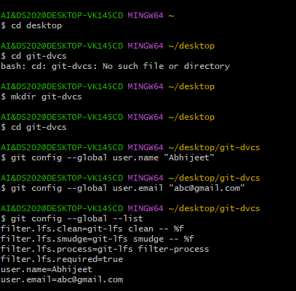
If you want to check your configuration settings, you can use the git config --list command to list all the settings Git can find at that point:

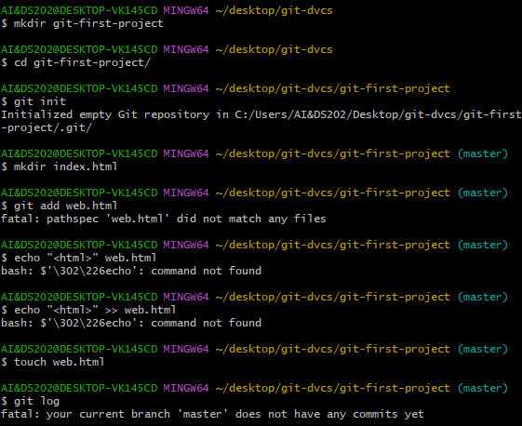
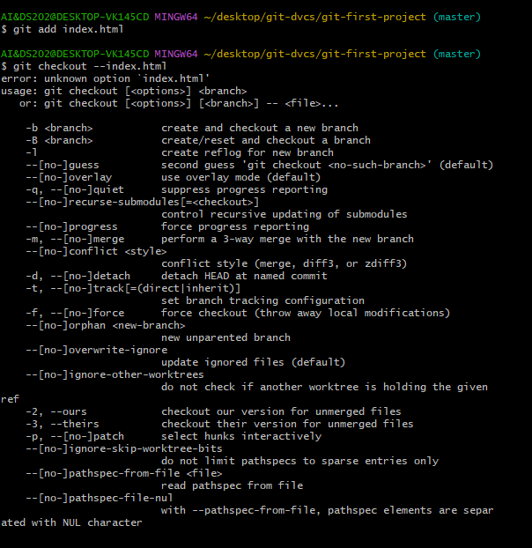
Conclusion: We have learnt different git commands and implemented it.

