**ID=O2 https://docs.djangoproject.com/en/4.0/intro/tutorial01/**

**msa 30.6.2022**

(django-test) G:\LUT>django-admin startproject mysite

(django-test) G:\LUT>cd mysite

(django-test) G:\LUT\mysite>dir

Volume in drive G is Seagate 2TB

Volume Serial Number is AACC-28DD

Directory of G:\LUT\mysite

30.06.2022 16.08 <DIR> .

30.06.2022 16.08 <DIR> ..

30.06.2022 16.08 684 manage.py

30.06.2022 16.08 <DIR> mysite

1 File(s) 684 bytes

3 Dir(s) 888 382 574 592 bytes free

(django-test) G:\LUT\mysite>python manage.py runserver

Watching for file changes with StatReloader

Performing system checks...

System check identified no issues (0 silenced).

You have 18 unapplied migration(s). Your project may not work properly until you apply the migrations for app(s): admin, auth, contenttypes, sessions.

Run 'python manage.py migrate' to apply them.

June 30, 2022 - 16:10:44

Django version 4.0.5, using settings 'mysite.settings'

Starting development server at http://127.0.0.1:8000/

Quit the server with CTRL-BREAK.

Not Found: /polls/

[30/Jun/2022 16:11:47] "GET /polls/ HTTP/1.1" 404 2095

Not Found: /favicon.ico

[30/Jun/2022 16:11:47] "GET /favicon.ico HTTP/1.1" 404 2110

[30/Jun/2022 16:11:50] "GET / HTTP/1.1" 200 10697

[30/Jun/2022 16:11:50] "GET /static/admin/css/fonts.css HTTP/1.1" 200 423

[30/Jun/2022 16:11:50] "GET /static/admin/fonts/Roboto-Bold-webfont.woff HTTP/1.1" 200 86184

[30/Jun/2022 16:11:50] "GET /static/admin/fonts/Roboto-Light-webfont.woff HTTP/1.1" 200 85692

[30/Jun/2022 16:11:50] "GET /static/admin/fonts/Roboto-Regular-webfont.woff HTTP/1.1" 200 85876

<http://127.0.0.1:8000/>

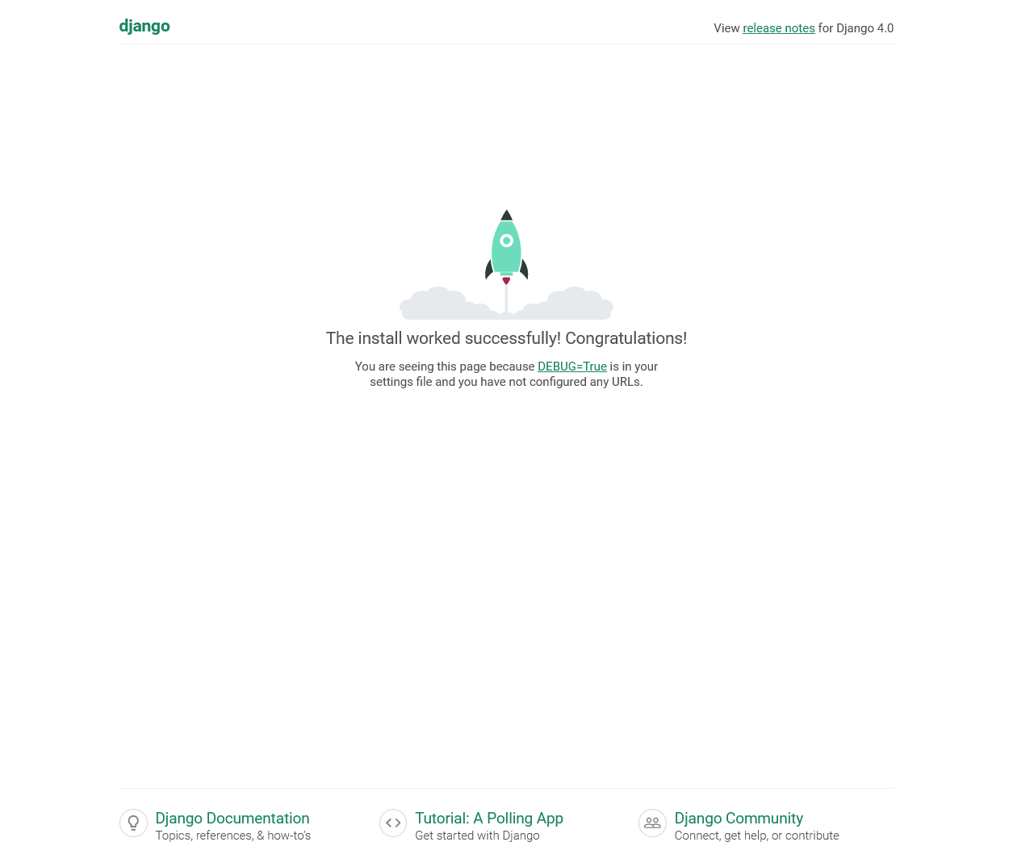

(django-test) G:\LUT\mysite>python manage.py startapp polls

(django-test) G:\LUT\mysite>python manage.py runserver

Watching for file changes with StatReloader

Performing system checks...

System check identified no issues (0 silenced).

You have 18 unapplied migration(s). Your project may not work properly until you apply the migrations for app(s): admin, auth, contenttypes, sessions.

Run 'python manage.py migrate' to apply them.

June 30, 2022 - 16:21:10

Django version 4.0.5, using settings 'mysite.settings'

Starting development server at http://127.0.0.1:8000/

Quit the server with CTRL-BREAK.

[30/Jun/2022 16:21:24] "GET /polls/ HTTP/1.1" 200 36

Not Found: /favicon.ico

[30/Jun/2022 16:21:24,589] - Broken pipe from ('127.0.0.1', 53054)

http://localhost:8000/polls/

