(django-test) G:\LUT\mysite>python manage.py makemigrations polls

Migrations for 'polls':

polls\migrations\0001_initial.py

- Create model Question

- Create model Choice

(django-test) G:\LUT\mysite>type polls/migrations/0001_initial.py

The syntax of the command is incorrect.

(django-test) G:\LUT\mysite>type polls\migrations\0001_initial.py

# Generated by Django 4.0.5 on 2022-07-01 08:10

from django.db import migrations, models

import django.db.models.deletion

class Migration(migrations.Migration):

initial = True

dependencies = [

]

operations = [

migrations.CreateModel(

name='Question',

fields=[

('id', models.BigAutoField(auto_created=True, primary_key=True, serialize=False, verbose_name='ID')),

('question_text', models.CharField(max_length=200)),

('pub_date', models.DateTimeField(verbose_name='julkaisup├ñiv├ñ')),

],

),

migrations.CreateModel(

name='Choice',

fields=[

('id', models.BigAutoField(auto_created=True, primary_key=True, serialize=False, verbose_name='ID')),

('choice_text', models.CharField(max_length=200)),

('votes', models.IntegerField(default=0)),

('question', models.ForeignKey(on_delete=django.db.models.deletion.CASCADE, to='polls.question')),

],

),

]

(django-test) G:\LUT\mysite>python manage.py sqlmigrate polls 0001

BEGIN;

--

-- Create model Question

--

CREATE TABLE "polls_question" ("id" integer NOT NULL PRIMARY KEY AUTOINCREMENT, "question_text" varchar(200) NOT NULL, "pub_date" datetime NOT NULL);

--

-- Create model Choice

--

CREATE TABLE "polls_choice" ("id" integer NOT NULL PRIMARY KEY AUTOINCREMENT, "choice_text" varchar(200) NOT NULL, "votes" integer NOT NULL, "question_id" bigint NOT NULL REFERENCES "polls_question" ("id") DEFERRABLE INITIALLY DEFERRED);

CREATE INDEX "polls_choice_question_id_c5b4b260" ON "polls_choice" ("question_id");

COMMIT;

(django-test) G:\LUT\mysite>python manage.py migrate

Operations to perform:

Apply all migrations: admin, auth, contenttypes, polls, sessions

Running migrations:

Applying contenttypes.0001_initial... OK

Applying auth.0001_initial... OK

Applying admin.0001_initial... OK

Applying admin.0002_logentry_remove_auto_add... OK

Applying admin.0003_logentry_add_action_flag_choices... OK

Applying contenttypes.0002_remove_content_type_name... OK

Applying auth.0002_alter_permission_name_max_length... OK

Applying auth.0003_alter_user_email_max_length... OK

Applying auth.0004_alter_user_username_opts... OK

Applying auth.0005_alter_user_last_login_null... OK

(django-test) G:\LUT\mysite>python manage.py shell

Python 3.9.1 (tags/v3.9.1:1e5d33e, Dec 7 2020, 17:08:21) [MSC v.1927 64 bit (AMD64)] on win32

Type "help", "copyright", "credits" or "license" for more information.

(InteractiveConsole)

>>> from polls.models import Choice, Question

>>> Question.objects.all()

<QuerySet [<Question: What's up?>]>

>>> Question.objects.filter(id=1)

<QuerySet [<Question: What's up?>]>

>>> Question.objects.filter(question_text__startswith='What')

<QuerySet [<Question: What's up?>]>

>>>

>>> from django.utils import timezone

>>> current_year = timezone.now().year

>>> Question.objects.get(pub_date__year=current_year)

<Question: What's up?>

>>> # Request an ID that doesn't exist, this will raise an exception.

>>> Question.objects.get(id=2)

Traceback (most recent call last):

File "<console>", line 1, in <module>

File "G:\LUT\django-test\lib\site-packages\django\db\models\manager.py", line 85, in manager_method

return getattr(self.get_queryset(), name)(*args, **kwargs)

File "G:\LUT\django-test\lib\site-packages\django\db\models\query.py", line 496, in get

raise self.model.DoesNotExist(

polls.models.Question.DoesNotExist: Question matching query does not exist.

>>>

>>> Question.objects.get(pk=1)

<Question: What's up?>

>>>

>>> q = Question.objects.get(pk=1)

>>> q.was_published_recently()

True

>>>

>>> q = Question.objects.get(pk=1)

>>> q.choice_set.all()

<QuerySet []>

>>> q.choice_set.create(choice_text='Not much', votes=0)

<Choice: Not much>

>>> q.choice_set.create(choice_text='The sky', votes=0)

<Choice: The sky>

>>> c = q.choice_set.create(choice_text='Just hacking again', votes=0)

>>>

>>> c.question

<Question: What's up?>

>>> q.choice_set.all()

<QuerySet [<Choice: Not much>, <Choice: The sky>, <Choice: Just hacking again>]>

>>> q.choice_set.count()

3

>>> Choice.objects.filter(question__pub_date__year=current_year)

<QuerySet [<Choice: Not much>, <Choice: The sky>, <Choice: Just hacking again>]>

>>>

>>> c = q.choice_set.filter(choice_text__startswith='Just hacking')

>>> c.delete()

(1, {'polls.Choice': 1})

>>>

(django-test) G:\LUT\mysite>

(django-test) G:\LUT\mysite>python manage.py createsuperuser

Username (leave blank to use 'msa'):

Email address: el4302@gmail.com

Password:

Password (again):

Superuser created successfully.

(django-test) G:\LUT\mysite>python manage.py runserver

Watching for file changes with StatReloader

Performing system checks...

System check identified no issues (0 silenced).

July 01, 2022 - 12:15:51

Django version 4.0.5, using settings 'mysite.settings'

Starting development server at http://127.0.0.1:8000/

Quit the server with CTRL-BREAK.

[01/Jul/2022 12:15:57] "GET /polls/ HTTP/1.1" 200 36

Not Found: /

[01/Jul/2022 12:16:01] "GET / HTTP/1.1" 404 2165

Not Found: /favicon.ico

[01/Jul/2022 12:16:01] "GET /favicon.ico HTTP/1.1" 404 2216

Not Found: /msa

[01/Jul/2022 12:16:17] "GET /msa HTTP/1.1" 404 2192

Not Found: /msa/

[01/Jul/2022 12:16:28] "GET /msa/ HTTP/1.1" 404 2195

[01/Jul/2022 12:16:41] "GET /admin/ HTTP/1.1" 302 0

[01/Jul/2022 12:16:41] "GET /admin/login/?next=/admin/ HTTP/1.1" 200 2215

[01/Jul/2022 12:16:43] "GET /static/admin/css/base.css HTTP/1.1" 200 19513

[01/Jul/2022 12:16:43] "GET /static/admin/css/responsive.css HTTP/1.1" 200 18575

[01/Jul/2022 12:16:43] "GET /static/admin/css/nav_sidebar.css HTTP/1.1" 200 2616

[01/Jul/2022 12:16:43] "GET /static/admin/css/login.css HTTP/1.1" 200 954

[01/Jul/2022 12:16:43] "GET /static/admin/css/fonts.css HTTP/1.1" 304 0

[01/Jul/2022 12:16:43] "GET /static/admin/js/nav_sidebar.js HTTP/1.1" 200 3763

[01/Jul/2022 12:16:43] "GET /static/admin/fonts/Roboto-Regular-webfont.woff HTTP/1.1" 200 85876

[01/Jul/2022 12:16:43] "GET /static/admin/fonts/Roboto-Light-webfont.woff HTTP/1.1" 200 85692

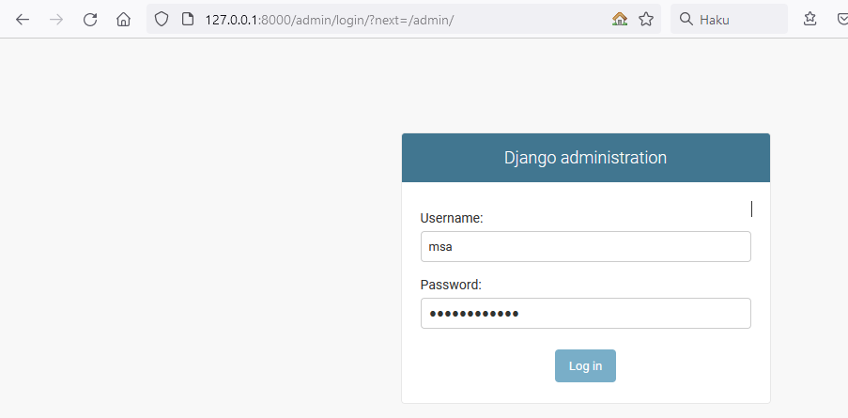



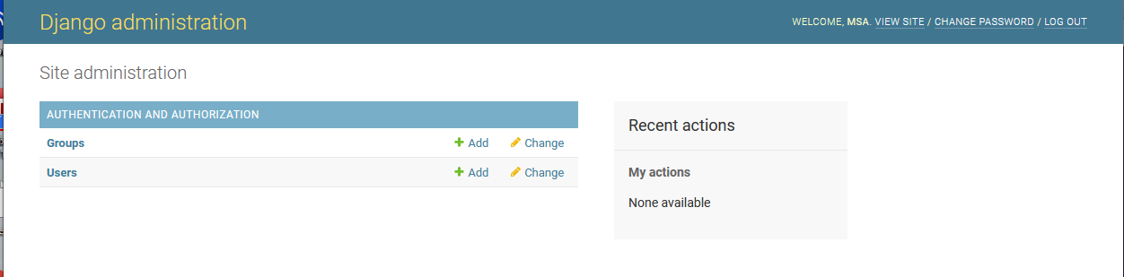

lisätty polls/admin.py –tiedostoon:

from .models import Question

admin.site.register(Question)

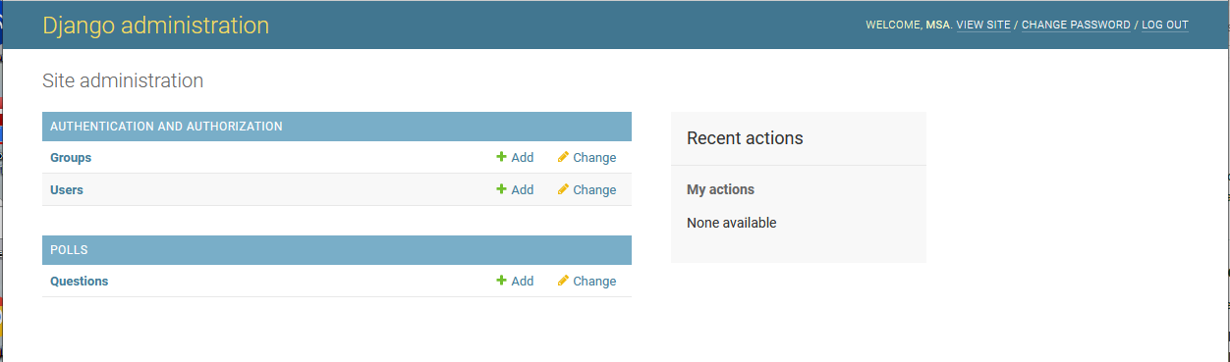

click Questions

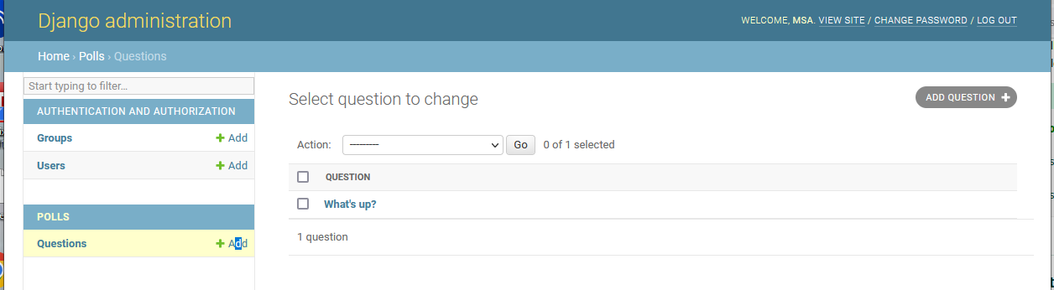

click What’s up?

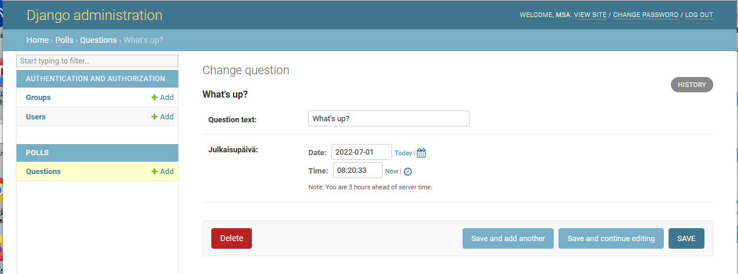

mietittävää:

* kieleistys ? (date + time)
* aikavyöhyke (nyt 3 tuntia eroa)

mysite\settings.py –tiedostossa päivitetty muuttuja TIME_ZONE = “EET”

* kellonaika on nyt oikein

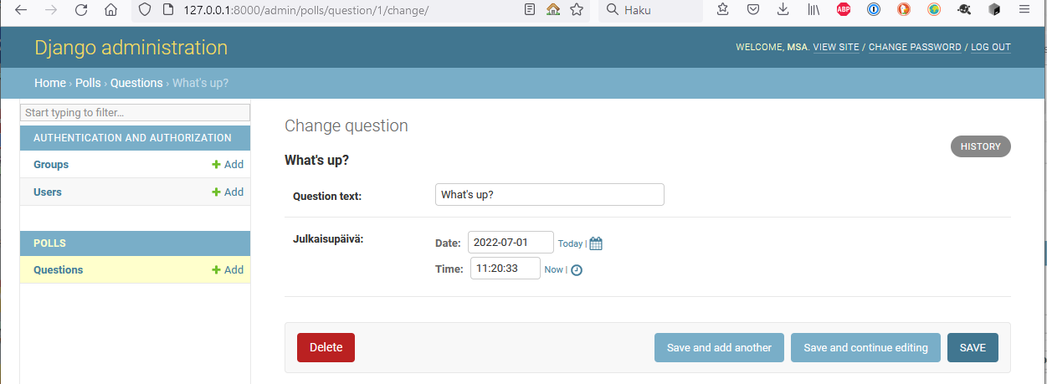

päiväyksen ja kellonajan muuttaminen

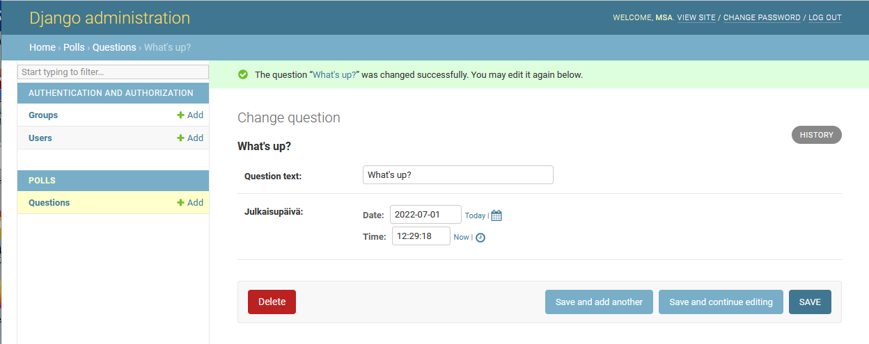

ja historian tarkastelu

