**ID=O2** [**https://docs.djangoproject.com/en/4.0/intro/tutorial03/**](https://docs.djangoproject.com/en/4.0/intro/tutorial03/)

**2.7.2022 10:00**

(django-test) G:\LUT\mysite>python manage.py runserver

Watching for file changes with StatReloader

Performing system checks...

System check identified no issues (0 silenced).

July 02, 2022 - 10:23:57

Django version 4.0.5, using settings 'mysite.settings'

Starting development server at http://127.0.0.1:8000/

Quit the server with CTRL-BREAK.

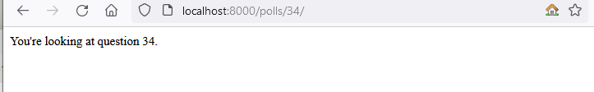

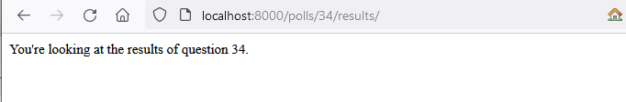

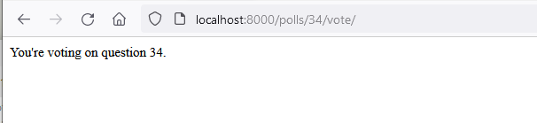

(django-test) G:\LUT\mysite>mkdir polls\templates

(django-test) G:\LUT\mysite>mkdir polls\templates\polls

(django-test) G:\LUT\mysite>type polls\templates\polls\index.html

{% if latest_question_list %}

<ul>

{% for question in latest_question_list %}

<li><a href="/polls/{{ question.id }}/">{{ question.question_text }}</a></li>

{% endfor %}

</ul>

{% else %}

<p>No polls are available.</p>

{% endif %}

(django-test) G:\LUT\mysite>

(django-test) G:\LUT\mysite>python manage.py runserver

Watching for file changes with StatReloader

Performing system checks...

System check identified no issues (0 silenced).

July 02, 2022 - 10:42:26

Django version 4.0.5, using settings 'mysite.settings'

Starting development server at http://127.0.0.1:8000/

Quit the server with CTRL-BREAK.

