**ID=O2** [**https://docs.djangoproject.com/en/4.0/intro/tutorial04/**](https://docs.djangoproject.com/en/4.0/intro/tutorial04/)

**msa 2.7.2022 11:20**

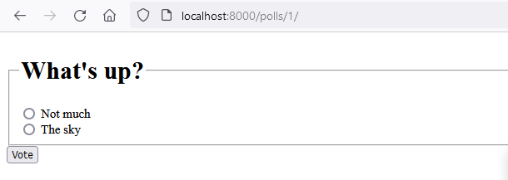

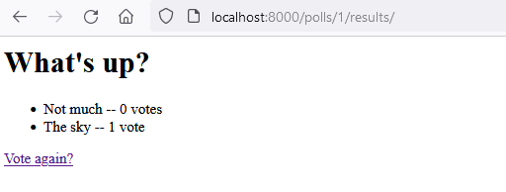

# generic views –muutokset

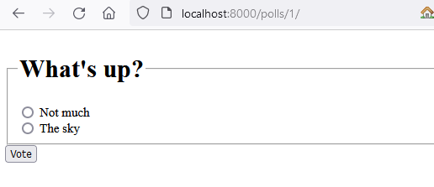

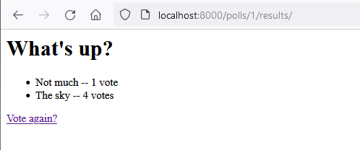

(django-test) G:\LUT\mysite>python manage.py shell

Python 3.9.1 (tags/v3.9.1:1e5d33e, Dec 7 2020, 17:08:21) [MSC v.1927 64 bit (AMD64)] on win32

Type "help", "copyright", "credits" or "license" for more information.

(InteractiveConsole)

>>>

>>> from polls.models import Choice, Question # Import the model

>>> Question.objects.all()

<QuerySet [<Question: What's up?>, <Question: Entäs nyt?>]>

>>> Question.objects.filter(id=2)

<QuerySet [<Question: Entäs nyt?>]>

>>> q = Question.objects.get(pk=2)

>>> q.choice_set.all()

<QuerySet []>

>>> q.choice_set.create(choice_text='Lisää tehtäviä', votes=0)

<Choice: Lisää tehtäviä>

>>> q.choice_set.create(choice_text='Kahville', votes=0)

<Choice: Kahville>

>>> q.choice_set.create(choice_text='miitti', votes=0)

<Choice: miitti>

>>> q.choice_set.create(choice_text='ei harmainta aavistusta', votes=0)

<Choice: ei harmainta aavistusta>

>>> q.choice_set.count()

4

>>> q.choice_set.all()

<QuerySet [<Choice: Lisää tehtäviä>, <Choice: Kahville>, <Choice: miitti>, <Choice: ei harmainta aavistusta>]>

>>>

KeyboardInterrupt

>>> ^D

File "<console>", line 1

♦

^

SyntaxError: invalid syntax

>>> ^X

File "<console>", line 1

↑

^

SyntaxError: invalid syntax

>>> ^Z

now exiting InteractiveConsole...

(django-test) G:\LUT\mysite>python manage.py runserver

Watching for file changes with StatReloader

Performing system checks...

System check identified no issues (0 silenced).

July 02, 2022 - 14:58:44

Django version 4.0.5, using settings 'mysite.settings'

Starting development server at http://127.0.0.1:8000/

Quit the server with CTRL-BREAK.

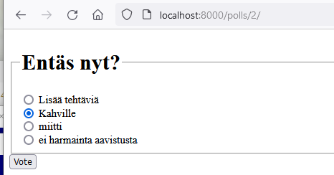

+ “lisää tehtäviä”

