**ID=O2** [**https://docs.djangoproject.com/en/4.0/intro/tutorial06/**](https://docs.djangoproject.com/en/4.0/intro/tutorial06/)

**msa 2.7.2022 17:30**

# koodimuutokset (css)

(django-test) G:\LUT\mysite>py manage.py runserver

Watching for file changes with StatReloader

Performing system checks...

System check identified no issues (0 silenced).

July 02, 2022 - 17:38:06

Django version 4.0.5, using settings 'mysite.settings'

Starting development server at http://127.0.0.1:8000/

Quit the server with CTRL-BREAK.

[02/Jul/2022 17:38:14] "GET /polls/ HTTP/1.1" 200 278

[02/Jul/2022 17:38:14] "GET /static/polls/style.css HTTP/1.1" 200 28

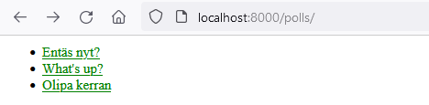

# lisää kuva

