**ID=O2** [**https://docs.djangoproject.com/en/4.0/intro/tutorial07/**](https://docs.djangoproject.com/en/4.0/intro/tutorial07/)

**msa 2.7.2022 18:15**

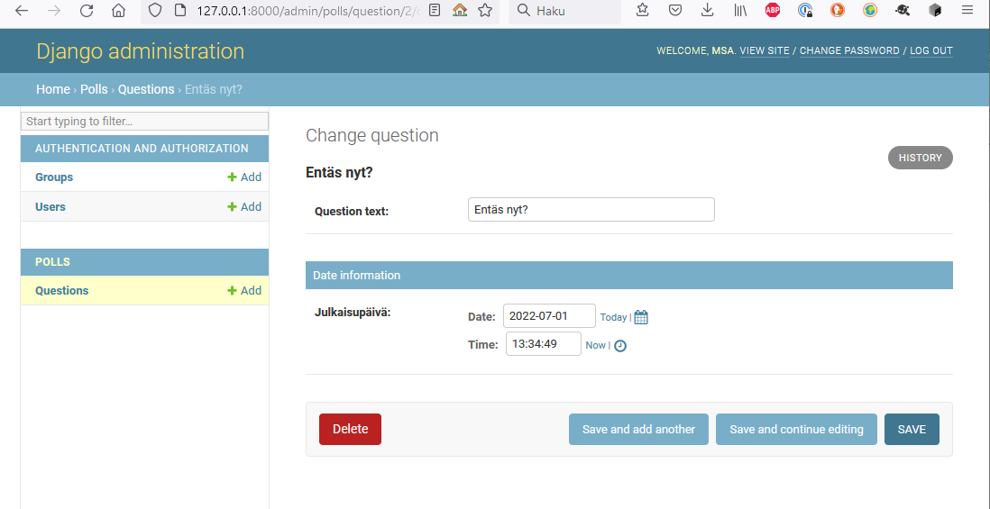

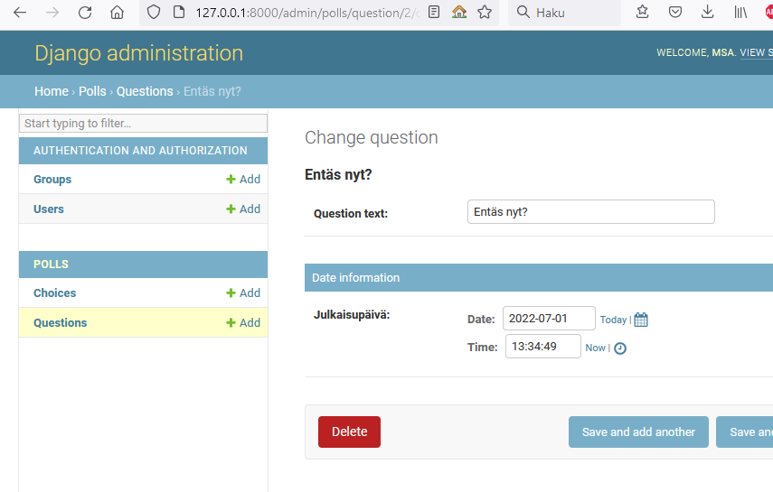

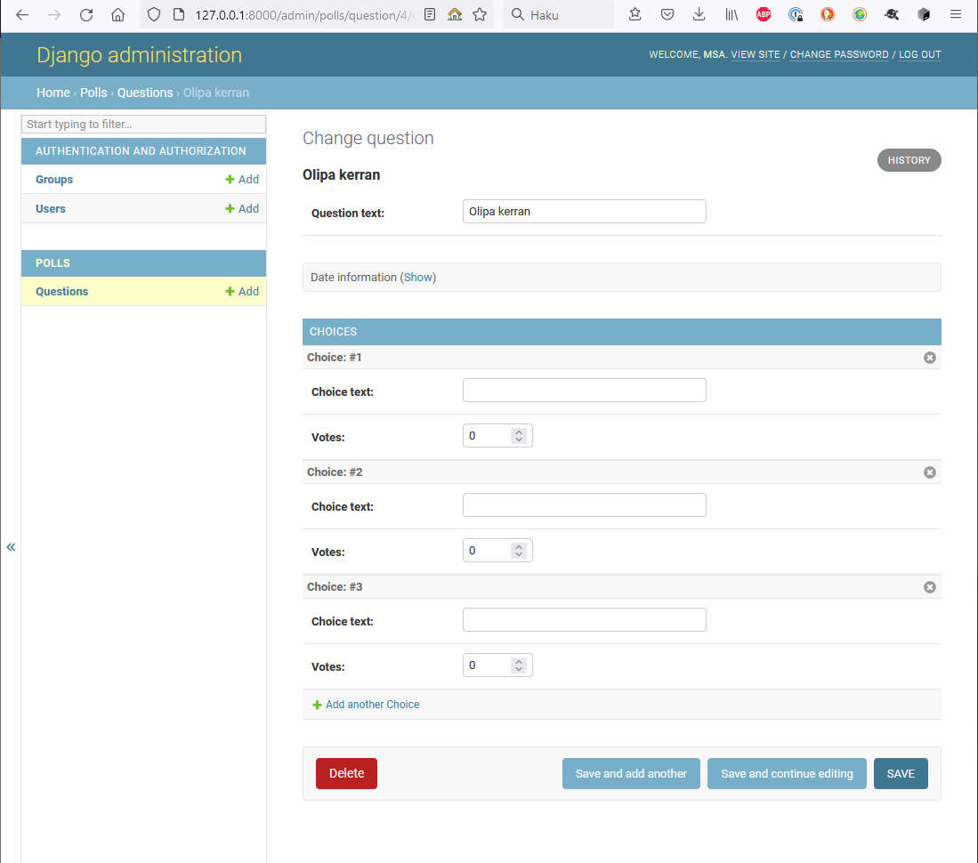

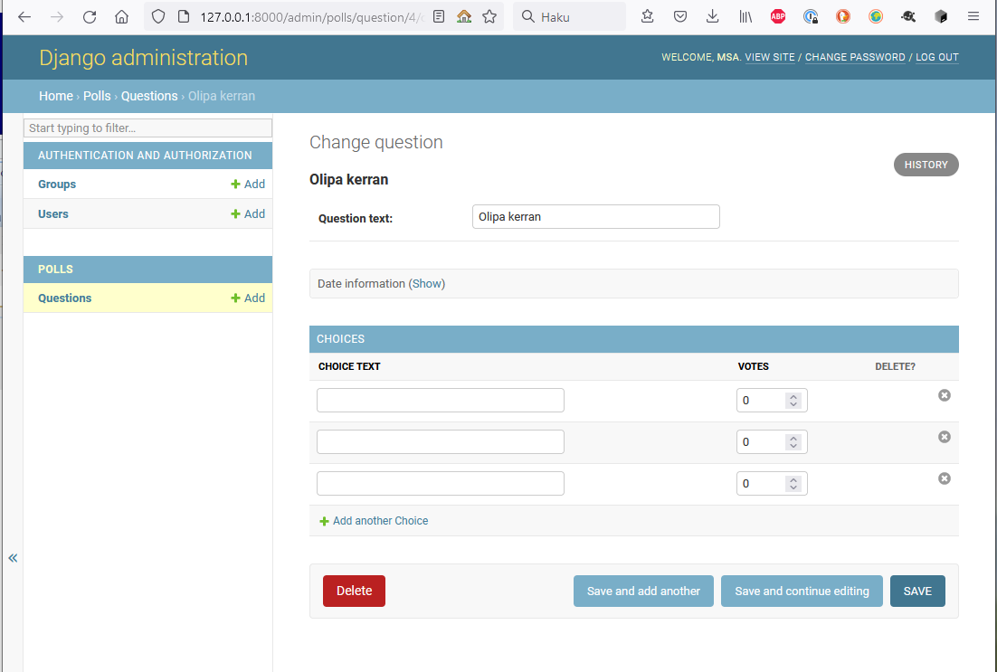

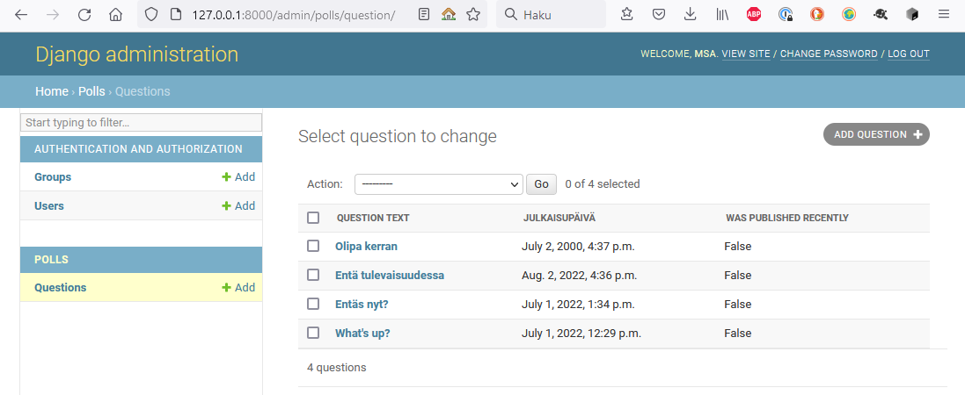

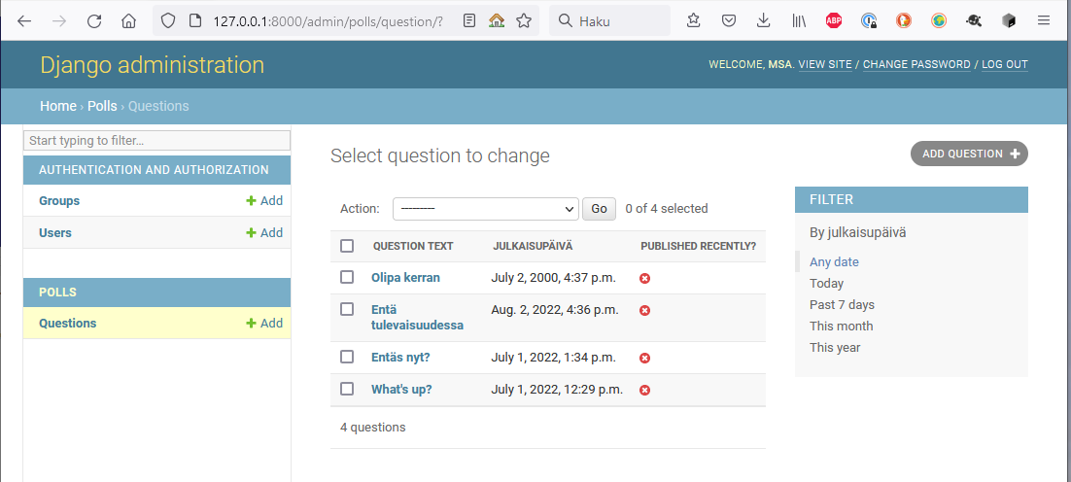

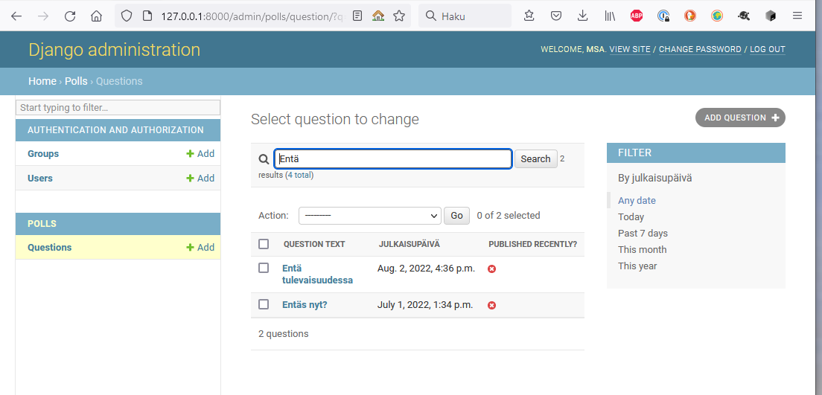

EI onnistu:

Then, edit the file and replace {{ site_header|default:_('Django administration') }} (including the curly braces) with your own site’s name as you see fit. You should end up with a section of code like:

Löydetty vika: TEMPLATES oli kahteen kertaan settings.py tiedostossa, jonka jälkeen tomiii

