COMSATS University Islamabad
Attock Campus

Department Of Computer Science

Course | MAD
Instructor | Sir Kamran
Assignment No. | 03

Group Members Details

Registration No. | Name
FA23-BSE-059 | Taimoor Shaikh

Mobile App Development
Assignment # 03

Question:

Title:
INSTAGRAM CLONE APP

1. Introduction
- This project is a mobile application developed using React Native (Expo) that replicates the core UI and functionality of Instagram.
- The app features three main screens: Home Feed, Search, and User Profile.
- It demonstrates understanding of React Native components, navigation, and modern mobile UI design patterns.

2. Objective
- Create multiple screens in a React Native app.
- Use React Navigation for screen navigation.
- Implement Tab Navigation.
- Recreate real-world mobile app layouts.
- Improve UI design, spacing, colors, icons, and component structure.

3. Technologies Used
- React Native
- Expo
- React Navigation
- @expo/vector-icons
- JavaScript (ES6+)
- React Hooks
- FlatList

4. App Features
- 3 Complete Screens (Home, Search, Profile)
- Tab Navigation between screens
- Instagram-like UI
- Story section with horizontal scroll
- Search functionality with filtering
- Profile with follow/unfollow
- Reusable components
- Pakistani dummy data integration

5. Screens Description
- Home Feed Screen with stories and posts feed.
- Search Screen with user filtering.
- Profile Screen with followers, following, and gallery.

6. Project Structure
- App.js – Main application
- components/ – Reusable components
- screens/ – App screens
- assets/ – Images and icons
- data/ – Dummy data

7. Installation & Setup
- Install Node.js and Expo Go.
- Create Expo app using create-expo-app.
- Install dependencies.
- Run project using expo start.

8. Code Explanation
- Tab Navigation implemented using React Navigation.
- useState hooks used for state management.
- Reusable components improved maintainability.

9. Screenshots
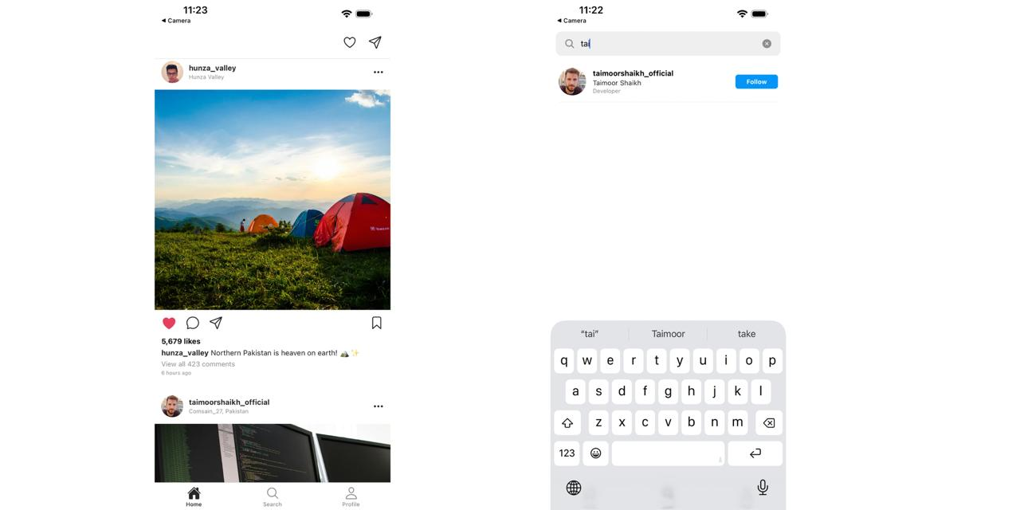
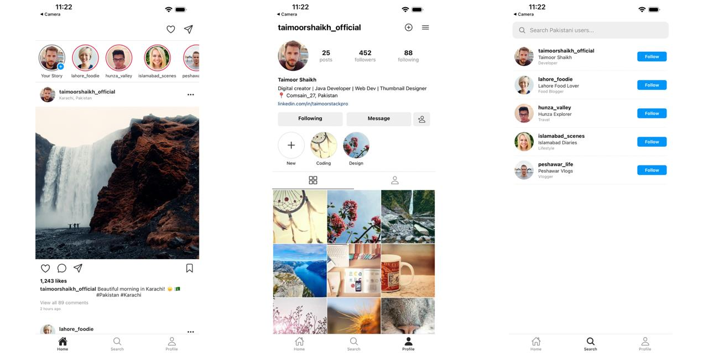

10. Challenges Faced
- Navigation setup issues.
- Image loading problems.
- State management handling.
- SafeAreaView deprecation.

11. Future Improvements
- Add Firebase backend.
- Implement messaging feature.
- Add dark mode.
- Enable push notifications.

12. Conclusion
- The Instagram Clone successfully demonstrates React Native concepts and navigation.
- The project fulfills all assignment requirements professionally.

13. References
- React Native Documentation
- Expo Documentation
- React Navigation Documentation
- Instagram UI Inspiration

