COMSATS University Islamabad
Attock Campus

Department Of Computer Science

Course | DevOps
Instructor | Sir Kamran
Project Title | Lab MID

Group Members Details

Registration No. | Name
FA23-BSE-059 | Taimoor Shaikh

Lab MID DevOps

Repository URL:
https://github.com/taimoor-stack/Lab_Mid_DevOps
Live Site URL:
https://taimoor-stack.github.io/Lab_Mid_DevOps/
(https://taimoor-stack.github.io/Lab_Mid_DevOps/)

1. Executive Summary & System Architecture
This project implements an end-to-end Continuous Integration and Continuous Deployment (CI/CD) pipeline for an Assignment Submission Portal. The system incorporates automated unit testing, local real-time report dispatch via SSH tunneling, conditional static deployment, and automated email notifications using repository secrets.
Architecture & Pipeline Overview
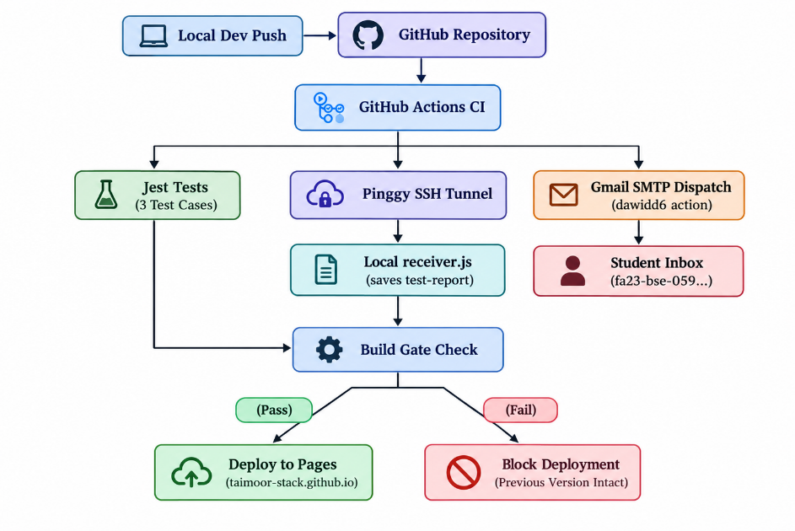

2. Project Setup & Directory Structure
2.1 Technology Stack
- Language & Runtime: Node.js (v20), Express.js framework.
- Testing Framework: Jest, Supertest.
- CI/CD Platform: GitHub Actions.
- Tunneling Utility: Pinggy SSH Tunneling.
- Hosting Platform: GitHub Pages (Static Frontend).
- Notification System: SMTP / Gmail App Passwords via GitHub Action Secrets.

2.2 Directory Structure
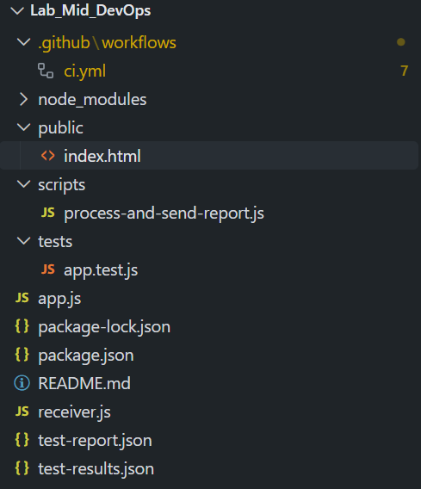

3. Assignment Submission Portal & Automated Testing
3.1 Portal Implementation
The application allows students to enter their name, registration number, assignment title, and submission URL. Validation rules enforce:
- All input fields must be non-empty.
- The submission URL must follow a valid URL pattern (http:// or https://).
- For static deployment on GitHub Pages (where no backend is active), client-side localStorage acts as a seamless fallback, rendering saved submissions directly to the UI.
3.2 Automated Test Suite Implementation
The project contains three automated Jest integration tests in tests/app.test.js:
const request = require("supertest");
const app = require("../app");

describe("Assignment Submission Portal API", () => {
// Test Case 1: Complete details and valid submission URL (MODIFIED TO FAIL)
test("Complete details and a valid submission URL", async () => {
const response = await request(app).post("/api/submissions").send({
name: "John Doe",
regNo: "SP21-BCS-001",
title: "DevOps Midterm",
url: "https://github.com/johndoe/devops-lab",
});

// INTENTIONAL FAILURE FOR VERIFICATION: Expected 201, changed to 500
expect(response.statusCode).toBe(201);
expect(response.body.submission).toBeDefined();
expect(response.body.submission.regNo).toBe("SP21-BCS-001");

const listRes = await request(app).get("/api/submissions");
expect(listRes.statusCode).toBe(200);
expect(listRes.body.length).toBeGreaterThan(0);
});

// Test Case 2: Missing registration number
test("Missing registration number", async () => {
const response = await request(app).post("/api/submissions").send({
name: "Jane Doe",
title: "DevOps Midterm",
url: "https://github.com/janedoe/devops-lab",
});

expect(response.statusCode).toBe(400);
expect(response.body.error).toBe("Missing required fields");
});

// Test Case 3: Invalid submission URL
test("Invalid submission URL", async () => {
const response = await request(app).post("/api/submissions").send({
name: "Alex Smith",
regNo: "SP21-BCS-002",
title: "DevOps Midterm",
url: "not-a-valid-url",
});

expect(response.statusCode).toBe(400);
expect(response.body.error).toBe("Invalid submission URL");
});
});

4. Local Report Receiver & Pinggy Tunnel Setup
4.1 Local HTTP Receiver (receiver.js)
receiver.js listens on local port 5000. When GitHub Actions sends execution results, it updates test-report.json with repository details, commit SHA, execution timestamp, test breakdown, and overall pipeline status.

4.2 Tunneling Configuration
To allow GitHub-hosted runners to communicate with local machine port 5000, Pinggy establishes a secure tunnel:
npx pinggy -l 5000

The generated HTTPS tunnel endpoint is stored as the RECEIVER_URL repository secret on GitHub.

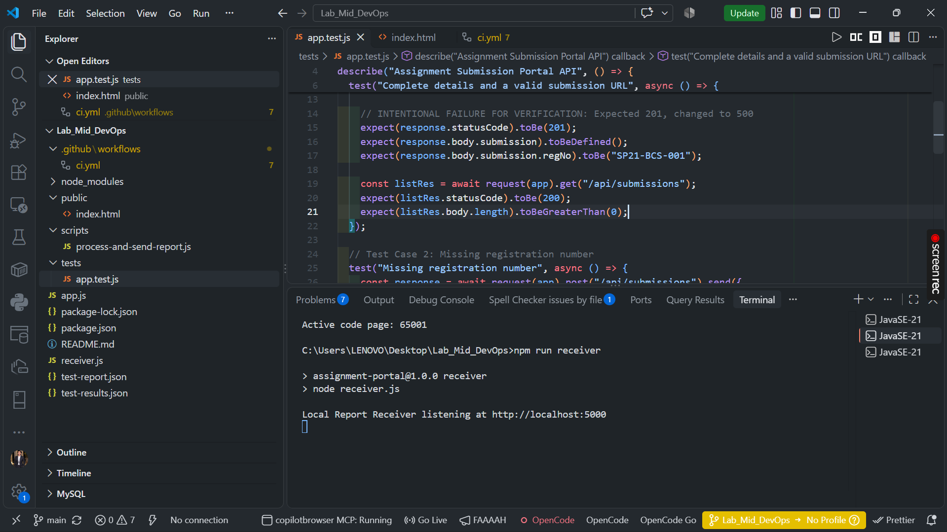

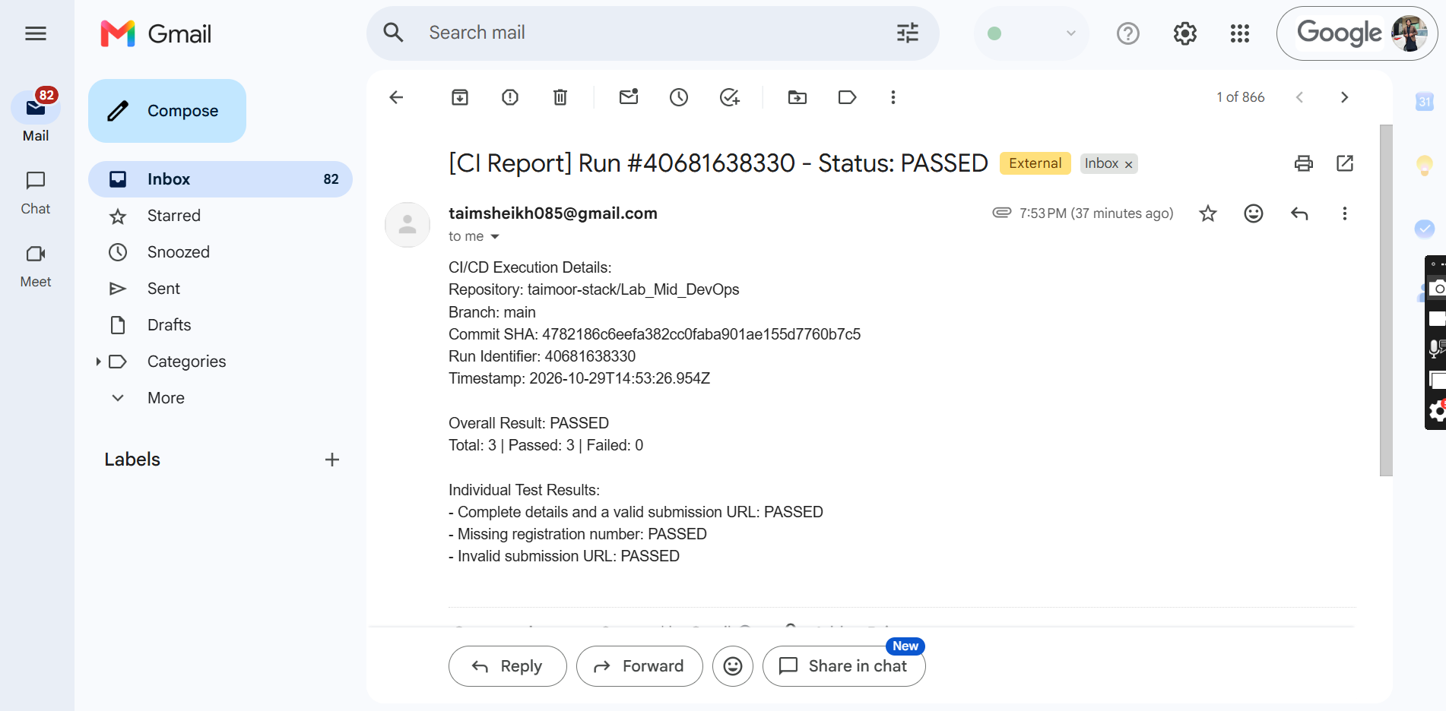

5. CI/CD Workflow Specification (ci.yml)
name: CI Assignment Portal

on:
push:
branches: [ "main" ]

permissions:
contents: read
pages: write
id-token: write

concurrency:
group: "pages"
cancel-in-progress: false

jobs:
test-and-report:
runs-on: ubuntu-latest
steps:
- name: Checkout Repository
uses: actions/checkout@v4

- name: Setup Node.js
uses: actions/setup-node@v4
with:
node-version: '20'

- name: Install Dependencies
run: npm ci

- name: Execute Automated Test Suite
id: run_tests
continue-on-error: true
run: npm test

- name: Generate and Dispatch Test Report
if: always()
env:
RECEIVER_URL: ${{ secrets.RECEIVER_URL }}
EMAIL_USER: ${{ secrets.EMAIL_USER }}
EMAIL_PASS: ${{ secrets.EMAIL_PASS }}
EMAIL_TO: ${{ secrets.EMAIL_TO }}
run: node scripts/process-and-send-report.js

- name: Send Test Report Email (Bonus Task)
if: always()
uses: dawidd6/action-send-mail@v3
with:
server_address: smtp.gmail.com
server_port: 465
secure: true
username: ${{ secrets.EMAIL_USER }}
password: ${{ secrets.EMAIL_PASS }}
subject: "CI Test Report - ${{ github.repository }} [${{ github.sha }}]"
to: ${{ secrets.EMAIL_TO }}
from: "GitHub Actions CI <${{ secrets.EMAIL_USER }}>"
body: |
Automated CI Test Run Completed.

Repository: ${{ github.repository }}
Branch: ${{ github.ref_name }}
Commit SHA: ${{ github.sha }}
Workflow Run ID: ${{ github.run_id }}

Please review the attached test-report.json file for complete test results.
attachments: test-report.json

- name: Fail Pipeline on Test Failure
if: steps.run_tests.outcome != 'success'
run: |
echo "Automated tests failed."
exit 1

deploy-pages:
name: "Bonus Task: Conditional Deploy to GitHub Pages"
needs: test-and-report
if: github.ref == 'refs/heads/main' && success()
runs-on: ubuntu-latest
steps:
- name: Checkout Repository
uses: actions/checkout@v4

- name: Setup GitHub Pages
uses: actions/configure-pages@v4

- name: Upload Static Frontend Artifact
uses: actions/upload-pages-artifact@v3
with:
path: './public'

- name: Deploy Artifact to Pages
id: deployment
uses: actions/deploy-pages@v4

6. Pipeline Demonstration & Verification
6.1 Successful Run Demonstration
When a commit contains valid application code and passing tests:
- Execute Automated Test Suite passes all 3 Jest test cases.
- Generate and Dispatch Test Report transmits output to local receiver.js.
- Send Test Report Email emails test-report.json to the target address.
- deploy-pages executes, updating the live GitHub Pages application.

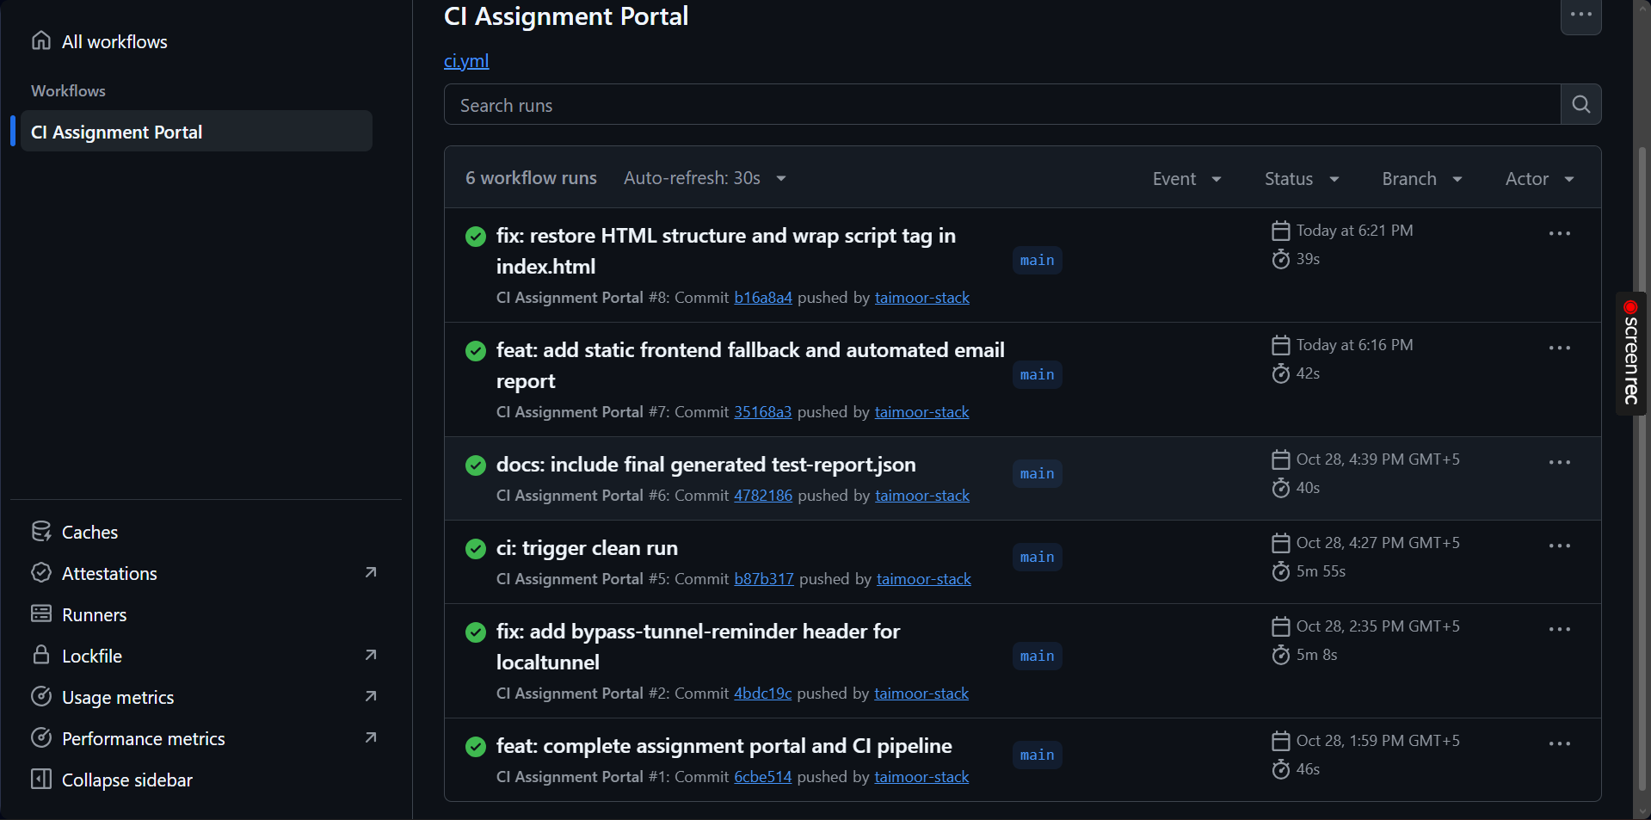

7. Bonus Tasks Implementation
7.1 Bonus Task 1: Conditional GitHub Pages Deployment (+5 Marks)
- Strategy: The deployment job uses if: github.ref == 'refs/heads/main' && success() and depends on needs: test-and-report.
- Live Application URL: [https://taimoor-stack.github.io/Lab_Mid_DevOps/](https://taimoor-stack.github.io/Lab_Mid_DevOps/)[cite: 10]
- Client-side Storage: Static HTML/JS validates inputs and stores state in browser localStorage when no Node.js backend is hosted on Pages.
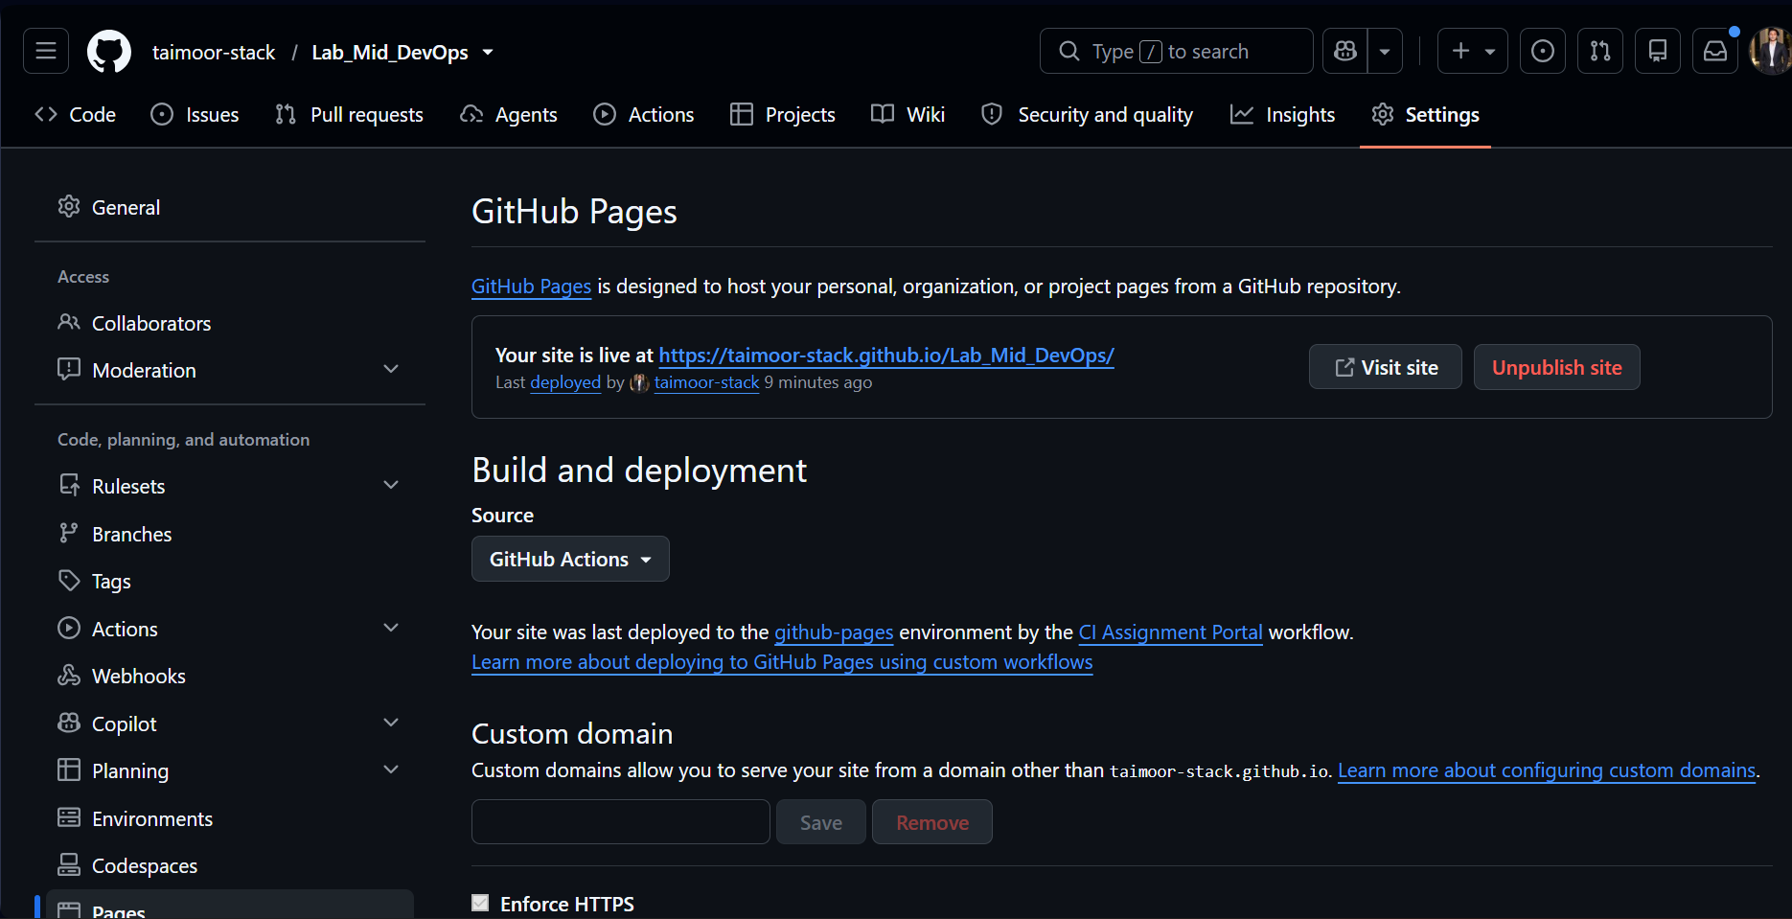

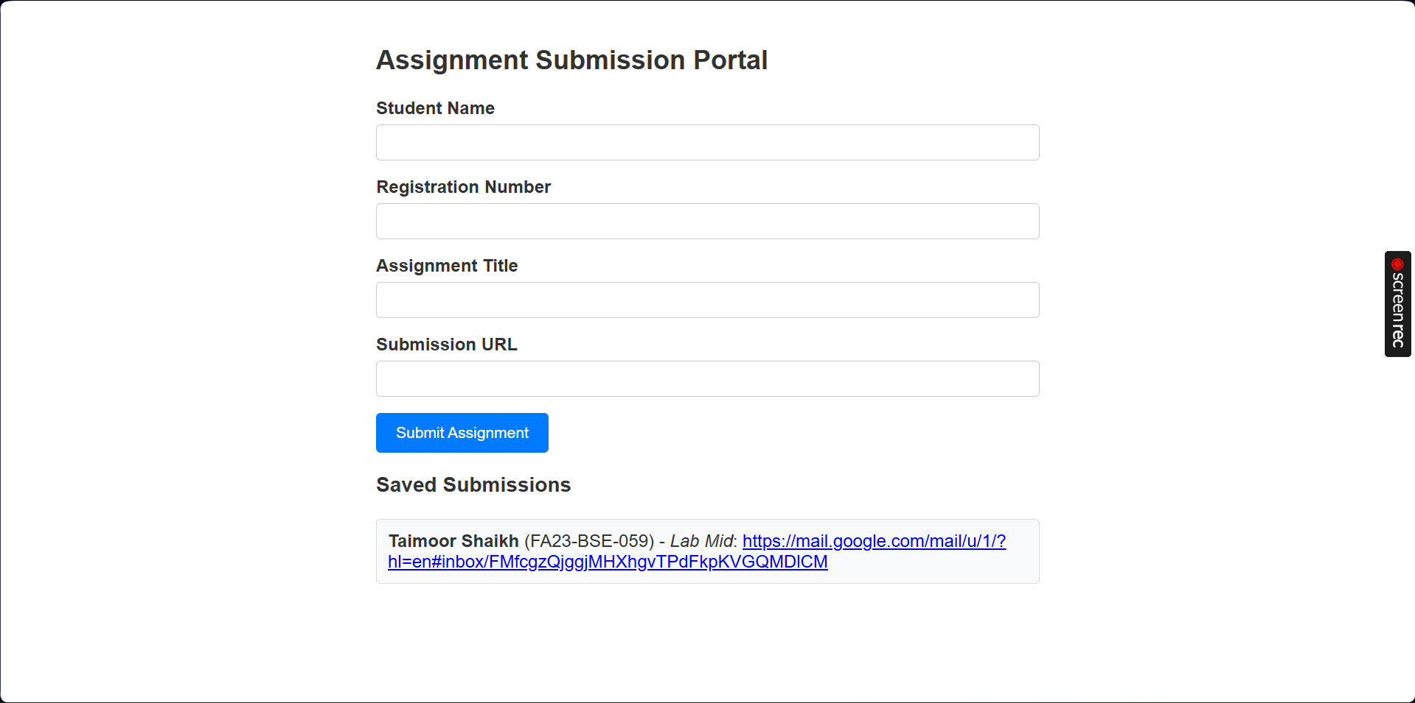

7.2 Bonus Task 2: Custom Email Report (+5 Marks)
- Configuration: Leverages dawidd6/action-send-mail@v3 via Gmail SMTP on SSL port 465.
- Credentials: Managed through encrypted GitHub Repository Secrets (EMAIL_USER, EMAIL_PASS, EMAIL_TO).
- Attachment: Automatically attaches the generated test-report.json file on every run.

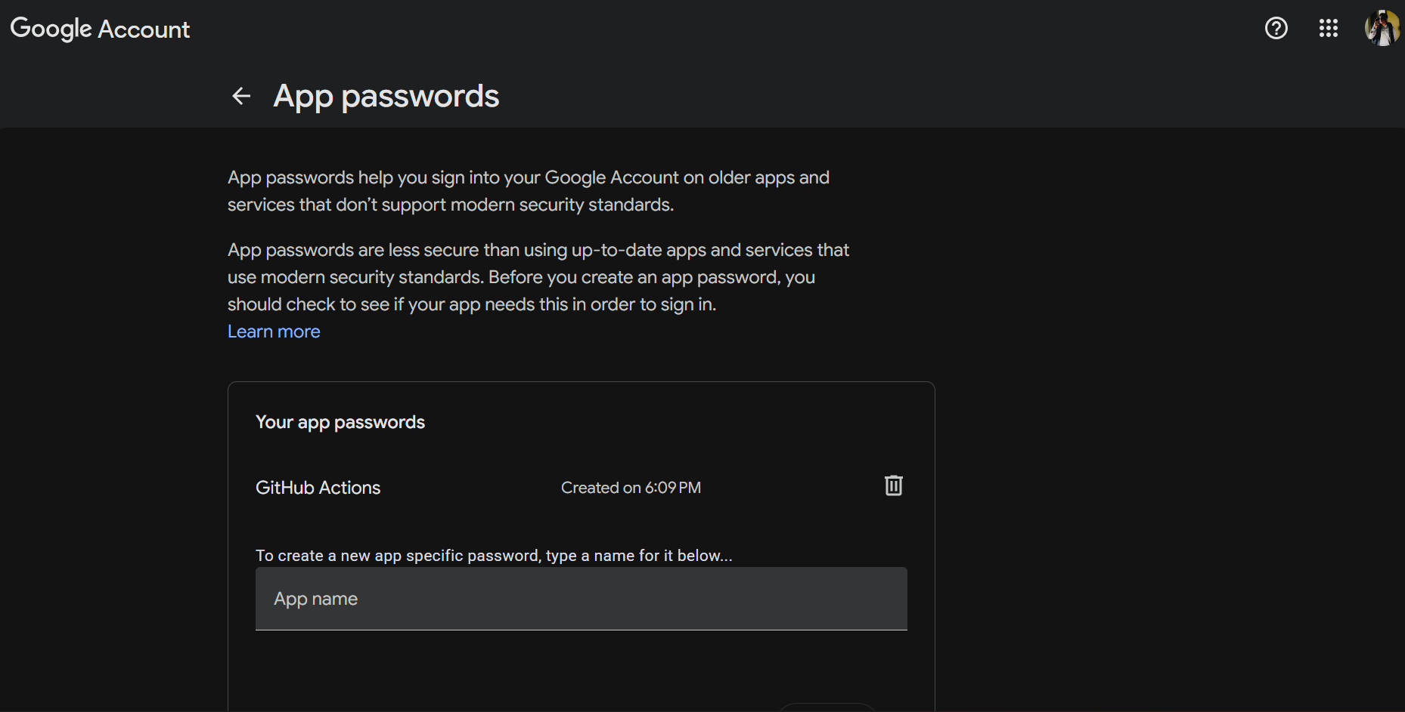

Secret:

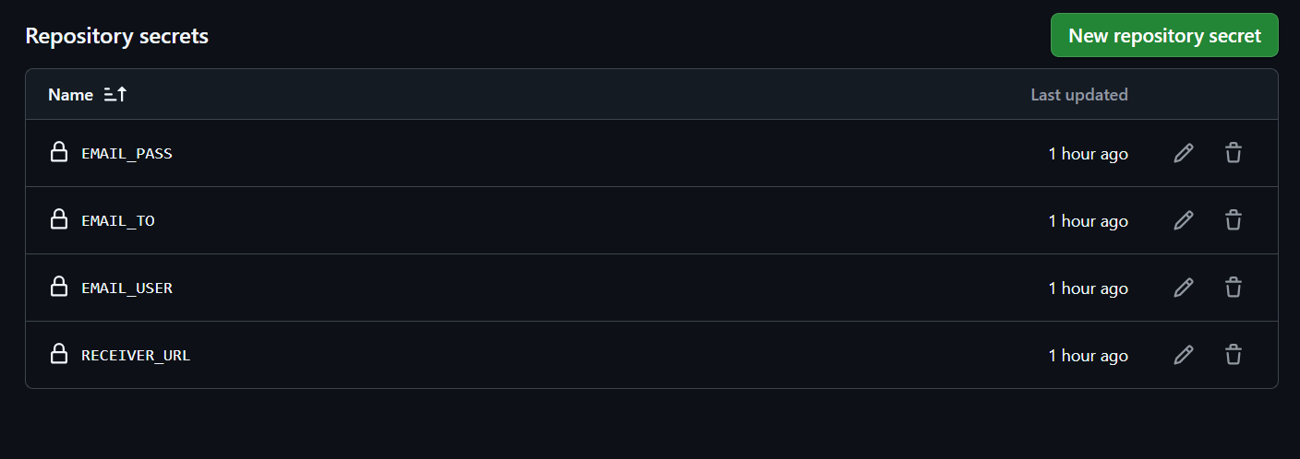

GitHub Repository:
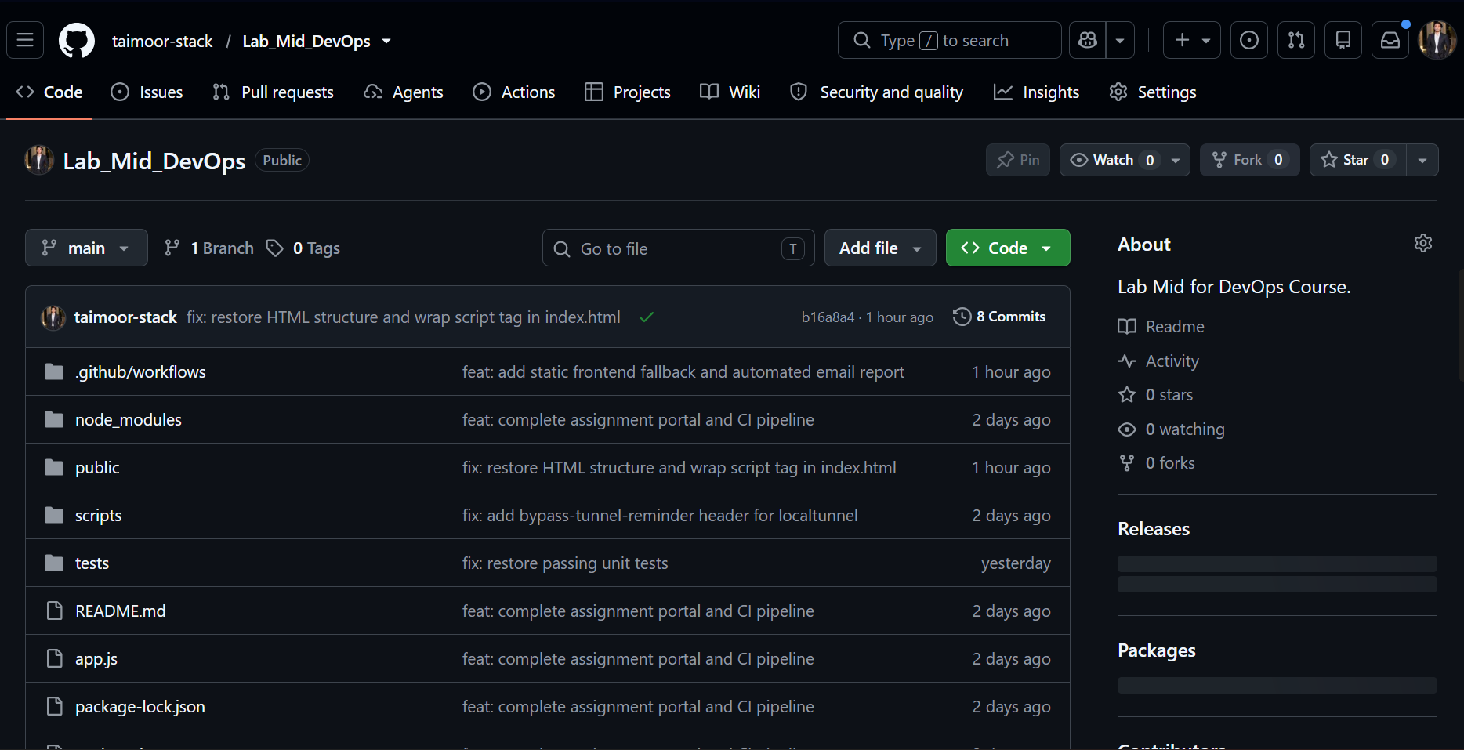

VS CODE:
