## Author

Developed by a beginner learning C++ dev

Taimoor Ashraf

SAP I’D 70173199

# Movie Recommender System - C++ Project

## Introduction

This project is a simple C++ console application that allows users to manage a collection of movies. Users can add, update, delete, search, and display movies based on different criteria like mood, genre, or rating. All movie data is stored in and loaded from a file named 'movies.txt'. This project demonstrates basic concepts of C++ programming, including file handling, vectors, structures, and control flow.

## Features

1. Add new movies to the collection.

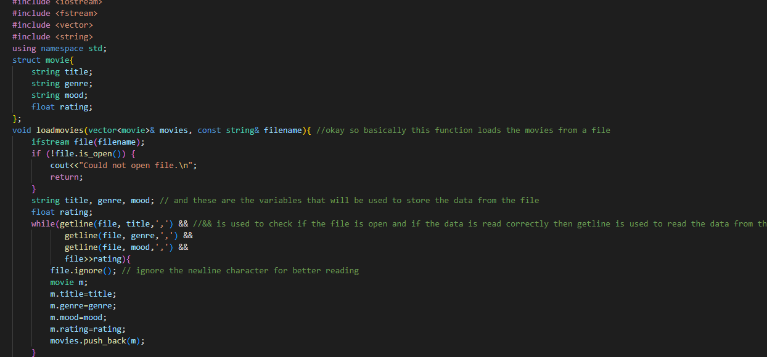2. View all stored movies.

3. Update movie details by title.

4. Delete a movie by title.

5. Search movies by mood, genre, or rating.

6. Save and load movie data using file I/O.

## Technologies Used

- C++ programming language

- Standard Template Library (STL)

- File I/O operations using <fstream>

- Data handling using <vector> and <string>

## How to Run

1. Make sure you have a C++ compiler installed (e.g., g++, MSVC).

2. Save the source code in a file named 'main.cpp'.

3. Create an empty text file named 'movies.txt' in the same directory.

4. Compile the code:  
 g++ -o moviemanager main.cpp

5. Run the executable:  
 ./moviemanager (Linux/macOS) or moviemanager.exe (Windows)

## File Structure

- main.cpp: Source code file

- movies.txt: Data file to store movie records

## Example movie.txt Format

In 'movies.txt', each line represents a movie in the following format:

Title,Genre,Mood,Rating

Example:

Inception,Sci-Fi,Exciting,9.0