# Assignment No. 1

## Submitted by Taimoor Bin Khalid (32163)

## Introduction:

The assignment was about finding chains between all the words that has connection in the sense they are different because of one letter at maximum. Then we had to use these chains to solve two words i.e. convert first word to the second using these chains. So we can change only one letter at the maximum in one move. All the dictionary words were tested against every other word whether it was solvable or not and the results were compiled in 3 different files. Tasks like frequency distribution, longest chain are displayed on console screen.

NOTE: I’ve tested this for small number of words to avoid extra time wastage. It takes too long to run it for all the words in dictionary (102,448; using text file) but the solution is guaranteed correct, it’ll not crash and compile the correct results for any n numbers of words, just takes too long as it is not very well optimized. I’m attaching “testDictionary.txt” to test the functionality of program (original dictionary is named “dictionary.txt”). I’ve attached screenshots for smaller number of words (testDictionary.txt) as original one is taking too long to write the files and I’m sure they will not be completed by the deadline.

## What did I learn?

The main thing I learned from this assignment is time management. The time was very short (obviously because of other assignments too) so had to manage it between class breaks/other free slots. From programming perspective, I learned to use STL, problem solving technique by dividing the problem into sub-problems. I could’ve uploaded it on GIT repository too but it’s public and there is chance of plagiarism case so didn’t upload it. Otherwise I know how it works, used it in last semester to work on semester project collaboratively with other group members.

## How to Run my Application?

I used C++ to code my program. You can use visual studio to run it, just create a project and copy/paste dictionary.txt/testDictionary.txt (change the file name in main function accordingly) in the project directory and hit run. It’s done, the program will do the rest for you. ☺

## Results:

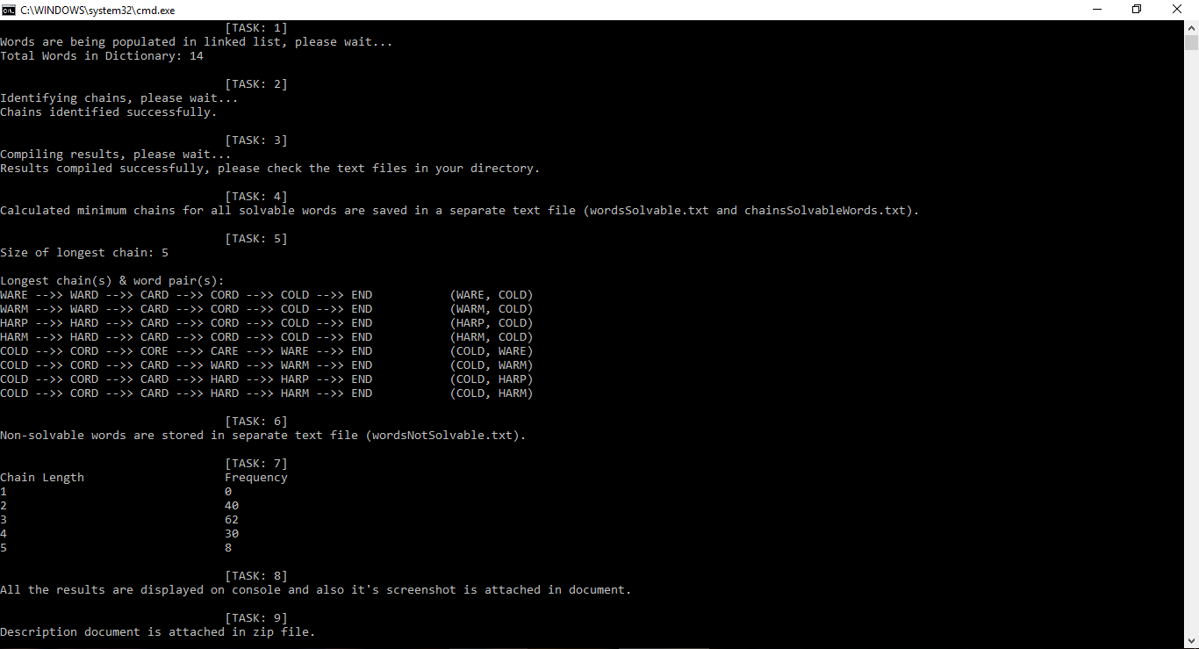



NOTE: Analysis files are attached in zip file.