**Steps**

**Download and Install python 2.7**

* Download python from the link below and install **(**[**https://www.python.org/ftp/python/2.7.14/python-2.7.14.amd64.msi**](https://www.python.org/ftp/python/2.7.14/python-2.7.14.amd64.msi)**)**

**Setup environment variables for Python**

* Right click my computer and go to Properties
* Click Advanced System Settings
* Click Environment Variables
* Click New in the System Variables section
* In Variable name field enter PYTHON_HOME
* In Variable value field C:\Python27
* Click OK

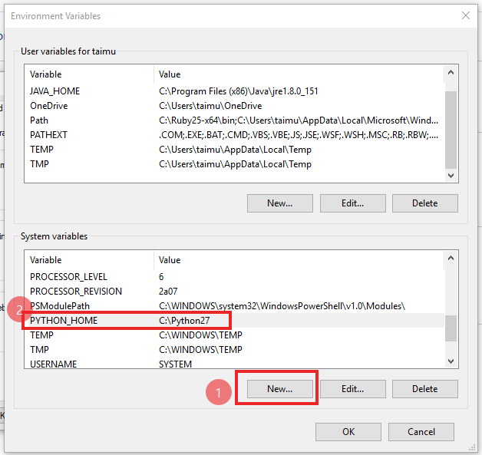

* Now in system variables find Path and double click to open it
* Click New
* Add C:\Python27\Scripts
* Click New again
* Add C:\Python27
* Click New again
* Add C:\Python27\Lib\site-packages\robot
* Now Click Ok

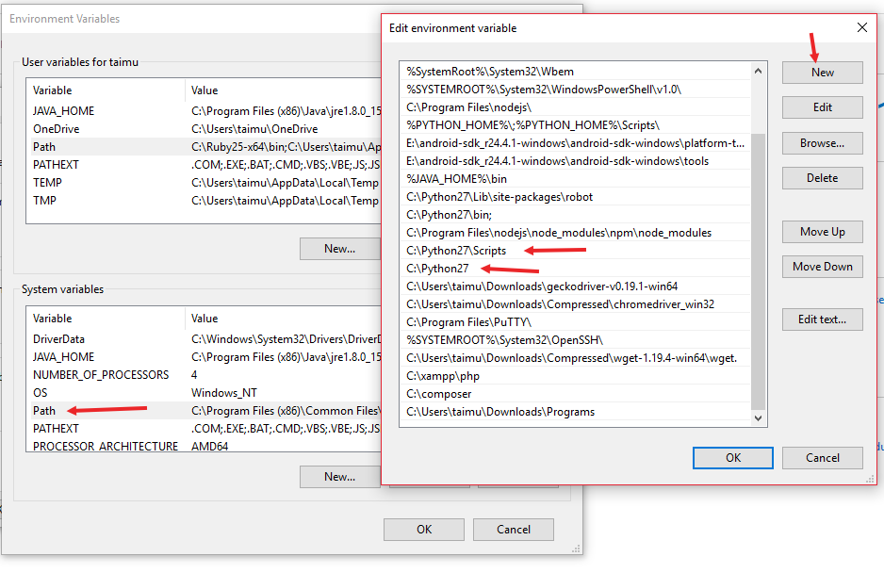

**Download and install pip**

* Download pip from <https://bootstrap.pypa.io/get-pip.py>
* Once the download is complete place it in D drive
* Now click start button
* Write cmd
* Open command prompt and write these commands
* D: (press enter)
* Python get-pip.py (Press Enter)
* Wait for the installation to complete

**Install Selenium**

* Open command prompt
* Run this command pip install –U selenium

**Install robot framework**

* In order to install pip open command prompt (cmd) again
* Paste this command pip install robotframework
* Wait for the framework to install

**Install atom**

* Download atom editor from the given link and open the robot files provided in atom (<https://atom.io/download/windows_x64>) (Optional)

**Download Chrome Driver**

* Download chrome driver and unzip the files (<https://chromedriver.storage.googleapis.com/2.41/chromedriver_win32.zip>)
* Now cut the exe file and place it in C:\Python27\Scripts

**Run the following commands in command prompt**

* pip install --upgrade robotframework-selenium2library
* pip install wheel
* pip install six
* pip install robotremoteserver
* pip install kitchen
* pip install setuptools

**How to Run Tests**

* Open command prompt
* robot (drag you test on top of command prompt) or
* Navigate to the location where your tests are located in command prompt
* E.g (tests are located in D\tests )
* Write cd D:\tests press enter
* Now write robot (your test name)
* robot test.robot