SZABIST
Shaheed Zulfikar Ali Bhutto Institute of Science & Technology
Department of Computing

PROJECT PROPOSAL
Sach Check
An Urdu Fake News Detector Using an Artificial Neural Network, Delivered Through WhatsApp

Course: Artificial Neural Networks (Lab)
Submitted by: Taimur Sultan
Student ID: ____________________
Submitted to: ____________________
Date: October 30, 2026

Abstract
Fake news in Urdu spreads quickly on WhatsApp, especially during floods, elections and health scares. Most fact-checking websites work in English, so ordinary Urdu readers have no easy way to check a message before they believe it or forward it. This project builds Sach Check, a tool that reads an Urdu news message and gives a score showing how likely it is to be fake.
We trained a feed-forward neural network on about 9,200 Urdu news items that journalists had already labeled as real or fake. Before training, we cleaned the data carefully: we removed empty and repeated rows, fixed broken labels, and made Urdu letters consistent. The final model correctly judged 85.9% of news items it had never seen before, better than the simpler models we compared it with.
The model will run on our own Linux server and connect to WhatsApp. A user forwards a message or a news link to the bot, the neural network scores it, and the bot replies in simple Urdu. A small language model writes the reply so each answer sounds a little different, but the decision always comes from our neural network.

1. Introduction

1.1 Background
In Pakistan, WhatsApp is one of the main ways people share news. Messages move from one family group to the next within minutes. Many of these messages are true, but many are rumours: fake government announcements, edited videos described as real, or false claims about health and medicine. Once a rumour spreads, it is hard to stop, and it can cause panic or real harm.

1.2 Problem Statement
An ordinary person who receives an Urdu news forward has no quick way to tell whether it is likely to be true. Fact-checking services mostly cover English news, and checking every message by hand takes time and skill that most people do not have. There is a need for a simple tool that works in Urdu, inside the app people already use, and gives a quick warning before a message is forwarded further.

1.3 Research Objectives
- Collect and clean a reliable labeled dataset of Urdu real and fake news.
- Train a feed-forward neural network that classifies Urdu news as likely real or likely fake.
- Compare the neural network with simpler models to show whether the extra layers actually help.
- Measure the model fairly with accuracy, precision, recall, F1 score and a confusion matrix.
- Make the model usable through a WhatsApp bot that accepts both text messages and news links.

1.4 Scope and Significance
Scope. The project covers news written in Urdu script. It judges a message by its wording and writing style. It does not check facts against other sources, and it does not handle English, Roman Urdu, images or videos.
Significance. Urdu is spoken by more than 230 million people, but very few tools exist to fight misinformation in this language. A tool that lives inside WhatsApp reaches people where rumours actually spread, and even a short warning such as “this looks like a rumour, please verify” can stop a message from being forwarded.

2. Literature Review
Research on Urdu fake news is still young. The first public dataset, Bend the Truth, had only 900 news articles, and it was used in the UrduFake shared tasks at FIRE 2020 and 2021, where teams tried different machine learning methods. These early datasets were small, so results did not carry over well to new kinds of news.
In 2023, Harris and colleagues released Ax-to-Grind Urdu, a much larger dataset of 10,083 news items from 15 subject areas, labeled by expert journalists. Using large transformer models, they reached an F1 score of 0.924. In 2026, Haroon pointed out a weakness in this dataset: fake items are, on average, much longer than real ones, so a model can partly “cheat” by looking at length instead of content. We took this warning seriously in our own method (see Section 3.4).
Our project differs from these studies in two ways. First, we use a smaller, easy-to-explain neural network instead of very large transformer models. Second, we focus on putting the model in people’s hands through WhatsApp, not only on reporting a score.

3. Proposed Methodology
We followed a simple path: understand the data, clean it, prepare it, train simple models first, then train the neural network and test everything fairly. Each step below explains the problem we found and how we solved it.

3.1 The Data
We used the Ax-to-Grind Urdu dataset, which is freely available on GitHub. Each row has an Urdu news item and a label: TRUE or FAKE. The news comes from Pakistani and Indian Urdu news websites between 2017 and 2023, and covers topics such as politics, health, sports, business and religion.

3.2 Step 1: Checking and Fixing the Data
Before training anything, we checked the file row by row. We found several problems that would have quietly hurt the model:
Problem we found | Why it matters | How we fixed it
22 completely empty rows | Empty rows carry no information | Removed them
47 labels with a hidden space, e.g. “TRUE ” | The computer treats “TRUE ” and “TRUE” as different labels | Trimmed the spaces
The header row repeated in the middle of the file | The file was made by joining two files | Removed that row
848 news items appearing twice | The same item could land in both training and testing, making the score look better than it is | Kept only one copy
All fake items first, then all real items | A split without shuffling would be unfair | Shuffled the data when splitting

After this step we had 9,235 news items: 4,637 fake and 4,598 real. The two groups are almost equal in size, which is ideal for training.

3.3 Step 2: Cleaning the Urdu Text
Raw text contains many things that do not help the model. We wrote one cleaning function and applied it to every news item. The same function will also clean WhatsApp messages later, so the model always sees text prepared in the same way.
- Links, numbers and punctuation removed. These rarely help decide whether news is real.
- Arabic letters changed to Urdu letters. Some letters look the same but have different computer codes (for example Arabic ي and Urdu ی). Without this step, the model would treat one word as two different words.
- Zer, zabar and pesh removed. So that کِتاب and کتاب count as the same word.
- News-agency tags removed. Some items begin with tags such as “کوئٹہ (آن لائن)”. These describe the source, not the news, so we removed them.
- English words kept in lowercase. Urdu news often uses English words like CPEC, so we kept them.

3.4 Step 3: Handling the Length Problem
When we counted words, we confirmed the problem reported by earlier research. Fake items averaged 116 words, while real items averaged only 33. Many fake items were full-length articles, while real items were mostly short headlines.
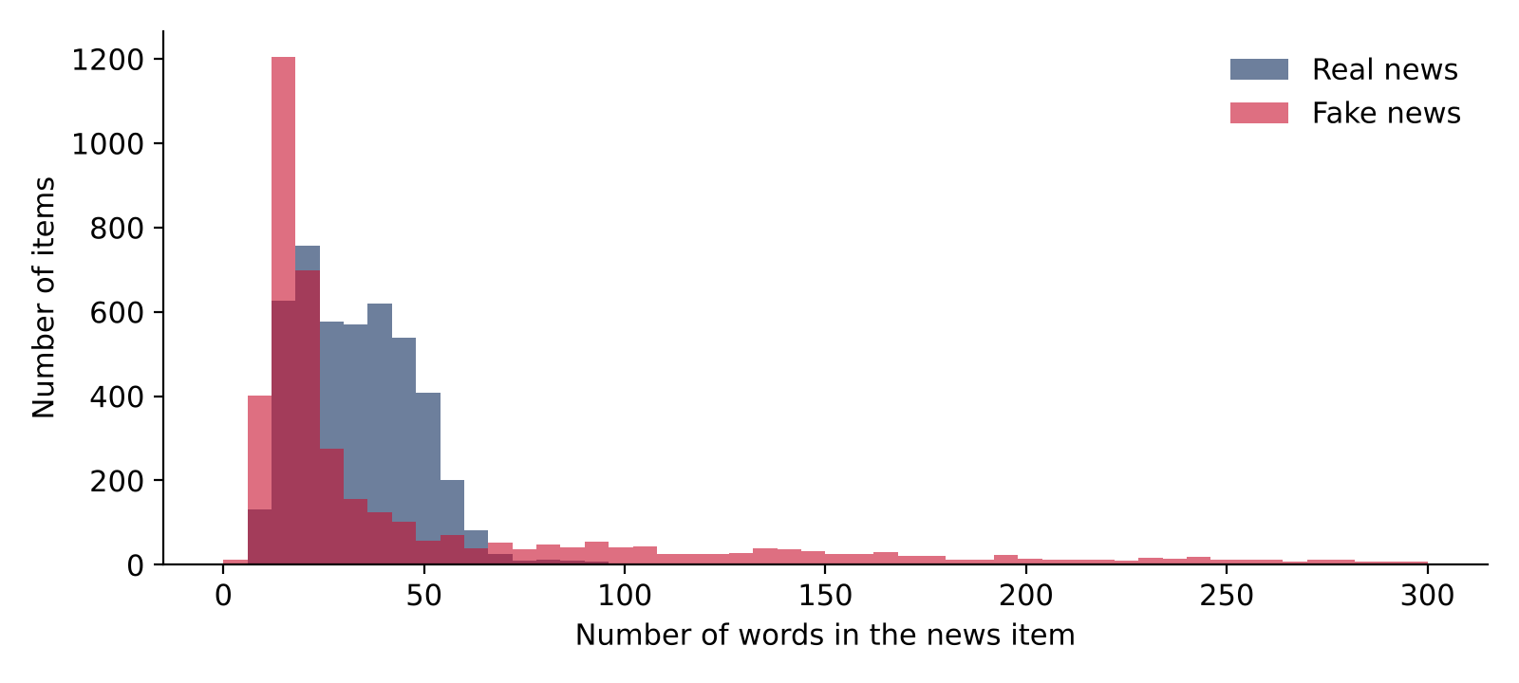
Figure 1: Fake items include many long articles, while real items are mostly short.
If we ignored this, the model could learn “long means fake”, which would fail badly on WhatsApp, where a long real message is common. To prevent this, we cut every news item to its first 40 words. This cost only about 1% in accuracy, but it forces the model to judge the words, not the length. It also makes the training text look more like real WhatsApp forwards.

3.5 Step 4: Splitting the Data
We divided the data into three parts. The model learns from the training set, we check its progress on the validation set, and we only use the test set once, at the very end, as a final exam. All three parts keep the same 50/50 mix of real and fake news.
Part | Items | Purpose
Training (70%) | 6,464 | The model learns from these
Validation (15%) | 1,385 | Checked after every round of training
Test (15%) | 1,386 | Final exam, never seen during training

3.6 Step 5: Turning Words into Numbers (TF-IDF)
A neural network can only work with numbers. We used TF-IDF to turn each news item into a list of 5,000 numbers, one for each of the 5,000 most common words. A word gets a high value when it appears often in this item but is rare in other items. Very common words, such as “کے” or “ہے”, get low values because they tell us little. The TF-IDF vocabulary was learned from the training set only, so no information from the test set leaked into training.

3.7 Step 6: Simple Models First
To know whether our neural network is truly useful, we first built two simple models to beat:
- Length only: a model that sees nothing but the word count. This tells us how far length alone can go.
- Logistic regression: a simple, well-known model that gives each word one weight.

3.8 Step 7: The Neural Network
Our main model is a feed-forward neural network with the following layers:
Layer | What it does
Input (5,000 values) | Receives the TF-IDF numbers of one news item
Hidden layer, 128 neurons (ReLU) | Finds useful patterns in the words
Dropout (50%) | Randomly switches off half the neurons while training, so the model cannot just memorise
Hidden layer, 64 neurons (ReLU) | Combines those patterns into bigger patterns
Dropout (50%) | Same as above
Output, 1 neuron (sigmoid) | Gives a number from 0 to 1: the chance that the news is fake

The model learned using the Adam optimiser and binary cross-entropy loss, which is the standard choice for yes-or-no problems. We also used early stopping: training stops automatically when the validation score stops improving, and the best version of the model is kept.
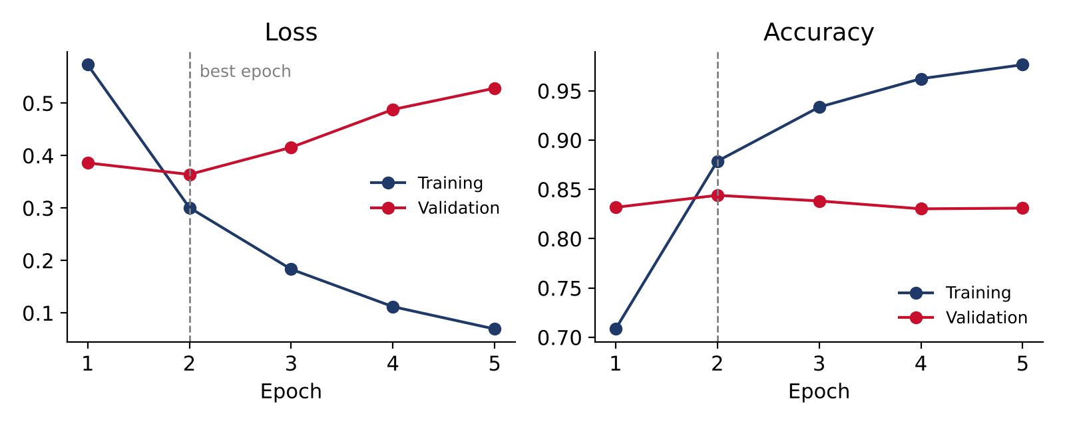
Figure 2: Training and validation curves. After epoch 2 the model starts memorising, so early stopping keeps the epoch-2 version.
Figure 2 shows overfitting clearly. Training accuracy keeps rising towards 98%, but validation accuracy peaks at epoch 2 and then slowly falls. This means the model had started memorising the training examples. Early stopping caught this and kept the best version.

3.9 Step 8: Testing
Finally, we tested all three models on the 1,386 test items. Accuracy alone can hide problems, so we also measured precision (when the model says “fake”, how often it is right), recall (how many of the fake items it catches) and the F1 score, which combines the two.

4. Tools Used
Tool | What we used it for
Python | The main programming language
Jupyter Notebook | Writing and running code step by step, with results and charts in one place
pandas | Loading the data, finding problems and cleaning rows
scikit-learn | Splitting data, TF-IDF, logistic regression and evaluation scores
TensorFlow / Keras | Building and training the neural network
Matplotlib | Drawing charts for the report
Flask | Running the model as a small web service on the server
Node.js + whatsapp-web.js | Connecting the system to WhatsApp
Small language model (LLM) | Writing friendly, varied replies in Urdu
GitHub and a Linux server | Storing the code and running the system all the time

5. How the WhatsApp System Works
The trained model and its TF-IDF vocabulary are saved to files, uploaded to GitHub, and then downloaded onto our Linux server. Two small programs run on the server all the time: the WhatsApp bot and the model service. When someone sends a message, this is what happens:
- A user forwards an Urdu news message, a news link, or both, to the bot’s WhatsApp number.
- If the message has a link, the server opens the page and takes the headline and first few lines.
- The text is cleaned and cut to 40 words, exactly as in training.
- The neural network gives a fake score between 0 and 1.
- Based on the score, the bot picks a reply type (see the table below).
- A small language model writes the reply in simple Urdu, so replies are not repeated word for word. If the language model is unavailable, the bot uses one of several ready-made replies instead.
Fake score | Verdict | Style of reply
0.75 or more | Likely fake | Friendly and lightly humorous, with a request not to forward
0.40 to 0.75 | Not sure | Neutral, asks the user to check a trusted news source
Below 0.40 | Looks like normal news | Calm, but still reminds the user to verify

Important rules. The neural network always makes the decision; the language model only writes the words. The bot never uses humour when a message is about death, injury, accidents or illness. It always says “likely”, never “definitely”, because the model judges writing style, not facts. It replies only in private chats, not in groups.

6. Results and Expected Results
The neural network achieved the best overall results on the test set:
Model | Accuracy | Precision | Recall | F1
Length only | 61.5% | 0.750 | 0.349 | 0.476
Logistic regression | 84.8% | 0.865 | 0.828 | 0.846
Neural network | 85.9% | 0.856 | 0.865 | 0.861

Length alone reached only 61.5%, so our models are clearly learning from the words, not just the length. The neural network beat logistic regression mainly by catching more fake news (recall 0.865 against 0.828).
Out of 1,386 test items, the neural network judged 1,191 correctly. It wrongly flagged 101 real items as fake, and missed 94 fake items. The two kinds of mistakes are almost equal, so the model does not lean towards one answer.
Expected results of the full system: a working WhatsApp bot that replies within a few seconds, handles both text and news links, gives a clear score-based warning, and writes a friendly, varied reply in Urdu.

7. Limitations
- It reads style, not truth. A carefully written fake that sounds like official news can still fool the model.
- It reacts to certain words. A message that warns people about a rumour can itself be flagged as fake, because it contains words like “جعلی خبر” (fake news).
- The dataset has source patterns. Real and fake items come from different websites, which sometimes spell the same word differently (for example لیے and لئے). The model partly learns these habits.
- News articles are not WhatsApp messages. The training data is news from 2017 to 2023. WhatsApp forwards are often shorter and messier, and new topics appear all the time.
- Urdu script only. English, Roman Urdu, images and videos are not checked.
- Some links cannot be opened. Facebook, Instagram and YouTube often hide content behind a login.
- WhatsApp rules. whatsapp-web.js is an unofficial library, so the bot uses a separate SIM, not a personal number.

8. Data References
- Harris, S., Liu, J., Hadi, H. J., and Cao, Y. (2023). Ax-to-Grind Urdu: Benchmark Dataset for Urdu Fake News Detection. IEEE TrustCom 2023. Data: github.com/Sheetal83/Ax-to-Grind-Urdu-Dataset
- Haroon, M. A. (2026). Cross-Dataset Generalization in Urdu Fake News Detection: An Empirical Study with XLM-RoBERTa and a Length Confound Analysis.
- Amjad, M. et al. (2020). Bend the Truth: Benchmark Dataset for Fake News Detection in Urdu Language. Used in the UrduFake shared tasks at FIRE 2020 and 2021.

