DEPARTMENT OF ROBOTICS & ARTIFICIAL INTELLIGENCE
Total Marks: 7.5
Obtained Marks: ________

Artificial Neural Networks
(Lab)
Project Proposal
Last date of Submission: October 23, 2026
Project Title: Sach Check: Urdu Fake News Detector Using
Artificial Neural Networks, Delivered Through WhatsApp

Submitted To: Mr. Hasaan Mujtaba
Student Name: Taimur Sultan
Registration Number: 24108145

DEPARTMENT OF ROBOTICS & ARTIFICIAL INTELLIGENCE
Sach Check: Urdu Fake News Detector Using
Artificial Neural Networks
Abstract. Fake news in Urdu spreads quickly on WhatsApp, and most fact-checking tools only work in English. This project builds Sach Check, a WhatsApp bot that reads an Urdu news message or news link and tells the user how likely it is to be fake. We trained a feed-forward neural network on the Ax-to-Grind Urdu dataset of journalist-labelled news [2]. Before training, we cleaned the data carefully and cut every item to its first 40 words, because fake items in this dataset are much longer than real ones and a model could otherwise “cheat” by looking at length [3]. On 1,386 news items it had never seen, the network reached 85.9% accuracy and an F1-score of 0.861, beating a logistic regression baseline and a length-only baseline. The trained model runs on our own Linux server and answers on WhatsApp with a chart of the score and a short, friendly explanation written by a language model. The neural network always makes the decision; the language model only explains it. The system flags news for checking; it does not verify facts.
1. Introduction
1.1 Background
In Pakistan, WhatsApp is one of the main ways people share news. A message forwarded in one family group can reach thousands of people within hours. Many of these messages are rumours: fake government announcements, false health cures, or videos described with the wrong story. Most of this content is in Urdu, but most automatic fake news tools and datasets were built for English.
Research on Urdu fake news has grown from a first dataset of 900 articles [1] to more than 10,000 labelled news items [2]. This makes it possible to train a neural network that learns which words and writing styles are typical of rumours and which are typical of normal news reporting.
1.2 Problem Statement
An ordinary person who receives an Urdu news forward has no quick way to tell whether it is likely to be true. Checking every message by hand takes time and skill that most people do not have. There is a need for a simple tool that works in Urdu, lives inside the app people already use, and gives a quick, honest warning before a message is forwarded again.
1.3 Research Objectives
- To clean and prepare the Ax-to-Grind Urdu dataset, fixing broken rows, duplicates and Urdu letter differences.
- To train a feed-forward neural network that classifies Urdu news as likely real or likely fake.
- To compare the network fairly with two simpler baselines: a length-only model and logistic regression.
- To evaluate all models on unseen data using accuracy, precision, recall, F1-score and a confusion matrix.
- To deploy the model on a server and connect it to WhatsApp, so people can check text messages and news links.
1.4 Scope and Significance
Scope. The system checks news written in Urdu script, sent as text or as a link to a news page. It judges the wording and writing style of the message. It does not check facts against other sources, and it does not handle English, Roman Urdu, images or videos.
Significance. Urdu is spoken by more than 230 million people, but very few tools exist to fight misinformation in this language. A tool that lives inside WhatsApp reaches people exactly where rumours spread, and even a short warning such as “this looks like a rumour, please verify” can stop a message from travelling further.
2. Literature Review
2.1 Neural Networks for Text Classification
A common way to classify text is to turn each document into numbers with TF-IDF, which gives each word a weight based on how often it appears in a document and how rare it is overall, and then train a classifier on those numbers [6]. A feed-forward neural network adds hidden layers that can learn combinations of words, not just single words. Such networks are trained by backpropagation with an optimiser such as Adam [4], and techniques like dropout [5] and early stopping help prevent overfitting on small datasets.
2.2 Urdu Fake News Datasets and Studies
Amjad et al. [1] released Bend the Truth, the first Urdu fake news dataset, with 900 articles, which was later used in the UrduFake shared tasks. Harris et al. [2] released Ax-to-Grind Urdu, with 10,083 news items from 2017 to 2023 across fifteen subject areas, labelled by expert journalists; an ensemble of large transformer models reached an F1-score of 0.924 on it.
2.3 Research Gap
Haroon [3] found that fake items in Ax-to-Grind average about 117 words while real items average about 35, so models can score well by noticing length instead of content. Most studies also stop at a test score and never put the model in the hands of real users. This project addresses both points: it uses a small, explainable neural network with a length-controlled input, and it delivers the model through WhatsApp, where Urdu rumours actually spread.
3. Proposed Methodology
3.1 System Workflow
The project follows the workflow in Figure 1. The data is checked and cleaned, cut to a fixed length and split. Then two baselines and the neural network are trained, and all models are tested on the same unseen test set. The best model is saved together with its TF-IDF vocabulary and moved to the server.
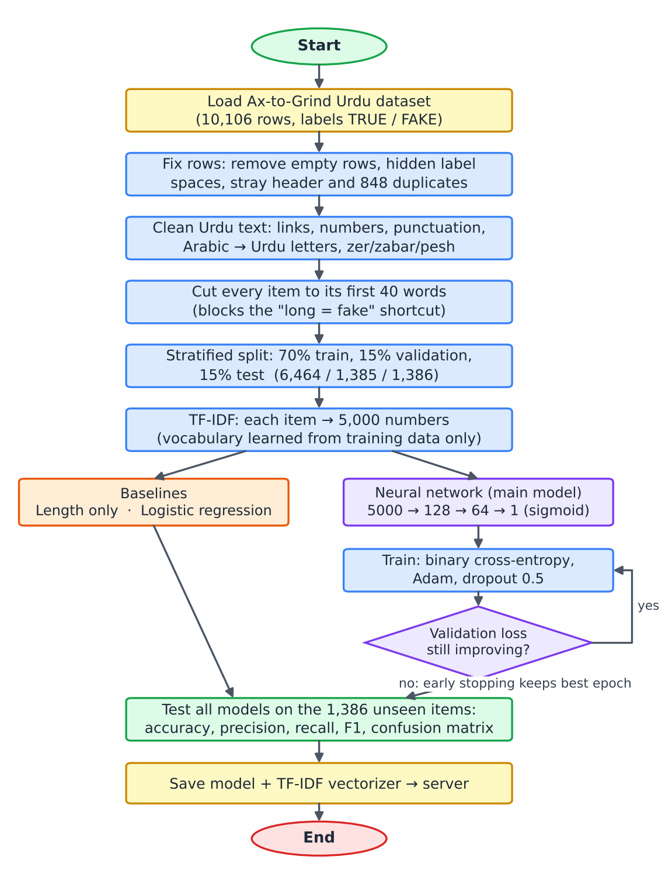
Figure 1. Training workflow of the Sach Check model.
3.2 Methodological Steps
Step 1 — Checking the data. Before training, we checked the file row by row and found several problems that would have quietly hurt the model (Table 1). After fixing them, 9,235 news items remained: 4,637 fake and 4,598 real, an almost perfect balance.
Problem found | Why it matters | How we fixed it
22 empty rows | They carry no information | Removed them
47 labels with a hidden space (“TRUE ”) | The computer treats them as a different label | Trimmed the spaces
Header row repeated in the middle | The file was made by joining two files | Removed that row
848 repeated news items | The same item could appear in both training and testing | Kept one copy only
All fake items first, then all real | An unshuffled split would be unfair | Shuffled when splitting
Table 1. Data problems and how they were fixed.
Step 2 — Cleaning the Urdu text. One cleaning function was written and applied to every item. It removes links, numbers and punctuation; changes Arabic letters that look the same as Urdu letters (for example ي → ی and ك → ک) so one word is not counted as two; removes zer, zabar and pesh; and removes news-agency tags at the start of an item. The same function is used again on the server for every WhatsApp message, so the model always sees text prepared in the same way.
Step 3 — Handling the length problem. We confirmed the problem reported in [3]: fake items averaged 116 words and real items 33 (Figure 2). To stop the model from learning “long means fake”, every item was cut to its first 40 words. This cost only about one percent of accuracy, and it also makes the training text look more like real WhatsApp forwards.
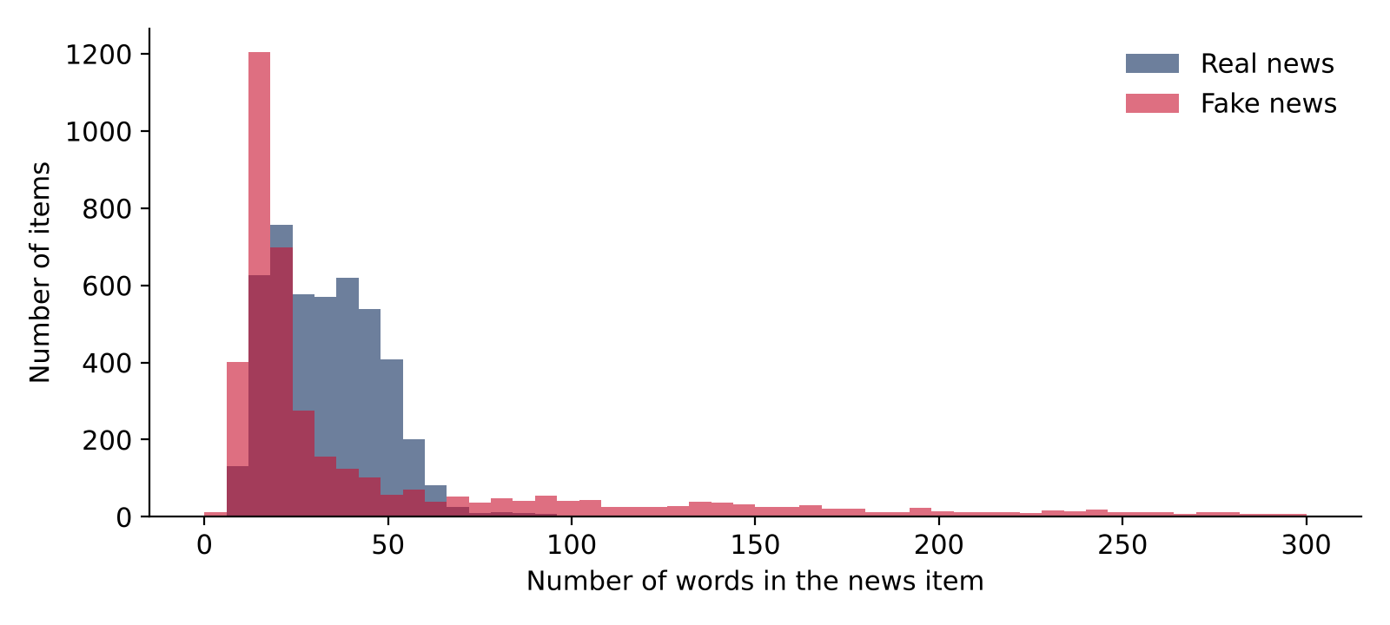
Figure 2. Word count of real and fake items before the 40-word cut.
Step 4 — Splitting. The data was split into training (70%, 6,464 items), validation (15%, 1,385) and test (15%, 1,386) sets, keeping the same fake/real balance in each part and using a fixed random seed so results can be repeated.
Step 5 — Turning words into numbers. TF-IDF turned each item into 5,000 numbers, one for each of the 5,000 most common words. The vocabulary was learned from the training set only, so no information from the test set leaked into training.
Step 6 — Baselines. Two simple models were trained first, as reference points the neural network must beat: a length-only model that sees nothing but the word count, and logistic regression on the TF-IDF numbers.
Step 7 — The neural network. The main model is a feed-forward network (Table 2). It was trained with binary cross-entropy loss and the Adam optimiser [4], in batches of 32, with early stopping when the validation loss stopped improving.
Layer | What it does
Input (5,000 values) | Receives the TF-IDF numbers of one news item
Dense, 128 neurons, ReLU | Finds useful patterns of words
Dropout 50% | Switches off half the neurons during training so the network cannot simply memorise [5]
Dense, 64 neurons, ReLU | Combines those patterns into bigger patterns
Dropout 50% | Same as above
Dense, 1 neuron, sigmoid | Outputs a number from 0 to 1: the chance the news is fake
Table 2. Layers of the feed-forward neural network (648,449 trainable weights).
Step 8 — Watching for overfitting. Figure 3 shows the training curves. Training accuracy kept rising towards 98%, but validation loss was lowest at epoch 2 and then increased, which is a clear sign of overfitting. Early stopping detected this and kept the weights from epoch 2.
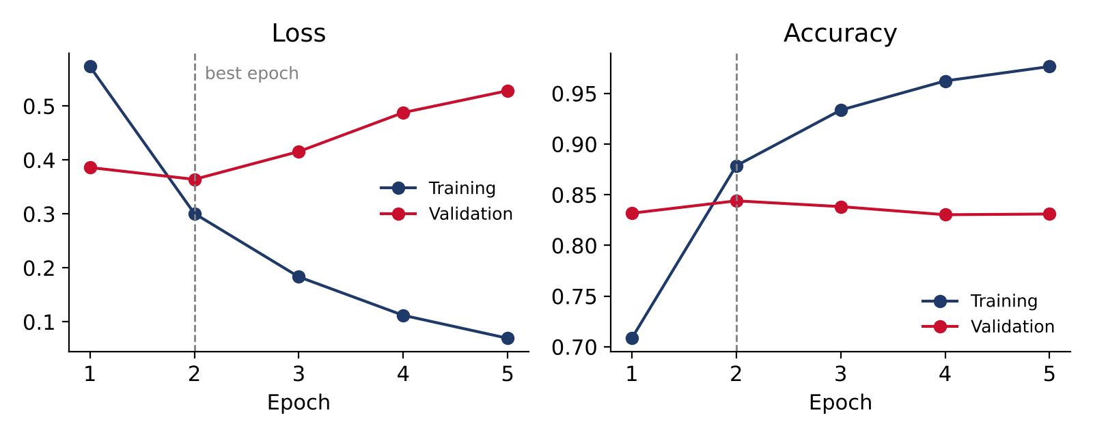
Figure 3. Training and validation loss and accuracy. Early stopping keeps the epoch-2 model.
Step 9 — Testing. All three models were tested once, at the end, on the 1,386 test items. Besides accuracy we measured precision (when the model says “fake”, how often it is right), recall (how many fake items it catches) and the F1-score, which combines both.
3.3 Theoretical Concepts
- TF-IDF: turning text into numbers that show how important each word is in one item compared with all items.
- Feed-forward network: layers of neurons where each neuron multiplies its inputs by weights, adds a bias and applies an activation function.
- Activation functions: ReLU in the hidden layers and sigmoid at the output to give a probability.
- Loss and optimisation: binary cross-entropy measures the error; backpropagation and Adam reduce it [4].
- Regularisation: dropout and early stopping to control overfitting [5].
- Shortcut learning: checking that the model learns words, not just length [3].
3.4 Tools and Technologies
Tool or technology | Purpose
Python, Jupyter Notebook | Writing and running the code step by step
Pandas, NumPy | Loading, checking and cleaning the data
Scikit-learn | Splitting, TF-IDF, logistic regression and evaluation scores [6]
TensorFlow and Keras | Building and training the neural network
Matplotlib | Charts and the verdict image sent on WhatsApp
Flask | Running the model as a small service on the server
Node.js and whatsapp-web.js | Connecting the system to WhatsApp [7]
Claude API (Anthropic) | Writing a short, friendly Urdu explanation [8]
Linux server, pm2, GitHub | Running the system all the time and updating the code
Table 3. Tools and technologies.
3.5 System Modules
Module | Responsibility | Output
Data Cleaner | Fixes rows, cleans Urdu text, cuts to 40 words | Clean dataset
Model Trainer | Builds TF-IDF, trains baselines and the network | Saved model and vocabulary
Evaluator | Computes scores and the confusion matrix | Results tables and charts
Link Reader | Opens a news link and takes the headline and first lines | Text to check
Model API | Cleans the message, runs the network, draws the chart | Fake score and chart
Reply Writer | Asks the language model for a short Urdu explanation | Friendly reply
WhatsApp Bot | Receives messages, checks the allow-list, sends replies | Verdict on WhatsApp
Table 4. System modules.
4. System Infrastructure
4.1 How the System Is Built
The trained model and its TF-IDF vocabulary are stored on GitHub and downloaded onto our Linux server. Two small programs run on the server all the time, kept alive by pm2 (Figure 4). The WhatsApp bot receives messages and decides who may use the system. The model API does the actual checking. Only the bot can reach the model API, because it listens inside the server only.
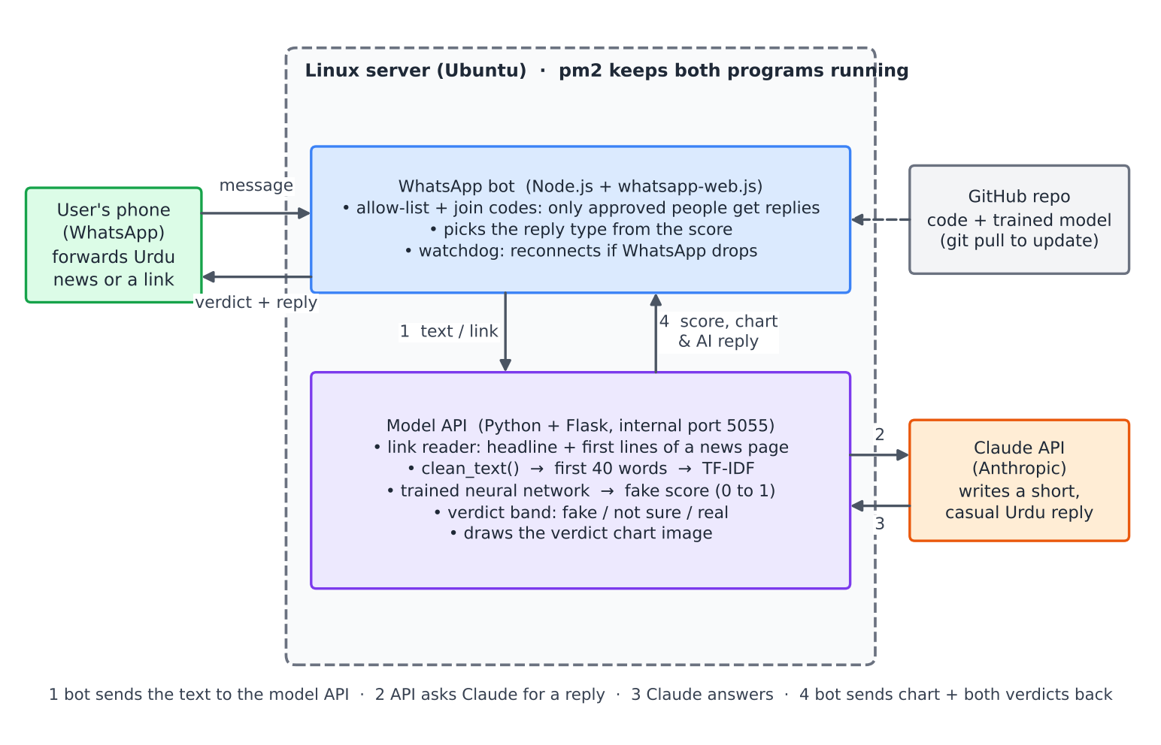
Figure 4. Infrastructure of the Sach Check system.
4.2 What Happens to One Message
- A user forwards an Urdu news message, a news link, or both, to the bot’s WhatsApp number.
- If there is a link, the server opens the page and takes its headline and first lines.
- The text is cleaned and cut to 40 words, exactly as during training.
- The neural network gives a fake score between 0 and 1, which decides the verdict (Table 5).
- The bot sends back two replies: the model verdict with a chart of the score, and a short, casual explanation in Urdu written by the language model.
Fake score | Verdict | Style of reply
0.75 or more | Likely fake | Friendly and lightly humorous, asks the user not to forward
0.40 to 0.75 | Not sure | Neutral, asks the user to check a trusted news source
Below 0.40 | Looks like normal news | Calm, but still reminds the user to verify
Table 5. Score bands and reply styles.
4.3 Safety and Reliability Rules
- The network decides, the language model explains: the language model is told the verdict and is not allowed to change it.
- No jokes on sad news: messages about death, accidents, illness or disasters always get a calm, respectful reply.
- Only approved people: the bot answers only people on its allow-list, who join with a secret code; everyone else and all groups are ignored.
- Honest wording: replies always say “likely”, never “definitely”, because the model judges style, not facts.
- Always connected: a watchdog checks the WhatsApp connection every minute and restarts it automatically if it drops, without a new login.
5. Results
5.1 Test Results
The neural network gave the best overall results on the 1,386 unseen test items (Table 6 and Figure 5).
Model | Accuracy | Precision | Recall | F1-score
Length only | 61.5% | 0.750 | 0.349 | 0.476
Logistic regression | 84.8% | 0.865 | 0.828 | 0.846
Neural network | 85.9% | 0.856 | 0.865 | 0.861
Table 6. Results on the test set.
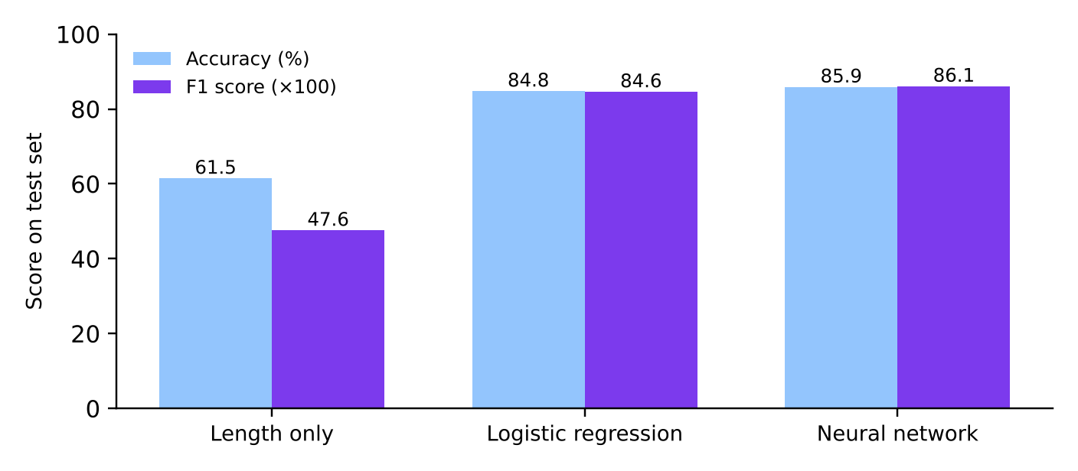
Figure 5. Accuracy and F1-score of the three models.
Length alone reached only 61.5%, so our models clearly learn from the words, not just the length. The network beat logistic regression mainly by catching more fake news (recall 0.865 against 0.828). Out of 1,386 test items it judged 1,191 correctly; it flagged 101 real items as fake and missed 94 fake items. The two kinds of mistake are almost equal, so the model does not lean towards one answer. The model running on the server gives exactly the same scores as the training notebook.
5.2 Evaluation Summary
Aspect | Test | Outcome
Classification quality | Accuracy, precision, recall and F1 on the test set | F1 0.861, above both baselines
Fake news detection | Recall on the fake class | 86.5% of fake items caught
Length shortcut | Length-only baseline and 40-word cut | Length alone: 61.5%; network: 85.9%
Overfitting | Training vs validation curves | Detected at epoch 2, stopped early
Real use | Live test on WhatsApp with text and links | Working end to end on our server
Table 7. Evaluation summary.
6. Limitations
The model reads writing style, not facts, so a carefully written fake that sounds like official news can still be judged real. It reacts to certain words: a message that warns people about a rumour can itself be flagged as fake because it contains words like “جعلی خبر” (fake news). Real and fake items in the dataset come from different websites, which sometimes spell the same word differently (for example لیے and لئے), and the model partly learns these habits. The training data is news from 2017 to 2023, while WhatsApp forwards are shorter and new topics appear all the time. The system only reads Urdu script, and some links, such as Facebook or YouTube, cannot be opened.
7. Future Work and Scalability
7.1 Improving the Model
- Sequence models: train an LSTM or a small transformer that reads word order, and compare it with the current network.
- More and newer data: add real WhatsApp forwards labelled by volunteers, and newer datasets such as Hook and Bait Urdu, so the model keeps up with new topics.
- Roman Urdu and English: add support for the way many people actually type on WhatsApp.
- Images and voice notes: read text from screenshots (OCR) and from voice notes (speech-to-text), since many rumours are shared as pictures.
- Fact-check links: match messages against known fact-checks from trusted sources and show the link to the correct news.
7.2 Making It Scalable
- Official WhatsApp Business API: move from the current personal-number setup to the official API, which supports many users without the risk of the number being blocked.
- Queue and more workers: put incoming messages in a queue and run several copies of the model service, so many checks can happen at the same time.
- Docker and the cloud: package each part in a container so it can run on any cloud server and grow when traffic grows.
- Caching: remember results for messages that were already checked, since the same rumour is forwarded thousands of times.
- Dashboard: show which rumours are spreading most, which can help journalists and authorities respond faster.
7.3 Reaching More People
- Public bot number: share one number that anyone can message, with the join code removed.
- Partnerships: work with universities, news channels and fact-checking groups to promote the number and label new data.
- Other apps and languages: add Telegram and Facebook Messenger, and later Pashto, Sindhi and Punjabi.
- Awareness: short videos and posters showing people how to forward a message to Sach Check before sharing it.
Phase | Goal | Main work
Short term | Better accuracy on WhatsApp | Collect real forwards, add Roman Urdu, try an LSTM
Medium term | Handle more users | Official WhatsApp API, queue, Docker, caching
Long term | Reach the public | Public number, partnerships, more apps and languages
Table 8. Future roadmap.
References
[1] M. Amjad, G. Sidorov, A. Zhila, H. Gómez-Adorno, I. Voronkov and A. Gelbukh, “‘Bend the truth’: Benchmark dataset for fake news detection in Urdu language and its evaluation,” Journal of Intelligent & Fuzzy Systems, vol. 39, no. 2, pp. 2457–2469, 2020.
[2] S. Harris, J. Liu, H. J. Hadi and Y. Cao, “Ax-to-Grind Urdu: Benchmark dataset for Urdu fake news detection,” in Proc. 22nd IEEE Int. Conf. Trust, Security and Privacy in Computing and Communications (TrustCom), 2023. Data: github.com/Sheetal83/Ax-to-Grind-Urdu-Dataset.
[3] M. A. Haroon, “Cross-dataset generalization in Urdu fake news detection: An empirical study with XLM-RoBERTa and a length confound analysis,” arXiv:2607.14131, 2026.
[4] D. P. Kingma and J. Ba, “Adam: A method for stochastic optimization,” in Proc. 3rd Int. Conf. Learning Representations (ICLR), 2015, arXiv:1412.6980.
[5] N. Srivastava, G. Hinton, A. Krizhevsky, I. Sutskever and R. Salakhutdinov, “Dropout: A simple way to prevent neural networks from overfitting,” Journal of Machine Learning Research, vol. 15, pp. 1929–1958, 2014.
[6] F. Pedregosa et al., “Scikit-learn: Machine learning in Python,” Journal of Machine Learning Research, vol. 12, pp. 2825–2830, 2011.
[7] whatsapp-web.js, a WhatsApp Web client library for Node.js, wwebjs.dev.
[8] Anthropic, Claude API documentation, docs.claude.com.

