Lecture 6 Worksheet
Routers

CMSI 3550 | Networks and Internets

Part 1: Router Basics
1. What is a colocation facility (carrier hotel), and why is it important for the Internet?
________________________________________
________________________________________
2. Router capacity is defined as the number of ports multiplied by the speed of each port. The speed of a port is also called the ________________.

3. Calculate the total capacity for each router below.

Router | # Ports | Line Rate | Total Capacity
Home Router A | 4 | 100 Mbps
Home Router B | 4 @ 100 Mbps + 1 @ 1 Gbps | (mixed)
Enterprise | 48 | 10 Gbps
Modern Core | 288 | 400 Gbps
Next-Gen Core | 288 | 800 Gbps

4. Why is innovation in router capacity currently focused on improving line rate rather than adding more ports?

Part 2: Router Planes
5. Fill in the table below describing the three planes of a router.

Plane | Primary Function | Time Scale | Example Task
Data
Control
Management

6. Fill in each router component’s description.

Component | Description
Chassis
Controller Card
Linecard
Forwarding Chip
Fabric

7. On the diagram below, trace the path of a user packet entering on Linecard 1 Port 1 and exiting on Linecard 3 Port P9. Label which components it passes through.
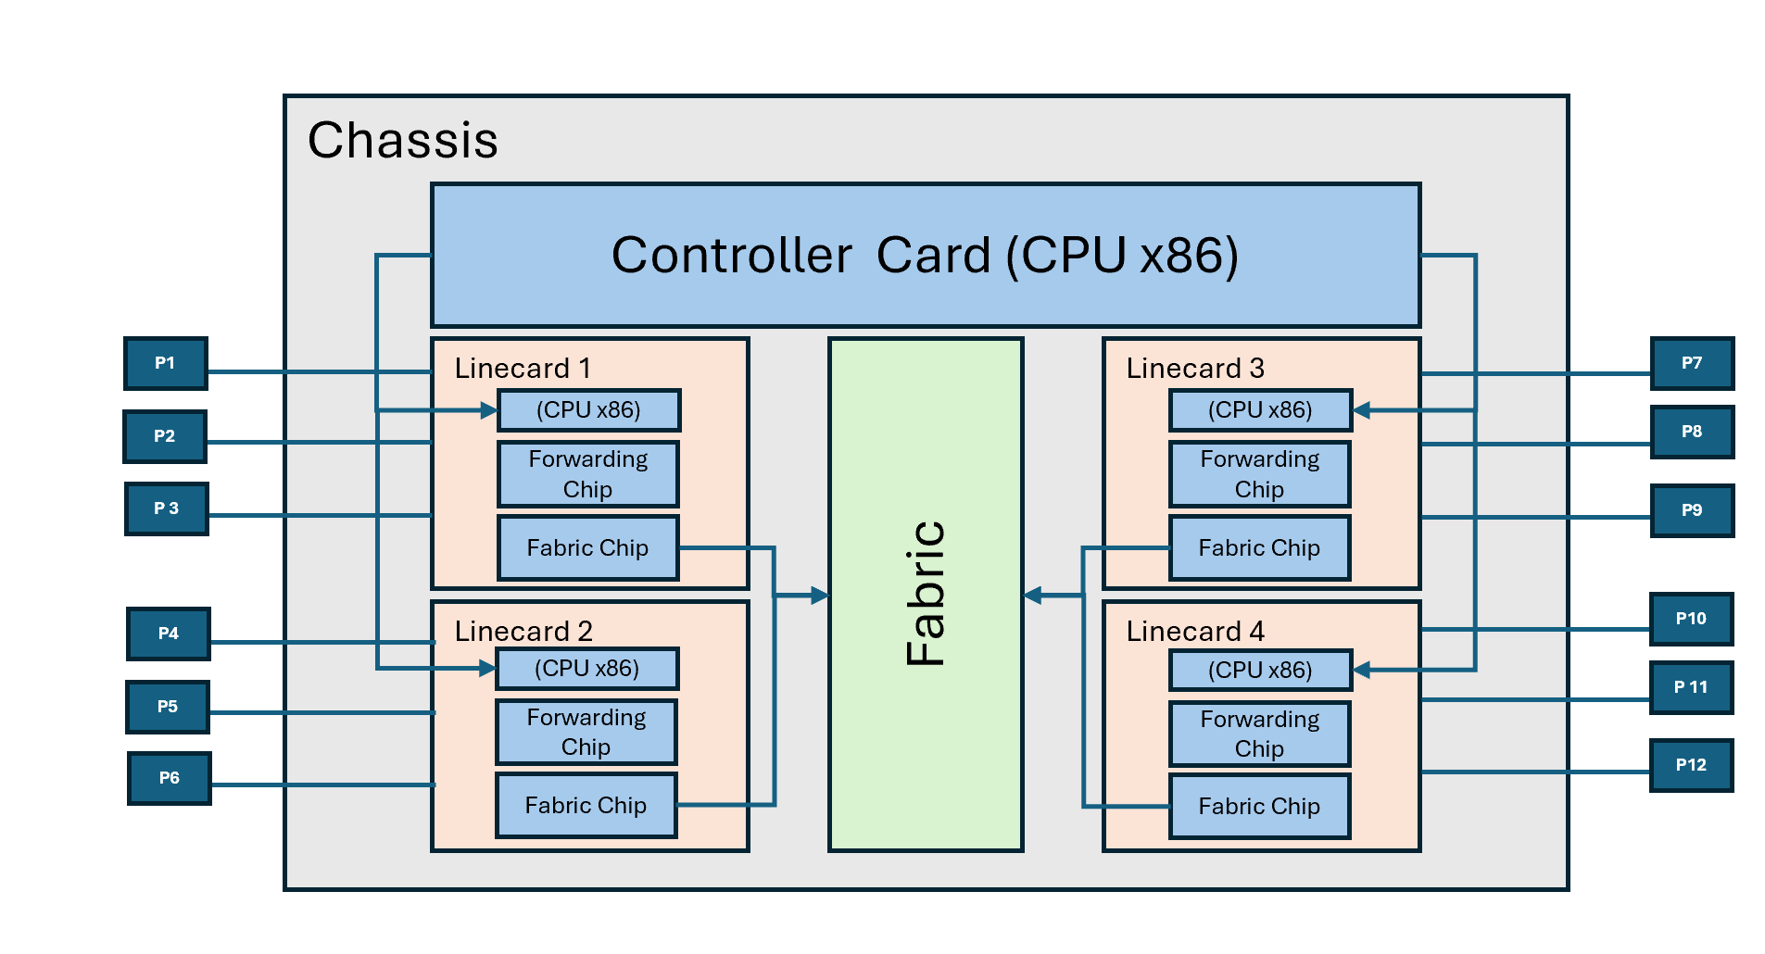
Path: ____________________________________________________________

Part 3: Packet Types
8. For each scenario, identify the packet type (user, control plane, or punt) and describe what happens inside the router.

Scenario | Packet Type | What Happens?
A web request packet arrives, destined for a server two hops away.
An OSPF link-state advertisement arrives from a neighboring router.
A packet arrives with TTL = 1.
A BGP update message arrives from a peer router.
A packet arrives that is too large and needs to be fragmented.

9. What is the difference between the "fast path" and the "slow path" in a router? Why does this distinction matter?
________________________________________
________________________________________
________________________________________

Part 4: Scaling and Hardware Forwarding
10. A router has 36 ports, each running at 400 Gbps. Assume minimum-size 64-byte packets.

a) How many packets per second must a single port handle?
Show your work:
________________________________________
________________________________________
b) How many packets per second must the entire router handle across all 36 ports?
Show your work:
________________________________________
c) How many nanoseconds does the router have to process each packet (per port)?
Show your work:
________________________________________
11. Why can't we use general-purpose software (e.g., a C program on a CPU) to forward packets at line rate?
________________________________________
________________________________________

Part 5: Forwarding Pipeline
12. Put the following forwarding pipeline stages in the correct order:
Actions (decrements TTL, recompute checksum, etc..), Fabric Interconnect, Lookup, MAC, Parse, PHY

Stage 1 | Stage 2 | Stage 3 | Stage 4 | Stage 5 | Stage 6

13. For each pipeline stage, briefly describe what it does and whether it runs on general hardware, the forwarding chip, or the fabric chip.
________________________________________
________________________________________
________________________________________
________________________________________
14. Which stage of the forwarding pipeline is the hardest to implement efficiently in hardware? Why?
________________________________________
________________________________________
15. The lecture describes three queuing decisions. Fill in the blanks with the simple default assumption for each:
a) Classification (which queue?): ________________
b) Buffer management (drop packets?): ________________
c) Scheduling (what order?): ________________

Part 6: Longest Prefix Match and Tries
16. Why can't we simply list every individual IP address on the forwarding table?
_____________________________________
________________________________________

17. Given the forwarding table below, determine the output port for each destination address using longest prefix match.
Prefix (Forwarding Table) | Port
10.0.0.0/8 | 1
10.1.0.0/16 | 2
10.1.1.0/24 | 3
192.168.0.0/16 | 4
0.0.0.0/0 (default) | 5

Destination Address | Matching Prefix(es) | Output Port
10.1.1.5
10.1.2.100
10.2.0.1
192.168.1.50
172.16.0.1

18. Consider the following binary trie built from this forwarding table:

Prefix (binary) | Port
0* (default) | 1
01* | 2
011* | 3
10* | 4
101* | 5

a) Draw the binary trie for this table in the space below. Mark nodes that are valid prefixes.

b) Using your trie, perform longest prefix match for each destination. Show which nodes you visit.

Destination | Nodes Visited | Output Port
0100
0110
1010
1100
0000

19. What is the runtime complexity of longest prefix match using a trie for IPv4 addresses? Explain why this is considered O(1).
________________________________________
________________________________________
________________________________________

Part 7: Putting It All Together
20. A network operator notices their router is dropping packets even though the CPU utilization is very low. The forwarding chip utilization is near 100%. Which plane is the bottleneck? Explain.
________________________________________
________________________________________
________________________________________
21. Why does the Internet generally avoid using complex IP options (e.g., source routing, record route) in practice?
________________________________________
________________________________________
22. True or False. Briefly explain each answer.

a) The control plane and management plane both run on the controller card. T / F
________________________________________
b) Every packet that arrives at a router is processed by the controller CPU. T / F
________________________________________
c) The fabric connects linecards to each other inside the router. T / F
________________________________________
d) A naive forwarding table lookup (scanning all entries) is O(log N). T / F
________________________________________
e) Longest prefix match in a trie visits at most 32 nodes for IPv4. T / F
________________________________________

