CMSI 3550 - Lecture 7 Worksheet
Inter-Domain Routing

Part 1: Autonomous Systems
Question 1: Vocabulary
Fill in the blanks with the correct term.

a) An __________________ is one or more local networks, all under a single administrative control.

b) Each AS is assigned a unique __________________ (abbreviation: ______).

c) A __________________ AS only sends/receives packets on behalf of hosts inside it. It does NOT forward packets between other ASes. Most ASes are this type. Example: a university.

d) A __________________ AS forwards packets on behalf of other ASes. Example: AT&T or Verizon.

e) Today, ASNs are assigned by __________________ (abbreviation: ______).

Question 2: Stub vs. Transit
For each of the following, indicate whether it is most likely a stub AS or a transit AS, and briefly explain why.

Entity | Stub or Transit? | Reasoning
Loyola Marymount University
AT&T
A local credit union
Verizon
A small startup company

Part 2: Business Relationships
Question 3: Relationship Types
a) In a customer-provider relationship, who pays whom, and what do they receive in exchange?
___________________________________________________________________________
___________________________________________________________________________
b) In a peering relationship, who pays whom? What is exchanged?
___________________________________________________________________________
___________________________________________________________________________

c) Why does the AS graph (considering only customer-provider edges) have no cycles?
___________________________________________________________________________
___________________________________________________________________________

Question 4: Reading an AS Graph
Consider the following AS graph. Arrows point from provider to customer. Double lines indicate peering.
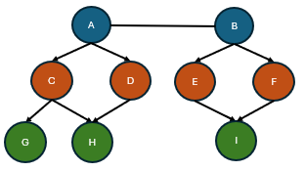

a) List all stub ASes in this graph.
___________________________________________________________________________

b) List all transit ASes in this graph.
___________________________________________________________________________

c) Which ASes are Tier 1? How can you tell?
___________________________________________________________________________
___________________________________________________________________________

d) If G wants to reach I, trace a valid path upward through the hierarchy. What path do packets take?
___________________________________________________________________________

e) D wants to send packets to F. Is the path D -> A -> B -> F valid under Gao-Rexford? Why or why not?
___________________________________________________________________________
___________________________________________________________________________

Part 3: Gao-Rexford Rules
Question 5: Route Preference
According to Gao-Rexford, if an AS receives route advertisements from a customer, a peer, and a provider. Rank them from most preferred to least preferred. Explain the business reasoning.
___________________________________________________________________________
___________________________________________________________________________
___________________________________________________________________________

Question 6: Participation Decisions
For each scenario below, determine whether AS B agrees to participate in forwarding packets along the given path. Apply the Gao-Rexford rule: B participates if and only if at least one of its neighbors on the path is a customer.

Path | A's relationship to B | C's relationship to B | B participates? (Y/N) | Explanation
A -> B -> C | Customer | Provider
A -> B -> C | Peer | Peer
A -> B -> C | Provider | Customer
A -> B -> C | Customer | Customer
A -> B -> C | Provider | Provider
A -> B -> C | Peer | Customer

Question 7: Valley-Free Routes
Gao-Rexford guarantees routes are "valley-free" and "single-peaked." Consider the following AS graph:
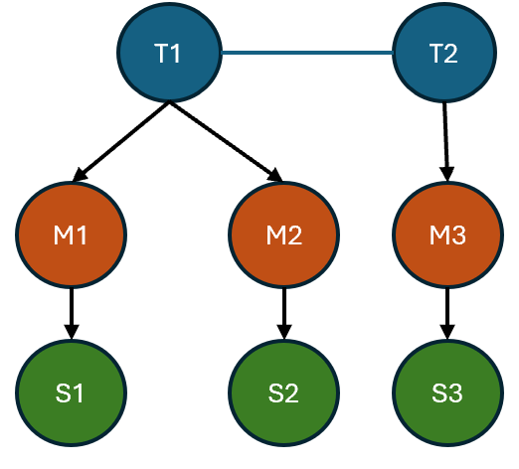

(T1, T2 are Tier 1; M1, M2, M3 are mid-tier; S1, S2, S3 are stubs)

a) Draw the valid Gao-Rexford path from S1 to S3. Label each link as uphill, peering, or downhill.
___________________________________________________________________________
___________________________________________________________________________

b) Is the path S1 -> M1 -> T1 -> M2 -> S2 valid? Explain using the single-peaked property.
___________________________________________________________________________
___________________________________________________________________________

c) Is the path S2 -> M2 -> T1 -> T2 -> M3 -> S3 valid? Explain.
___________________________________________________________________________
___________________________________________________________________________

d) Would the path S1 -> M1 -> T1 -> M2 -> T2 -> M3 -> S3 be valid? Why or why not?
___________________________________________________________________________
___________________________________________________________________________

Part 4: Policy-Based Routing Scenarios
Question 8: Adding a Peering Link
Consider the following AS graph where D and E are stub ASes:
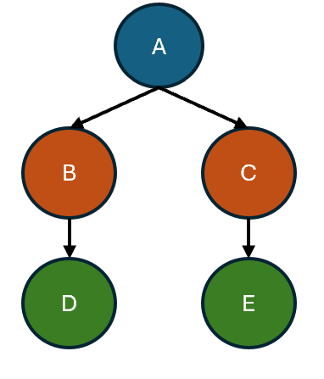

a) What is the current valid path from D to E? Will all transit ASes agree to participate?
___________________________________________________________________________
___________________________________________________________________________

b) Now suppose B and C establish a peering relationship. What is the new preferred path from D to E?
___________________________________________________________________________

c) Why would B and C prefer this new path over the old one through A?
___________________________________________________________________________
___________________________________________________________________________

d) What is the trade-off for B and C in establishing this peering link?
___________________________________________________________________________
___________________________________________________________________________

Part 5: BGP - Import and Export
Question 9: DV vs. BGP
Fill in the table comparing distance-vector routing with BGP.

Feature | Distance-Vector | BGP
What is advertised? | Distance (cost) to destination
How to pick best route?
Who to advertise to?
Why not use link-state? | N/A

Question 10: Export Policy
Complete the Gao-Rexford export policy table. For each source of a route advertisement, indicate who you should re-export it to.

Route learned from... | Export to providers? | Export to peers? | Export to customers?
Customer
Peer
Provider

Explain the business logic: Why do we export routes learned from customers to everyone, but routes learned from peers/providers only to customers?
___________________________________________________________________________
___________________________________________________________________________
___________________________________________________________________________

Question 11: Import and Export Walkthrough
Consider the following topology. All arrows point from provider to customer.
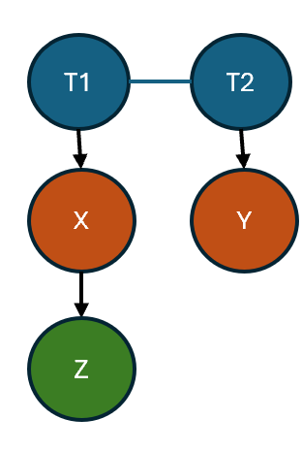
(T1-T2 are peers; X and Y are transit ASes; Z is a stub)

a) Z originates from the prefix 10.5.0.0/16. To which of its providers (X, Y, or both) does Z export this route?
___________________________________________________________________________

b) X receives the route from Z (its customer). To whom does X export it? (T1, T2, Y, or some subset?)
___________________________________________________________________________

c) T1 receives the route from X (its customer). To whom does T1 export it?
___________________________________________________________________________

d) T2 now has two paths to Z: one via T1 (peer) and one via Y (customer). Which does T2 prefer under Gao-Rexford import rules, and why?
___________________________________________________________________________
___________________________________________________________________________

Part 6: Path-Vector and Aggregation
Question 12: Why Path-Vector?
a) BGP uses path-vector instead of distance-vector. Give two specific problems that path-vector solves which distance-vector cannot.
___________________________________________________________________________
___________________________________________________________________________
___________________________________________________________________________
b) An AS receives a BGP advertisement: "Path to 10.0.0.0/8 via [AS30, AS20, AS10]." The receiving AS is AS20. Should it accept this advertisement? Why or why not?
___________________________________________________________________________
___________________________________________________________________________

c) An AS has a policy: "Never route traffic through AS54." It receives an advertisement: "Path to 172.16.0.0/12 via [AS54, AS33, AS12]." Can it enforce its policy? How?
___________________________________________________________________________
___________________________________________________________________________

Question 13: Prefix Aggregation
a) The following three prefixes all use the same next hop. Can they be aggregated into a single entry? If so, what is the aggregated prefix?

Destination Prefix | Next Hop
---------------------|------------
192.168.0.0/24 | Port 1
192.168.1.0/24 | Port 1
192.168.2.0/24 | Port 1

___________________________________________________________________________
___________________________________________________________________________

b) What is multi-homing, and why does it limit prefix aggregation?
___________________________________________________________________________
___________________________________________________________________________
___________________________________________________________________________

c) A stub AS has prefix 4.78.0.0/16 and is connected to two providers: AT&T (who owns 4.0.0.0/8) and Verizon. Explain why AT&T cannot simply aggregate 4.78.0.0/16 into 4.0.0.0/8.
___________________________________________________________________________
___________________________________________________________________________
___________________________________________________________________________

Part 7: Putting It All Together
Question 14: Reachability and Convergence
The Gao-Rexford model guarantees reachability and convergence under certain conditions. List the three conditions required for these guarantees.

1) ___________________________________________________________________________

2) ___________________________________________________________________________

3) ___________________________________________________________________________

What happens to these guarantees if an AS uses arbitrary (non-Gao-Rexford) policies?
___________________________________________________________________________

Question 15: Comprehensive Scenario
Consider the following AS graph:
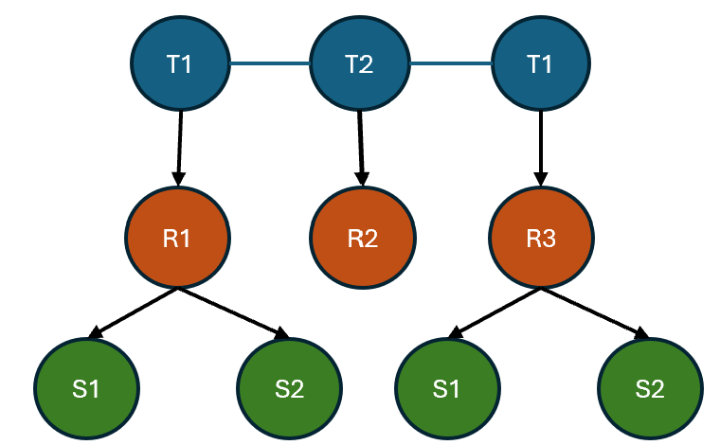

(T1, T2, T3 are Tier 1 ASes with mutual peering; R1, R2, R3 are regional providers; S1-S4 are stubs)

a) S1 wants to send packets to S4. List all valid Gao-Rexford paths. Which path would each AS along the way prefer?
___________________________________________________________________________
___________________________________________________________________________
___________________________________________________________________________
___________________________________________________________________________

b) S4 originates prefix 10.99.0.0/16. Trace the BGP export process: which ASes learn about this prefix, and from whom?
___________________________________________________________________________
___________________________________________________________________________
___________________________________________________________________________
___________________________________________________________________________

c) Does R2 ever learn a route to S4's prefix? If so, from whom? If not, why not?
___________________________________________________________________________
___________________________________________________________________________

d) If R1 and R3 established a peering relationship, what new path to S4 would become available from S1? Would this path be preferred over the existing one(s)?
___________________________________________________________________________
___________________________________________________________________________

