Lecture 8 Worksheet
BGP Implementation and IP Header
CMSI 3550 | Networks and Internets

Part 1: eBGP, iBGP, and IGP
1. Fill in the table below comparing the three types of inter/intra-domain communication.
 | eBGP | iBGP | IGP
Between routers in...
Purpose
Which routers participate?
Example message

2. Consider the following AS with border routers A, B, G and interior routers C, D, E, F (same topology as the lecture slides).
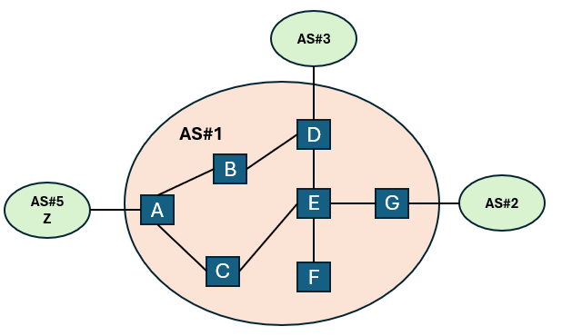

(a) Suppose router A learns via eBGP that destination Z is reachable through AS#5. Describe the steps by which router D eventually learns how to forward packets to Z. Which protocols are involved at each step?
______________________________________________________________________
______________________________________________________________________
______________________________________________________________________
______________________________________________________________________

(b) Router D wants to send a packet to external destination Z. It knows the egress router is A (from its BGP table) and the next hop to A is B (from its IGP table). Write out D’s two routing table lookups.
______________________________________________________________________
______________________________________________________________________
______________________________________________________________________

3. Why don’t stub ASes need to speak BGP? What do they do instead?
______________________________________________________________________
______________________________________________________________________
______________________________________________________________________

4. In the simple iBGP implementation, every router maintains a session with every border router. For an AS with N = 20 total routers and B = 4 border routers, how many iBGP sessions are needed? Why might this be a scaling concern?
______________________________________________________________________
______________________________________________________________________

Part 2: Hot Potato Routing and MED
5. Consider AT&T and Verizon connected by two links (F—A on the west coast and J—E on the east coast). AT&T router X on the west coast wants to send a packet to Verizon router Y on the east coast.
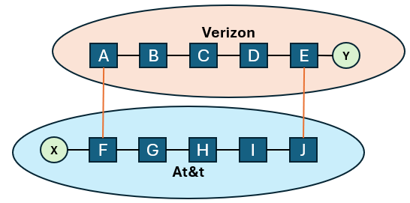

(a) Under hot potato routing, which egress router does AT&T choose? Why?
______________________________________________________________________
______________________________________________________________________

(b) Which path does Verizon prefer AT&T to use? Why?
______________________________________________________________________
______________________________________________________________________

(c) Explain why hot potato routing can lead to asymmetric paths between X and Y.
______________________________________________________________________
______________________________________________________________________
______________________________________________________________________

6. Now consider the scenario where Verizon’s border router A advertises MED = 5 to reach Y, and border router E advertises MED = 1 to reach Y. AT&T’s routers F and J are equidistant from X (same IGP cost).
(a) Which egress router does AT&T choose, and why?
______________________________________________________________________
______________________________________________________________________

(b) In the import policy priority list, which rule is checked first: hot potato routing or MED? Why does this ordering matter?
______________________________________________________________________
______________________________________________________________________
______________________________________________________________________

Part 3: BGP Route Selection
7. Put the BGP import policy rules in the correct priority order by numbering 1–5.
Priority | Rule | Goal
 | Shortest AS path
 | Gao-Rexford (LOCAL PREF)
 | Lowest MED
 | Hot potato (nearest egress)
 | Arbitrary tiebreaker

8. AS#91 receives two BGP advertisements for destination 128.112.0.0/16:
Route A: ASPATH = [7, 25], LOCAL PREF = 3000 (from customer AS#7)
Route B: ASPATH = [79, 25], LOCAL PREF = 1000 (from peer AS#79)
Which route does AS#91 select? Which import rule determined the answer?
______________________________________________________________________
______________________________________________________________________

9. Now suppose AS#91 receives two routes both from customer ASes (same LOCAL PREF):
Route C: ASPATH = [7, 25], LOCAL PREF = 3000
Route D: ASPATH = [12, 44, 25], LOCAL PREF = 3000
Which route is selected? Which rule?
______________________________________________________________________
______________________________________________________________________

Part 4: BGP Route Attributes and Messages
10. Fill in the table for the three BGP route attributes we studied.
Attribute | Value type | Scope | Used for

11. Name the four BGP message types and briefly describe each.
______________________________________________________________________
______________________________________________________________________
______________________________________________________________________
______________________________________________________________________

Part 5: Issues with BGP
12. Explain why AS path length can be a misleading measure of route quality.
______________________________________________________________________
______________________________________________________________________

13. What security guarantee is missing in BGP regarding prefix advertisements? What could go wrong?
______________________________________________________________________
______________________________________________________________________
______________________________________________________________________

Part 6: IPv4 Header Fields
14. Match each IP task to the header field(s) used. Some fields may be used for more than one task.
Task | Header Field(s)
Parse the packet
Forward packet to next hop
Tell destination what to do next
Send responses back to source
Handle errors (loops)
Handle errors (corruption)
Handle errors (packet too large)

15. Explain what de-multiplexing means in the context of the Protocol field. Why is it needed?
______________________________________________________________________
______________________________________________________________________
______________________________________________________________________

16. A packet with a 20-byte IP header carries 3000 bytes of payload. It encounters a link with MTU = 1020 bytes. Show how the packet is fragmented by filling in the table. (Remember: offset is measured in units of 8 bytes.)
Fragment | Payload bytes | ID | MF flag | Offset
#1
#2
#3
Show your work:
______________________________________________________________________
______________________________________________________________________
______________________________________________________________________

Part 7: IPv6 and IP Security
17. For each IPv6 change below, explain (a) what was changed, (b) the benefit, and (c) the design philosophy behind it.

Change | What changed? | Benefit | Philosophy
Eliminate checksums
Eliminate fragmentation
Eliminate options / Next Header
Add flow label

18. Why can’t IPv6 eliminate the TTL (Hop Limit) field, even though it eliminated checksums, fragmentation, and options?
______________________________________________________________________
______________________________________________________________________

19. Match each IP header field to the attack that exploits it.
Header Field | Attack | How it works
Source IP address
Type of Service
Fragmentation / Options
TTL

20. Explain how traceroute uses the TTL field to discover the path a packet takes. What happens at each step?
______________________________________________________________________
______________________________________________________________________
______________________________________________________________________
___________________________________________________________________

