Interface Design Description

Library Management System

1. Introduction

1.1 Purpose
This document describes the user interface design of the Library Management System. The purpose of the system is to provide a modern, user-friendly, and responsive web application for managing library resources, borrowing activities, and user information.

1.2 Scope
The system supports three types of users:
- Administrator
- Librarian Staff
- Reader
The interfaces are designed to help users perform library operations efficiently through a simple and intuitive web interface.

2. Login Interface

Purpose
The Login page allows users to authenticate themselves and gain access to the system using a valid username and password.

Interface Components
Component | Description
Username Textbox | Enter registered username
Password Textbox | Enter account password
Login Button | Submit login information
Error Message | Display invalid username or password
Register Link | Navigate to registration page

Input Fields
Field | Type | Validation
Username | Text | Required
Password | Password | Required

Navigation Flow
Login Page
|
|
Valid Credentials
|
↓
Dashboard
If authentication fails, the system displays an error message and remains on the Login page.

Interface Screenshot
Figure 1. Login Page

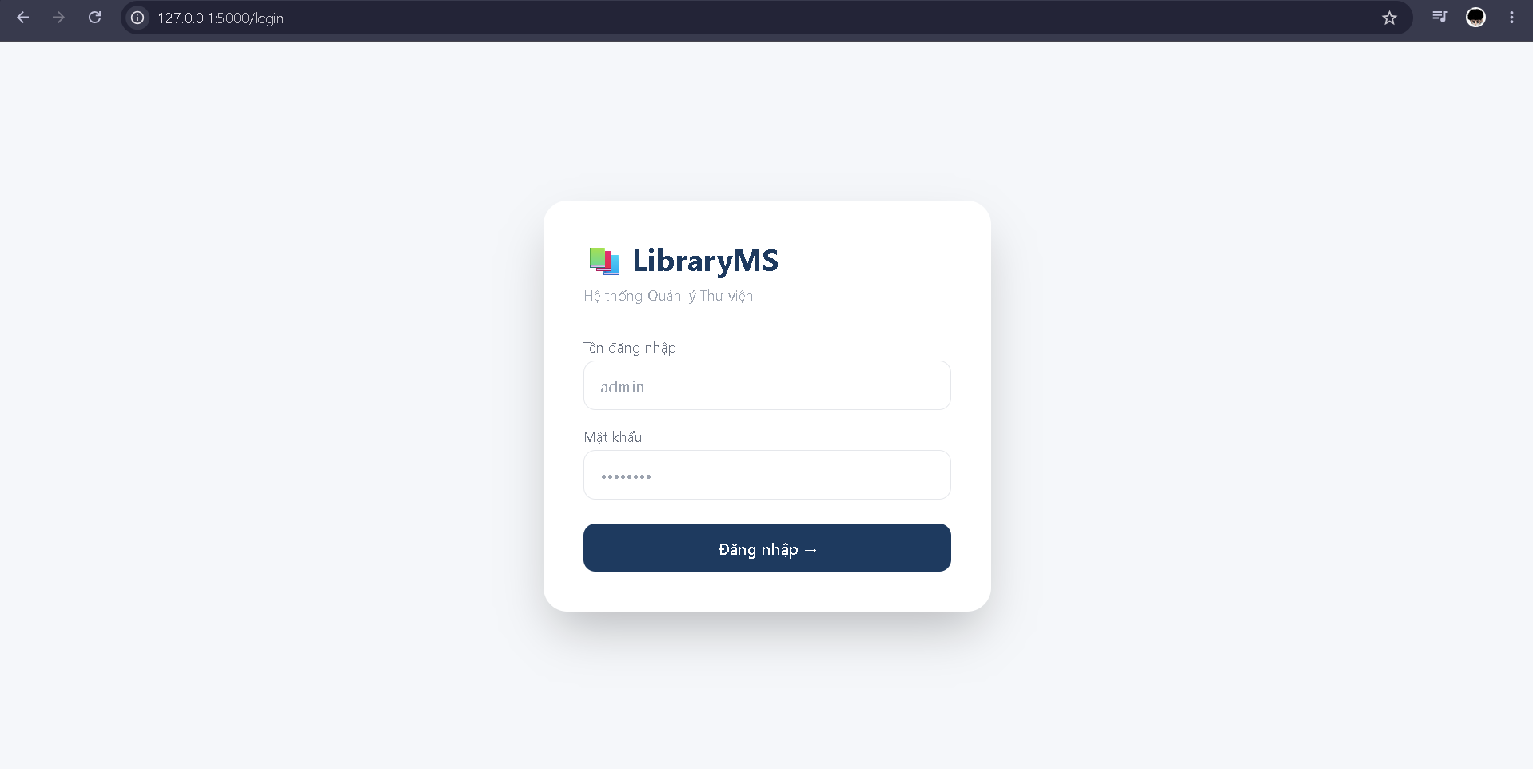
Login

3. Dashboard Interface

Purpose
The Dashboard provides an overview of library information and system statistics.

Interface Components
Component | Description
Total Books Card | Display total number of books
Total Users Card | Display total number of users
Borrowed Books Card | Display active borrowing records
Overdue Books Card | Display overdue records
Categories Card | Display total categories
Notifications Card | Display total notifications
Sidebar Menu | Navigate between system modules

Displayed Information
- Total Books
- Total Users
- Total Categories
- Borrowed Books
- Overdue Books
- Total Notifications

Navigation
Users can access:
- Dashboard
- Book Management
- Borrow & Return
- Category Management
- Notifications
- Profile
- Reports
- Logout

Interface Screenshot
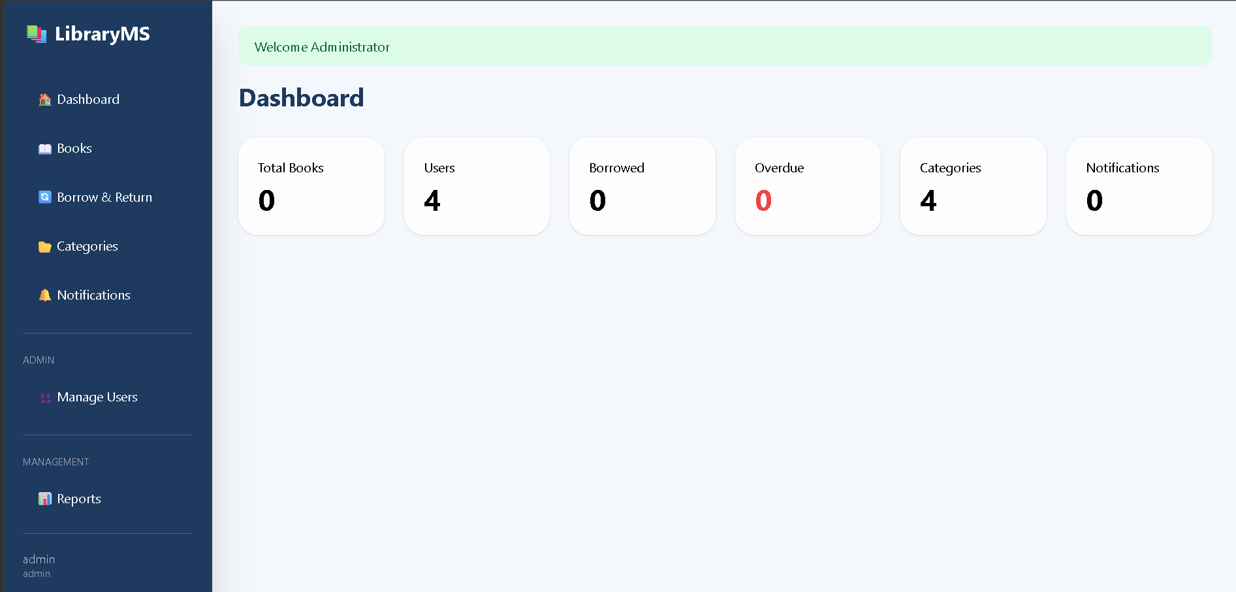
Figure 2. Dashboard Page

Dashboard

4. Book Management Interface

Purpose
Allows librarians and administrators to manage books stored in the library database.

4.1 Book List Interface

Interface Components
Component | Description
Search Box | Search books by title
Add Book Button | Open Add Book form
Book Table | Display all books
Detail Button | View detailed information
Update Button | Edit book information
Delete Button | Remove book
Category Badge | Display category name
Quantity Status | Display available quantity

Book Information Table
Column
ISBN
Title
Author
Publisher
Publish Year
Quantity
Available Copies
Category
Actions

Interface Screenshot
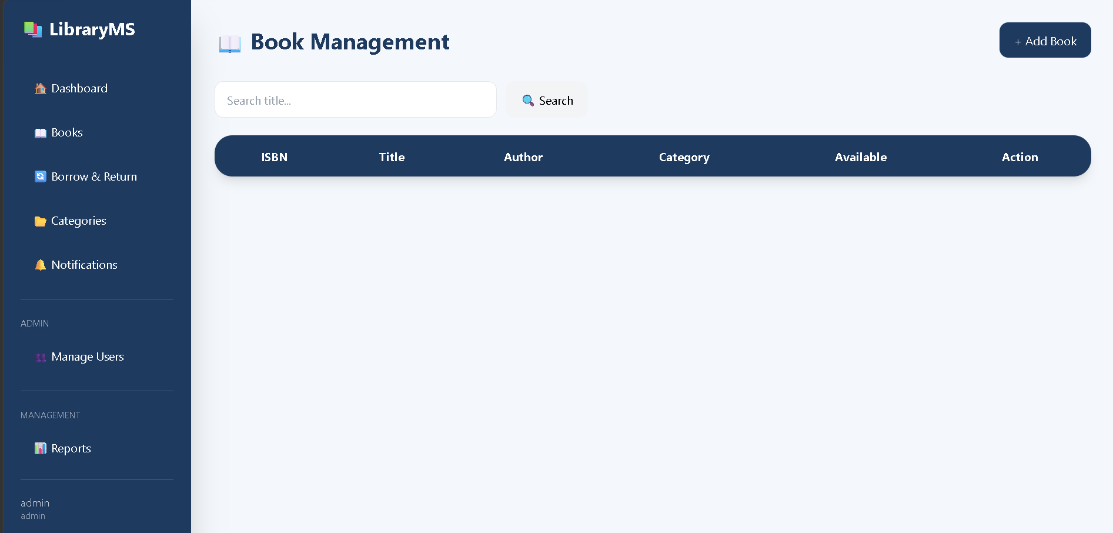
Figure 3. Book Management Page

Books

4.2 Add Book Interface

Purpose
Allows librarians to add new books into the library system.

Input Fields
Field | Description
ISBN | Book identification number
Title | Book title
Author | Author name
Publisher | Publisher name
Publish Year | Publication year
Category | Book category
Quantity | Number of copies

Buttons
Button | Description
Add | Save book information
Cancel | Close form

Interface Screenshot
Figure 4. Add Book Form
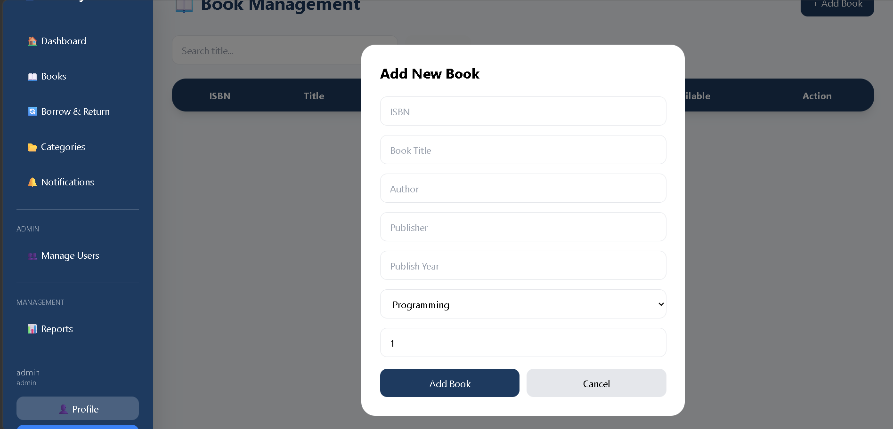
Add Book

4.3 Book Detail Interface

Purpose
Displays complete information about a selected book.

Information Displayed
Information
ISBN
Title
Author
Publisher
Publish Year
Quantity
Available Copies
Category
Created Date

Buttons
Button | Description
Edit Book | Open update form
Back | Return to Book List

Interface Screenshot
Figure 5. Book Detail Page
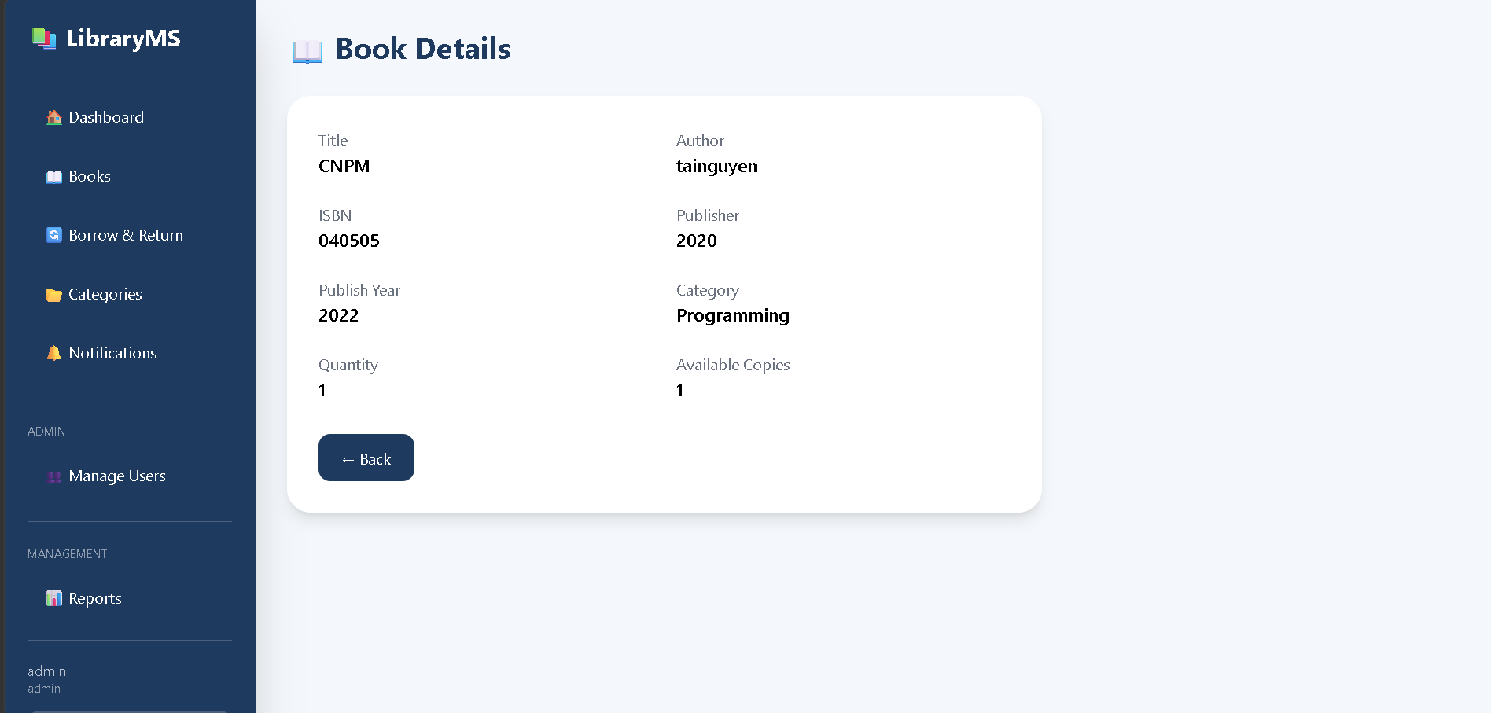
Book Detail

4.4 Update Book Interface

Purpose
Allows librarians and administrators to update existing book information.

Input Fields
Field | Description
ISBN | Edit ISBN
Title | Edit title
Author | Edit author
Publisher | Edit publisher
Publish Year | Edit publication year
Quantity | Edit number of copies
Category | Change category

Buttons
Button | Description
Save Changes | Update book information
Cancel | Return without saving

Interface Screenshot
Figure 6. Update Book Page
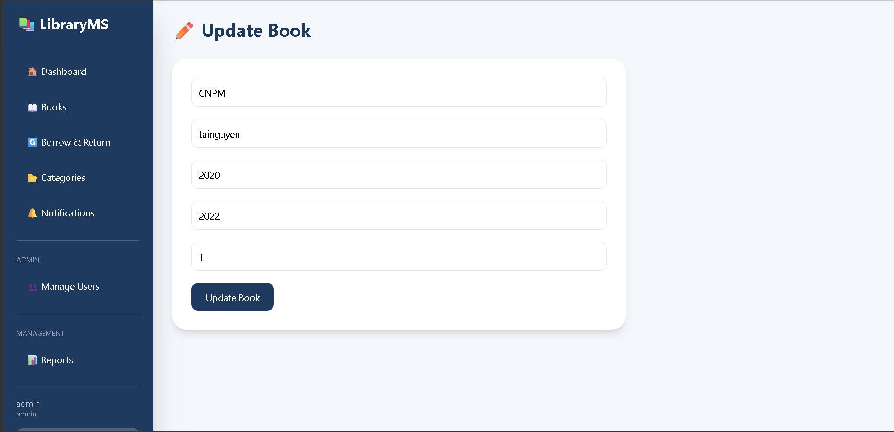
Update Book

5. Borrow & Return Interface

Purpose
Allows librarians to manage borrowing and returning operations.

Interface Components
Component | Description
Reader Dropdown | Select reader
Book Dropdown | Select book
Borrow Button | Create borrowing record
Borrow Record Table | Display borrowing records
Return Button | Process returned books
Fine Button | View overdue fine
Overdue Indicator | Highlight overdue books

Borrow Record Information
Field
Reader
Book
Borrow Date
Due Date
Return Date
Status
Fine Amount

Interface Screenshot
Figure 7. Borrow Management Page
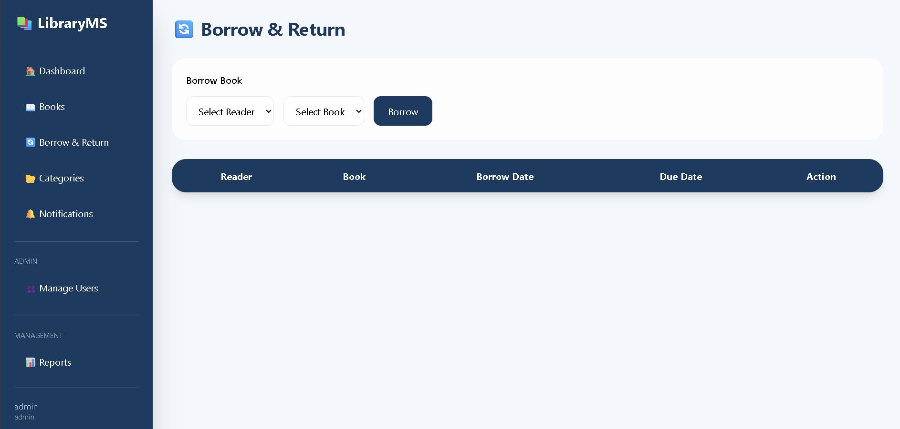
Borrow & Return

5.1 Fine Interface

Purpose
Displays overdue fine information when books are returned late.

Information Displayed
Information
Reader Name
Book Title
Due Date
Return Date
Overdue Days
Fine Amount

Buttons
Button | Description
Back | Return to Borrow Management

Interface Screenshot
Figure 8. Fine Information Page
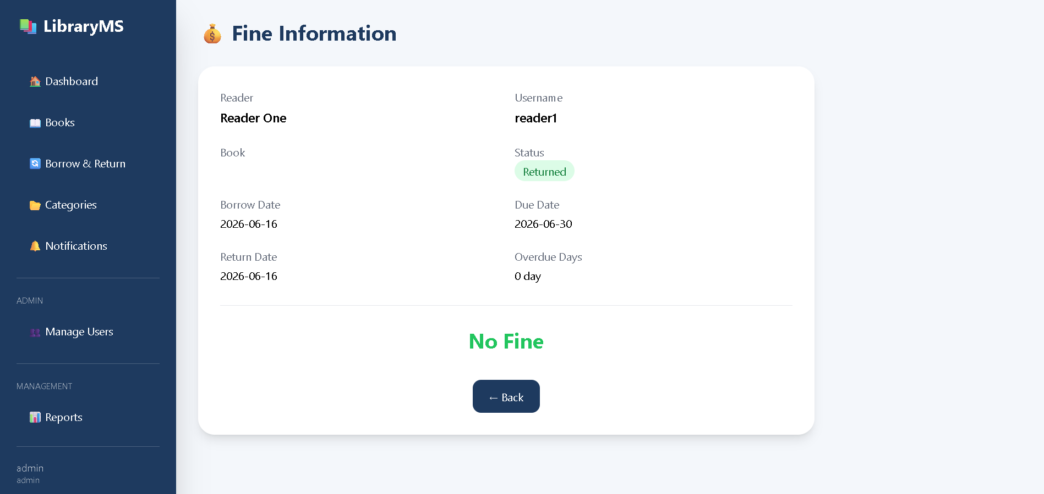
Fine Information

6. Category Management Interface

Purpose
Allows administrators and librarians to manage book categories.

Interface Components
Component | Description
Category Name Textbox | Enter category name
Description Textbox | Enter category description
Add Button | Create category
Category Table | Display categories
Edit Button | Update category
Delete Button | Remove category

Interface Screenshot
Figure 9. Category Management Page
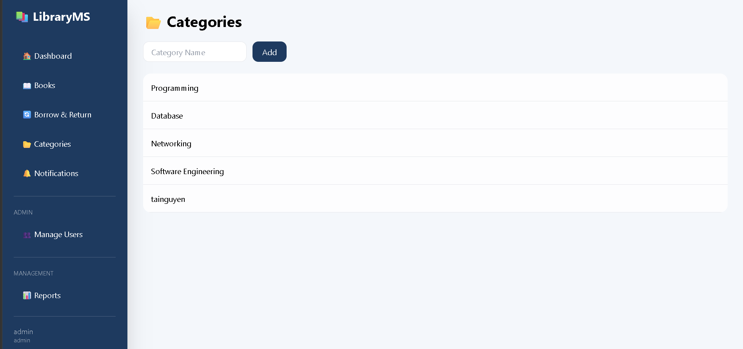
Category

7. Notification Interface

Purpose
Displays notifications generated by library activities.

Interface Components
Component | Description
Notification List | Display all notifications
Message Content | Notification details
Created Date | Notification creation time
Read Button | Mark notification as read

Notification Types
- Borrow Book Notification
- Return Book Notification
- Overdue Book Notification
- System Information Notification

Interface Screenshot
Figure 10. Notification Page
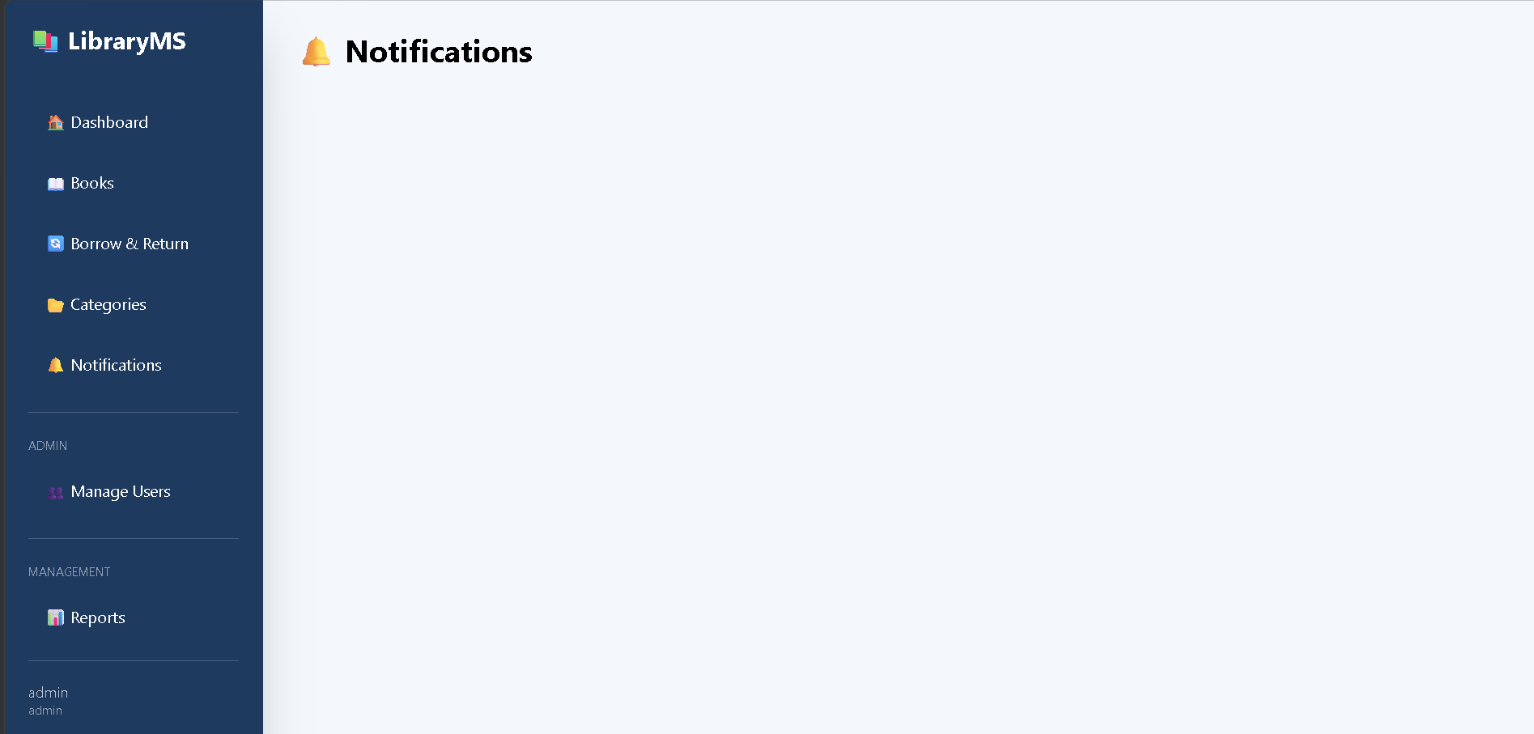
Notification

8. Profile Interface

Purpose
Allows users to view and update their personal information.

Displayed Information
- Full Name
- Username
- Email
- Phone Number
- Address
- Role
- Account Creation Date

Functions
- Update Personal Information
- Change Password

Interface Screenshot
Figure 11. Profile Page
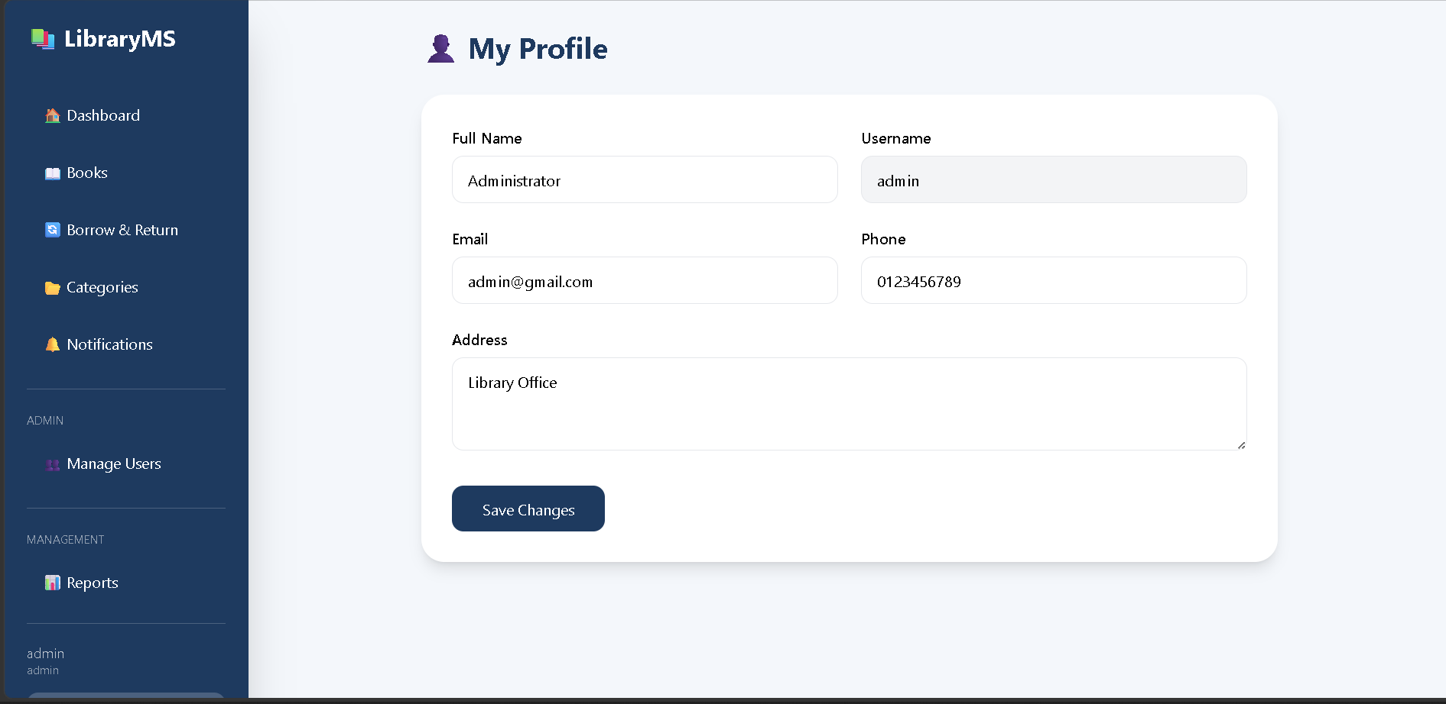
Profile

9. Reports Interface

Purpose
Provides statistical reports for administrators and librarians.

Report Information
- Total Books
- Total Users
- Total Categories
- Borrow Statistics
- Returned Books
- Overdue Books

Interface Screenshot
Figure 12. Reports Page
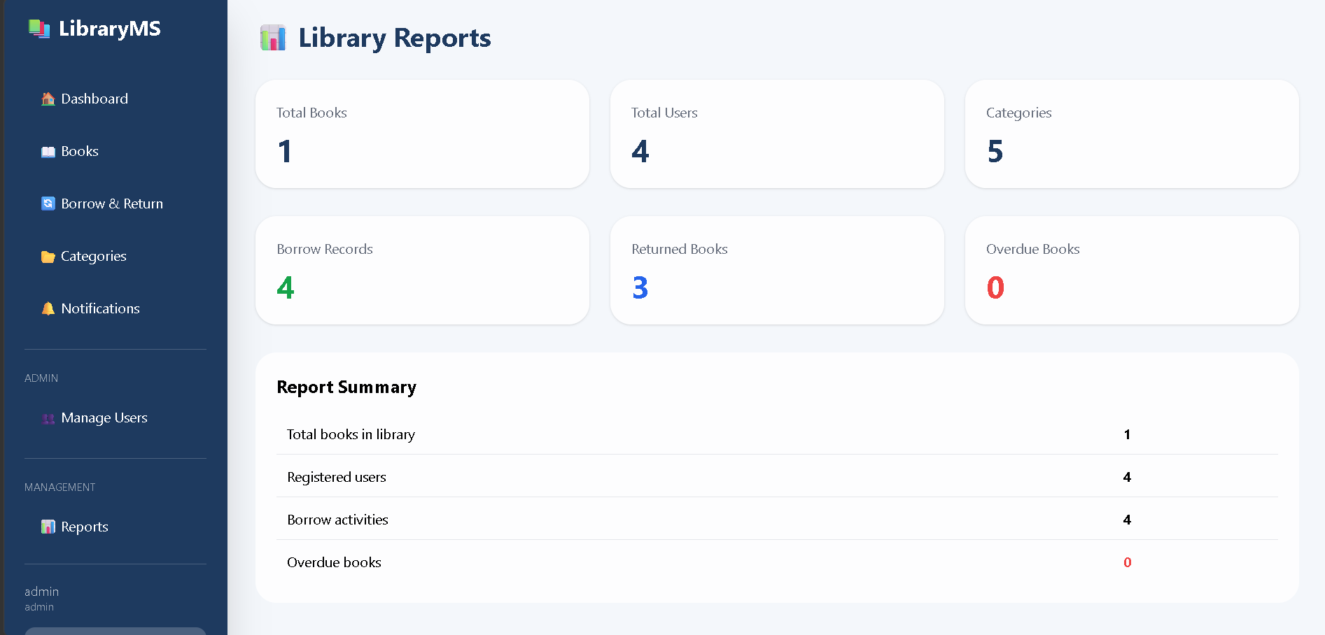
Reports

10. Design Principles

Color Scheme
Color | Usage
#1E3A5F | Sidebar and primary buttons
White | Main content background
Green | Success messages
Red | Error messages and overdue alerts
Gray | Secondary information

Typography
- Font Family: Tailwind CSS Default Sans-serif
- Responsive Typography
- Clear and readable text

Animation
GSAP animations are used for:
- Sidebar slide-in effect
- Page fade-in effect
- Modal opening animation
- Smooth transitions
- Card loading effects

11. Navigation Structure
Login
|
↓
Dashboard
├── Profile
├── Books
│ ├── Add Book
│ ├── Book Detail
│ └── Update Book
├── Borrow & Return
│ └── Fine Information
├── Categories
├── Notifications
├── Reports
└── Logout

12. Responsive Design
The system supports:
- Desktop Computers
- Laptop Devices
- Tablet Devices

Technologies Used

Backend
- Python Flask

Database
- SQLite

ORM
- SQLAlchemy

Frontend
- HTML5
- Tailwind CSS
- JavaScript

Animation
- GSAP Animation Library

Top of Form

Bottom of Form

