CO3103 – PROGRAMMING INTEGRATION PROJECT
SOFTWARE ENGINEERING | SEMESTER 261

INTERIM PROJECT REPORT
LINGOSPHERE
An Online Learning Platform Integrating Short Practice Activities
and Learning Analytics & Early Warning

Field | Details
Course | CO3103 – Integration Project (Software Engineering track)
Semester | 261
Group | DATH-261 Group 12
Team members | Nguyễn Lê Phú Tài – 2413039  Nguyễn Huỳnh Đức – 2036118  Khâu Phương Nghi – 2412246  Phạm Tiến Đạt – 2410724
Group leader | Nguyễn Lê Phú Tài – 2413039
Project repository | https://github.com/tainlp0306/DATH-261-Group-12
Prototype | https://dath-261-group-12-frontend.onrender.com
Report date | 30 October 2026

1. Agreed scope, changes and progress against the proposal
LingoSphere is a role-based language-learning LMS. At the interim stage, the group has integrated the proposal-selected Learning Analytics & Early Warning component and the short-practice activity concept into the main course workflow. The table below compares each area with its current status and evidence.
Proposal area | Implementation and interim assessment
Core LMS: instructors create courses and lessons; learners enroll, study, receive notifications and track progress. | Substantially implemented: role-based accounts, course creation and publication, modules, lessons and learning materials, enrollment, progress, notifications, assessments and grading. The checklist records checks of the main flows.
Active practice: keyboard input, non-Latin character writing and repeated practice. | Partially achieved: vocabulary typing is checked; canvas strokes are normalized and stored, and learners can make multiple attempts. The system does not recognize characters, validate stroke order or grade character shape. The writing-learning outcome in the proposal is not fully met.
Automatic grading and immediate feedback. | Achieved for quizzes, short vocabulary activities and LMS quizzes: answers are checked and scores returned. Instructors grade file submissions. Writing strokes are saved for self-review and are not automatically graded.
Learning Analytics & Early Warning (mandatory advanced component). | A prototype is available: timestamped events, course and learner progress indicators, warning reasons and instructor-triggered reminders. Progress, inactivity and quiz scores contribute to warnings. Detection accuracy and a validated vocabulary-retention measure have not been established.
Proposal evaluation plan: simulated logs, warning accuracy, chart performance and instructor usability. | A simulated cohort of 24 learners and tests of rule behavior are available. Precision, recall or accuracy against labeled data have not been measured; chart performance and structured instructor usability have not been evaluated.
Architecture, technology and storage. | React/Vite, Django/DRF, PostgreSQL and Docker/Compose align with the proposal. Uploaded files are currently recorded as locally stored, with no object storage configured. Render deployment was attempted, but the latest backend log reported a CORS-origin configuration error.

2. UI/UX, architecture, data model and main APIs

2.1 User flows, architecture, data and APIs
UI/UX: The learner outline presents chapters, lessons, assignments and short activities in one list; selecting a lesson or activity opens a separate content page. Instructors manage content, assessments and analytics through tabs. Administrators have areas for managing accounts, courses, reports and logs. The frontend hides actions that are not appropriate for a role, while the backend independently checks authentication, ownership, enrollment and publication status.
Role | Main flow | Demo video
Visitor | Browse published courses → search, sort and paginate → register or sign in. | https://youtu.be/SDVAgY4aHSk
Learner | Enroll → continue learning → open the outline and lessons → complete lessons or submit quizzes/files → review permitted results and notifications. | https://youtu.be/Gid0ICqR_7Y
Instructor | Create, edit and publish own courses → add chapters, lessons and assignments → review learner progress and submissions → grade or send notices → view analytics and send reminders when justified. | https://youtu.be/OV-lO797NnM
Administrator | View the dashboard → find and manage accounts/courses → handle reports → inspect logs. | https://youtu.be/Gid0ICqR_7Y
Architecture: The browser runs React/Vite/Tailwind. The API client sends JWTs to Django 5/DRF; the backend enforces permissions and reads/writes PostgreSQL. Media is currently stored in Supabase. Docker Compose provides the local backend/database environment.
Data group | Role in the system
User, Course, Module, Lesson, Enrollment | Accounts and roles, course ownership, outline, publication and enrollment permissions.
LessonProgress, LearningEvent | Learning progress, resume position and timestamped events for analytics.
Assignment, Question, Submission | Quiz/file assignments, questions, attachments, answers, submitted files, scores and feedback.
LearningActivity, LearningActivityItem, LearningActivityAttempt | Activity types and content; learner responses, scores or saved writing strokes.
Intervention, Notification, Report, AdminLog | Reminder history, notifications, user reports and administrative actions.
Main APIs:
GET /courses/{course_id}/analytics/
POST /courses/{course_id}/analytics/intervene/
GET/POST /courses/{course_id}/activities/
GET/PATCH /activities/{activity_id}/
POST /activities/{activity_id}/attempts/.
Other LMS routes support authentication/profile, course/chapter/lesson management, enrollment/progress, assignment submission, grading, notifications, reports and administration.

3. Completed web functionality, runnable evidence and integration

3.1 Visitors, accounts and authentication
Published courses, search, sorting and an unauthorized attempt to open a draft course: https://youtu.be/x9qbWocpkFQ
Account registration with Gmail OTP verification: https://youtu.be/JrRK0RcDaIg
Password recovery: https://youtu.be/vC1nMWZSFYY

3.2 Learners: courses, lessons, interaction and quizzes
My courses, enrollment, leaving a course, chapters, lessons, materials, completion marking and progress retained after refresh: https://youtu.be/hLcxtO0bMI0
Comments and comment reporting: https://youtu.be/kgD5c12cbg
Multiple-choice quizzes, file submission, timer, submission and history: https://youtu.be/e9F2xf1vLQQ

3.3 Instructors: course creation, content and notifications
Create a course, select/remove prerequisites, save as draft, edit and publish: https://drive.google.com/file/d/1ofSPjOP-sQgZpKrtKnPZdighMwNjxiMP/view?usp=sharing
Create chapters; add, edit and delete text, video, PDF and slide lessons; view learner updates and notifications: https://drive.google.com/file/d/10a3edzgs3eD2qrSXf0yXo0PS-myulE3h/view?usp=sharing
View each learner’s progress and send a class notification: https://drive.google.com/file/d/1UMGbaduPP2AQqGh8A4BF1pzTVffoFz6n/view?usp=sharing

3.4 Instructors: assessments and grading
Create multiple-choice quizzes and file assignments, rotate question tables, view learner attempt history, review files and grade, and check assignment notifications: https://drive.google.com/file/d/1E3qVe_9h_Wi-CCDiTdfz5vYbf3SoAaGD/view?usp=sharing

3.5 Administration and data protection
Dashboard, user search, account lock/unlock, course management, protection against an administrator locking their own account, and other administrative views: https://drive.google.com/file/d/1Stf-uTFlMhUbRaOHkQKaaRjRiTeOtn2j/view?usp=sharing
Data protection: instructors cannot manage one another’s courses; role boundaries and unpublished courses are protected: https://drive.google.com/file/d/1hsUphaj-RRZ2owHbLiQdxEXs7gnVuZpU/view?usp=sharing

4. Advanced component prototypes and initial results

4.1 Learning Analytics & Early Warning (mandatory advanced component)
Analytics combines lesson progress, timestamped events, quizzes and practice attempts. The dashboard shows enrollment, completion, progress groups, weekly trends, recent activity, quiz scores and warning reasons. Only the instructor responsible for the course or an administrator can access it. Instructors can send course-linked reminders when a reason is identified; duplicate reminders for the same learner, course and action are blocked for 24 hours.
Rule | Description and limitation
Low completion | After at least 14 days of enrollment, completion below 40% adds a low-progress reason.
Inactivity | At least 7 days of inactivity together with completion below 80% adds a reason.
Low quiz scores | Three consecutive latest quiz scores below 5/10 add a risk reason.
28-day progress reference | A visual reference line; not a trained model or an individualized prediction.
Retention and accuracy | No separately validated vocabulary-retention measure or real-world detection accuracy is available.
Initial result: seed_analytics_demo creates a simulated cohort of 24 learners with on-track, delayed, inactive and repeated-low-quiz scenarios. Tests check warning reasons, course permissions, weekly data and duplicate-reminder prevention. The group has confirmed that the dashboard renders and displays warnings.
https://drive.google.com/file/d/1sy2eYdQs0XlVdCKfyFBAJCMFL-WuZg1k/view?usp=sharing

4.2 Reusable short-practice activities (the group’s own component)
The idea is to build short activities inspired by Duolingo that can be reused across subjects, not only language learning. Instructors can create activities for a course or chapter: short quizzes for review, vocabulary typing for recall, or writing practice for characters outside the Latin alphabet. Learners complete these activities in a short session, receive results and can practice again; attempt data can also help track learning progress.
A prototype lets instructors create, edit and publish quizzes, vocabulary-typing activities and writing practice. Enrolled learners can complete activities that have been opened. Quizzes and vocabulary are automatically scored out of 10. Writing strokes are saved for learners to review themselves; character shapes are not recognized or automatically graded. The backend stores attempts to support learning-activity tracking.
https://drive.google.com/file/d/1SfH1VCQu5Pte7xPlXwiLSs4sEltCyLaP/view?usp=sharing

5.1 Testing results and deployment

5. Testing, security, trial deployment and technical issues
Testing: The main functions were checked during development, followed by one overall review. A checklist is available in the group repository.
Security: The server checks access by role, ownership, enrollment and publication status. Django hashes passwords; the system also limits OTP requests and validates input, file size and writing-stroke coordinates.
Trial deployment: Production configuration reads secrets, database settings and CORS from environment variables; it supports HTTPS-aware behavior and uses WhiteNoise for static files. Do not include secrets or database URLs in the report or video.
Technical issue: There is concern that the free Render and Supabase plans may result in data loss, requiring redeployment if problems occur.
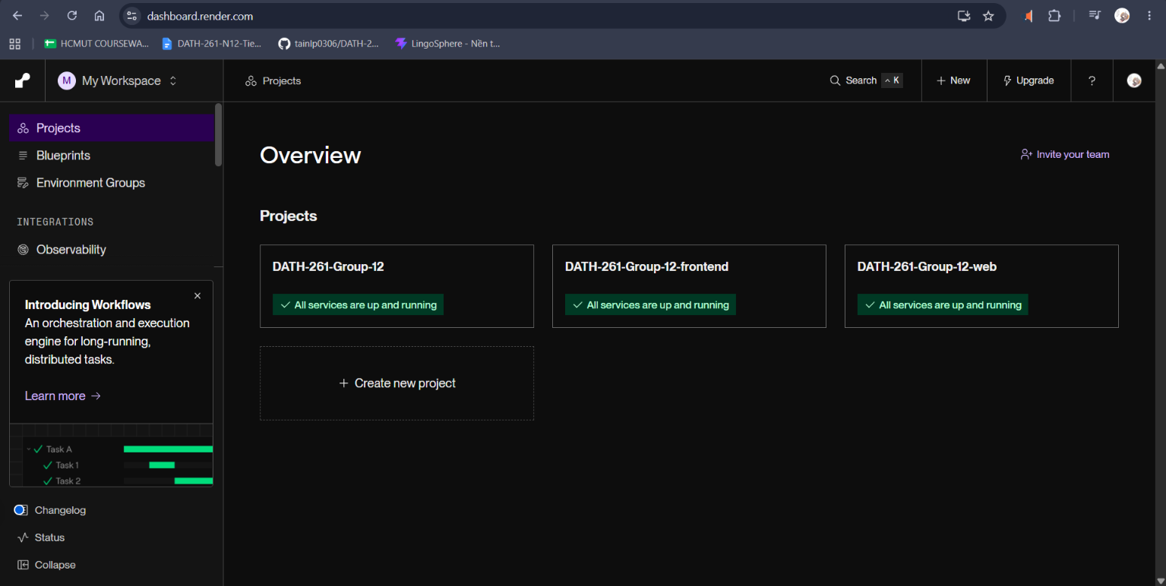
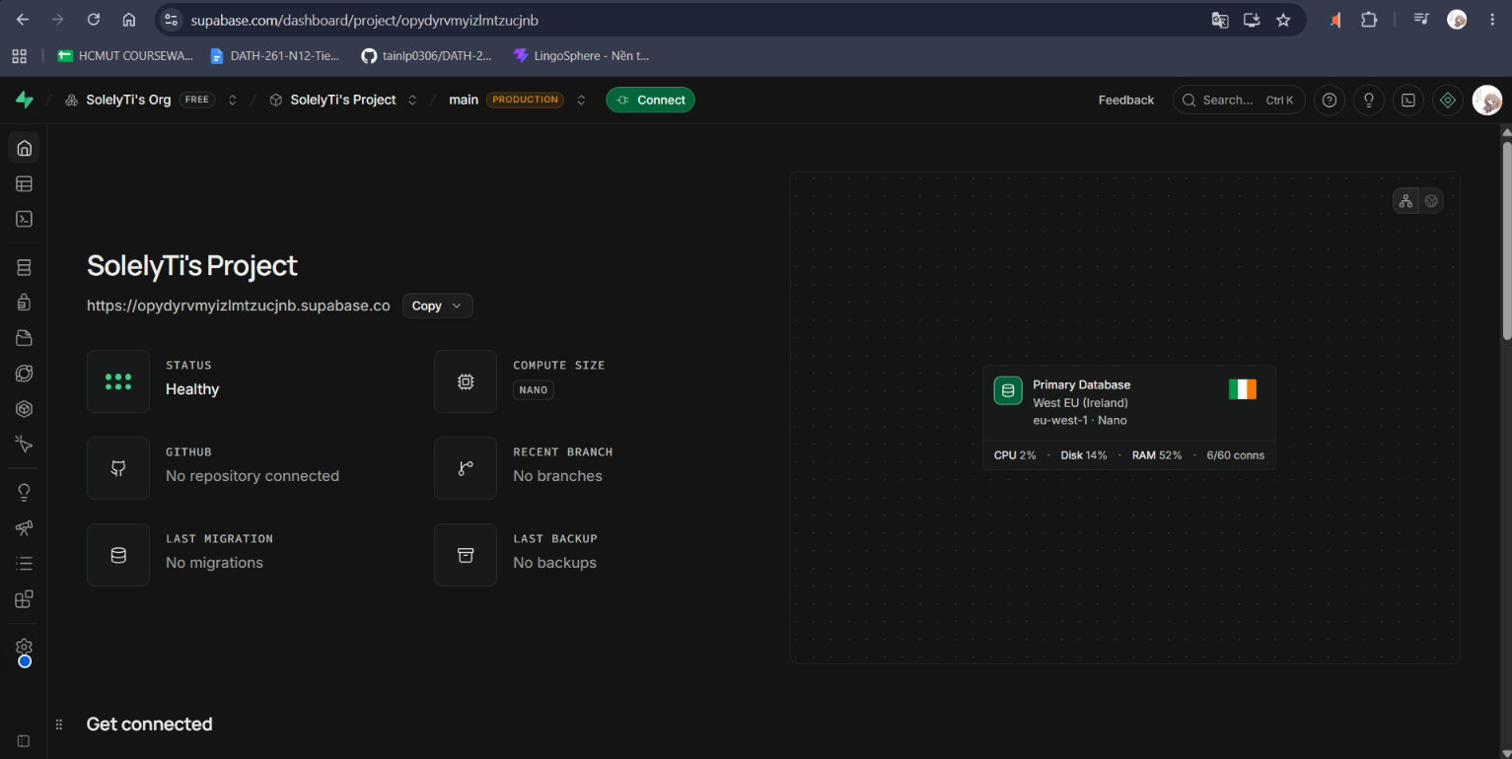

6. Proposal assessment and work progress

6.1 Overall assessment against the proposal
Overall comparison with the proposal: the main functions have working prototypes; completed work, remaining development and general risks are summarized below.
Proposal area | Completed | Further development / risks
Core LMS | Main flows are available: accounts and roles, courses/chapters/lessons, enrollment and progress, quizzes/file submissions, grading, notifications and administration. | Complete end-to-end testing on the deployed version; verify permissions and file access after deployment.
Short-practice activities | Quiz, vocabulary typing and writing prototypes are integrated into the learning flow; quizzes/vocabulary are scored and writing strokes are saved. | No automatic character recognition or stroke grading. Fully test all activity types that remain in scope.
Learning Analytics & Early Warning | A dashboard and warnings use progress, activity and quiz scores; the rules have been checked with simulated data. | Accuracy and effectiveness on labeled real-world data are unverified; measure correct and false warnings.
General risks: There is no evidence that the Render version has passed end-to-end testing; only local testing is recorded. Persistent file storage and quality checks in the deployed environment still need confirmation. The security measures in Section 5 are not a penetration test or formal security certification.

6.2 Work recorded by week
Week (period) | Work completed / results recorded | Not completed or no result recorded
39 (21–27 Sep) | Tài drafted the architecture, set up and pushed foundational tools, and incorporated the ERD into the system diagram; the document also records trying the application. | Nghi did not complete the typing/drawing prototype and canvas research due to health issues; Đạt did not complete the analytics/SRS work due to health issues; Đức could not be contacted.
40 (28 Sep–4 Oct) | Tài added functions for all three user groups and redesigned the interface (commit b0c2e55). | Nghi and Đạt did not contribute; Đức still could not be contacted.
41 (5–11 Oct) | Tài worked on the checklist and quiz (commit 0b7703c). | Nghi and Đạt did not contribute. Đức’s work depended on the other two members; no separate completed result is listed.
42 (12–18 Oct) | Tài checked the system, identified issues and optimized it (commit 518b977); Nghi worked on the practice prototype (commit abaaa56); Đức wrote tests, integrated the advanced components, completed E2E tests and added the character-writing tool; Đạt ran migrations in Docker, researched SRS, signed in to the admin backend and created a prototype branch.
43 (19–25 Oct) | Tài fixed issues and optimized the quiz (commit 1767899); Nghi added a Hiragana lesson (commit 6548679). | Đạt and Đức did not provide progress updates.

