

AWS First Cloud AI Journey – Project Plan

SE-CITY – FPT Univeristy – FindNest

12/12/2025
Table of Contents
1 BACKGROUND and motivation 3
1.1 executive summary 3
1.2 PROJECT SUCCESS CRITERIA 3
1.3 Assumptions 3
2 SOLUTION ARCHITECTURE / ARCHITECTURAL DIAGRAM 3
2.1 Technical Architecture Diagram 3
2.2 Technical Plan 4
2.3 Project Plan 4
2.4 Security Considerations 4
3 Activities AND Deliverables 5
3.1 Activities and deliverables 5
3.2 OUT OF SCOPE 5
3.3 PATH TO PRODUCTION 5
4 EXPECTED AWS COST BREAKDOWN BY SERVICES 5
5 TEAM 6
6 resources & cost estimates 6
7 Acceptance 7

BACKGROUND and motivation

executive summary
Finding suitable accommodation in urban areas is often a frustrating experience due to fragmented information and rigid search filters (e.g., price, district only). Users struggle to find places that match their specific lifestyle needs, such as "safety," "proximity to gyms," or "food availability."
FindNest solves this by introducing a Serverless AI Platform that leverages Amazon Bedrock for natural language understanding and Amazon Location Service for geospatial intelligence. Our solution allows users to search using natural queries (e.g., "Find me a safe room near HCMC University of Technology with cheap food around"), automatically enriching listings with real-world context score.
By utilizing AWS Serverless architecture, FindNest ensures high scalability, low operational maintenance, and cost-effectiveness, aiming to revolutionize the rental market experience.

PROJECT SUCCESS CRITERIA

The project will be considered successful if the following metrics are met:
- Functional AI Search: The system accurately interprets at least 90% of natural language queries to map them to correct database filters and ranking criteria.
- Performance: Search results are returned within < 3 seconds (achieved via pre-calculated data enrichment).
- Contextual Accuracy: Listings successfully display derived metrics (Safety Score, Food Density, Amenity Distance) using Amazon Location Service.
- Cost Optimization: The MVP infrastructure cost remains under $30/month for up to 1,000 active users.
- Security: 100% of user data is encrypted at rest and in transit; no public access to raw S3 buckets.

Assumptions

- The team has access to an AWS Account with Amazon Bedrock (Claude 3 Haiku/Sonnet) enabled in the selected region (e.g., us-east-1 or ap-southeast-1).
- Mock data for accommodation listings (approx. 50-100 items) will be generated for the MVP phase.
- OpenStreetMap may be used as a fallback for specific Vietnamese POI data if Amazon Location Service data is insufficient in certain narrow streets.

SOLUTION ARCHITECTURE / ARCHITECTURAL DIAGRAM

Technical Architecture Diagram

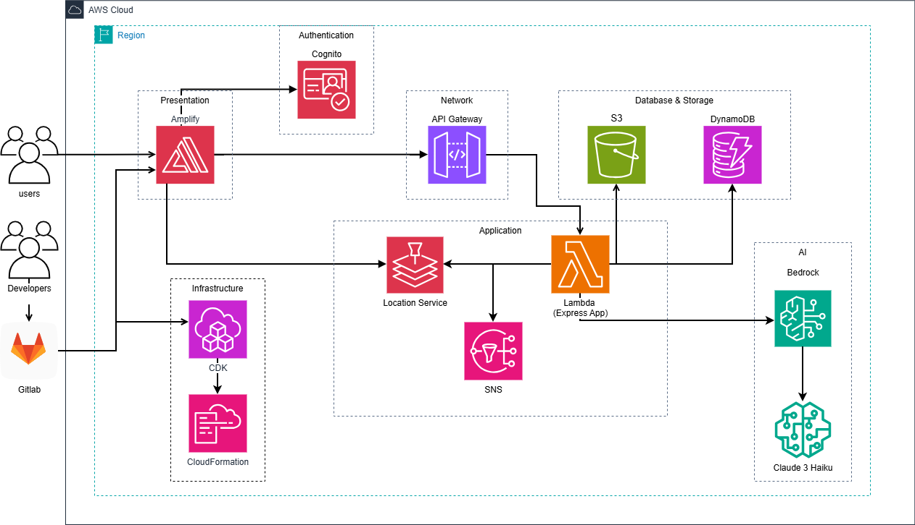

Technical Plan

To ensure performance and scalability, we adopt an Asynchronous Enrichment Strategy:
- Frontend: Built with React and deployed via AWS Amplify for CI/CD and hosting.
- Core Backend: AWS Lambda (Node.js) behind API Gateway handles RESTful requests.
- Data Layer: Amazon DynamoDB stores listings.
- AI & Logic:
  - Amazon Bedrock: Used at search time to parse natural language into structured query parameters (JSON).
  - Amazon Location Service: Used at creation time (async) to calculate distances to amenities and safety scores, storing these as static attributes in DynamoDB to minimize search latency.
- Storage: Amazon S3 for storing room images.

Project Plan

- Week 1: Initialize AWS Environment, Setup Amplify Project.
- Week 2: Implement User Auth (Cognito) and CRUD Listing APIs (Lambda + DynamoDB).
- Week 3: Implement Async Data Enrichment Pipeline (Location Service integration).
- Week 4: Integrate Amazon Bedrock for search intent parsing.
- Week 5: Frontend integration, UI/UX polish, and Maps visualization.
- Week 6: Testing, and Final Presentation.

Security Considerations

- Identity & Access Management: Use Amazon Cognito for user pools. Implement IAM Roles with "Least Privilege" principles for all Lambda functions.
- Input Validation: Sanitize all inputs at API Gateway and Lambda level to prevent Injection attacks.

Activities AND Deliverables

Activities and deliverables
[Provide project milestones with timeline and respective deliverables, corresponding to the items and activities described in the Scope of Work / Technical Project Plan section. Indicate plans on how to govern the project/ change management; communication plans; transition plans]
Project Phase | Timeline | Activities | Deliverables/Milestones | Total man-day
Assessment & Design | Week 1 | - Analyze system requirements.  - Design AWS Architecture.  - Define API Specifications. | - System Architecture Document.  - Swagger API Spec. | 5 man-days
Setup base infrastructure | Week 2 | - Initialize GitLab repository.  - Setup AWS Amplify CI/CD pipeline.  - Configure Cognito User Pools & S3 Buckets. | - Functional CI/CD Pipeline.  - Basic AWS Environment (Dev). | 4 man-days
Setup component 1 (Core Backend) | Week 2-3 | - Develop Lambda functions for CRUD operations.  - Implement API Gateway endpoints.  - Integrate DynamoDB. | - Working Backend APIs (Create/Read Listings).  - Postman Collection. | 6 man-days
Setup component 2 (AI & Location) | Week 3-4 | - Integrate Amazon Bedrock for NLP search.  - Integrate Amazon Location Service for Maps.  - Implement data enrichment logic. | - Smart Search Feature (Backend).  - Map Data API operational. | 6 man-days
Frontend Integration | Week 5 | - Develop React UI (Search, Map, Detail).  - Integrate Frontend with Backend APIs.  - Implement Landlord Portal. | - Complete Web Application UI.  - Connected Frontend-Backend system. | 4 man-days
Testing & Golive | Week 6 | - Perform User Acceptance Testing (UAT).  - Bug fixing.  - Deploy to Production via Amplify. | - Production URL live.  - Demo Video.  - Presentation Slides. | 2 man-days

OUT OF SCOPE
- Payment Processing: Real-time booking payments will not be implemented in MVP.
- Native Mobile App: The solution is a Progressive Web App (PWA), not a native iOS/Android artifact.

PATH TO PRODUCTION

- Code Commit: Developer pushes code to GitLab main branch.
- Build & Test: AWS Amplify automatically triggers build and runs unit tests.
- Deploy: Upon success, Amplify promotes the build to the Production environment.
- Monitoring: Amazon CloudWatch tracks API errors and Lambda latency.

EXPECTED AWS COST BREAKDOWN BY SERVICES

Region: ap-southeast-1 (Singapore) Currency: USD Period: Monthly Estimate (MVP Scale)
Service | Metric / Usage | Unit Cost | Monthly Cost
Amazon Bedrock | Claude 3 Haiku (1M in / 1M out tokens) | ~$0.25 / 1K tokens (avg) | $10.00
Amazon Location Service | 10,000 Geocoding & Place requests | $0.50 / 1k requests | $5.00
AWS Lambda | 100,000 invocations (128MB) | Free Tier / ~$0.20 per 1M | $0.50
Amazon API Gateway | 100,000 requests | $3.50 / 1M requests | $0.35
Amazon DynamoDB | 1GB Storage, 1M WCU/RCU | Mostly Free Tier | $3.00
Amazon S3 | 5GB Storage + Data Transfer | Standard pricing | $1.00
Amazon Cognito | 1,000 MAU | Free Tier (up to 50k) | $0.00
AWS Amplify | Build minutes & Hosting | Pay-as-you-go | $5.00
Others | CloudWatch Logs, SNS | Usage based | $5.00
TOTAL |  |  | ~$22.85

TEAM
Partner Project Team
Name | Title | Role | Email / Contact Info
Nguyen Nhut Truong | Backend Lead | Project Manager / Solutions Architect | truonngnnse182324@fpt.edu.vn
Nguyen Tien Tai | Frontend Developer | Engineer (Map Integration) | taintse183152@fpt.edu.vn
Huynh Hoang Long | Frontend Developer | Engineer (UI/UX Layout) | longhhse182429@fpt.edu.vn
Nguyen Hai Nam | Frontend Developer | Engineer (Landlord Portal) | hainambl996@gmail.com
Nguyen Le Dang Khoa | DevOps Engineer | Engineer (CI/CD & Ops) | khoanldse170105@fpt.edu.vn
Project Escalation Contacts
Name | Title | Role | Email / Contact Info
Nguyen Nhut Truong | Team Leader | Primary Contact for Technical Issues | truonngnnse182324@fpt.edu.vn

resources & cost estimates

Resource | Responsibility | Rate (USD) / Hour
Solution Architects [1] | Project Leadership, AWS Architecture Design, Bedrock Integration Strategy. | $0 (Student Project)
Engineers [4] | Full-stack Implementation (Frontend, Backend), CI/CD DevOps Setup, Testing. | $0 (Student Project)
Other (AWS Infrastructure) | Cloud Services (Lambda, Bedrock, Location, S3, etc.) usage fees. | N/A

Project Phase | Solution Architects | Engineers | Other  (Please specify) | Total Hours
Design | 20 | 20 | 0 | 40
Backend Development | 10 | 40 | 0 | 50
Frontend Development | 5 | 90 | 0 | 95
Testing & Handover | 5 | 20 | 0 | 25
Total Hours | 40 | 170 | 0 | 210
Total Cost | $0 | $0 | $0 | $0

Cost Contribution distribution between Partner, Customer, AWS:
Party | Contribution (USD) | % Contribution of Total
Customer | $0 | 0%
Partner | $0 | 0%
AWS | $50 | 100%

Acceptance
The project is considered complete and accepted when:
- All 5 Project Success Criteria in Section 1.2 are met.
- All Deliverables in Section 3.1 are completed.
The system operates stably in the Production environment (AWS Amplify URL) and passes User Acceptance Testing (UAT).

