International Max Planck  Research School  Primary Metabolism and  Plant Growth (IMPRS-PMPG) | 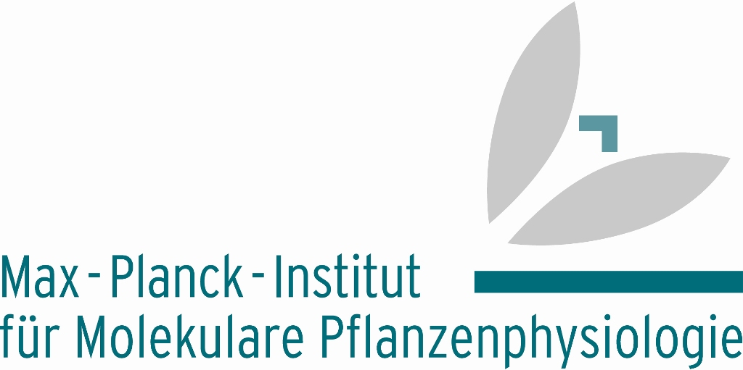 | 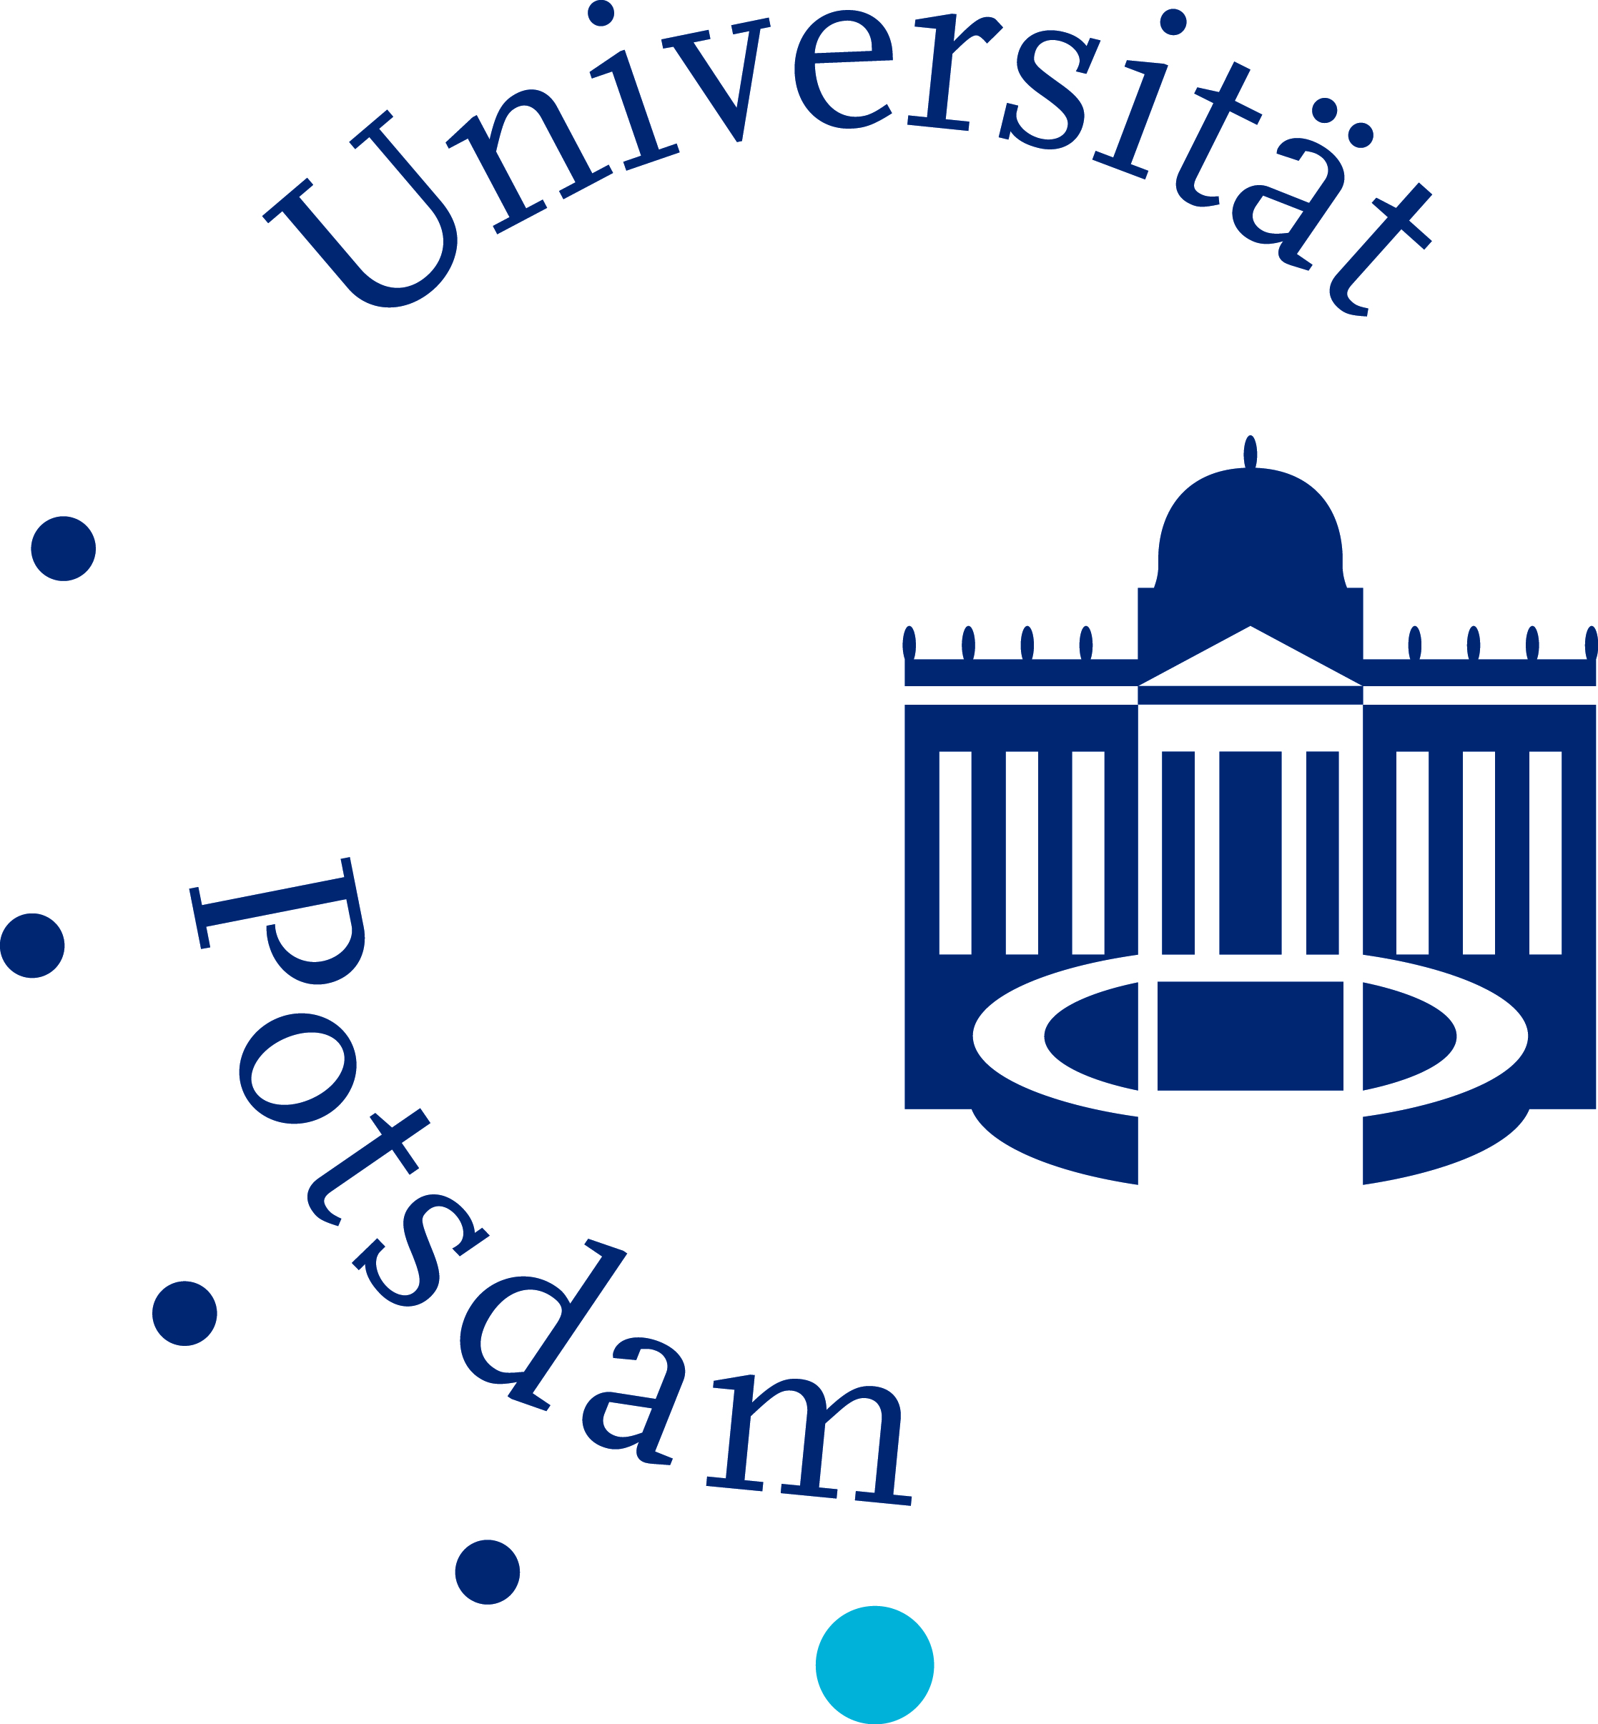

Doctoral fellowships

We are seeking students who are highly motivated to tackle scientific problems in modern plant biology. We offer cutting-edge interdisciplinary training spanning genetics, genomics, physiology, high-end analytical techniques, and bioinformatics.
Doctoral studies will focus on systems-oriented approaches using the model plant Arabidopsis thaliana with an emphasis on molecular phenotyping (’omics’) technologies, data integration, and modelling. Individual career development plans will be configured with the students.
The IMPRS-PMPG, a joint initiative of the Max Planck Institute of Molecular Plant Physiology and the University of Potsdam, has internationally renowned faculty, strong research groups, and vibrant doctoral students. The entire programme is in English and no tuition fees apply.

For further information about the programme and the online application procedure, please visit our web site at: http://www-en.mpimp-golm.mpg.de/IMPRS_GoFORSYS/index.html

The Max Planck Institute of Molecular Plant Physiology is one of the largest plant research centres in Europe. Three Max Planck Institutes, two Fraunhofer Institutes, the University of Potsdam, and a new centre for start-up companies provide an excellent infrastructure for modern cross-disciplinary training. The campus is located in close proximity to the many research and educational facilities in Berlin. Further information about the institute can be found at: www.mpimp-golm.mpg.de.

Applications by February 29, 2008

