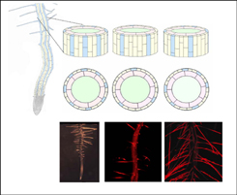
The Schmidt lab (http://ipmb.sinica.edu.tw/faculty/wschmidt.html) is seeking a highly-motivated Bioinformatician at the postdoctoral level for conducting Information-driven research related to microarray data analysis. Candidates should be ambitous to make new discoveries in the Plant Biology field while interacting with Mathematicians, Computer Scientists and Biologists on an international team.
Please send an English resume and a description of your previous research to: Wolfgang Schmidt (wosh@gate.sinica.edu.tw). Suitable candidates will be invited for an interview.

