# Buffalo.MongoDB帮助

## 1.介绍

Buffalo.MongoDB是一个MongoDB操作库项目依赖文件输出可以在 Buffalo安装工具🡪选择对应的.net版本🡪输出 获取

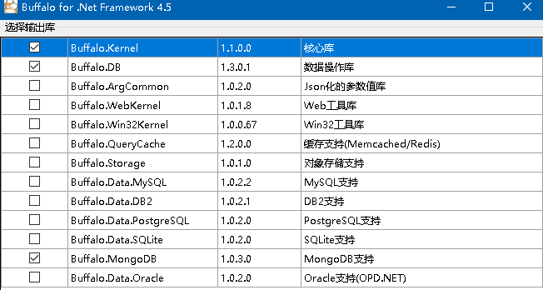

## 2.使用

### ****2.1初始化:****

private void InitLogDB()

{

string connString = “mongodb://127.0.0.1:27017”;

string dbName =”MyDB”;

Buffalo.MongoDB.MongoDBManager.AddConfig ("MyDB", connString, dbName,typeof(GameBoxLib.BQLEntity.MyDB).Assembly);

}

在程序启动时候使用Buffalo.MongoDB.MongoDBManager.AddConfig 加载配置到内存

### **2.2声明示例**

/// <summary>

/// 玩家分成记录

/// </summary>

[MGCollection("MyDB ", "GBMUserCommissionLog")]

[BsonIgnoreExtraElements]

public class GBMUserCommissionLog : MongoEntityBase

{

public readonly static MongoDBOperate<GBMUserCommissionLog> Context = MongoDBManager.CreateOperate<GBMUserCommissionLog>();

/// <summary>

/// ID

/// </summary>

public virtual ObjectId _id { get; set; }

/// <summary>

/// 自增长ID

/// </summary>

[MongoAutoIncrement]

public virtual long SeqId

{

get;

set;

}  
/// <summary>

/// 创建时间

/// </summary>

public virtual long CreateTime { get; set; }

/// <summary>

/// 分成

/// </summary>

public virtual long Coins{ get; set; }

public static void CreateIndex()

{

GBMUserCommissionLog.Context.CreateIndex("SeqId", MGSortType.DESC);

GBMUserCommissionLog.Context.CreateIndex("CreateTime", MGSortType.DESC);

}

}

标签MGCollection

参数1：属于那个数据库标签,**初始化**时候，AddConfig的第一个参数为数据库名

参数2：哪个参数

标签MongoAutoIncrement

**标记为自增长**

CreateIndex方法

创建索引的示例

### 2.3查询

#### 2.3.1标准查询

ConditionList<GBMUserCommissionLog> condition = new ConditionList<GBMUserCommissionLog>();

int currentPage= 0;

condition.AddEqual<int>("UserId", user.Id);//条件

condition.OrderBy.Add("CreateTime", MGSortType.DESC);//排序

condition.OrderBy.Add("_id", MGSortType.DESC);

condition.PageContext.CurrentPage = currentPage;//当前页面(从0开始)

condition.PageContext.PageSize = 50;//页码

condition.PageContext.IsFillTotalRecords = false;//是否查询最大页数

List<GBMUserCommissionLog> lst = GBMUserCommissionLog.Context.SelectList(condition);

#### 2.3.2插入

GBMUserCommissionLog value = _userCommissionLog;

value.SeqId = MinSeqId;

value. CreateTime = (long)CommonMethods.ConvertDateTimeInt(DateTime.Now);

GBMUserCommissionLog.Context.Insert(value, false);

#### 2.3.3删除

ConditionList<GBMUserCommissionLog> queryDelete = new ConditionList<GBMUserCommissionLog>();

queryDelete.AddIn("SeqId", lstId);

GBMUserCommissionLog.Context.Delete(queryDelete);

#### 2.3.4分组统计

ConditionList< GBMUserCommissionLog> lstScope = new ConditionList< GBMUserCommissionLog>();

long start = (long)CommonMethods.ConvertDateTimeInt(dtStart);

long end = (long)CommonMethods.ConvertDateTimeInt(dtEnd);

lstScope.AddBetween("CreateTime", start, end);//条件，如果没此条件则为符合条件的总条数

lstScope.AddShowProperty("Coins", MGAggregateType.Sum, "Coins");//要Sum的条件

List<BsonDocument> lst = GBMUserValueChange.Context.SelectGroupBy(lstScope);

long ret = 0;

foreach (BsonDocument dic in lst)

{

ret += dic["Coins"].AsInt64;

}

return ret;