Design and Evaluation Framework for Optimistic-101: A Private On-Premise Agentic AI Workbench
Optimistic-101 Research Project
CSE-AI | SIH Problem Statement SIH26117
Smart Automation — Software

Abstract
Industrial organizations increasingly seek generative and multimodal AI for tasks such as document analysis, maintenance assistance, quality inspection and operational decision support. However, confidential engineering documents, process knowledge, maintenance records and operational data may not be suitable for transmission to external cloud AI services. This paper proposes a sovereign, on-premise agentic AI workbench in which open-weight multimodal large language models operate within the organization’s infrastructure. The proposed architecture combines multimodal ingestion, retrieval-augmented generation (RAG), vector-based knowledge retrieval, multi-agent orchestration, approved industrial tools, policy guardrails, human-in-the-loop approval and immutable audit logging. The system is designed to support industrial inputs including SOPs, manuals, standards, engineering drawings, defect images, dashboards, machinery audio and sensor time-series. The paper defines an experimental framework to evaluate answer quality, retrieval grounding, latency, resource utilization, hallucination, tool selection and audit coverage. Rather than assuming performance results, the study establishes measurable evaluation criteria for a future pilot. The central design principle is that deterministic systems compute and verify, agents plan and explain, and humans approve safety-critical actions.

Keywords
Sovereign AI; On-Premise AI; Agentic AI; Multimodal LLM; Open-Weight LLM; Retrieval-Augmented Generation; Industrial AI; Data Sovereignty; Human-in-the-Loop; Industrial Automation

1. Introduction
Industrial environments generate heterogeneous and highly valuable information, including standard operating procedures, machine manuals, engineering drawings, maintenance reports, quality images, dashboards, machinery audio and sensor data. Large language models and multimodal models provide an opportunity to make this information easier to search, understand and operationalize. However, confidential industrial information can contain intellectual property, proprietary process knowledge and operationally sensitive information. Sending such data to external AI services can introduce concerns involving privacy, data residency, security, network dependency and organizational control.
The proposed Optimistic-101 system addresses this challenge through a sovereign on-premise architecture. Instead of moving confidential data to a remote AI service, the AI models and supporting services are deployed within the plant or organization-controlled infrastructure. The proposed workbench is intended to move beyond a conventional chatbot by combining knowledge retrieval, multimodal understanding, specialized agents, verified tools, guardrails and human approval into an operational copilot.

2. Problem Statement
Organizations with confidential industrial data need AI assistance for knowledge retrieval, analysis and workflow support without exposing proprietary information outside their controlled environment. Existing cloud-centric AI workflows may be unsuitable where data sovereignty, air-gapped operation, regulatory requirements or strict intellectual-property protection are important. The research problem is therefore to design and evaluate an on-premise AI architecture that can provide useful multimodal and agentic assistance while preserving data locality, controllability, verification and auditability.

3. Research Gap
Research has substantially advanced individual capabilities such as open-weight large language models, multimodal language models, retrieval-augmented generation and LLM-based agents. A practical research challenge remains in integrating these capabilities into a unified architecture for confidential industrial workflows while simultaneously addressing data sovereignty, grounded generation, tool verification, human approval and auditability. This work focuses on that integration and proposes an evaluation framework rather than claiming that the individual technologies are themselves novel.

4. Research Questions
- RQ1. Can an on-premise agentic AI workbench using open-weight multimodal LLMs provide reliable and efficient assistance for confidential industrial workflows while maintaining data sovereignty and human control?
- RQ2. How does retrieval-augmented generation affect the accuracy and grounding of domain-specific industrial responses?
- RQ3. How do model size and quantization affect response quality, latency and computational requirements for on-premise deployment?
- RQ4. Can agentic task routing improve the handling of multi-step industrial workflows compared with a single-model interaction?
- RQ5. Can policy guardrails and human approval provide a practical control mechanism for safety-critical AI-assisted actions?

5. Objectives
- Design a sovereign on-premise architecture for confidential industrial AI applications.
- Integrate an open-weight multimodal LLM with RAG for grounded industrial knowledge retrieval.
- Develop an agentic orchestration layer that routes tasks to specialized industrial agents.
- Evaluate trade-offs among model capability, latency and computational resources.
- Evaluate reliability, security, auditability and human-approval mechanisms for industrial AI workflows.

6. Proposed System Architecture
The proposed workflow begins with an operator query or multimodal input. An ingestion layer processes text, images, audio and sensor information. The knowledge core combines retrieval-augmented generation, a vector database and the selected language model. An agent orchestrator plans the task and routes it to specialist agents such as maintenance, quality, HSE or supply-chain agents. Approved tools can connect to enterprise and operational systems such as CMMS, ERP and SCADA/OPC-UA through controlled interfaces. Guardrails enforce policies and confidence thresholds. Safety-critical, low-confidence or out-of-scope requests are sent to a human for approval before execution.

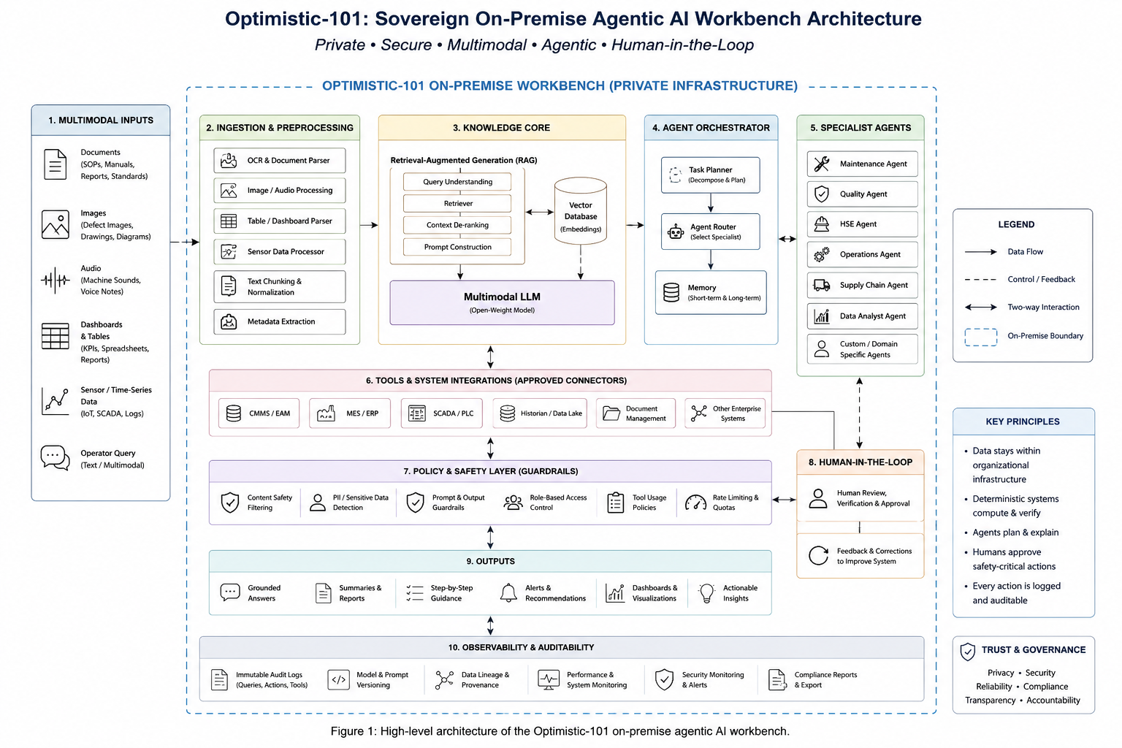

The architecture follows a deliberate separation of responsibilities: deterministic systems perform calculations and verification; AI agents plan and explain; and humans retain authority over safety-critical actions. This reduces the risk of allowing a generative model to directly control critical industrial operations.

7. Multimodal Data and Knowledge Layer
The system is designed to accept multiple forms of industrial information. Textual sources such as SOPs, manuals and standards can be parsed and indexed for retrieval. Visual sources such as defect images, engineering drawings and dashboards can be processed by multimodal models. Machinery audio and sensor time-series can provide additional operational context. A vector database can store representations of approved knowledge sources, allowing relevant passages or records to be retrieved before generation.
RAG is used to ground responses in organization-specific knowledge rather than relying solely on model parameters. The evaluation should therefore measure not only whether an answer is plausible, but whether it is supported by retrieved evidence.

8. Agentic Orchestration
A supervisor agent can classify an operator request, determine the required workflow and route the task to a specialized agent. A maintenance agent may assist with maintenance knowledge and work-order drafting, while quality and HSE agents can address their respective domains. Tool calls are restricted to approved interfaces and policies. The intended pipeline is: understand → retrieve → plan → call verified tools → validate → request approval when required → audit the result.

9. Security and Data Sovereignty
The proposed deployment is designed for plant-controlled infrastructure and can support air-gapped operation. Security mechanisms include role-based access control, policy enforcement, network segmentation, controlled OT/IT gateways, blocked external egress, encrypted communications, protected key management, signed software containers and immutable audit logs. The objective is not only to keep data local, but also to control who can access AI capabilities, which tools can be invoked and which actions require approval.

10. Candidate Technology Stack
Layer | Candidate Technology | Purpose
Model | Llama-family / Qwen2.5-VL / Phi-family | Open-weight language and multimodal reasoning
Serving | vLLM; INT8/FP8 where appropriate | Efficient local inference
Orchestration | LangGraph | Agent workflow and routing
Backend | FastAPI | Application and tool APIs
Knowledge | PostgreSQL + pgvector | Metadata and vector retrieval
Messaging | Redis / Kafka / MQTT | Application and industrial messaging
OT integration | OPC-UA / controlled gateways | Industrial system connectivity
Security | RBAC / OPA / TLS / audit logging | Access, policy and traceability

11. Experimental Methodology
The proposed evaluation will use a controlled industrial-style dataset consisting of approved manuals, SOPs, technical documents and representative multimodal samples. No fabricated performance claims are made in this draft; numerical results should be added only after experiments are conducted.

11.1 Experiment A — RAG versus No-RAG
The same model can be evaluated with and without retrieval. A question set derived from the knowledge corpus can be used to measure answer correctness, evidence relevance and unsupported statements. This experiment tests whether retrieval improves domain grounding.

11.2 Experiment B — Model and Quantization Comparison
Candidate models can be compared using the same workload. Measurements should include response quality, first-token or end-to-end latency, throughput, GPU memory and resource utilization. Quantized and non-quantized configurations can be compared where hardware permits.

11.3 Experiment C — Agentic versus Single-Agent Interaction
Representative multi-step tasks can be evaluated using a single-model baseline and the proposed supervisor-plus-specialist-agent architecture. Evaluation can include task completion, correct agent selection, tool-call correctness and number of unnecessary actions.

11.4 Experiment D — Security and Audit Evaluation
The deployment should be tested for external network egress, unauthorized tool access and audit completeness. Safety-critical scenarios should verify that human approval is required before the corresponding action is executed.

12. Evaluation Metrics
Metric | Measurement | Purpose
Answer accuracy |  | Assess response quality
Retrieval relevance | Relevant retrieved evidence | Assess RAG quality
Groundedness | Supported claims / evaluated claims | Measure evidence-based generation
Hallucination rate | Unsupported responses / total responses | Assess reliability
Latency | End-to-end response time | Assess usability
Throughput | Completed requests per unit time | Assess serving capacity
GPU memory | Peak memory consumption | Assess deployment requirements
Tool-selection accuracy | Correct tool calls / tool-call tasks | Assess agent reliability
Audit coverage | Logged actions / auditable actions | Assess traceability
Data egress | Observed external data transfer | Assess sovereignty

13. Expected Contributions
- A practical architecture for deploying open-weight multimodal and agentic AI within a controlled industrial environment.
- An integrated RAG and agentic workflow for domain-grounded industrial assistance.
- A verification and human-approval pattern for reducing uncontrolled execution by generative AI.
- An experimental framework for evaluating accuracy, grounding, latency, resource usage, security and auditability.

14. Limitations
The proposed work may be constrained by GPU availability, limited access to real industrial datasets, the complexity of multimodal processing, integration with legacy OT systems, model hallucination and the operational difficulty of updating models in air-gapped environments. Real-world industrial validation would require appropriate safety procedures, domain experts and controlled deployment.

15. Future Work
Future work can investigate smaller specialized models for edge deployment, improved multimodal fusion, automated evaluation of agent plans, stronger tool verification, predictive-maintenance workflows, digital-twin integration and multi-plant model and knowledge management. Additional work is also required to establish safety assurance methods for increasingly capable industrial agents.

16. Conclusion
This paper proposes a sovereign on-premise agentic AI workbench for confidential industrial applications. The architecture combines open-weight multimodal models, RAG, agent orchestration, approved industrial tools, policy guardrails, human approval and audit logging. Its central objective is to provide AI assistance without requiring confidential industrial data to leave the organization's controlled environment. The proposed experiments are designed to determine whether the integrated architecture can achieve useful response quality and workflow assistance while meeting practical requirements for latency, resource efficiency, security and auditability. The final research conclusions should be based on measured experimental results rather than assumed performance.

17. References — Initial Sources
[1] Meta AI, “Llama 3 Model Card and Herd of Models,” 2024.
[2] Qwen Team, “Qwen2.5-VL Technical Report,” arXiv:2502.13923, 2025.
[3] K. Kwon et al., “Efficient Memory Management for Large Language Model Serving with PagedAttention,” arXiv:2309.06180, 2023.
[4] MeitY, Government of India, “Digital Personal Data Protection Act, 2023.”
[5] National Institute of Standards and Technology, “Artificial Intelligence Risk Management Framework: Generative Artificial Intelligence Profile,” NIST AI 600-1, 2024.

Project Alignment Note
This draft is based on the Optimistic-101 project proposal material supplied for this project. The proposal identifies the sovereign on-premise concept, multimodal inputs, agentic orchestration, RAG/vector knowledge, verified tools, guardrails, security controls, candidate models and pilot KPIs. The proposal also states that the examples are illustrative and that pilot KPIs will be reported after validation; therefore this document intentionally does not fabricate experimental results.

