# Size of hw4tiny

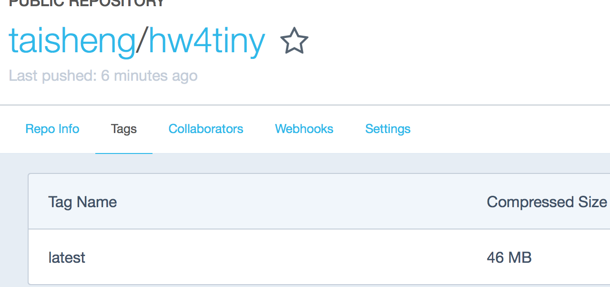

# Size of hw4large

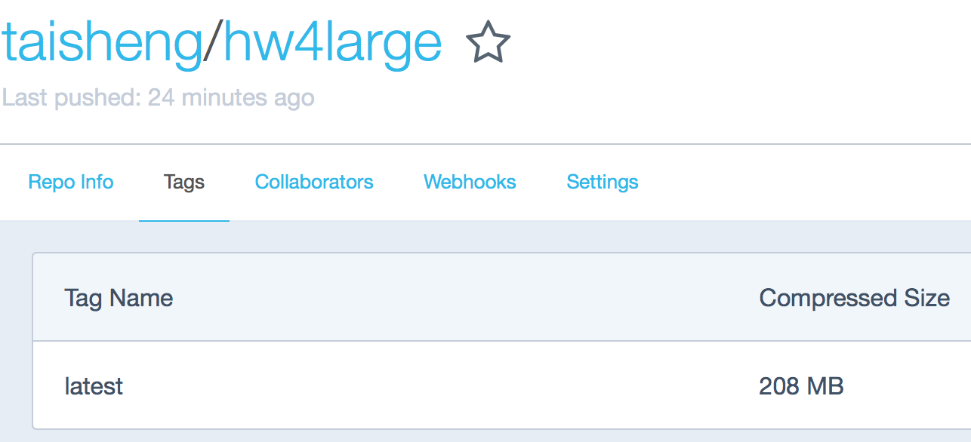

# Empty all the containers and container images



# Pull the taisheng/hw4large and test

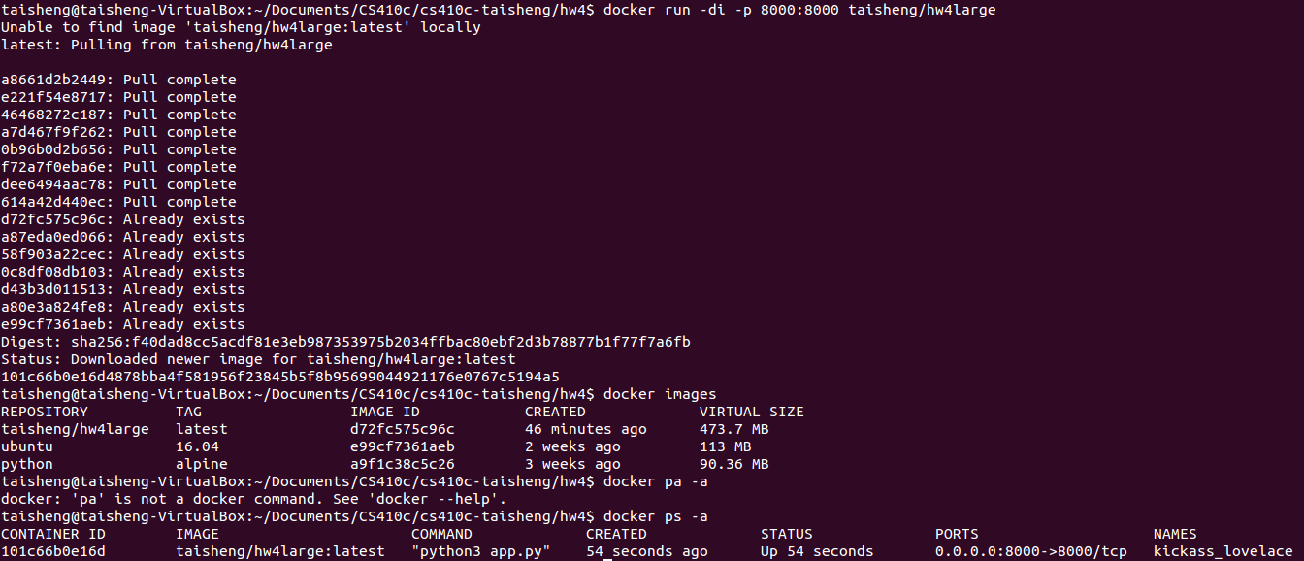

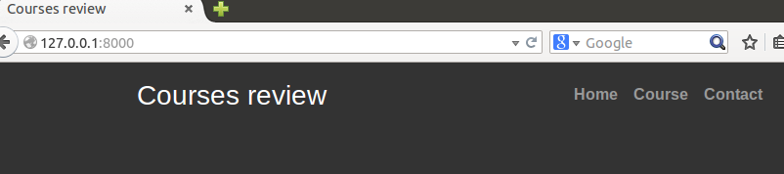

# Pull the taisheng/hw4tiny and test

