***Time Series Analysis of Yokohama Household Consumption by Autoregressive Analysis and Yokohama Weather Data from 2000 to 2016.***

***by***

***School of Economics, Keio University***

***Taishiro Yamada(2018)***

***嘉治佐保子研究会***

***-Abstract-***

This paper is an investigation on the impact of weather against household total consumption. I study Yokohama, Japan weather from 2000 to 2016 to analyze Yokohama total consumption. My main purpose is to study the relationship between weather and household consumption.

Data in many periods on weather in Japan can be found on Japan Meteorological Agency Database. However, data on consumption in Yokohama does only exist from 2000 to the previous year. Thus, in this paper analysis is mainly focused on 2000s.

In chapter one, I provide a general introduction of weather and consumption data. In chapter two, I study consumption time series data, using autoregressive model of autoregressive moving average model(ARMA), autoregressive integrated moving average model(ARIMA). Scoring the accuracy of these models with root mean square error provides that ARIMA model was the most accurate. In chapter three, weather variables are taken into account by conducting vector autoregressive model(VAR) and granger causality model. In the last chapter, I compare the results of the results of chapter two and three, showing some evidence that weather has almost no effect on consumption compared to past consumption time series data.

-Acknowledgement-

I would like to thank to Professor Sahoko Kaji, for your helpful comments and suggestions made in the course of your seminar of writing this paper. To finish this thesis, I have ever received a lot of advice from the participants who I have studied with as well. I appreciate all of your help.

January 2016

Taishiro Yamada

-Contents-

List of Contents

[Chapter 1 5](¥l)

[1.1 Introduction 5](¥l)

[1.2 Overview of data 5](¥l)

[1.3 Test for regression analysis 9](¥l)

[1.4 Different series 11](¥l)

[Chapter 2 14](¥l)

[2.1 Estimation with autoregressive moving average model. 14](¥l)

[2.2 Scoring the accuracy of ARMA 15](¥l)

[2.3 Estimation with autoregressive moving integrated average model. 16](¥l)

[2.4 Comparing the accuracy of the models 18](¥l)

[Chapter 3 19](¥l)

[3.1 Selection of variables for VAR model 19](¥l)

[*-*References*-* 21](¥l)

# Chapter 1

## 1.1 Introduction

As factors of transition in household consumption, transition in propensity to consume is sometimes taken up. However, weather is sometimes also recognized as factors of that. Therefore, by omitting economic factors, including consumer price index, I try quantitative analysis on the relationship between household consumption and weather. In this thesis, I study data of Yokohama prefecture in Japan from 2000 to 2016 since household data in consumption does not exist before 2000.

## 1.2 Overview of data

Although consumption in household sector in Yokohama prefecture has a trend, it does not have a drastic transition. Figure 1.1 illustrates monthly consumption in household in Yokohama prefecture from 2000 to 2016. Weather in Yokohama does not have drastic a trend. From figure1.2 to figure 1.6 shows each phenomena change from 2000 to 2016. Focusing on figure1.1, this shows that this is under unit root process. Weather data represented by figure 1.2, 1.3, 1.4, 1.5, 1.6 is mixture of unit root process and stationary process. From figure 1.2 and 1.3, temperature and rain are apparently under stationary process because moving average and variance has uniformity over the years. In contrast, from figure 1.5 illustrates that wind speed is under unit root process since moving average has a trend. Additionally, variance is not uniform. Therefore, before conducting regression analysis to study the relation between weather and household consumption, unit root and cointegration should be tested.

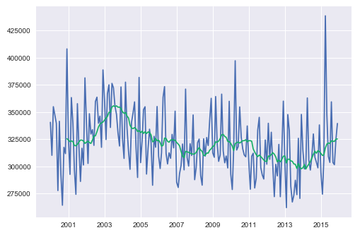

**Figure1.1** Yokohama prefecture monthly total household consumption from 200 to 2016 and that of moving average.

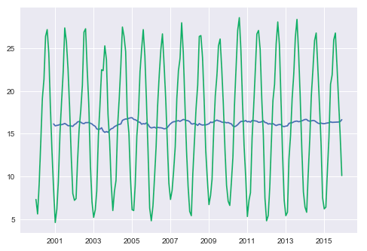

**Figure1.2** Yokohama prefecture monthly average temperature of daily average temperature from 2000 to 2016 and that of moving average.

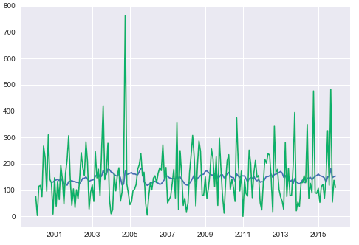

**Figure1.3** Yokohama prefecture monthly precipitation from 2000 to 2016 and that of moving average. Y axis’s unit is mm.

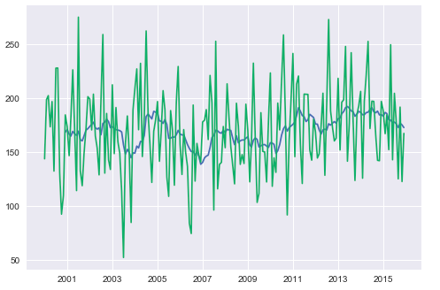

**Figure1.4** Yokohama prefecture monthly sum of sunshine hours from 2000 to 2016 and that of moving average. Y axis’s unit is hours.

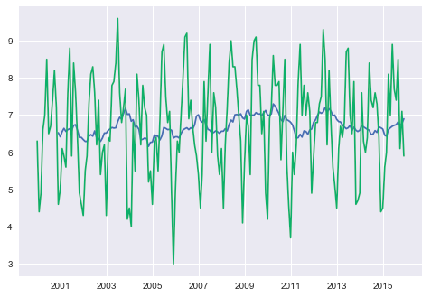

**Figure1.5** Yokohama prefecture monthly average of cloud cover from 2000 to 2016. Definition of cloud cover is the rate of how much cloud covers all the skies. If cloud covers all, the index of cloud cover is 10. If cloud does not cover the sky at all, then the index is 1.

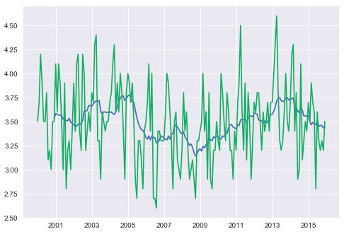

**Figure1.6** Yokohama prefecture monthly average of wind speed from 2000 to 2016 and that of moving average. Unit is mm per second.

## 1.3 Test for regression analysis

From 1.2, necessity for unit root test and becomes clear. Accordingly, I test household consumption and average temperature, rainfall, sunshine hours, cloud cover and wind speed. This time, I adopt Augmented Dickey–Fuller test(ADF test)（Dickey, Fuller 1979） to all data with a way that constant is only considered (trend is ignored) and autolag is Akaike’s information criterion(AIC). Table1.1 provides the results of adfuller-dickey test. This shows that Household consumption and wind speed are unit root process because pvalue is less than 0.05, meaning these two null hypothesis fail to be rejected. The other null hypothesis succeeded to be rejected in terms of pvalue. Therefore, cointegration test to data has to be done as some of data has unit root process.

|  |  |  |  |  |  |  |
| --- | --- | --- | --- | --- | --- | --- |
|  | Household Consumption | Average Temperature | Sunshine Hours | Rainfall | Cloud Cover | Wind Speed |
| ADF  statistic | -1.8142038948570183 | -3.2900637663836467 | -5.616589192480479 | -7.969310934484765 | -2.8600582212346004 | -1.9690874586506262 |
| Pvalue | 0.3734330038095893 | 0.015328508913554114 | 1.170606324354971e-06 | 2.8091012202364616e-12 | 0.05019373726663235 | 0.3002894367029275 |

**Table1.1** Results of ADF test to Yokohama household consumption and weather data from 2000 to 2016

From the results of ADF test, I study cointegration by using cointegration test advocated by Johansen (1991, 1995). Table 1.2 shows the results of cointegration test. Table 1.2 illustrates that cloud cover and wind speed which have a trend of unit root do not have any cointegration with household consumption since pvalues of cloud cover and wind speed are much more than 0.05, leading to the consequence that these variables are not in the relationship of cointegration with household consumption. Thus, original series of weather data and household consumption must not be analyzed by regression. In next section, I take different series out of original series of weather and household consumption data having unit root process for regression analysis.

|  |  |  |
| --- | --- | --- |
|  | Cloud Cover | Wind Speed |
| Coint-t | -1.656160653380096 | -1.731214228680023 |
| Pvalue | 0.6966142169811066 | 0.6624925441074415 |

**Table1.2** Results of cointegration test of household consumption with unit root data.

## 1.4 Different series

Tests provided in the last section 1.3 proves that original series of household consumption, wind speed and cloud cover are unit root and do not have cointegration. Hence, I take different series out of these data. Figure 1.7, 1,8 and 1.9 are the different series. By taking difference series, wind speed, cloud cover and household consumption come to be stationary.

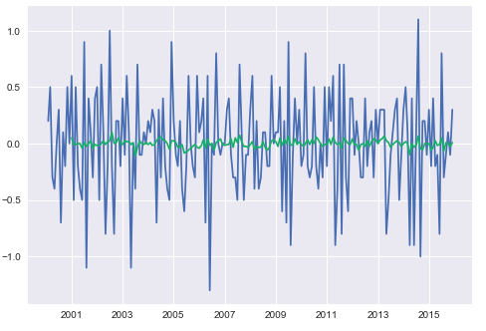

Figure 1.7 Different series of wind speed and moving average of that.

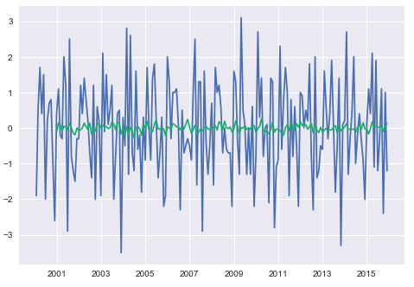

Figure 1.8 Different series of cloud cover and moving average of that.

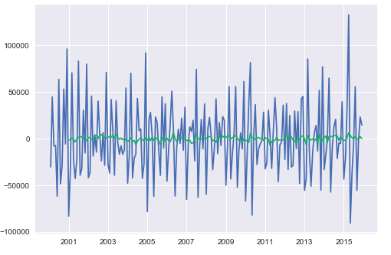

Figure 1.9 Different series of household consumption and moving average of that.

The result of ADF test, represented by Table 1.3, also shows these variable become stationery. Method of ADF test takes over the last method represented in Table 1.1. Since pvalue of each variable is less than 0.05 and ADF statistics of each variable is enough big, these variables change stationary.

|  |  |  |  |
| --- | --- | --- | --- |
|  | Household consumption | Cloud Cover | Wind Speed |
| ADF  statistics | -8.00045229539132 | -10.686799428742827 | -12.10730820681971 |
| Pvalue | 2.3416464404906063e-12 | 3.814864619840895e-19 | 1.9554655283788218e-22 |

**Table 1.3**

In chapter 2, I study autoregressive model applied to household consumption for estimating goodness of fit with the preprocessed data in chapter 1.

# Chapter 2

## 2.1 Estimation with autoregressive moving average model.

In chapter 2, I study the relationship between the past household consumption and the current consumption by autoregressive model. Three models are adopted for achieving this. First model is Autoregressive moving average model in which the value $Y_{t}$ at the time point t is a linear function of the past Y values

$Y_{t-1}$ ​​

, $Y_{t-2}$..., $Y_{t-p}$ and the past white noise $ε_{t}$, $ε_{t-1}$, $ε_{t-2}$..., $ε_{t-p}$, denoted as

$Y_{t }= μ+ ∅_{1}Y_{t-1}+ ∅_{2}Y_{t-2}… +∅_{p}Y_{t-p}+ ε_{t}- {θ_{t}ε}_{t-1}… - {θ_{t}ε}_{t-q }$**(2.1)**

$Y_{t}$ is monthly household consumption in 2016. Explanatory variables are past monthly household consumption from 2000 to 2015. The results of ARMA model is below figure 2.1. Residual error still has seasonal periodicity.

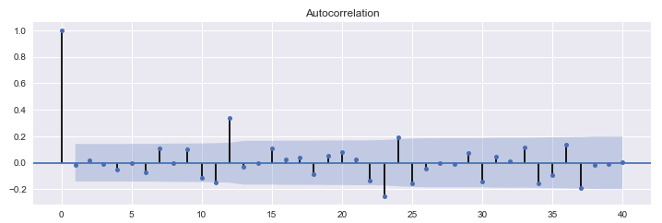

**Figure2.1** Residual error of ARMA model

From the summary of ARMA model represented by figure 2.2, AR model’s lag operator’s pvalue is much less than 0.05, therefore this ARMA model is significant.

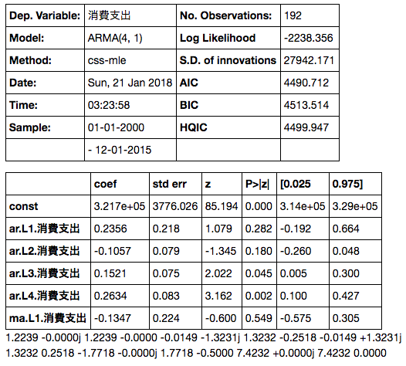

**Fiture2.2** Summary of ARMA model

## 2.2 Scoring the accuracy of ARMA

To test the generalized performance of this model, root mean square error(RMSE) is measured.

$σ_{x}= \sqrt{{Σ (\overline{X}-Xi)}^{2}}$**(2.2)**

In this model, $\overline{X}$ is household consumption in 2016 estimated by ARMA model with data from 2000 to 2015. Xi is real value of household consumption in 2016. Below is obtained by substituting these variables.

|  |  |
| --- | --- |
|  | Root Mean Square Error |
| ARMA | 38929.07006164997 |

**Table 2.1** Root mean square error of ARMA model applied to household consumption. Test data is in 2016 as train data is from 2000 to 2016.

This RMSE is compared to other models’ RMSE in the later section of this chapter.

## 2.3 Estimation with autoregressive moving integrated average model.

From figure 2.1, it comes out that residual error still has a trend. In every twelve months, autocorrelation goes up. To make model more accurately, residual error of seasonal periodicity should be less. Therefore, to decrease a trend, autoregressive integrated moving average model is employed which is one of ARMA model fit to difference series of time series data.

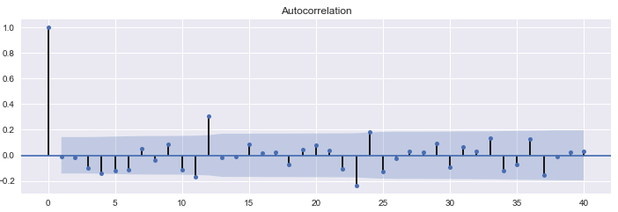

**Figure 2.3** Residual error of ARIMA model

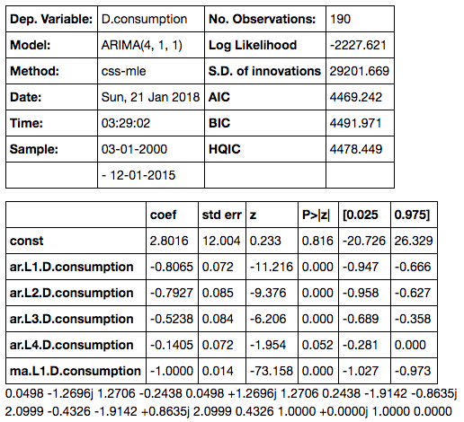

**Figure 2.4　Summary of ARIMA model result**

Figure 2.3 and 2.4 show that a trend still exists, which is autocorrelation becomes high every 12 months. Thus, there is still possibility that generalized performance can be more accurate by omitting seasonal periodicity. To test the generalized performance of this model, root mean square error(RMSE) is measured.

|  |  |
| --- | --- |
|  | Root Mean Square Error |
| ARIMA | 336224.9541796184 |

**Table 2.2** ARIMA models’ root mean square from January 2016 to December 2016

Comparing table 2.1 with 2.2, it comes out that ARIMA explains the model better. However, ARIMA model still has a seasonal residual error represented by figure 2.3. To raise the model accuracy, a seasonal periodicity must be removed. However, in this paper, I do not study model considering seasonal periodicity because the accuracy of the model is not as accurate as I expected.

## 2.4 Comparing the accuracy of the models

Comparing root mean square error, table 2.3 concludes that ARIMA model is more accurate than ARMA model.

|  |  |
| --- | --- |
|  | Root Mean Square Error |
| ARMA | 38929.07006164997 |
| ARIMA | 336224.9541796184 |

**Table 2.3** Comparison between ARMA and ARIMA models’ root mean square from January 2016 to December 2016

In the next chapter, I compare the result of ARIMA and model which includes weather variable dealt as exogenous variable in ARIMA to study weather variable can improve the generalized performance. This is because if the RMSE of ARIMA and model including weather variable are almost same, it becomes clear that weather does not affect household consumption.

# Chapter 3

## 3.1 Selection of variables for VAR model

To estimate household consumption, I use vector autoregressive model (VAR) denoted as

**(3.1)**

where is constant expressing n columns vector whereas *Ai* (i = 1, 2, . . ., p) is coefficient and Ut is disturbance. To use this model, I study correlation of weather variables to avoid multiple collinearity. Figure 2.3 is heat map of correlation coefficient of weather variables illustrating that cloud cover has strong correlation with sunshine hours. Additionally, cloud cover has a strong correlation with precipitation. Therefore, cloud cover must be dropped out of VAR model variables.

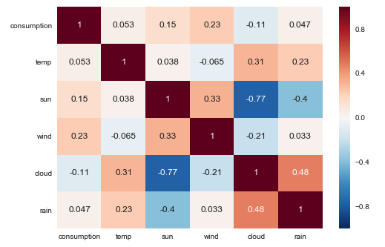

**Figure 3.1** correlation matrix of weather variables.

Figure 3.2, 3.3, 3.4 and 3.5 show result of granger-causality test representing relationship between consumption and each weather variable. This test can be used only to data which is stationary and do not have cointegration. In chapter 1 and 2, ADF test to check unit root and cointegration test are passed. Therefore, granger-causality test can be applied. Granger-causality’s null hypothesis is each weather variable does not grander-cause consumption. From the figures from 3.2 to 3.5, it comes clear that wind speed has the weakest effect on household consumption since pvalue is the biggest amongst the figures .Therefore, in the next section, I estimate VAR model with temperature, sunshine hours and precipitation and score the accuracy.

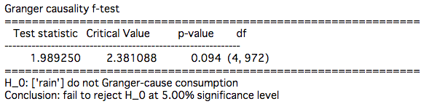

**Figure 3.2** granger-causality test to precipitation.

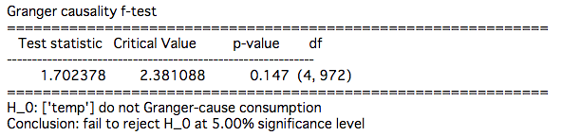

**Figure 3.3** granger-causality test to temperature

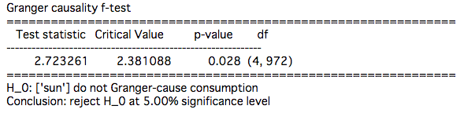

**Figure 3.4** granger-causality test to sunshine hours

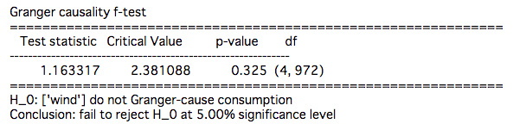

**Figure 3.5**

# 3.2 Estimation with VAR model

To study the relationship between weather and household consumption, VAR model is applied. The result is illustrated in figure 3.6. This shows that

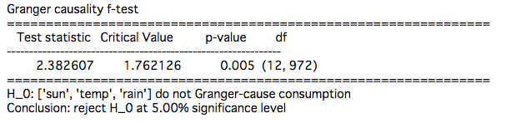

# ***-***References***-***

*-Papers and Articles-*

* *経済産業省(2007), 個人消費に影響する天候など各種要因*
* *Yoshinori Kawasaki and Genjiro Kitagawa (2017), Iwanami Data Science vol6, pp4-81*
* *Kitagawa, G. (1987) Non-Gaussian State Space Modeling of Nonstationary Time Series, Journal of the American Statistical Association Vol82, 1032-1063*
* *Kitagawa, G. (1987) A self-organizing state-space model. Journal of the American Statistical Association, Vol.93 1203-1215*
* *Kitagawa, G(2005) 時系列解析入門, Iwanami*
* Green. “Econometric Analysis,” 5th ed., Pearson (2003)
* Hamilton, J.D. “Time Series Analysis”. Princeton (1994)
* MacKinnon, J.G. (1994). “Approximate asymptotic distribution functions for unit-root and cointegration tests. *Journal of Business and Economic Statistics* 12, 167-76.
* MacKinnon, J.G. 2010. “Critical Values for Cointegration Tests.” Queen’s University, Dept of Economics, Working Papers. Available
  + Found from <http://ideas.repec.org/p/qed/wpaper/1227.html>
* Durbin, James, and Siem Jan Koopman. 2012. Time Series Analysis by State Space Methods: Second Edition. Oxford University Press.

*-Data Source-*

* *Temperature, sunshine hours, precipitation, wind speed and cloud cover from Japan Meteorological Agency.*
  + *Found from* [*http://www.data.jma.go.jp/gmd/risk/obsdl/index.php*](http://www.data.jma.go.jp/gmd/risk/obsdl/index.php)
* *Yokohama consumption and its breakdown from Yokohama statistical portal site*
  + *Found from* [*http://www.city.yokohama.lg.jp/ex/stat/toukeisho/new/index3.html#12*](http://www.city.yokohama.lg.jp/ex/stat/toukeisho/new/index3.html#12)
* *Consumer Price Index from Statistic Bureau*
  + *Found from* [*http://www.stat.go.jp/data/cpi/*](http://www.stat.go.jp/data/cpi/)