***Time Series Analysis of Yokohama Household Consumption by Autoregressive Analysis and Yokohama Weather Data from 2000 to 2016.***

***by***

***School of Economics, Keio University***

***Taishiro Yamada(2018)***

***嘉治佐保子研究会***

***-Abstract-***

This paper is an investigation on the impact of weather against household total consumption. I study Yokohama, Japan weather from 2000 to 2016 to analyze Yokohama total consumption. My main purpose is to study the relationship between weather and household consumption.

Data in many periods on weather in Japan can be found on Japan Meteorological Agency Database. However, data on consumption in Yokohama does only exist from 2000 to the previous year. Thus, in this paper analysis is mainly focused on 2000s.

In chapter one, I provide a general introduction of weather and consumption data. In chapter two, I study consumption time series data, using autoregressive model of autoregressive moving average model(ARMA), autoregressive integrated moving average model(ARIMA) and seasonal autoregressive integrated moving average model(SARIMA). Scoring the accuracy of these models with root mean square error provides that ARIMA model was the most accurate. In chapter three, weather variables are taken into account by conducting vector autoregressive model(VAR) and granger causality model. In the last chapter, I compare the results of the results of chapter two and three, showing some evidence that weather has almost no effect on consumption compared to past consumption time series data.

-Acknowledgement-

I would like to thank to Professor Sahoko Kaji, for your helpful comments and suggestions made in the course of your seminar of writing this paper. To finish this thesis, I have ever received a lot of advice from the participants who I have studied with.

January 2016

Taishiro Yamada

-Contents-

List of Contents

[Chapter 1 5](¥l)

[1.1 Introduction 5](¥l)

[1.2 Overview of data 5](¥l)

[1.3 Test for unit root 9](¥l)

# Chapter 1

## 1.1 Introduction

As factors of transition in household consumption, transition in propensity to consume is sometimes taken up. However, weather is sometimes also recognized as factors of that. Therefore, by omitting economic factors, including consumer price index, I try quantitative analysis on the relationship between household consumption and weather. In this thesis, I study data of Yokohama prefecture in Japan from 2000 to 2016 since household data in consumption does not exist before 2000.

## 1.2 Overview of data

Although consumption in household sector in Yokohama prefecture has a trend, it does not have a drastic transition. Figure 1.1 illustrates monthly consumption in household in Yokohama prefecture from 2000 to 2016. Weather in Yokohama does not have drastic a trend. From figure1.2 to figure 1.6 shows each phenomena change from 2000 to 2016. Focusing on figure1.1, this shows that this is under unit root process. Weather data represented by figure 1.2, 1.3, 1.4, 1.5, 1.6 is mixture of unit root process and stationary process. From figure 1.2 and 1.3, temperature and rain are apparently under stationary process because moving average and variance has uniformity over the years. In contrast, from figure 1.5 illustrates that wind speed is under unit root process since moving average has a trend. Additionally, variance is not uniform. Therefore, before conducting regression analysis to study the relation between weather and household consumption, unit root and cointegration should be tested.

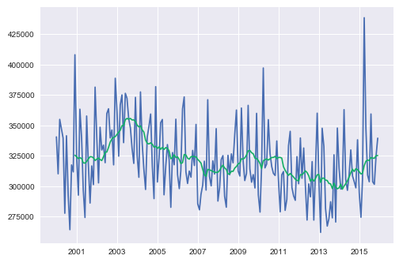

**Figure1.1** Yokohama prefecture monthly total household consumption from 200 to 2016 and that of moving average.

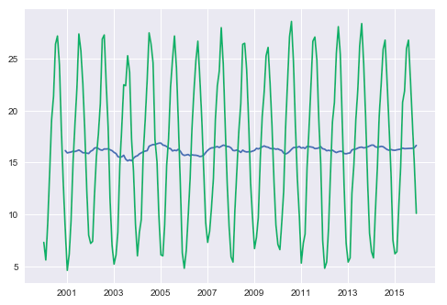

**Figure1.2** Yokohama prefecture monthly average temperature of daily average temperature from 2000 to 2016 and that of moving average.

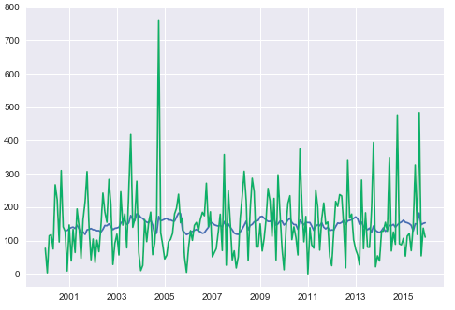

**Figure1.3** Yokohama prefecture monthly precipitation from 2000 to 2016 and that of moving average. Y axis’s unit is mm.

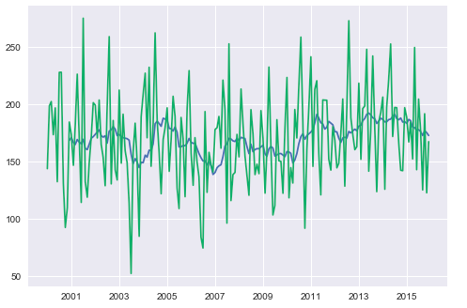

**Figure1.4** Yokohama prefecture monthly sum of sunshine hours from 2000 to 2016 and that of moving average. Y axis’s unit is hours.

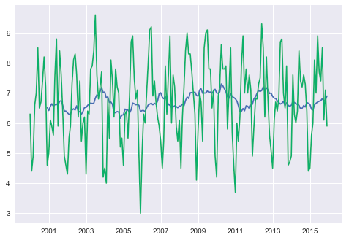

**Figure1.5** Yokohama prefecture monthly average of cloud cover from 2000 to 2016. Definition of cloud cover is the rate of how much cloud covers all the skies. If cloud covers all, the index of cloud cover is 10. If cloud does not cover the sky at all, then the index is 1.

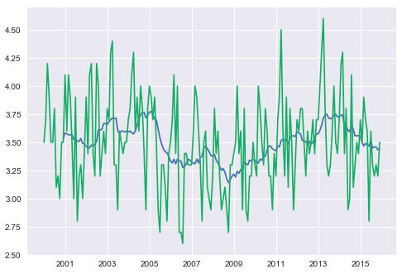

**Figure1.6** Yokohama prefecture monthly average of wind speed from 2000 to 2016 and that of moving average. Unit is mm per second.

## 1.3 Test for regression analysis

From 1.2, necessity for unit root test and becomes clear. Accordingly, I test household consumption and average temperature, rainfall, sunshine hours, cloud cover and wind speed. This time, I adopt Augmented Dickey–Fuller test(ADF test)（Dickey, Fuller 1979） to all data with a way that constant is only considered (trend is ignored) and autolag is Akaike’s information criterion(AIC). Table1.1 provides the results of adfuller-dickey test. This shows that Household consumption and wind speed are unit root process because pvalue is less than 0.05, meaning these two null hypothesis fail to be rejected. The other null hypothesis succeeded to be rejected in terms of pvalue. Therefore, cointegration test to data has to be done as some of data has unit root process.

|  |  |  |  |  |  |  |
| --- | --- | --- | --- | --- | --- | --- |
|  | Household Consumption | Average Temperature | Sunshine Hours | Rainfall | Cloud Cover | Wind Speed |
| ADF  statistic | -1.8142038948570183 | -3.2900637663836467 | -5.616589192480479 | -7.969310934484765 | -2.8600582212346004 | -1.9690874586506262 |
| Pvalue | 0.3734330038095893 | 0.015328508913554114 | 1.170606324354971e-06 | 2.8091012202364616e-12 | 0.05019373726663235 | 0.3002894367029275 |

**Table1.1** Results of ADF test to Yokohama household consumption and weather data from 2000 to 2016

From the results of ADF test, I study cointegration by using cointegration test advocated by Johansen (1991, 1995). Table 1.2 shows the results of cointegration test. Table 1.2 illustrates that cloud cover and wind speed which have a trend of unit root are

|  |  |  |
| --- | --- | --- |
|  | Cloud Cover | Wind Speed |
| Coint-t | -1.656160653380096 | -1.731214228680023 |
| Pvalue | 0.6966142169811066 | 0.6624925441074415 |

**Table1.2** Results of cointegration test of household consumption with unit root data.

***-***References***-***

*-Papers and Articles-*

* *経済産業省(2007), 個人消費に影響する天候など各種要因*
* *Yoshinori Kawasaki and Genjiro Kitagawa (2017), Iwanami Data Science vol6, pp4-81*
* *Kitagawa, G. (1987) Non-Gaussian State Space Modeling of Nonstationary Time Series, Journal of the American Statistical Association Vol82, 1032-1063*
* *Kitagawa, G. (1987) A self-organizing state-space model. Journal of the American Statistical Association, Vol.93 1203-1215*
* *Kitagawa, G(2005) 時系列解析入門, Iwanami*
* Green. “Econometric Analysis,” 5th ed., Pearson (2003)
* Hamilton, J.D. “Time Series Analysis”. Princeton (1994)
* MacKinnon, J.G. (1994). “Approximate asymptotic distribution functions for unit-root and cointegration tests. *Journal of Business and Economic Statistics* 12, 167-76.
* MacKinnon, J.G. 2010. “Critical Values for Cointegration Tests.” Queen’s University, Dept of Economics, Working Papers. Available
  + Found from <http://ideas.repec.org/p/qed/wpaper/1227.html>

*-Data Source-*

* *Temperature, sunshine hours, precipitation, wind speed and cloud cover from Japan Meteorological Agency.*
  + *Found from* [*http://www.data.jma.go.jp/gmd/risk/obsdl/index.php*](http://www.data.jma.go.jp/gmd/risk/obsdl/index.php)
* *Yokohama consumption and its breakdown from Yokohama statistical portal site*
  + *Found from* [*http://www.city.yokohama.lg.jp/ex/stat/toukeisho/new/index3.html#12*](http://www.city.yokohama.lg.jp/ex/stat/toukeisho/new/index3.html#12)
* *Consumer Price Index from Statistic Bureau*
  + *Found from* [*http://www.stat.go.jp/data/cpi/*](http://www.stat.go.jp/data/cpi/)